FORM ONE WORK
CHAPTER 1
INTRODUCTION TO GEOGRAPHY
1. What is practical geography? (2mks)
2. Name two branches of geography (2mks)
3. Name any three study areas in human geography (3mks)
4. Define the term environment (2mks)
5. Explain three reasons for importance of studying geography (3mks)
6. Name five human features (3mks)
7. What is habitat (2mks)
8. List six disciplines related to geography (6mks)
9. Differentiate between each of the following:
- Democracy and population geography
- Economics and economic geography (4mks)
10. Name two Greek words from which term geography originate (2mks)
CHAPTER 2
THE EARTH AND THE SOLAR SYSTEM.
PAST KCSE QUESTIONS ON THE TOPIC

1. (a) State two effects of the rotation of the earth (2mks)
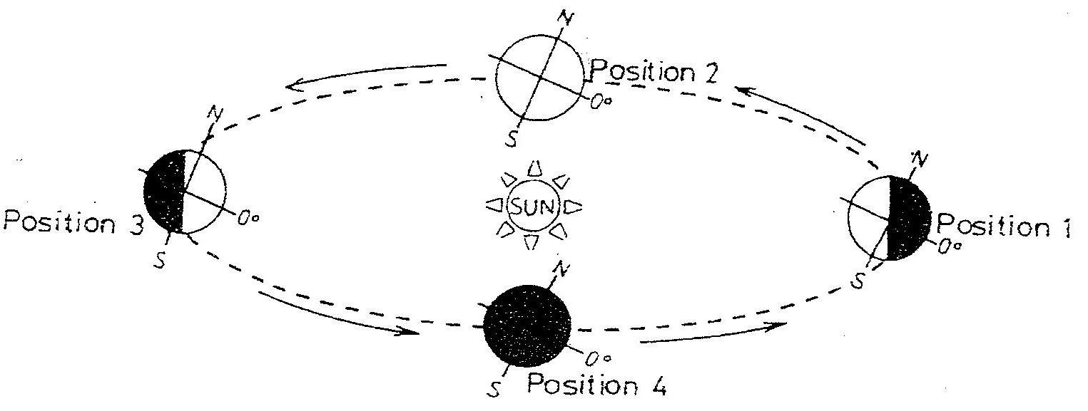
- Study the diagram below and answer the questions that follow

(i) Which movement of the earth is represented by the diagram? (1mk)
(ii) Give two effects of the movement represented by the diagram (2mks)
2. The diagram below represents the structure of the earth. Use it to answer question
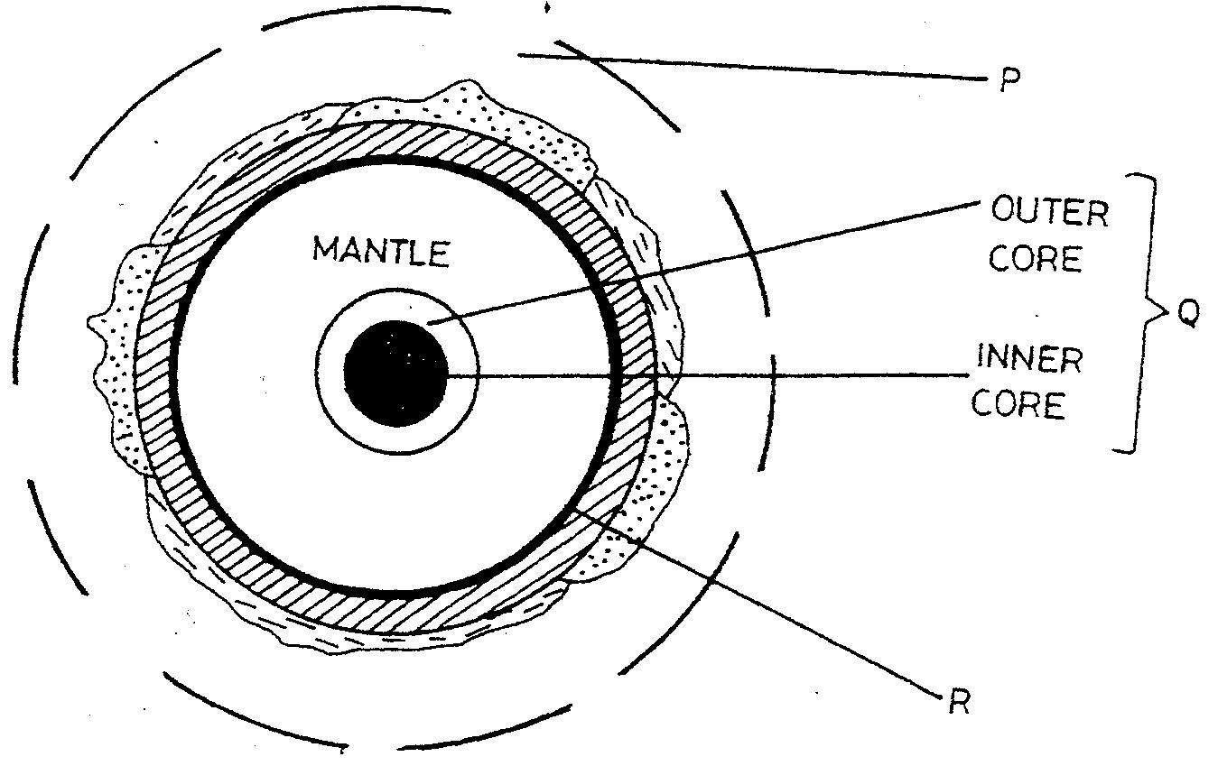

- Name
(i) The parts marked P and Q (2mks)
(ii) The discontinuity marked R (1mk)

(b) State three characteristics of the mantle (3mks)
3. The diagram below shows the composition of the solar system
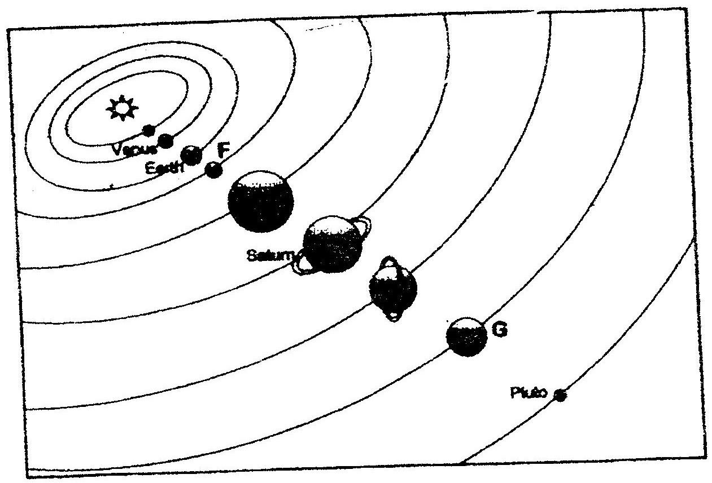

(a) Name the planets marked F and G (2mks)
(b) State three effects of the rotation of the earth on its axis (3mks)
4. a) What is the solar system?
b) Use the diagram below to answer the questions that follow.
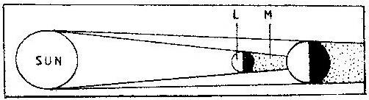

i) What type of eclipse is represented by the diagram?
ii) Name the features marked L and M
5. (a) (i) Give the two dates in a year during which the number of hours of
darkness is equal in both the north and south poles.
(ii) Why do the lengths of days and nights vary from one part of the earth to another?
(b) The diagram below shows the revolution of the earth around the sun. Use it to answer the questions that follow
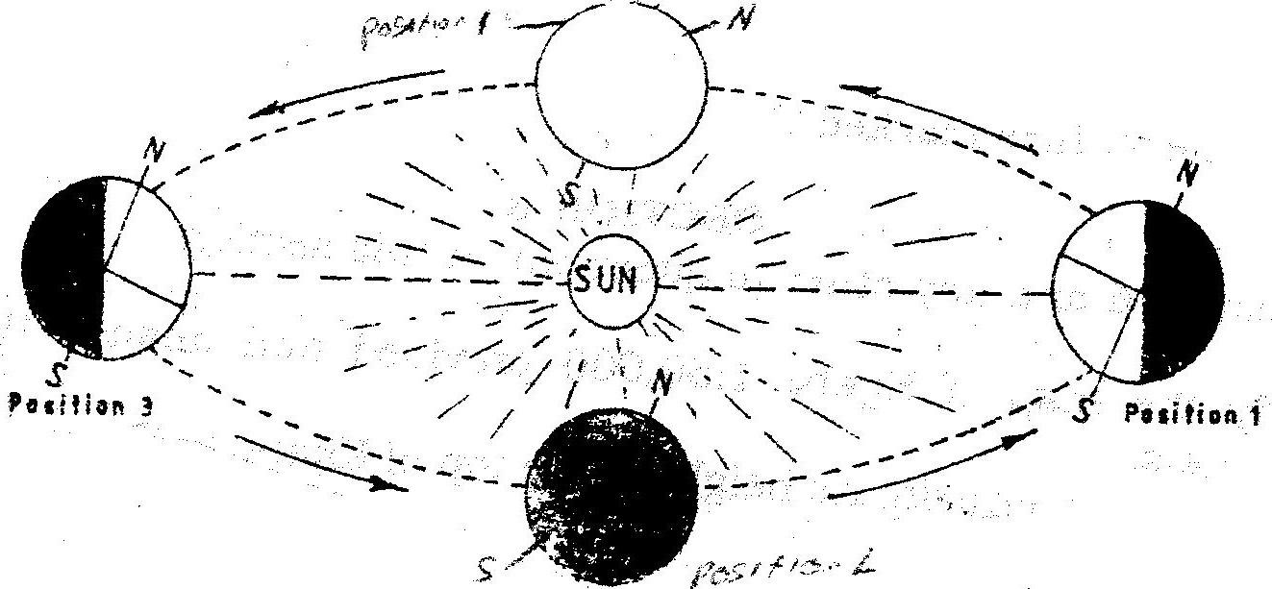

(i) If the earth takes 366 days to make a complete revolution during a leap year, how long will it take to move from position 1 to position 4?
(ii) What season is experienced in the southern hemisphere when the earth is in Position 1?
6. Define the following,
i. Solar system
ii. Galaxy
iii. Star
iv. Asteroids (6mks)
7. Differentiate between the following
(a) Latitude and longitude
(b) Dateline and international dateline
(c) Meteors and Meteorite. (6mks)
8. State three differences between solar eclipse and lunar eclipse. (2mks)
9. State four factors that support life on planet earth. (4mks)
10. (a) List four effects of earth rotation. (4mks)
(b) At Nairobi on longitude 37°E local time is 1 p.m. What time would it be at Sarissa on longitude 41 °E? (4mks)
11. (a) Define equinox. (2mks)
(b) State characteristics of summer solstice. (4mks)
12. The earth is inclined to the ecliptic plane at an angle of..... and the axis is also inclined at an angle ..... to perpendicular line. (4mks)
13. Fill in the table from (a) - (f) (10mks)

Property s/Layer | Major constituent | Thickness | Density | Temperature
Outer crust | (a) | iii. 16-24 kms | (b)
Inner crust | ii. Magnesium | S (c) | 2.8-30 gms/cc
Asthensophere | i. Iron | 2900 kms | (d) | 5000 C
Centrosphere | ii. Nickle | (e) |  | (f)

14. State three weaknesses of the passing star theory. (6mks)
15. Differentiate between hydrosphere and atmosphere. (4mks)
16. Planet ... 1... is seventh planet from the sun and is greenish in colour. Planet ...2... takes shortest time to revolve round the sun about 88 earth day. Planet ...3... and ...4... are referred to as twin planets. Planet ...5... takes about 11.86 earth years to revolve round the sun. All the planets have satellite orbiting round them except planet ...6... and ...7... (7mks)
17. Explain reasons for flattening and bulging of earth. (4mks)
18. State characteristics of winter solstice (4mks)
19. Differentiate between summer solstice and winter solstice. (4mks)
20. (a) What is an eclipse? (2mks)
21. Apart from planets name other heavenly bodies.
22. What is a longitude? (2mks)
23. State the effects of the elliptical shape of the earth's orbit. (6mks)
24. If the local time in Nairobi on longitude 37°E time is 10 p.m. What will the time be at Buchanan Liberia on longitude 10°W.? (4mks)
(a) What is the effect of International Date Line on crossing the line? (4mks)
(b) What is the angle of inclination of the earth axis from its orbit? (2mks)
(c) Give four proofs that the earth is spherical in shape. (8mks)
CHAPTER 3
WEATHER
1. (a) How does a sea breeze occur? ( 2 mks)
(b) Use the map of Africa below to answer questions (b) (i)
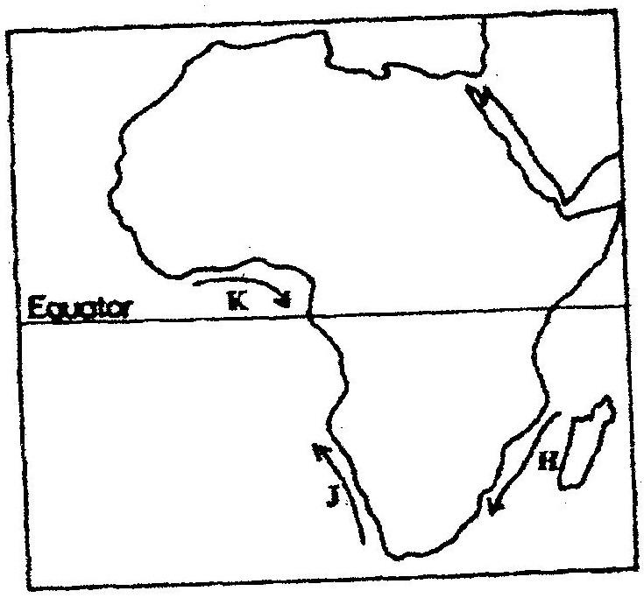

(i) Name the ocean currents marked H, J, and K (3 mks)
(ii) State two effects of a warm ocean current on the adjacent
coastlands (2 mks)
2. (a) Name two theories of the origin of the earth (2 mks)
(b) Name four layers of the earth’s atmosphere (4 mks)
3. (a) State two conditions that are necessary for the formation of fog.
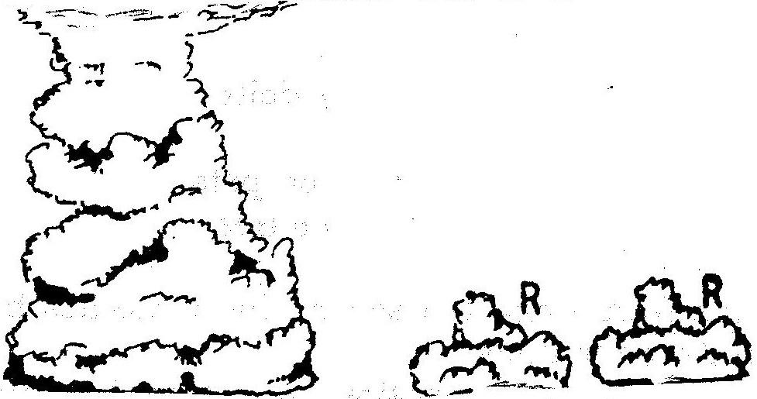
(b) The diagram below shows some types of clouds. Use it to answer the questions that follow.

(i) Name the clouds marked R

(ii) Give two weather conditions associated with cumulonimbus clouds
4. a) the tables below represent rainfall and temperature of stations X and Y.
Use them to answer questions (a) and (b)
MONTHS | J | F | M | A | M | J | J | A | S | O | N | D
TEMPERATURE IN ^{0c} | 30 | 31 | 31 | 31 | 30 | 29 | 29 | 28 | 28 | 29 | 29 | 30
RAINFALL IN MM | 250 | 250 | 325 | 300 | 213 | 25 | 25 | 25 | 100 | 275 | 380 | 200

MONTHS | J | F | M | A | M | J | J | A | S | O | N | O
TEMPERATURE IN ⁰C | 21 | 20 | 20 | 17 | 15 | 13 | 12 | 13 | 15 | 16 | 18 | 20
RAINFALL IN MM | 12 | 12 | 15 | 50 | 90 | 110 | 87 | 87 | 50 | 35 | 20 | 15

a) (i) For each of the two stations calculate the mean annual temperature.
X -
Y -
(ii) Calculate the annual rainfall for station Y
(iii) On the graph paper provided, draw a bar graph to represent rainfall for station x. Use vertical scale of 1cm to represent 50mm
b) Describe the climatic characteristics of station Y.
5. a) The table below shows climatic data of a station in Kenya.
Use it to answer question (a)

Month | Jan | Feb | Mar | April | May | June | Jul | Aug | Sep | Oct | Nov | Dec
Temp in ºC | 28.9 | 29.7 | 30.3 | 29.9 | 29.7 | 29.2 | 28.4 | 28.7 | 29.6 | 30.1 | 29.2 | 28.7
Rainfall in mm | 9.0 | 8.0 | 21.0 | 49.0 | 25.0 | 9.0 | 20.0 | 10.0 | 4.0 | 10.0 | 17.0 | 11.0

- What is the annual range of temperature at the station?
- Calculate the total rainfall for the station.
b) State three factors that influence climate.
6. (a) Name two elements of weather that can be recorded at a school weather
station
(b) Give three reasons why the recording of data at a school weather station
may be inaccurate

7. (a) Describe a suitable site where you would locate a weather station in your
School (2 mks)
(b) Give reasons why a Stevenson’s screen is:
(i) Painted White (2 mks)
(ii) Has louvers (2 mks)
8. Define relative humidity. (2 mks)
9. (a) Identify four characteristics of convectional rainfall. (4mks)
(b) State the difference between radiation fog and advection fog. (4mks)
10. (a) Briefly describe how the six thermometers operate. (5mks)
(b) Three ways in which clouds are classified. (3mks)
11. (a) Give three precautions to be taken when citing a weather station. (3mks)
(b) State three factors determining the amount of solar radiation reaching the earth's surface. (3mks)
12. Define the following terms:
(i) Climate
(ii) Relative humidity
(iii) Weather forecasting
(iv) Absolute humidity
(v) Weather lore (5mks)
13. State the advantages of studying weather through field work. (5mks)
14. (a) Describe how you would use the following apparatus during a field study.
Rainfall, maximum and minimum thermometers. (3mks)
(b) Identify and explain the formation of the type of rainfall found in the Lake Region or Kenya. (8mks)
(c) Briefly write down two problems associated with the type rainfall above.
(4mks)
15. (a) What is weather forecasting? (2mks)
(b) List four problems of weather forecasting. (4mks)
(c) State four ways in which weather forecasting is important to the human activities. (4mks)
16. (a) Explain three ways in which clouds influence weather. (3mks)
(b) Use the data below to answer questions that follow.
Month of the year | J | F | M | A | M | J | J | A | S | O | N | D
Temp in °C | 25 | 26 | 26 | 24 | 23 | 22 | 21 | 21 | 22 | 22 | 22 | 22
Rainfall in mm | 42 | 40 | 73 | 171 | 90 | 89 | 163 | 160 | 71 | 68 | 64 | 42
(i) Calculate mean annual temperature
(ii) Calculate annual rainfall
(iii) Calculate annual range of temperature.
(iv) Calculate the mean annual rainfall
(v) Which is the wettest month? (10 mks)
17. (a) Define 3 air mass. (2mks)
(b) Name types of air masses. (3mks)
(c) A mass of air at 15°C can hold 20gm/cm3 of moisture. The same air at the same temperature has 6gm/cm³ of moisture. What is its relative humidity?
(4mks)
18. Name two instruments placed in the Stevenson Screen. (2mks)
19. Why does sea breeze flow at night time? (3mks)
CHAPTER 4
STATISTICAL METHODS
1. The table below shows petroleum production in thousand barrels per day for countries in the Middle East in April 2006. Use it to answer question (a)

Country | Production in ‘000”  barrels
Iran  Kuwait  Qatar  Saudi Arabia  United Arab Emirates  Iraq | 3800  2550  800  9600  2500  1900

a) (i) What is the difference in production between the highest and the
lowest producer (1mk)
(ii) What is the total amount of petroleum produced in April 2006 in
the region? (1mk)

b) State three conditions that are necessary for the formation of petroleum (3mks)

2. The graph below shows percentage value of some export commodities from Kenya between 1999 and 2003. Use it to answer questions (a) and (b)
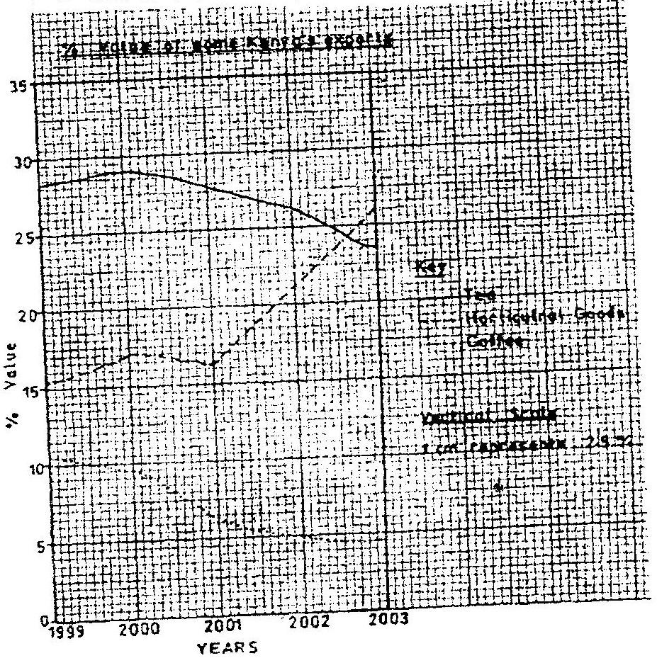

(a) (i) What was the percentage value of the tea exported in the year
2000? (2mks)
(ii) What was the difference in the percentage values of the
horticultural products and coffee exports in 1999? (2mks)
(iii) Describe the trend of the value of coffee exports from 1999 to
2003 (3mks)
(iv) Explain three factors which may have led to the increased export earnings from horticultural produce in Kenya between years 1999 and 2003 (6mks)
(v) Give three advantages of using simple line graphs to represent
data. (3mks)
(b) State four reasons why Kenya’s agricultural export earnings are generally low (4mks)
(c) State five reasons why the common market for Eastern and southern Africa (5mks)
3. (a) Define the following terms
- Statistics
- Statistical data
- Statistical methods (6mks)
(b) State two types of statistical data. (2mks)
(c) Write down two types of questionnaires. (2mks)
4. (a) What factors must be considered in selecting methods of data collection.
(3mks)
(b) Differentiate between discrete data and continuous data giving relevant examples. (4mks)
5. (a) What is sampling (1mk)
(b) State 3 types of sampling. (3mks)
6. (a) Name two main methods used in analyzing statistical data. (2mks)
(b) What is the significance of statistics in geography? (5mks)
7. (i) Name two types of graphs that you have learnt about. (2mks)
(ii) What are the advantages of using graphs named above in representing statistical data? Give advantages. (4mks)
8. (i) What is a questionnaire?
(ii) State four advantages of using questionnaires in collection of' statistical data. (4mks)
(iii) Explain oral interview method. (2mks)
9. Explain the following methods of data recording.
- Tabulation
- Photographing
- Tape recording
- Tallying
10. What is data? (2mks)
11. Marks 72, 60, 65, 70, 65, 80, 65, 70, 80, 84, 63, 75, 63, 71, 74
Use the data above to find out mean and mode. (4mks)
12. With the help of data above explain how median is obtained. (3mks)
CHAPTER 5
FIELD WORK
PAST KCSE QUESTIONS ON THE TOPIC
1. State two ways in which information collected during the field study would be useful to the local community. 2mks
2. Your class is required to carry out a field study of a river. What would be the advantage of dividing the class into groups according to the stages of the long profile 3 of a river?
3. What would be the disadvantages of c using secondary data in this kind of a field study?
4. You intend to carry out field study on population in the local open air market,
(i) State three reasons why it would be necessary for you to visit the market
before actual field study.
(ii) Give two methods you would use to collect information on pollution. ,
(iii) State three follow up activities necessary for the study. -51
5. You are supposed to carry out a field study on the uses of vegetation in the area around your school.
(a) State three reasons why it would be necessary to visit the area before the day of the study.
(b) Give four uses of vegetation you are likely to identify during the study.
(3mks)
(c) Why is it necessary to sample part of the forest for the study?
6. List three types of fieldwork. (3mks)
7. Explain the importance of field work. (5mks)
8. Outline the procedure for carrying out field study. (5mks)
9. List some topics in physical geography on which you can carry out a field study.
(4mks)
10. State five ways in which you would prepare for field study to a weather. (5mks)
11. What is the importance of carrying samples from the field to the school? (4mks)
12. Formulate five suitable objectives for field study on a visit to a forest. (5mks)
13. Discuss types of hypothesis. (2mks)
14. List five methods of data presentation. (5mks)
15. Explain five problems one would encounter on field study in a forest? (5mks)
16. Why is reconnaissance important?
CHAPTER 6
MAP WORK
1. Study the map of Taita Hills (1:50,000) sheet 189/4 provided and answer the following questions
(a) (i) What is the bearing of the peak of Mwatunga hill in grid square
3214 from the water tank in grid square 2619? (2mks)
(ii) What is the length in kilometers of the section of the Mwatate – Voi railway line in the south – eastern part of the map? (2mks)

(b) Draw a rectangle measuring 16cm by 12 cm to represents the area
enclosed by the Eastings 24 and 40 and Northings 20 and 30 ( 1 mk)

On the rectangle, mark and name the following features:
  - Mgange hills ( 1 mk)
  - A rock out crop ( 1 mk)
  - All weather road, bound surface ( 1 mk)
  - River Ruhia ( 1 mk)
  - Ronge forest ( 1 mk)
(c) Using evidence from the map, explain three factors that have favoured the establishment of the Teita sisal Estates in the Southern part of the area covered by the map ( 6 mks)
2. Study the map of Nyahururu, 1: 50,000 (sheet 105/4) provided and answer the following questions
(a) (i) Give the six figure grid of the junction where the road to
Ndaragwa (D 388) meets with the road to Nyeri & Nanyuki (B5) (2mks)
(ii) Calculate the bearing of point X from point Y (2mks)
(iii) Name three physical features found along the line XY (3mks)

(b) (i) Draw a square 12 cm by 12 cm to represent the area enclosed by
the Easting 10 and northing 10 to the North- eastern part of the
map (1mk)
(ii) On the square, mark and label
- The main river (1mk)
- All weather loose surface road (1mk)
- A forest (1mk)

(c) Citing evidence from the map, explain two
    - Physical factors that may have influenced the location of Nyahururu town (4mks)
    - Factors that favour saw milling in the area covered by the map (4mks)

3. Study the map of Taita Hills (150: 50,000 sheet 189\4) to answer the following
questions.
a) What is the approximate height of the hill at the grid square 3926. (2mks)
b) Measure the length of all weather 6 to roads (bound surface) from Wundanyi to southern edge of the area covered by the map. (2mks)
c) Citing evidence from the map describe the relief of the area shown. (5mks)
d) State differences between a map and a plan. (2mks)
e) Explain two importance of scale in maps. (2mks)
4. Study the map of Kisumu East (1:50,000) and answer the following questions.
(a) (i) What is the bearing of the trigonometrical station at grid reference
081980 from the rock antelop at grid reference 071992. (2mks)
(ii) Measure the length of the all weather road (bound surface) 1321, from, the junction at grid reference 974911 to the edge of the map, grid reference 947967. (2mks)
(b) (i) Describe the relief of the area covered by the map.
(ii) Explain how relief has influenced the settlement in the area
covered by the map. (8mks)
(c) Citing evidence give three economic activities carried out in the area
covered by the map.
(d) Students from the school at Masago (grid square 0681) carried out field
study of the course of river Ombeyi.
- State three findings they are likely to have come up with. (3mks)
- Give three advantages of studying rivers through field work
CHAPTER 7
ROCKS AND MINERALS
1. (a) Describe the following characteristics of minerals
(i) Colour (2mks)
(ii) Cleavage (2mks)
(iii) Hardness (2mks)
(b) (i) Give two types of igneous rocks (2mks)
(ii) Explain three conditions necessary fro the growth of coral polyps (6mks)
(c) State four uses of rocks (4mks)
(d) You are planning to carry out a field study on the rocks within your school environment
(i) Give two secondary sources of information you would use to prepare for the field study (2mks)
(ii) State why you would need the following items during the field study:
    - A fork jembe (1mk)
    - A polythene bag (1mk)
(iii) Suppose during the field study you collected marble, sandstone and granite, classify each of these samples according to its mode of formation (3mks)
2. (a) State two characteristics of sedimentary rocks (2mks)
(b) Give two examples of chemically formed sedimentary rocks (2mks)
3. a) Name the type of rocks which results from the metamorphism of:
(i) Granite
(ii) Clay (2mks)
b) Give two reasons why sedimentary rocks are widespread in the coastal plain of Kenya. (2mks)
4. (a) (i) What is a rock? (2mks)
(ii) Describe three ways through which sedimentary rocks are formed
  - Mechanically formed
  - Organically formed
  - Chemically formed (6mks)
(b) Describe two process through which sedimentary rocks changer into metamorphic rocks
(c) Give an example of each of the following types of igneous rocks
- Plutonic rocks (1mks)
- Hypabyssal rocks (1mks)
- Volcanic rocks (1mks)
(d) Suppose you were to carry out a field study of rocks within the vicinity of your school
(i) Name three secondary sources of information you would use to prepare for the field study (3mks)
(ii) State four activities you would carry during the filed study (3mks)
(iii) State three problems you are likely to experience during the field study (3mks)
5. (a) Differentiate between plutonic rocks and volcanic rocks
(b) Describe how lava plateau is formed
(c) (i) Name three volcanic features found in the rift valley of Kenya
(ii) Explain four negative effects of vulcanicity in Kenya
(d) You intend to carry out a field study of a volcanic landscape
(i) State four reasons why it is necessary to conduct a reconnaissance
of the area of study.
(ii) During your field work, you intend to study volcanic rocks, state
why you would need the following items
6. (a) State two main conditions that influence the characteristics of igneous
rocks. (2mks)
(b) Write down three characteristics of sedimentary rocks. (3mks)
(c) Name two examples of organic sedimentary rocks and where found in Kenya. (2mks)
(d) Name four examples of metamorphic rocks and state the original rock from which each was formed. (4mks)
(e) Describe the importance of rocks to human activities. (5mks)
7. (a) State with examples three classes of mechanically formed sedimentary
rocks. (6mks)
(b) Differentiate between regional metamorphism and contact metamorphism.
(4mks)
8. (a) List two examples of extrusive igneous rocks. (2mks)
(b) Differentiate between extrusive and intrusive rocks giving an example in
each case. (2mks)
9. What is a rock? (2mks)
10. What is a mineral? (2mks)
11. Describe changes that occur in sedimentary rocks when they are subjected to high heat and pressure. (4mks)
12. Describe calcareous rocks. (2mks)
13. Describe carbonaceous rocks. (2mks)
14. Give examples of chemically formed sedimentary rocks. (2mks)
15. How are coral rock formed? (3mks)
16. How do rocks become metamorphic? (3mks)
CHAPTER 8
MINING
1. The table below shows petroleum production in thousand barrels per day for countries in the Middle East in April 2006. Use it to answer question (a)

Country | Production in ‘000” barrels
Iran  Kuwait  Qatar  Saudi Arabia  United Arab Emirates  Iraq | 3800  2550  800  9600  2500  1900

a) (i) What is the difference in production between the highest and the
lowest producer (1mk)
(ii) What is the total amount of petroleum produced in April 2006 in
the region? (1mk)
b) State three conditions that are necessary for the formation of petroleum (3mks)
2. Use the map of East Africa below to answer questions (s).

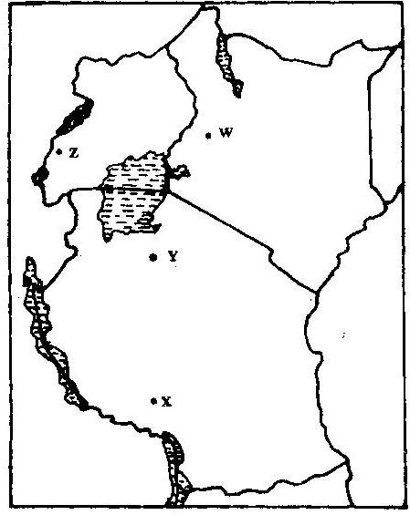

a) (i) Name the railway terminuses marked P, Q R (3mks)
(ii) In each case give the main commodity transported by the railway
lines marked s and T. (2mks)
b) (i) State four reasons why road network is more widespread than railways in East Africa. (4mks)
(ii) One of the problems facing road transport is the high frequency of accidents. Explain four conditions of roads in Kenya that may lead to accidents. (8mks)
c) i) Name three physical regions through which River Tana passes
(3mks)
ii) Explain thee effects of land pollution can be controlled
d) State four ways through which land pollution can be controlled (4mks)
3. The diagram below show the occurrence of petroleum in the earth’s crust.
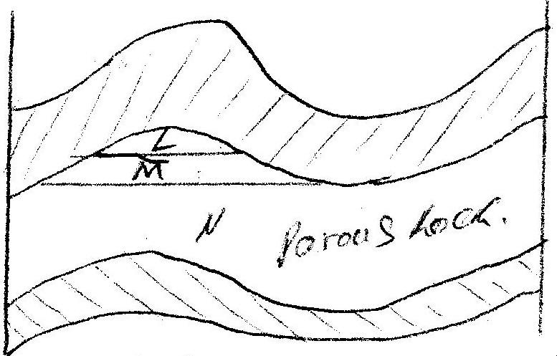
Use it to answer questions (a)

a) Name the substances in the areas labeled L. M and N (3mks)
b) Give two by-products obtained when crude oil is refined (2mks)
4. Use the map of Africa to answer question (a) (i)
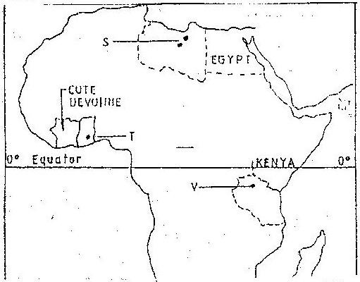

i) Name the minerals mined in the areas marked S, T and V.
ii) State two formation in which mineral ores occur.
b) Explain four problems, which Zambia experiences in the exportation
of copper.
c) Explain three ways in which coal contributes to the economy of
Zimbabwe.
d) Describe three negative effects of open cast mining on the environment.
5. a) Explain how deep shaft mining is done (2mks)
b) Disadvantages of using the above method (2mks)
6. Explain four effects of land dereliction on the environment. (4mks)
7. Describe how panning mining is carried out. (3mks)
8. Identify four problems facing gold mining in South Africa. (4mks)
9. (a) In what ways has Kenya benefited from the mining of soda ash in Lake
Magadi? (2mks)
(b) What are the negative effects of mining on the environment? (4mks)
10. (a) Explain what is meant by placer mining. (2mks)
(b) Name three mining methods.
11. Describe the occurrence and exploitation of Trona in Kenya till it is ready for
marketing.
12. Name seven significances of minerals in Kenya. (7mks)
13. Explain diamond and gold in South Africa under following headings:
- Occurrence
- Extraction
- Benefits to the economy
- Problems (10mks)14. Name five uses of soda ash. (5mks)
FORM TWO WORK
CHAPTER 1
INTERNAL LAND FORMING PROCESSES – EARTH MOVEMENTS.
1. (a) Name the two types of earth movements that occur within the earth’s
crust (2mks)
(b) Describe the origin of the continents according to the Theory of continental Drift (3mks)
2. Explain what you understand by each of the following:
(i) Earth movements.
(ii) Internal land forming processes.
(iii) External land forming processes. (6mks)
3. Explain four evidences put forward to proof continental drift theory. (8mks)
4. Explain plate tectonic theory. (4mks)
CHAPTER 2
INTERNAL LAND FORMING PROCESS – FOLDING
1. (a) In your answer booklet, draw a diagram to show a simple fold and on it
mark and name,
(i) An anticline. 1 mk
(ii) A limb. 1 mk
(iii) A syncline 1 mk
(b) Name two fold mountains in Africa. 2 mks
2. (a) Name one fold mountain in;
(i) Asia
(ii) North America
(iii) South America
(b) (i) Apart from Fold Mountains, name three other features resulting
from folding.
(ii) With the aid of a labelled diagram, describe the formation of an overthrust fold.
(c) Explain four effects of Fold Mountains on human activities.
(d) (i) How would students in your school prepare themselves for study
of landforms in your district,
(ii) State two advantages of studying landforms through field work.
3. Define orogenesis. 2 mks
4. What is folding? 2 mks
5. Explain the meaning of compressional boundaries. 2 mks
6. Differentiate between limb and axis in relation to folding. 4 mks
7. Differentiate between foreland and back land. 4 mks
8. Fill in the table provided details on age, period and features formed in each named orogenies.
Orogeny | Years (age) | Period | Mountains/features built
Charnian | 1 | Pre-cambrian period | 2
Caledonian | Old 440 million years ago |  | -Akwapim Hills of Ghana - Scottish highlands
Hercynian | 3 | Upper Carbon ferrous period | - Cape ranges -Appalachian mountains - Ural mountains
Alpine | Youngest 70 million years ago |  | 4
6 mks
9. Explain formation of Fold Mountains by contraction theory.
CHAPTER 3
INTERNAL LAND FORMING PROCESSES – FAULTING
1. a) A part from the Rift Valley name two other relief features that were
formed as result of faulting. (2mks)
b) With the aid of a well labeled diagram, describe how a Rift Valley is
formed by tensional forces. (8mks)
2. The diagram below represents features produced by faulting.
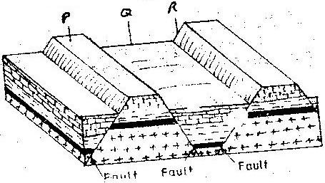
Use it to answer questions that follow.

- Name the features marked P, Q, and R
- Differentiate between a normal faulty and a reverse fault.
3. State ways in which faulting influences drainage. (3mks)
4. Name two examples of Horst Mountains in East Africa. (2mks)
5. Explain two ways in which features resulting from faulting are of economic importance (4mks)
6. (a) (i) With aid of diagrams outline formation of rift valley by tension
theory. (5mks)
(b) Students are planning to carry out field study of an area affected by
faulting.
(i) State four importance of having a pre-visit of the area.
(ii) Give three disadvantages of using observation to study such an
area.
7. Name three types of fault. (3mks)
8. Explain how compressional forces lead to formation of rift valley. (5mks)
9. Give two of escarpments in East Africa. (2mks)
10. Explain ways in which features resulting from faulting are of importance. (8mks)
11. Describe formation of fault steps with aid of diagrams. (6mks)
CHAPTER 4
INTERNAL LAND FORMING PROCESSES – VULCANICITY
1. The diagram below shows some intrusive features formed by vulcanicity.
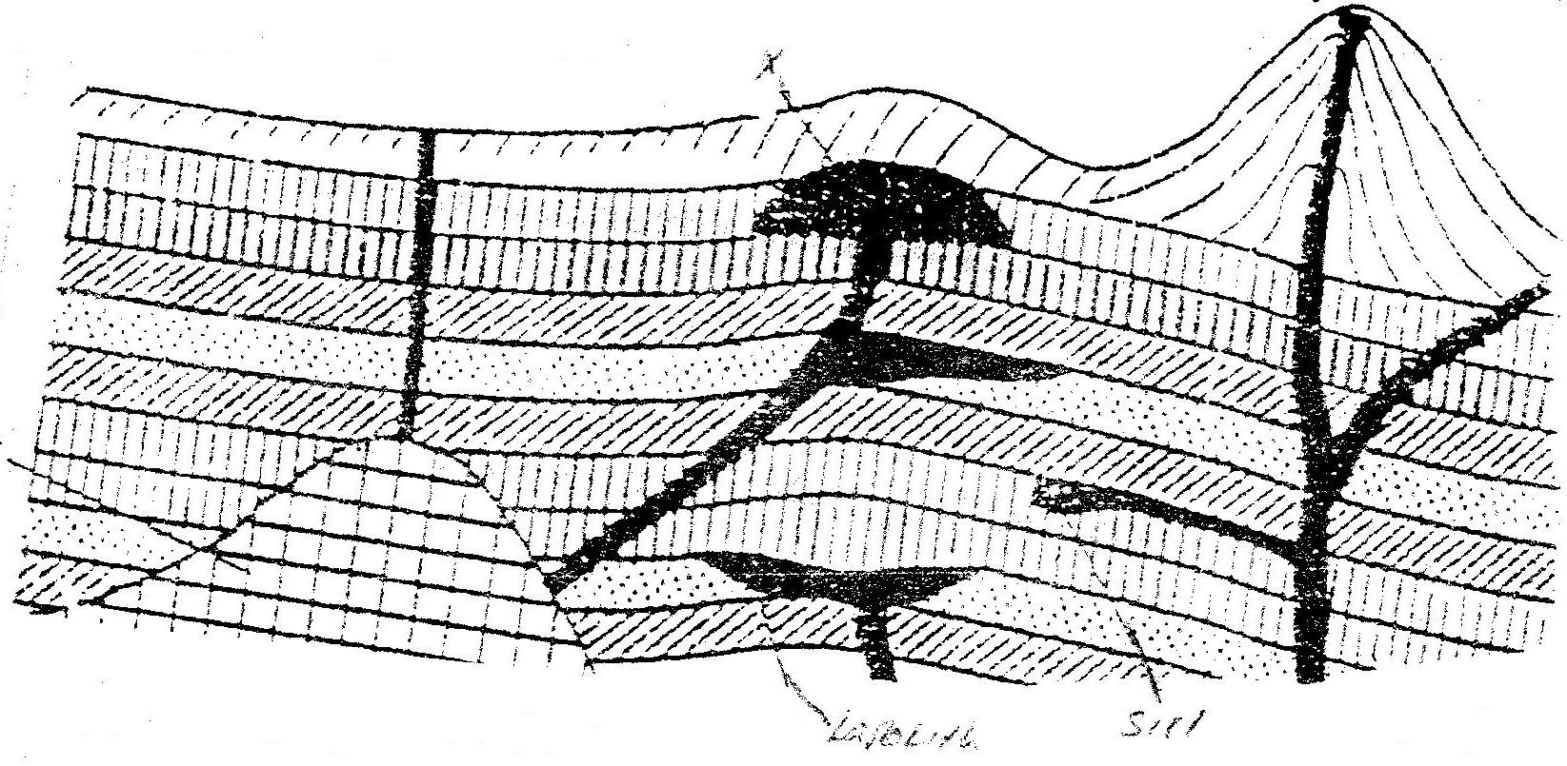
Use it to answer question (a)

a) i) Name features marked X,Y, and Z (3mks)
ii) Explain how a sill is formed (4mks)
b) Describe the characteristics of a composite volcano (4mks)
c) Explain four ways in which volcanic mountains positively influence human activities. (8mks)
d) Students carried a field study on volcanic rocks
i) Give four reasons why it is necessary to collect rock samples during such a field study. (4mks)
ii) State two problems they are likely to have experienced during the field study (4mks)
2. (a) Differentiate between plutonic rocks and volcanic rocks
(b) Describe how lava plateau is formed
(c) (i) Name three volcanic features found in the rift valley of Kenya
(ii) Explain four negative effects of vulcanicity in Kenya
(d) You intend to carry out a field study of a volcanic landscape
(i) State four reasons why it is necessary to conduct a reconnaissance
of the area of study.
(ii) During your field work, you intend to study volcanic rocks, state
why you would need the following items
3. Name three volcanic features found in the Rift Valley of Kenya. (3mks)
4. Explain four negative effects of vulcanicity in Kenya. (8mks)
5. Describe how lava plateau is formed. (5mks)
6. Differentiate between sill and dyke. (4mks)
7. What is vulcanicity. (2mks)
8. Describe how Crater Lake is formed. (5mks)
9. Describe how Mt. Kenya was formed.
CHAPTER 5
INTERNAL LAND FORMING PROCESSES – EARTHQUAKES.
1. (a) Name two scales used to measure the intensity of an earthquake (2mks)
(b) Give three causes of earthquakes (3mks)
2. The diagram below represents the internal structure of the earth. Use it
to answer question(a)
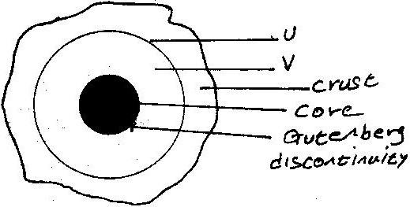

- Name the part marked U and V.
- Describe the deposition of:
    - The crust
    - The core
- (i) What are earthquakes
(ii) Name two types of earthquakes.
(iii) State the five ways in which the earths’ crust is affected by earthquakes.
- You intend to carry out a field study of an area recently affected by intense earthquake.
    - Give two sources of information that you would use in preparation for the study.
ii. Explain two factors that would make it difficult for you to collect accurate data during the field study.
3. (a) State three causes of earthquakes
(b) Give two effects of earthquakes in built up areas
4. State the major causes of earthquakes (2mks)
5. Explain how intensity of earthquake is measured. (2mks)
6. List major effects of earthquakes where they occur. (4mks)
7. Distinguish between seismograph and seismogram (4mks)
8. Differentiate between intensity and magnitude of earthquake (4mks)
9. Students from your school intend to carry out a field study of an area recently affected by intense earthquake.
(i) Give two sources of information that you would use in preparation for the
study.
(ii) Explain two factors that would make it difficult for you to collect accurate data during the field study.
CHAPTER 6
PHOTOGRAPH WORK.
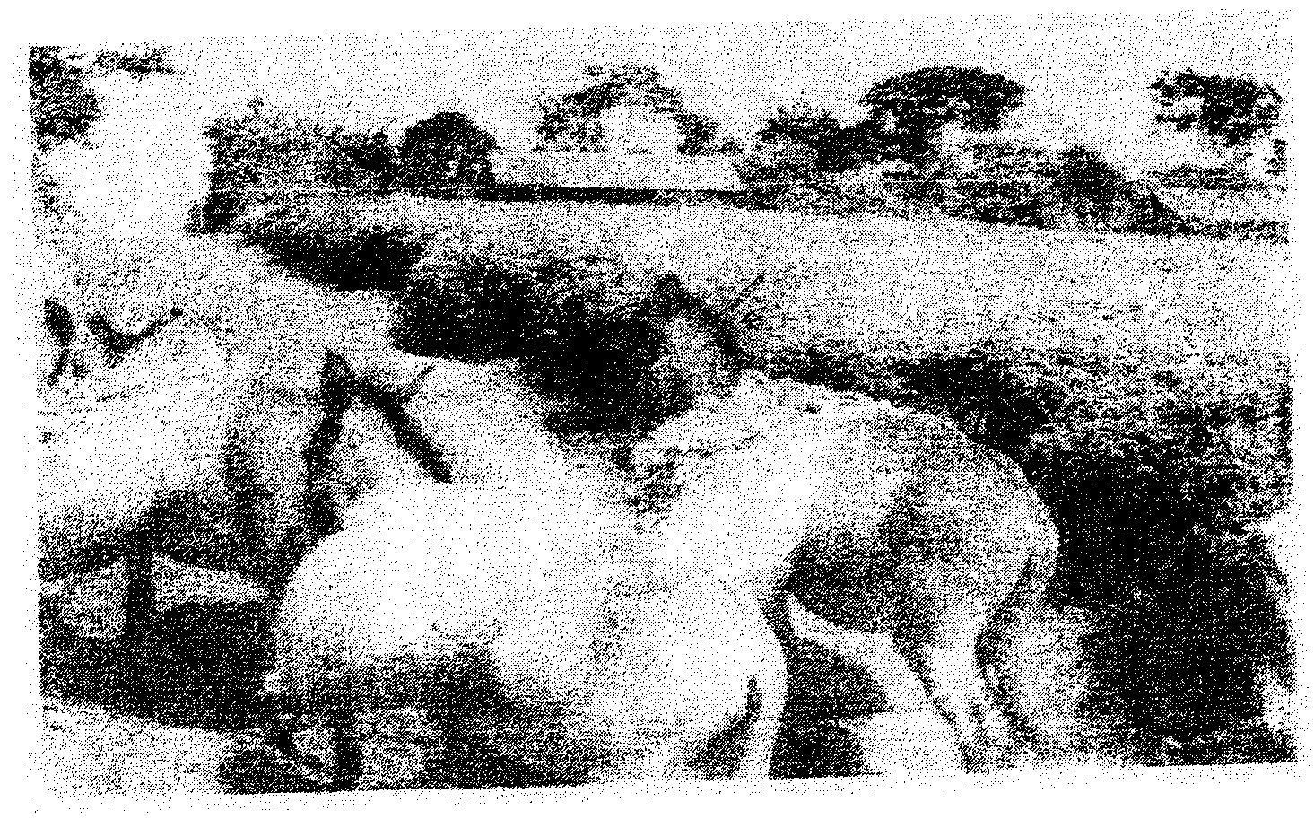
1. The photograph provided shows a tea growing area in Kenya. Use it to answer questions (a) and (b)

a) (i) What evidence in the photograph shows that this is a ground
general-view type of photograph? (2mks)
(ii) Draw a rectangle measuring 15cm by 10cm to represent the area of the photograph. On it sketch and label the main features shown on the photograph. (5mks)
(iii) Identify two features from the photograph that show that this is a small scale tea farm. (2mks)
b) Describe the stages involved in the cultivation of tea from land preparation to the stage shown on the photograph.
- (i) Name two districts in the Eastern province where tea is grown.
(2mks)
(ii) Explain four ways in which the Kenya Tea development agency (KTDA) assists small scale tea farmers in Kenya (8mks)
2. What is the type of photograph shown?
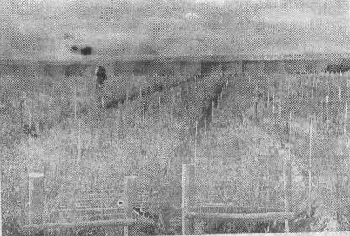

3. Name each of the following:
(i) Crop under cultivation (2mks)
(ii) Type of farming (2mks)
(iii) Other groups of crops in this type of farming. (2mks)
(iv) The province in Kenya where this photograph was taken. (2mks)
4. Name five problems facing this type of farming in Kenya. 5mks
5. Name two major export destinations (countries) for farm produce shown. (2mks)
6. Name three physical features at the background of the photograph. (3mks)
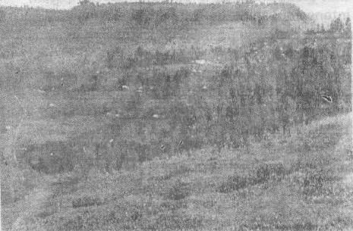
7. Draw a rectangle of 12cm by 7cm to represent the area covered by the photograph.
CHAPTER 7
CLIMATE.
1. (a) (i) What is climate? (2mks)
(ii) Explain two effects of climate change on the physical environment
2. The table below represents rainfall and temperature figures for a town in Africa. Use it to answer the questions that follow

Month | J | F | M | A | M | J | J | A | S | O | N | D
Temp (⁰C) | 27 | 28 | 28 | 28 | 27 | 25 | 25 | 24 | 25 | 26 | 27 | 26
Rainfall (mm) | 25 | 38 | 99 | 140 | 277 | 439 | 277 | 69 | 142 | 201 | 71 | 25
(a) Calculate the annual range of temperature for the town (2mk)
(b) Calculate the total annual rainfall for the town. (2mks)
(c) State two characteristics of the climate experienced in the town. (2mks)
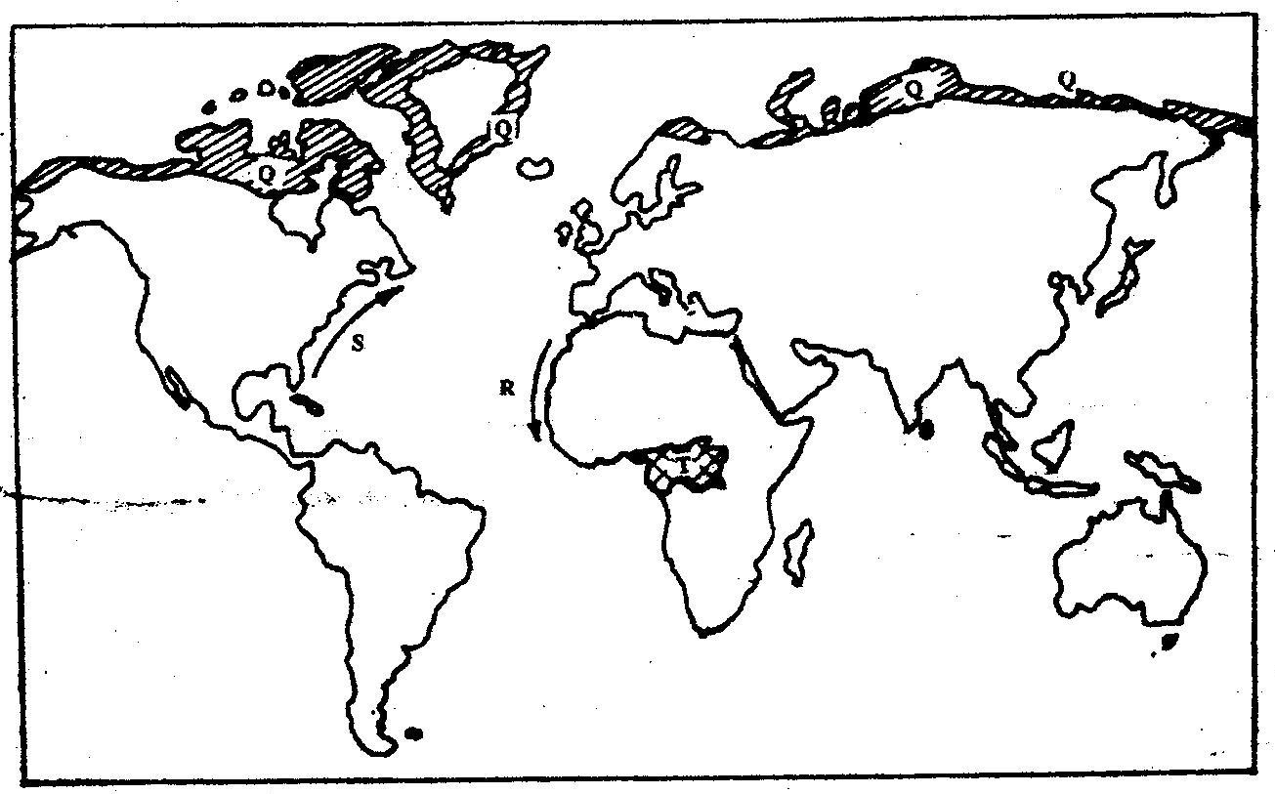
3. Use the map below to answer questions (a) and (b)

(a) Name:
(i) The type of climate found in the shaded area marked Q (1mk)
(ii) The ocean current marked R and S (2mks)
(b) Describe the characteristics of the type of climate found in the shaded area marked T (8mks)
(c) Explain how the following factors influence climate
(i) Altitude (4mks)
(ii) Distance from the sea (4mks)
(d) (i) Describe a suitable site where you would locate a weather station
in your School (2mks)
(ii) Give reasons why a Stevenson’s screen is:
- Painted White (2mks)
- Has louvers (2mks)
4. Describe the characteristics of natural vegetation associated with equatorial
climate (4mks)
5. Give five characteristics of hot desert climate (5mks)
6. How does the following factors influence climate?
(i) Wind/air masses.
(ii) Latitude.
7. Explain characteristics of climatic conditions experienced in the Kenyan highlands. (8mks)
8. Explain four ways in which mountains influence climate. (8mks)
9. What is greenhouse effect? (2mks)
10. How do human activities influence climate change? (6mks)
11. How does clearance of vegetation cause climate change? (3mks)
12. Define climate. (2mks)
13. What is isothermal layer? (2mks)
CHAPTER 8
VEGETATION
1. The map below shows some vegetation regions of the world.
Use it to answer questions (a) to (c).
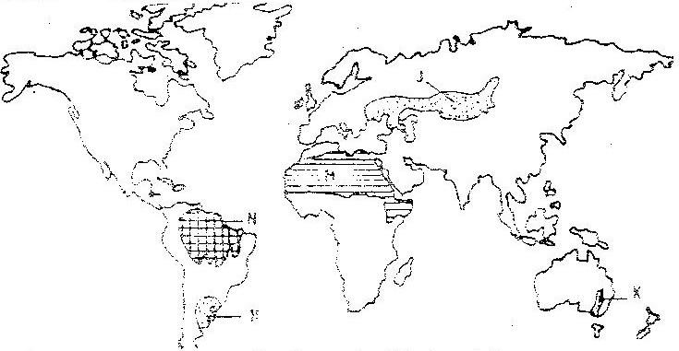

- Name the temperate grasslands marked H, J and K.
- Describe the characteristics of the natural vegetation found in the shaded area marked N.
- i) Explain four ways in which the vegetation found in the area
marked M adapts to the environment conditions of the region.
- You are required to carry out a field study of the vegetation within the local environment:
i) A part from identifying the different types of plants, state three
other activities you will carry out during the field study.
ii) How will you identify the different types of plants?
2. The diagram below represents zones of natural vegetation on a mountain in
Africa. Use it to answer question (a) (i) and (ii)

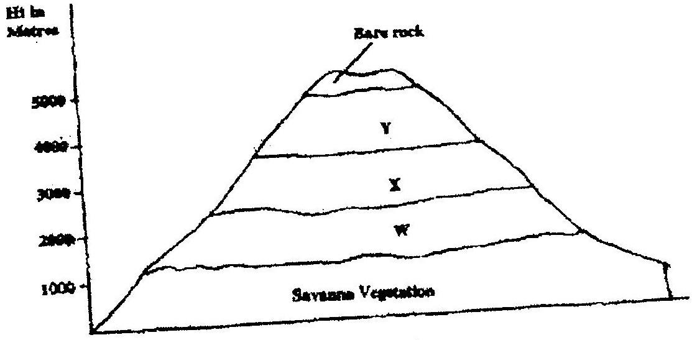

a) (i) Name the vegetation zones marked W, X and Y. (3mks)
(ii) Describe the characteristics of the savanna vegetation. (6mks)
(iii) Name the temperate grasslands found in the following countries:
- Canada (1mk)
- Russia (1mk)
- Australia (1mk)
b) Explain three causes of the decline of the areas under forest in Kenya.
(6mks)
c) You are supposed to carry out a field study on the uses of vegetation in the
area your school.
- State three reasons why it would be necessary to visit the area
before the day of the study. (3mks)
- Give four uses of you are likely to identify during the study (4mks)
3. (a) What is a natural vegetation? (2mks)
(b) State three characteristics of Mediterranean vegetation (3mks)

4. Explain three measures that the Kenyan government has taken to reduce the
decline of natural vegetation cover. (6mks)
5. How do the following factors influence distribution of vegetation in Kenya.
(i) Variation in rainfall
(ii) Variation of temperature
(iii) Variation of altitude/relief.
(iv) Aspect
(v) Soil
(vi) Human activities (10mks)
6. State two reasons why mountain tops have no vegetation. (2mks)
7. Define vegetation. (2mks)
8. Name areas where coniferous forests are found. (3mks)
9. State characteristics of temperate grassland. (5mks)
10. Distinguish between secondary vegetation and planted vegetation. (4mks)
11. State two ways in which vegetation is significant to human and physical environment. (5mks)

(a) Name the type of photograph and type of vegetation. (2mks)
(b) Describe how the vegetation is adapted to climatic conditions of the
region. (3mks)

CHAPTER 9
FORESTRY
1. a) i) What is forestry? (2mks)
ii) Explain three factors that favour the growth of natural forests on the slopes of Mt. Kenya. (6mks)
iii) State five factors that have led to the reduction of the area under forest on the slopes of Mt Kenya. (5mks)
b) Explain four measures that the government of Kenya is taking to conserve forests in the country. (8mks)

c) Give the differences in the exploitation of softwood forests in Kenya and Canada under the following sub-headings;
i) Period of harvesting; (2mks)
ii) Transportation (2mks)
2. Explain factors favouring forestry in Canada
3. List two species of indigenous hardwood forest trees in Kenya. (2mks)
4. Name two industries associated with forestry. (2mks)
5. Explain three measures being undertaken to conserve forests in Kenya. (6mks)
6. Explain four problems that are being experienced in exploitation of hardwood forests in Kenya. (8mks)
7. Explain three reasons why only a small part of Kenya is forested. (6mks)
8. Outline three consequences of forest depletion in Kenya. (3mks)
9. State the factors favouring forestry in Kenya. (8mks)
10. Name four secondary products of forests. (4mks)
11. List eight major indigenous tree species in West Africa. (8mks)
12. (a) Define agro-forestry. (1mk)
(b) Outline four benefits of agro-forestry (4mks)
FORM THREE WORK
CHAPTER 1
EXTERNAL LAND FORMING PROCESSES – WEATHERING.
1. (a) (i) What is the difference between weathering and mass wasting?
(ii) Apart from plants, give three other factors that influence the rate of
Weathering (3mks)
(iii) Explain two ways in which plants cause weathering (4mks)
(b) (i) List two types of mass wasting other than soil creep (2mks)
(ii) Explain three factors that cause soil creep. (6mks)
(c) Explain four effects of mass wasting on the environment. (8mks)
2. Give two processes involved in each of the following types of weathering
(a) Physical weathering (2mks)
(b) Chemical weathering (2mks)
3. (a) What is mechanical weathering? (2mks)
(b) How is an exfoliation dome formed? (5mks)
4. Describe five processes involved in chemical weathering? (3mks)
5. Name physical weathering processes that take place in the arid areas.
6. List factors that determine rate of weathering.
7. Define the term denudation
8.

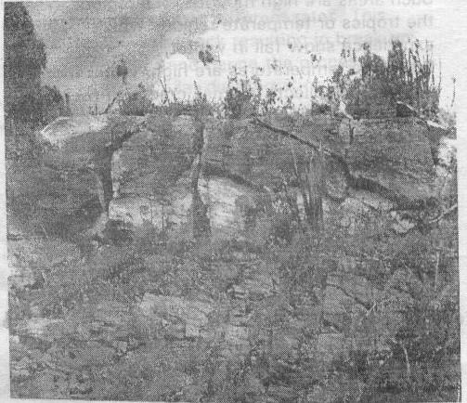

a) Name the above type of weathering.
b) Describe the process shown by the photograph

CHAPTER 2
EXTERNAL LAND FORMING PROCESSES – MASS MOVEMENT.
1. a) State two conditions which may influence the occurrence of landslides
b) Using the diagram (in question paper), name
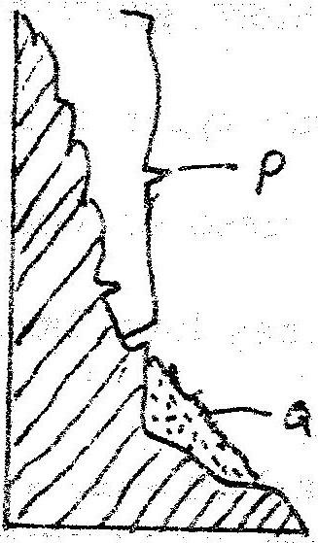

(i) The type of mass movement shown
(ii) The features marked P and Q (2mks)
2. Explain five ways in which soil creep occurs. (10mks)
3. Describes the effects of soil creep. (6mks)
4. Define the following:
a) Mass wasting.
b) Mass movement. (2mks)
5. Name and explain three process of slow mass movement. (4mks)
6. Explain the factors that are responsible for rapid mass wasting.
7. List the evidences of soil creep. (4mks)
CHAPTER 3
THE HYDROLOGICAL CYCLE
1. (a) The diagram below shows the hydrological cycle. Name the stages marked
E, F, and G (3mks)
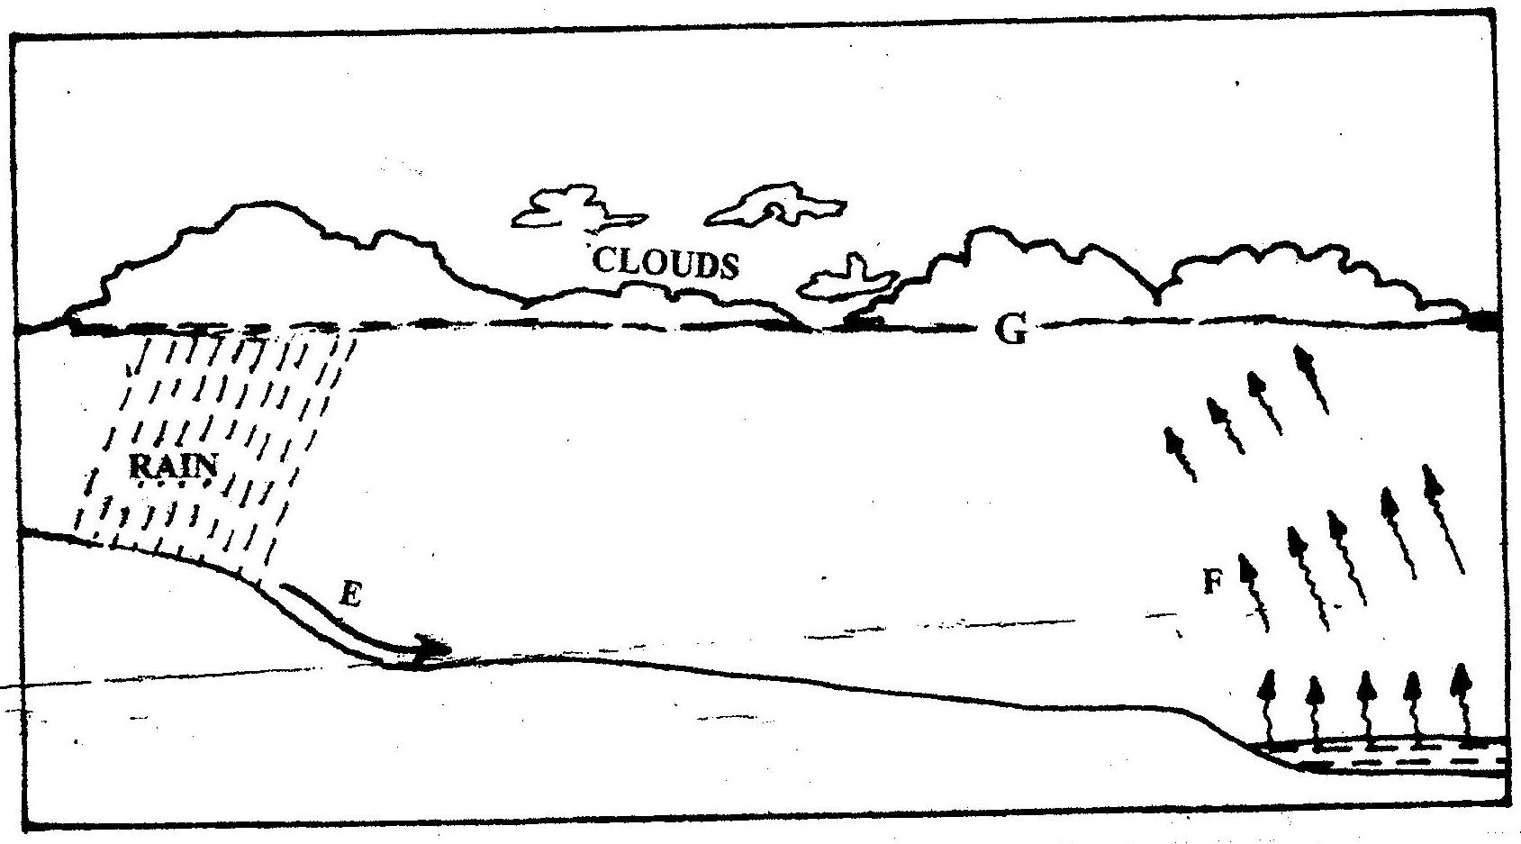

(b) Differentiate between watershed and a catchments area (2mks)
2. State four factors that determine the amount of surface run-off.
3. What is hydrological cycle? (2mks)
4. Explain factors that influence percolation of voter. (8mks)
5. (a) What is cyrosphere? (2mks)
(b) Name the significance of hydrological cycle. (4mks)
6. List other forms of precipitation other than rainfall that may also form major inputs into the system. (4mks)
7. What factors can influence surface run off or overland flow. (5mks)
8. In what ways can we sustain the process of the hydrological cycle? (8mks)
CHAPTER 4
ACTION OF RIVERS
1. (a) Name two types of the coastal deltas (2mks)
(b) State two conditions that lead to deposition of silt at the mouth of a river
(2mks)
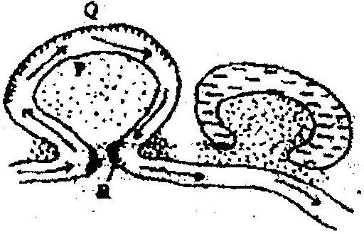
2. The diagram below shows river Mandera. Use it to answer question (a)

(a) (i) Name the process that take place at each of the points marked P
and Q. (2mks)
(ii) Name the feature formed at the point marked R (1mk)
(iii) Describe how an Ox- bow lake is formed (5mks)
(b) State five characteristics of a flood plain (5mks)
(c) Explain three causes of river rejuvenation (6mks)
- Your class is required to carry out a field study of a river
(i) What would be the advantages of dividing the class into groups according to the stages of the long profile of a river? (4mks)
(ii) What would be the disadvantage of using secondary data in this kind of a field study? (2mks)
3. (a) State two factors which influence the occurrence of surface run- off
(b) The diagram below shows a waterfall. Name the feature marked X, Y and
Z
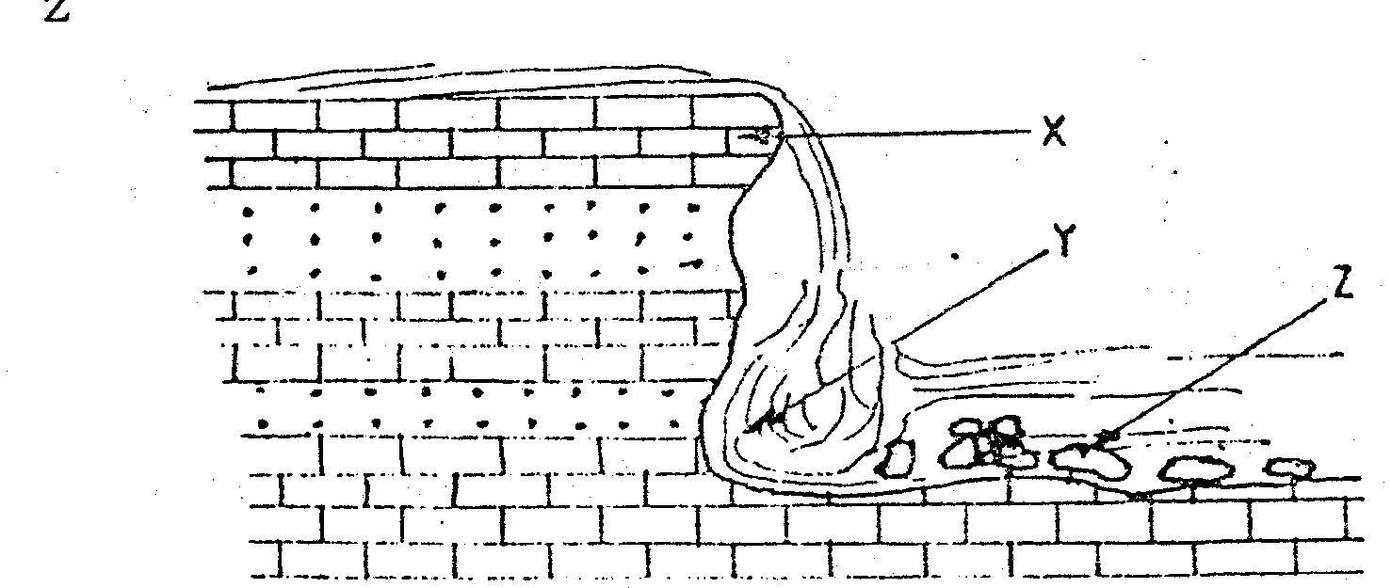

4. Describe three ways in which rivers transports its load.
5. Describe the following drainage patterns
(i) Dedritic.
(ii) Trellis.
(iii) Centipetal.
6. a) State two factors that influence the rate of erosion by the river in its
upper course.
b) (i) Define river rejuvenation
Name two features that result from river rejuvenation
7. Explain the following:
(a) River basin
(b) Watershed
(c) Catchment area
(d) River regime (8mks)
8. With examples from Africa, explain the differences between the following river features:
(a) Inland delta and alluvial fan.
(b) Estuarine delta and an estuary.
(c) Bluff and river cliff.
(d) Levees and river bank.
(e) River valley and river channel.
(f) Paired terrace and unpaired terrace.
(g) Drainage pattern and drainage system,
(h) Misfit river and deferred river,
(i) Antecedent drainage and superimposed drainage. (18mks)
9. Describe how a river erodes its channel through the following processes
(i) Abrasion
(ii) Hydraulic (4mks)
10. (a) (i) In which stage is the river at 'A'
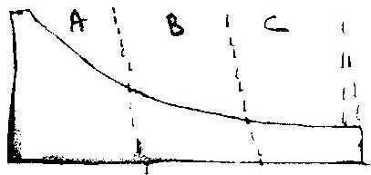

(ii) Name 3 features found at the above stage. (3mks)
(b) (i) In which stage is the river at 'B'
(ii) Which are the characteristics of the river at stage B?
(iii) Describe the characteristics of the river at the above stage C.
(4mks)

(c) In which stage is the river at C.
11. Explain the significance of rivers to man. (10mks)12.
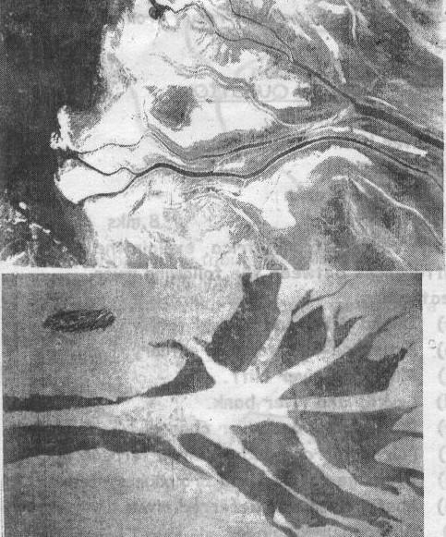

a) Name the type of photograph. (1mk)
b) Name the features shown by the photograph. I and II. (2mks)
c) State the conditions necessary for formation of these features. (3mks)
CHAPTER 5
LAKES.
1. Give three processes that lead to formation of lakes.
2. Describe how Lake Victoria was formed.
3. Explain how Lake Victoria influences the climate of the surrounding areas.
4. What is a lake?
5. State three ways in which lakes are formed.
6. Explain how each of the following lakes were formed :
(a) Victoria
(b) Tanganyika
(c) Chala
(d) Sare
(e) Kivu (15mks)
7. State the differences between the lakes on the eastern and western areas of East African Rift Valley. (6mks)
8. With reference to specific lakes in East Africa, explain the significance of lakes in
the region. (8mks)
CHAPTER 6
OCEANS, SEAS AND THEIR COASTS.
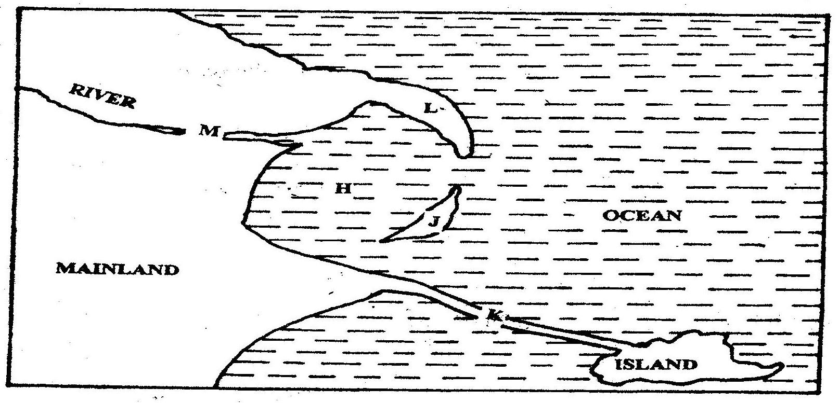
1. Use the diagram below to answer question (a)

(a) Name the coastal features marked H, J, K, L and M (5mks)
(b) (i) State four conditions necessary for the formation of a beach (4mks)
(ii) Describe three processes involved in marine erosion (6mks)

(c) You are planning to carry out a field study on the depositional features along the coast of Kenya
(i) State five objectives you would formulate for your study (5mks)
(ii) Give five methods you would use to record the information
collected (5mks)
2. (a) Name two types of submerged coasts. (2mks)
(b) Explain now the following factors determine effectiveness of wave
erosion along the coast.
(i) Nature of the material transported by waves
(ij) Nature of the coastal rocks. (4mks
3. State two causes of submerged coasts. (2mks)
4. Name two features that result from submergence of coasts. (2mks)
5. Define term coastline (2mks)
6. What are destructive waves? (2mks)
7. Name three resultant features of wave erosion. (3mks)
8 Describe formation of cliff. (5mks)
9. Describe formation of a wave-cut platform. (5mks)
10. Name three types of coast. (3rnks)
11. (a) Describe formation of coral coast. (5mks)
(b) Explain the significance of coral coast to Kenya.
12. Distinguish between shingle beaches and sand beaches. (6mks)
13. Name three types of submerged coasts. (3mks)
14. Name two types of movements of ocean water. (2mks)
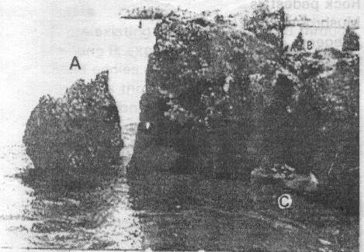
15.

(a) Name features marked A, B, and C.
(b) Describe the formation of feature marked C.
CHAPTER 7
ACTION OF WIND AND WATER IN ARID AREAS.
1. The diagram below represents a barchan. Use it to answer questions (a)
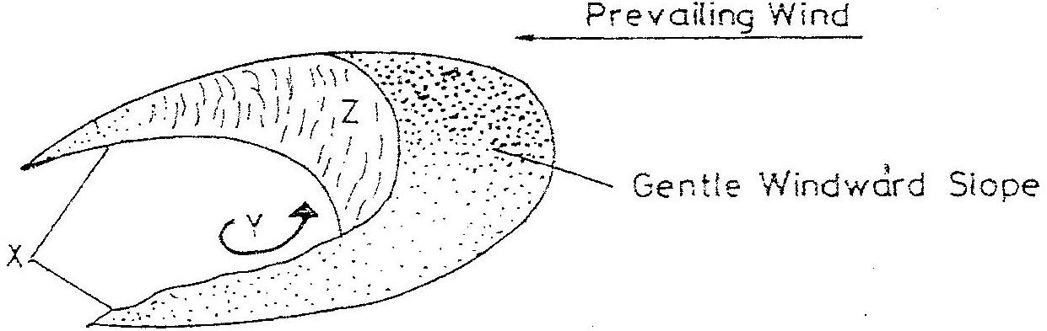

(a) Name
(i) The feature marked X (1mk)
(ii) The air current marked Y (1mk)
(iii) The slope marked Z (1mk)
(b) Give two ways in which wind transports its load (2mks)
2. a) (i) Two process through which wind erodes the surface
(ii) Three ways through which wind transports its load
b) (i) How an oasis is forced
(ii) How zeugens are formed
c) You are supposed to carry out a field study of a semi-arid area in Kenya.
(i) Two ways of preparing for the Field study
(ii) Information that would be collected through observation of the arid area
(iii) Measures to be recommended for controlling desertification.
3. Explain the process of abrasion. (2mks)
4. Name four features of wind erosion. (4mks)
5. Describe formation of zeugens, (4mks)
6. List features of wind deposition. (4mks)
7. Describe formation of wadis. (5mks)
8. Differentiate between suspension and saltation. (4mks)
9. Name four types of desert surface (4mks)
10. Identify and describe the processes of wind erosion. (6mks)
11. (a) Explain how wind transports its load.
(b) State the factors influencing wind transportation. (3mks)
12. Explain the formation of the following features:
(a) Bajadas.
(b) Pediments. (6mks)
13. Students carried out field study on desert landforms.
(i) State two type of information they collected through observation.
(ii) Which measures would they have recommended to control desertification?
CHAPTER 8
UNDERGROUND WATER
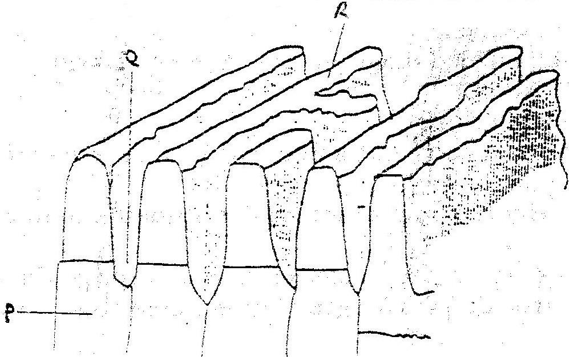
1. The diagram below show some features of a Karst scenery. Use it to answer questions (a)

a) Name the features marked P, Q, and R. (5mks)
b) Describe carbonation as a process of Chemical weathering (3mks)

2. State three conditions necessary for the development of Karst scenery, (3mks)
3. Give two reasons why there are few settlements in a Karst landscape. (4mks)
4. Explain factors influencing formation of springs. (8mks)
5. Distinguish between the following.
(i) Effluent streams and influent streams. (4mks)
(ii) Artesian basins and artesan well. (4mks)
6. Name three surface features of Karst landscape. (3mks)
7. What are stalactites? (2mks)
8. Explain the significance of limestone regions. (8mks)
CHAPTER 9
GLACIATION
1. (a) (i) What is an ice sheet? (2mks)
(ii) Give two reasons why there are no ice sheets in Kenya (2mks)
(iii) Explain three factors that influence the movement of the ice from the place where it has accumulated (6mks)
(b) Describe how an arête is formed (4mks)
(c) The diagram below shows types of moraines in a valley glacier

(i) Name the type of moraines marked S, T and V (3mks)
- Explain four positive effects of glaciation in lowland areas. (8mks)
2. a) (i) What is a glacier? (2mks)
(ii) Distinguish between valley glaciers and ice sheets (4mks)
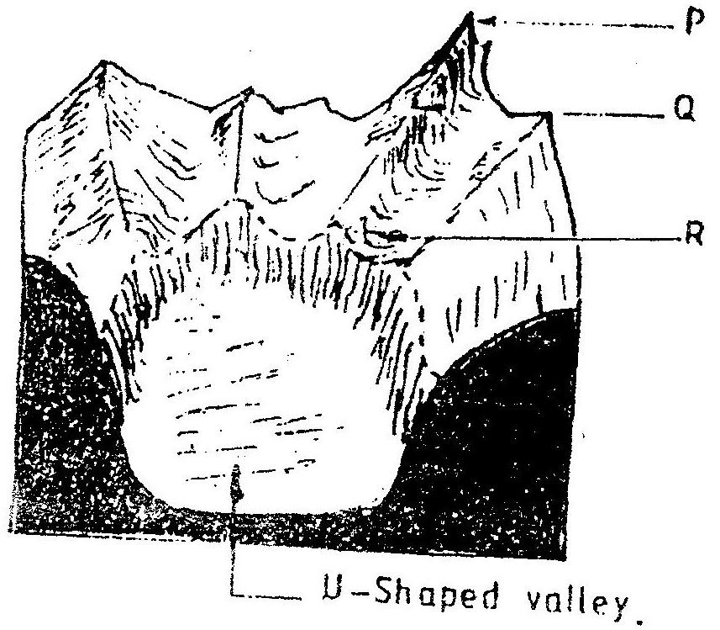
3. The diagram below shows a glaciated upland area

(a) Name the feature marked P, Q, and R (2mks)
(b) How is a U- shaped valley formed? (5mks)
4. a) Describe how pyramidal peak is formed. (6mks)
b) Explain the significance of upland glaciated features to human activities.
(6mks)
c) Students from a school near Mt. Kenya were planning to carry out a field study on the glaciated features on the top of the mountain.
(i) Give the reason why it would be difficult to undertake the field study on the glaciated features on the mountain. (4mks)
(ii) Describe how students would use a photograph of Mt. Kenya to identify the glaciated features on the mountains. (3mks)
5. Differentiate between snout and snow niche. (4mks)
6. Name three glaciers on Mt. Kenya. (3mks)
7. Describe the formation of a glacial trough. (3mks)
8. What is ice cap? (2mks)
9. Name three resulting features of glacial erosion on Mt. Kenya (3mks)
10. What is a nivation hollow? (2mks)
CHAPTER 10
SOIL
1. a) (i) What is soil catena?
(ii) Draw a labeled diagram to show a well developed soil profile. (5mks)
(iii) State three characteristics of the soils found in the arid regions of
Kenya. (3mks)

b) Give three factors that determine the colour of soil.

c) Describe how laterization occurs. (6mks)

d) Explain how the following farming practices cause soil erosion.
(i) Burning (2mks)
(ii) Continuous application of fertilizer on farm lands. (2mks)
(iii) Monocultures. (2mks)
2. (a) Name two types of soil according to texture. (2mks)
(b) State two ways in which humus improves the quality of soil. (2mks)
3. What is soil? (2mks)
4. Identify classification of soil according to order. (3mks)
5. Describe formation of soil through decomposition of organic matter. (3mks)
6. How does salination occur? (3mks)
7. What do you understand by zonal order soil?
8. List four soil conservation and management practices. (4mks)
9. What do you understand by podzolisarion? (2mks)
CHAPTER 11
AGRICULTURE.
1. a) State two climatic conditions that favour the growing of oil palm in
Nigeria. (2mks)
b) Give two problems experienced in the marketing of palm oil in
Nigeria. (2mks)
2. The photograph provided shows a tea growing area in Kenya. Use it to answer questions (a) and (b)

a) (i) What evidence in the photograph shows that this is a ground
genera-view type of photograph? (2mks)
(ii) Draw a rectangle measuring 15cm by 10cm to represent the area of the photograph. On it sketch and label the main features shown on the photograph. (5mks)
(iii) Identify two features from the photograph that show that this is a small scale tea farm. (2mks)
b) Describe the stages involved in the cultivation of tea from land preparation to the stage shown on the photograph.

c) (i) Name two districts in the Eastern province where tea is grown.
(2mks)
(ii) Explain four ways in which the Kenya Tea development agency
(KTDA) assists small scale tea farmers in Kenya (8mks)
3. (a) State three physical conditions that are necessary for the growing of cocoa
(3mks)
(b) Give three economic problems experienced in cocoa farming in Ghana
(3mks)
4. a) Give three physical factors that favour coffee growing in Kenya highlands.
b) State two problems facing coffee farming in Kenya
5. a) i) Name two provinces in Kenya where wheat is grown on large
scale (2mks)
ii) Explain four physical conditions that favour wheat growing in Kenya (8mks)
b) Compare wheat farming in Canada and / Kenya under the following
i) Storage (2mks)
ii) Transportation (2mks)
iii) Marking (2mks)
c) i) Explain three climate problems that affect wheat farming in
Canada (6mks)
ii) Give three uses of wheat (2mks)
d) Name two districts in Kenya where wheat is grown on commercial scale.
(2mks)
e) Name two wheat producing provinces in Canada (2mks)
f) Explain five factors which enable Canada to produce more wheat than
Kenya. (5mks)
6. a) State five physical conditions required for the growing of tea in Kenya
(5mks)
b) Explain four problems experienced in small scale tea farming in Kenya
(8mks)
7. The map below shows some major tea growing areas in Kenya.

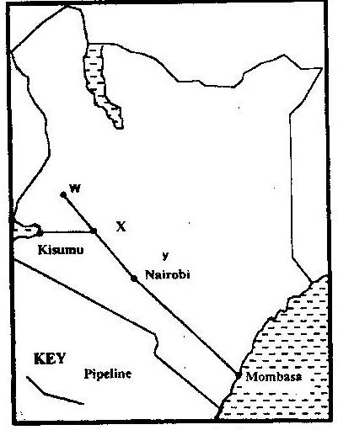

a) Name the areas marked W, X and Y. (3mks)
b) Give two reasons why there was an increase in tea production over the
given period. (2mks)
c) Describe the stages through which tea is processed from picking to the time it is ready for marketing. (5mks)
8. Name major cocoa growing areas in Ghana. (3mks)
9. List suitable conditions for cultivation of cocoa. (4mks)
10. Name types of commercially cultivated coffee. (3mks)
11. Explain ways in which Brazilian government responds to problems facing coffee industry. (6mks)
12. Name four uses of maize. (4mks)
13. List four problems facing maize farmers. (4mks)
14. Outline stages in industrial processing of cocoa. (5mks)
CHAPTER 12
AGRICULTURE – LIVESTOCK.
1. a) Name two exotic breeds of dairy cattle reared in Kenya. (2mks)
b) State three physical conditions that favour dairy farming in Denmark
(8mks)
2. a) Explain four ways in which the government of Kenya assist nomadic
pastoralist to improve the quality of their livestock
- Explain three factors that favour beef farming in Argentina.
- State three environmental conditions which favour commercial beef farming in Kenya. (3mks)
- Name two exotic breeds of cattle reared in commercial ranches in Kenya.
(2mks)
3. Mention three problems facing beef farming in Kenya. (3mks)
4. State five human factors that have favoured beef farming in Argentina. (5mks)
5. State differences in dairy farming in Kenya and in Denmark. (6mks)
6. What effort is Kenyan government making to improve dairy farming? (5mks)
7. What is nomadic herding? (2mks)
8. State five features of nomadic herding. (5mks)
9. Explain two efforts Kenyan government has made to improve beef farming. (4mks)
10. Explain four physical conditional that favour dairy farming in Kenya. (8mks)
9. The table below shows data on average milk yield in kg per cow in Denmark.

Year | 1990 | 1991 | 1992 | 1993 | 1994 | 1995
Yields (Kg) | 5243 | 6693 | 7398 | 7610 | 7792 | 7946

(a) (i) Draw a divided rectangle 15cm long to represent milk yield in
Denmark.
(ii) State two advantages of using divided rectangles.
(b) (i) Explain three factors that have favoured dairy farming in Denmark.
(6mks)
(ii) State 3 problems facing dairy farmers in Kenya.
(c) Explain why beef farming is more developed in Argentina than in Kenya.
FORM FOUR WORK
CHAPTER 1
LAND RECLAMATION AND REHABILITATION.
1. (a) Give two methods used to reclaim lend in Kenya. (2mks)
(b) Outline the stages through which land is reclaimed from the sea in the
Netherlands. (5mks)
2. (a) Difference between land reclamation and rehabilitation. (4mks)
(b) Five ways through which land is being reclaimed. (5mks)
(c) Describe of polderization process in Netherlands. (4mks)
(d) State three benefits that resulted from the reclamation of the Yala Swamp.
(3mks)
3. (a) State the objectives of Mwea irrigation scheme. (4mks)
(b) State the conditions that favoured establishment of Mwea irrigation
scheme. (4mks)
(c) Explain problems faced by rice farmers in Mwea irrigation scheme.
(5mks)
(d) State benefits of Perkerra irrigation scheme. (5mks)
(e) Explain factors that limits Perkerra irrigation scheme. (8mks)
4. Differentiate between horticulture and market gardening. 4 mks
5. Outline three problems facing horticulture farming in Kenya. 3 mks
6. Name five irrigation schemes in Kenya. 5 mks
7. State two factors that favour the occurrence of tsetse flies in Olambwe Valley.
8. State measures that were taken by Kenyan government to control Tsetse flies in Olumbwe Valley. 5 mks
9. Give three conditions that made Mwea suitable for establishment of irrigation
scheme. 3 mks
10. Explain two effects of tsetse flies on humans and livestock. 4 mks
11. (a) Differentiate between land reclamation and land rehabilitation. 4 mks
(b) State the reasons for the establishment of Mwea-Tebere irrigation project.
(c) Explain five problems facings Mwea -Tebere irragation scheme. 5 mks
12. State the problems facing Perkerra irrigation sceme. 5 mks
13. (a) Outline the benefits which Kenya derives from irrigation farming. 5 mks
(b) What are the problems experienced in irrigation farming in Kenya. 5 mks
14. (a) Apart from irrigation, list other methods of land reclamation in Kenya.
(b) Briefly describe the methods listed in 12 (a). 5 mks
15. State the benefits of Yala-Bunyala project. 5 mks
16. (a) What is a polder. 5 mks
(b) Describe the stages involved in ^{1f} reclamation of a polder. 5 mks
(c) State five benefits of land reclamation in Netherlands.
17. State the main differences between the methods of land reclamation in Kenya and Netherlands. 6 mks
CHAPTER 2
FISHING
1 (a) State three measures that have been taken to conserve fisheries in Kenya.
3 mks
(b) Give four reasons why Norway is a great fishing nation. 4 mks
(c) Two traditional/ subsistence methods of fishing. 2 mks
(d) Three measures the government of Kenya is undertaking to encourage fish culture. 3 mks
2. Use the map of North America to answer question (a).
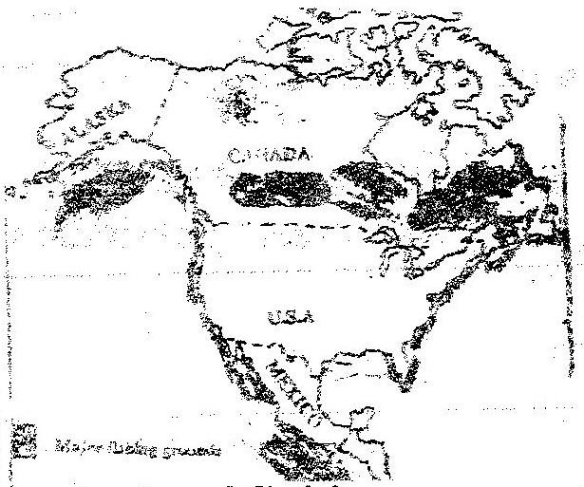

(a) Name two methods of fishing used in the shaded areas. 2 mks
(b) Name two types of fish caught along the West Coast of Canada. 2 mks
(c) Explain how the following factors favour fishing in the shaded areas,
(i) Indented coastline
(ii) Ocean currents 4 mks
(d) Give three methods used to preserve fish. 3 mks
(e) Explain three problems experienced by fishermen while fishing in Lake Victoria. 3 mks
3. The map below shows some major fishing grounds in the world. Use it to
Answer the questions below.
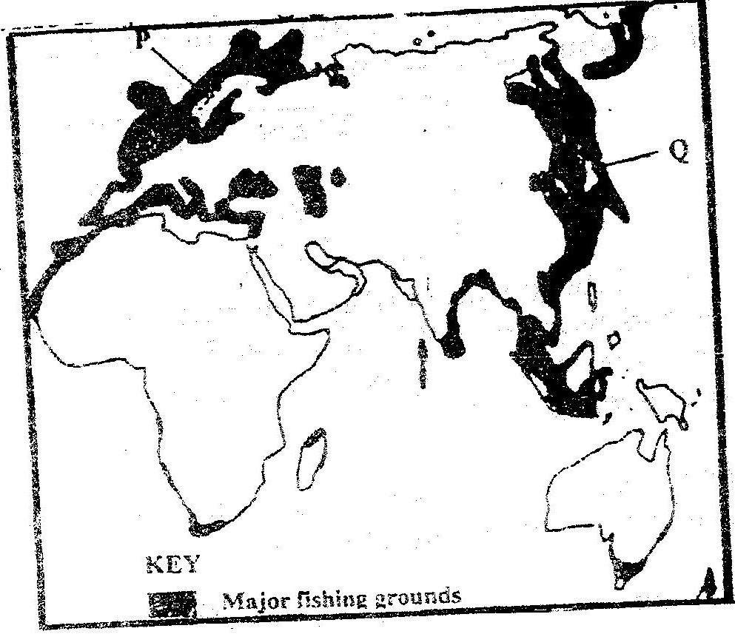

(a) Name the countries marked P and Q. 2 mks
(b) Explain four conditions that favour fishing in the shaded coastal waters.
8 mks
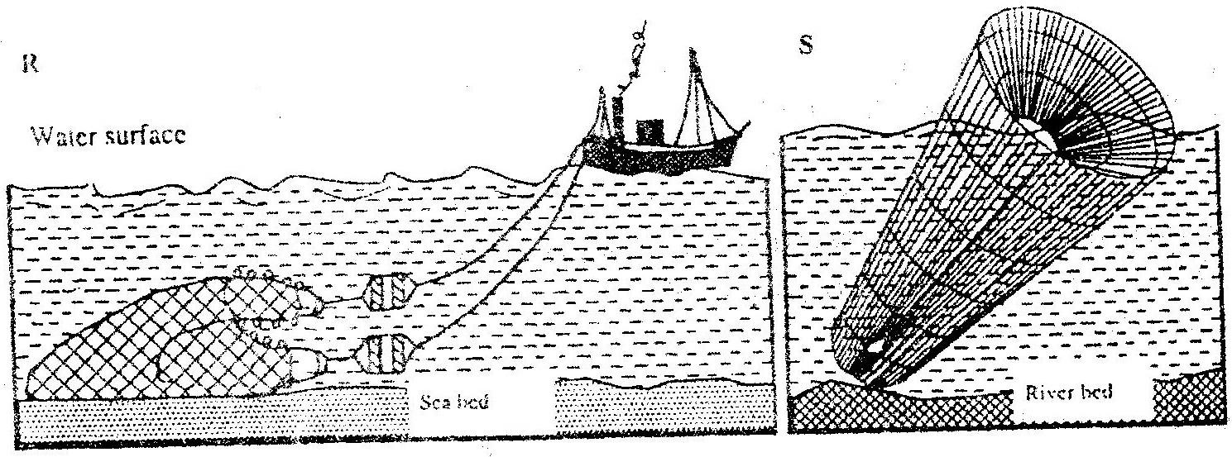
4. (a) The diagrams below represents some fishing methods.

(i) Name R and S. 2 mks
(ii) Describe how the above methods are used in fishing. 4 mks
5. (a) Differentiate between fishing and fisheries. 4 mks
(b) Identify the physical and human factors influencing fishing. 5mks
6. (a) Draw an outline map of the world and locate the major fishing grounds.
2 mks
(b) Account for the location of fishing grounds located in 6(a). 4 mks
7. (a) Discuss the main types of fishing. 3 mks
(b) List the traditional methods of fishing. 3 mks
(c) Describe how the following methods of fishing are carried out:
(i) Drifting
(ii) Trawling 4 mks
8. (a) (i) Apart from Lake Victoria, name other fresh water fisheries in
Uganda and Tanzania. 4 mks
(ii) Explain the factors favouring fishing on Lake Victoria. 6 mks
(b) Explain why marine fisheries are underdeveloped in East Africa. 5 mks
9. (a) State the significance of fishing to the economy of Kenya. 5 mks
(b) (i) Describe the problems facing fishing in Kenya. 5 mks
(ii) Identify the solutions in b(i) above. 5 mks
10. Draw a table showing the similarities and differences between fishing in Kenya and Japan. 6 mks
11. (a) Define:
(i) Management of fisheries.
(ii) Conservation of fisheries. 4 mks
(b) State the measures which can be undertaken to manage and conserve fisheries. 4 mks
CHAPTER 3
WILDLIFE.
1. Use the map of East Africa below to answer question (a) (i)
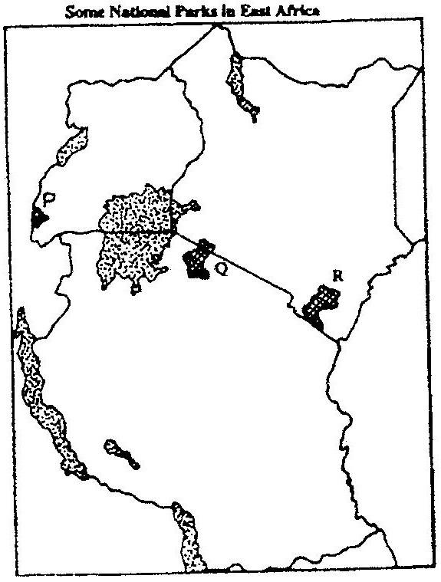

Name the national parks marked P, Q and R. 3 mks
2. Give FOUR reasons why wildlife conservation is encouraged in Kenya. 4 mks
3. State three reasons why National Parks have been established in Kenya. 3 mks
4. (a) Differentiate between game reserves and game parks. 4 mks
(b) State four steps taken by Kenyan government to promote wildlife resources. 4 mks
5. Explain three ways in which human activities are a threat to wildlife. 6 mks
6. What is wildlife? 2 mks
7. State five reasons for the need to conserve wildlife? 5 mks
8. State three types of wildlife one may find at I, Nakuru. 3 mks
9. Explain four problems the government of Kenya faces in efforts to conserve wildlife? 8 mks
10. State human factors that affect existence of wildlife. 5 mks
11. State ways in which government of Kenya can strengthen anti poaching unit.
12. (a) Define:
(i) Wildlife
(ii) Tourism 4 mks
(b) Distinguish between Same Reserves, National Parks and Sanctuaries.
(c) State five significance of wildlife in East Africa. 5 mks
13. (a) Discuss the problems facing wildlife in East Africa. 5 mks
(b) Explain the measures taken to manage and conserve wildlife in East Africa 6 mks
CHAPTER 4
TOURISM.
1. (a) Explain the differences between the tourist attractions in East Africa and
in Switzerland under the following subheadings:
(i) Climate.
(ii) Culture 4 mks
(b) Explain five benefits that Kenya derives from tourism. 10 mks
(c) Explain four measures that Kenya should take in order to attract more tourists. 8 mks
2. (a) Apart from historic sites, name two tourist attractions along the Coastal
strip of Kenya. 2 mks
(b) Give -three reasons why it is necessary to preserve historical sites. 3 mks
3. (a) Name two game reserves in Kenya. 2 mks
(b) Define of domestic tourism 2 mks
(c) How has the recent negative travel advisories affected Kenya's economy?
4 mks
4. (a) Explain four measures the Kenyan government has taken to attract more
tourists. 8 mks
(b) Explain three factors that have led to development of tourism in Switzerland.
5. (a) Differentiate between the following
(i) Ecotourism
(ii) Domestic tourism 4 mks
(b) Explain similarities between tourism in Kenya and in Switzerland. 8 mks
6. Explain why tourism is 'invisible export. 2 mks
7. Explain four positive effects of tourism. 8 mks
8. Explain four ways in which tourism in Kenya differ from that Switzerland. 8 mks
9. Why are some parts of Kenya not developed for tourism? 3 mks
10. What are the problems facing tourism in Kenya? 5 mks
11. State five efforts being made to improve tourism industry in Kenya. 5 mks
12. What is domestic tourism? 2 mks
13. Name tourist attractions found in Rift Valley province of Kenya. 5 mks
14. What factors hinder development of domestic tourism in Kenya? 5 mks
15. Name two historical attractions along Kenyan coast. 2 mks
16. (a) Define:
(i) Eco-tourism
(ii) Domestic tourism
(iii) International tourism 6 mks
(b) (i) State five tourist attractions in Kenya. 5 mks
(ii) Explain five factors influencing tourism in Kenya. 10 mks
17. (a) State six factors influencing tourism in Switzerland. 6 mks
(b) Explain five problems facing tourism in Kenya. 10 mks
18. Compare and contrast tourism in Kenya and Switzerland. 8 mks
19. The table below shows the number of tourists who visited Kenya.

Year | 1999 | 2000 | 2001 | 2002 | 2003
No. Of Tourists | 1.53 m | 1.64 m | 1.65 m | 1.77 m | 1.54 m

(a) Using a radius of 3cm draw a pie-chart to represent the above data.
(b) List three advantages of using pie-charts to represent statistical data.
CHAPTER 5
ENERGY.
1. (a) Apart from providing power, state three other benefits of the dams along
River Tana. 3 mks
(b) State two problems that affect hydroelectric power production along river Tana. 2 mks
(c) State two factors that hinder the expansion of geothermal power. 2 mks
2. (a) Name two non-renewable sources of energy. 2 mks
(b) Explain four physical factors that influence the location of a hydroelectric power station. 8 mks
3. (a) Explain three benefits that would result from rural electrification in
Kenya. 6 mks
(b) In what three ways did the power shortage resulting from the drought of the years 1999 and 2000 affect this industrial sector in Kenya? 5 mks
4. (a) Give three reasons that make tropical countries to have the potential to
develop HEP. 3 mks
(b) Give two reasons why tropical countries are not sufficient in HEP production. 2 mks
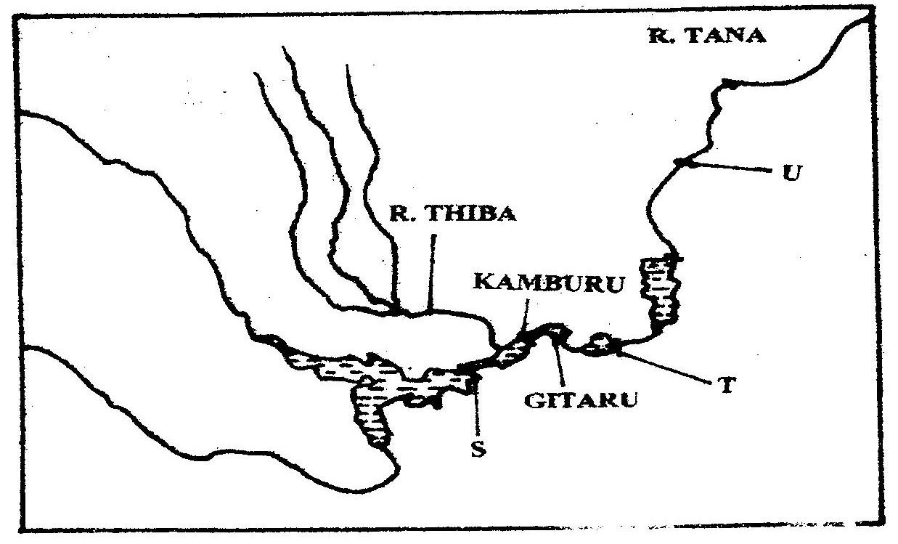
5. Use the diagram to answer questions below.

(a) Name
(i) The HEP stations marked S & T 2 mks
(ii) Name the proposed HEP station marked U. 1 mk
(b) Name renewable sources of industrial energy other than water 2 mks
6. The diagram below shows the occurrence of petroleum in the earth's crust. Use it to answer question (a).

(a) Name the substances labeled I, M and N. 3 mks
(b) Give two by-products obtained when crude oil is refined. 2 mks
(c) Explain efforts by Kenyan government to reduce cost on importation of petroleum. 6 mks
7. Name two main disadvantages of using coal as a source of energy. 2 mks
8. Suggest four solutions to Kenya's energy deficit. 4 mks
9. What are the causes of energy crises? 4 mks
10. List uses of nuclear energy. 4 mks
11. Name uses of wind energy. 2 mks
12. Name two non- renewable sources of energy. 2 mks
13. Why has usage of coal as a source of energy declined? 4 mks
14. Give four reasons why Kenya has been unable to exploit high geothermal power potential. 4 mks
15. Name the various methods that can be used to conserve energy. 4 mks
16. Define biomass. 2 mks
17. (a) Define energy. 2 mks
(b) List three renewable; sources of energy. 3 mks
(c) State the disadvantages of coal as a source of energy. 4 mks
18. (a) What is the name of power projects along river Tana.
(b) Apart from hydroelectric power production, state the other benefits of the dams along the Tana. 4 mks
(c) Identify the problems facing hydroelectric power production along the Tana. 4 mks
19. (a) Apart from the Tana, name three other hydroelectric power projects in
Kenya. 3 mks
(b) State the benefits of the Owen Falls Dam in Uganda. 4 mks
(c) State the factors limiting the expansion of geothermal power production in Kenya. 4 mks
20. Apart from hydro-electric power production; state the other benefits of the dams.
4 mks
21. State the significance of energy. 5 mks
22. (a) What is energy crisis? 2 mks
(b) State the causes of energy crisis. 2 mks
23. Explain the problems Kenya faces due to overdependence on petroleum. 4 mks
24. (a) Differentiate between management and conservation of energy. 2 mks
(b) Describe the measures of management and conservation of energy. 10 mks
CHAPTER 6
INDUSTRY
1. (a) State two reasons why some industries are located near the sources of raw. 2 mks
(b) Give three characteristics of the cottage industry in India. 3 mks
2. (a) State characteristics of jua kali industries in Kenya. 5 mks
(b) State problems facing Jua kali industries in Kenya. 5 mks
(c) Differentiate between manufacturing and j tertiary industries. 4 mks (d) State three factors that led to the growth of iron and steel industry in the:
Ruhr region of Germany. 3 mks
3. (a) Name three agricultural non-food manufacturing industries in Kenya. 3 mks
(b) Explain three causes of the decline in the textile industry in Kenya. 3 mks
(c) Describe the measures that should be taken to control the following.
(i) Water pollution
(ii) Rural urban migration. 2mks
(d) Explain four factors which have favoured the development of the electronics industry in Japan. 8 mks
4. (a) What is industrialization? 2 mks
(b) Name a town in Kenya where each one of the following industries is located,
(i) Oil refinery
(ii) Paper manufacturing
(iii) Motor vehicle assembly. 3 mks
(c) Give five factors why the development of the Jua kali industry is encouraged In Kenya. 5 mks
(d) Name two non-food agricultural industries in Thika. 2 mks
5. State benefits of exploiting soda ash in Kenya. 5 mks
6. State two major steps currently -undertaken by the government to promote industrial growth and development. 2 mks
7. What is industrialization? 2mks
8. State three reasons why the jua kali industry is encouraged in Kenya. 3 mks
9. (a) What is an industry. (2mks)
(b) State two ways in which each of the factors affect the location and
development of industries.
(i) Raw materials
(ii) Transport
(iii) Markets 6 mks
(c) Explain why power is not considered as a major industrial locational factor in the modern world. 2 mks
10. (a) Define:
(i) Primary industry
(ii) Secondary industry
(iii) Quaternary industry 6 mks
(b) (i) What is meant by Jua Kali industry in Kenya? 2 mks
(ii) State five economic benefits of the Jua Kali industry in Kenya. 5 mks
(c) Explain the significance of industrialization to Kenya. 6 mks
11. (a) State two main industries found in the towns below:
(i) Thika
(ii) Athi River
(iii) Kisumu
(iv) Nanyuki
(v) Nakuru 10 mks
(b) Explain the problems associated with industrialization. 6 mks
12. State five reasons why the Ruhr region in Germany is the leading industrial centre in Europe. 5 mks
13. (a) (i) Mention four industrial regions in Japan. 4 mks
(ii) List five factors that have aided car manufacture and electronic industries in Japan. 5 mks
(b) Explain the reasons which contributed to the growth and development of the cottage industry in India. 8 mks
CHAPTER 7
SETTLEMENT.
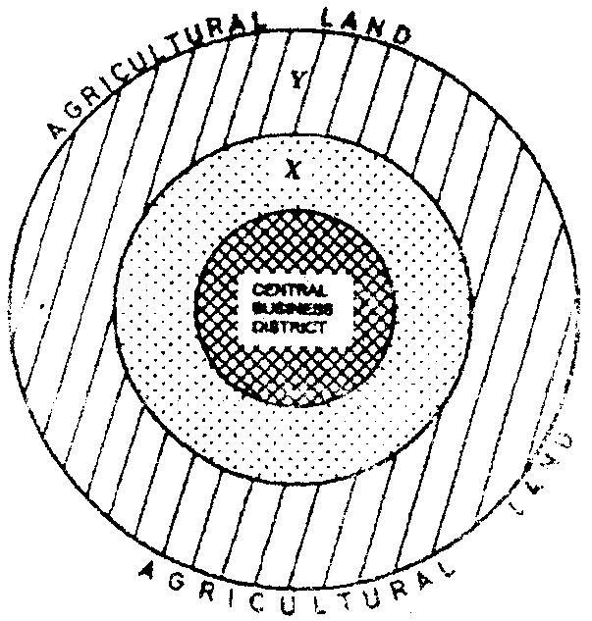
1. The diagram below represents the functional zones of urban centre. Use it to answer question (a)

(a) (i) Name the zones marked X and Y. 2 mks
(ii) List three functions of the Central Business District. 3 mks
2. (a) Name two types of human settlements. 2 mks
Use the sketch below to answer question (b)
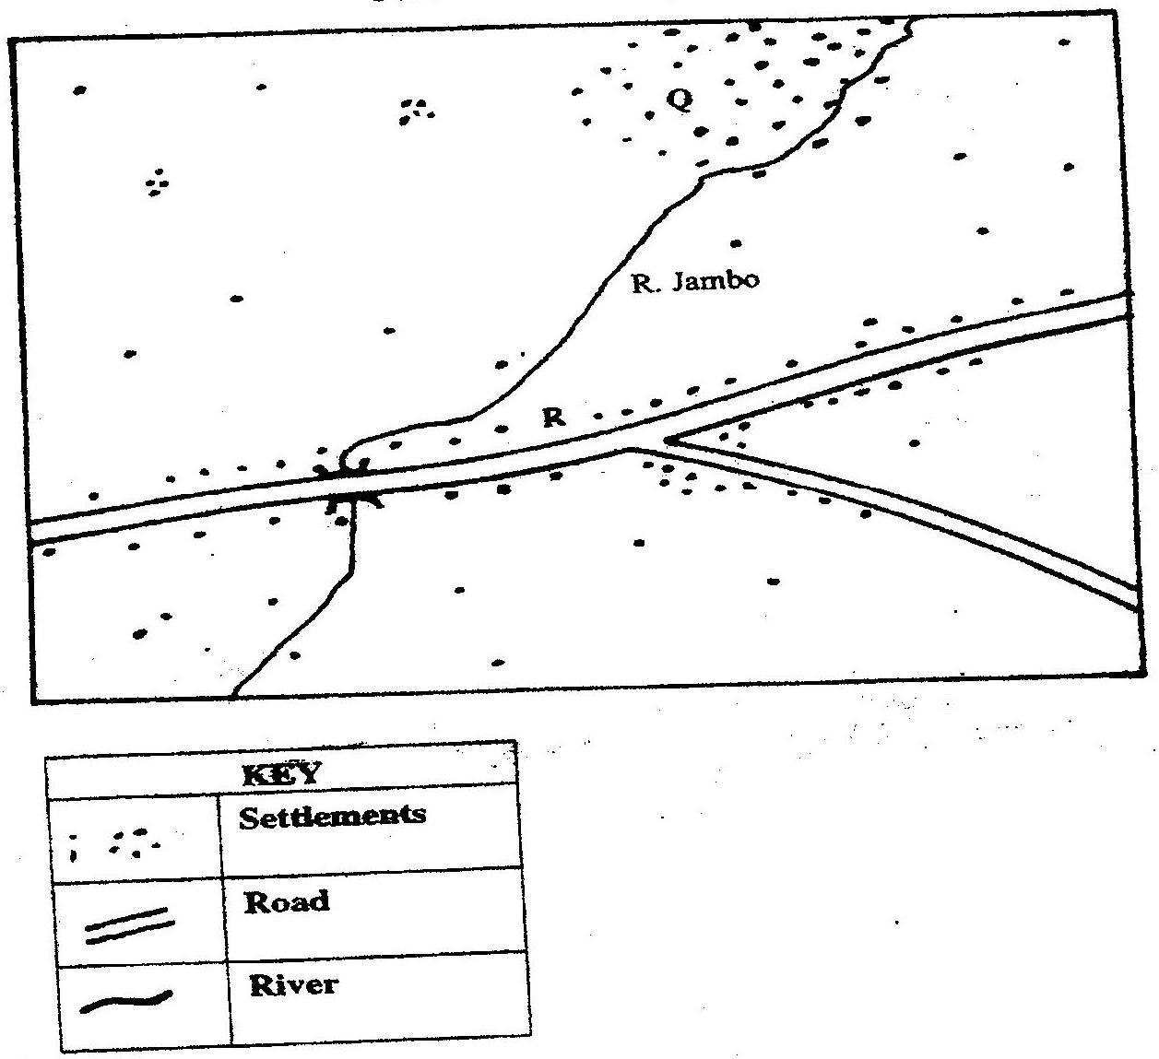

(b) Settlement patterns marked Q A R. 2 mks
3. (a) Name two types of rural settlement patterns. 2 mks
(b) Apart from urban-rural migration, name two other types of migration.
2 mks
(c) State three factors that may lead to urban-rural migration. 3 mks
4. State three factors which led to the development of Mombasa into a major sea port in the region. 3 mks
5. (a) What is urbanization? 2 mks
(b) Give two differences in the functions of New York and Nairobi cities.
4 mks
6. Apart from pollution, explain four problems experienced in urban centres. 8 mks
7. Explain similarities and differences between Nairobi and New York cities. 8 mks
8. State two main functions of rural settlements. 2 mks
9. Explain four problems that are experienced in Nairobi as one of the major urban centres in Kenya. 4 mks
10. List three factors that have led to rapid growth of Mombasa town. 3 mks
11. State ways through which the Kenyan government is using to solve problems of Nairobi city. 5 mks
12. (a) Differentiate between the terms settlement and urbanization. 4 mks
(b) Identify factors influencing settlement. 4 mks
(c) State the factors influencing patterns of settlement. 5 mks
13. (a) By use of relevant examples, explain the distribution of urban centres in
East Africa. 5 mks
(b) Explain 4 human factors which may lead to development of towns.
14. (a) Explain factors leading to the growth of Kisumu as a Lake Port. 8 mks
(b) What are the functions of Thika town? 5 mks
15. Explain the problems facing New York City. 6 mks
16. (a) Outline the main differences between the cities of New York and Nairobi.
4 mks
(b) Compare the port of Mombasa to the port of Rotterdam. 8 mks
17. Discuss the effects of urbanization. 4 mks
CHAPTER 8
TRANSPORT AND COMMUNICATION.
1. State the causes of the decline in the use of letter writing as a means of communication in Kenya. 5 mks
2. (a) Give three advantages of railway over road transport. 3 mks
(b) The map below shows the extent of the oil pipeline in Kenya. Use it to answer question (b).
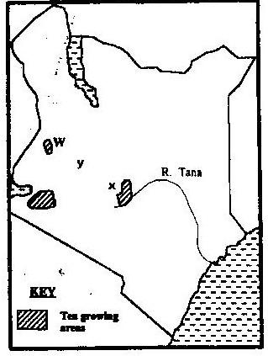

Name the towns marked X and Y which are served by the pipeline. 2 mks
(c) State two disadvantages of using pipelines as means of transporting oil.
(d) Use the map drawn below of St. Lawrence sea way to answer the questions that follow.

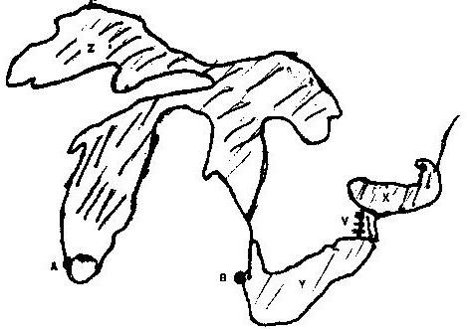

(i) Name the towns A and B
(ii) Name lakes X, Y, Z
(iii) Name canal marked V 3.
3. Use the sketch map of Lake Victoria below to answer question (a).
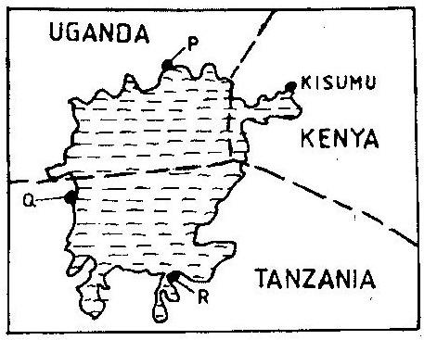

(a) Name the lake ports marked P, Q, and R 3 mks
(b) Outline two advantages of using containers while handling goods at the port of Kisumu. 2 mks
4. (a) Give three reasons why road transport is used more than air transport in
East Africa. 3 mks
(b) In what three ways does Kenya benefit from air links with the rest of the world? 3 mks
5. Use the map of East Africa below to answer question (a).
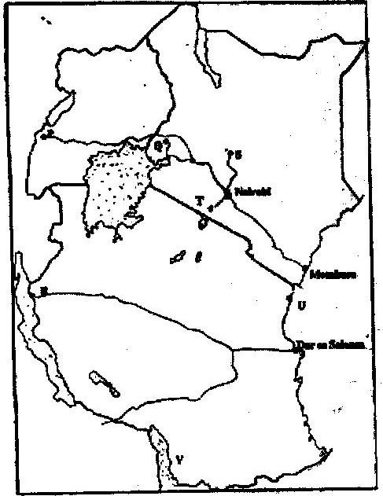

(a) Name the railway terminuses marked P, Q and R. 3 mks
(b) Give the main commodities transported by the railway lines marked S and T. 2 mks
(c) Name the port marked U and the lake marked V. 2 mks
(d) State four reasons why road network is more widespread than railway network in East Africa. 4 mks
(e) One of the problems facing road transport is the high frequency of accidents. Explain four conditions of roads in Kenya that may lead to accident. 8 rnks
6. Give four benefits of the efforts the government is data in streamlining pubic transport sector. 4 mks
7. Outline two major problems affecting the development of trans- African highway in Africa. 2 mks
8. State two major problems hindering river transport in Kenya. 2 mks
9. Suggest three benefits of the proposed Southern bypasses to be constructed in Kenya. 3 mks
10. (a) Define containerization.
(b) Outline three merits of using containerization as a method of transportation. 3mks
11. (a) State three problems facing railway transport in Kenya. 3 mks
(b) Identify importance of railway transport in a country. 4 mks
12. Differentiate between 'transport' and communication. 4 mks
13. Apart from cell phones, mention other two modern methods of communication.
2 mks
14. State advantages of using cell phones communication. 3 mks
15. State reasons why St. Lawrence sea way was set up by the government of USA.
4 mks
16. (a) Define:
(i) Transport
(ii) Communication 4 mks
(b) Apart from water transport, list the other modes of transport. 2 mks
(c) Name the two types of waterways used in transportation. 2 mks
17. (a) Give three reasons why river transportation in Africa is poorly developed.
3 mks
(b) Name the major ocean routes of the world. 3 mks
(c) State the advantages of water transport. 6 mks
18. (a) Account for the poor rail linkages j, between the African countries. 2 mks
(b) Name three trans-continental rail lines in Africa. 3 mks
(c) What are the advantages and disadvantages of transporting goods by rail?
6 mks
19. (a) Why is railway transport less used in Africa? 4 mks
(b) Name two railway systems in Africa. 2 mks
(c) Discuss the advantages and disadvantages of railway transport. 4 mks
20. State the advantages of road transport. 4 mks
21. (a) What is containerization? 2 mks
(b) Discuss advantages and disadvantages of containerization. 6 mks
(c) State advantages and disadvantages of air transport. 6 mks
22. Identify the main types of communication. 4 mks
23. (a) Name two trans-African highways 2 mks
(b) What are the benefits of trans-African highways? 2 mks
(c) Explain the problems facing the trans-African highways. 4 mks
24. Discuss the role of transport and communication in economic development of Africa. 4 mks
25. (a) State the problems facing transport and communication in Africa. 4 mks
(b) Outline the efforts being made to solve these problems. 4 mks
26. (a) (i) Identify the obstacles that face navigation along the St Lawrence
seaways. 3 mks
(ii) State ways in which navigation on the seaway was improved. 4 mks
(b) Explain the benefits of the St. Lawrence seaway on the economies of the United States of America and Canada. 6 mks
CHAPTER 9
TRADE.
1. (a) State five reasons why the common market for Eastern and Southern
Africa was formed. 5mks
2. (a) What is international trade? 5mks
(b) Name major imports from Europe to Kenya 2 mks
(c) List factors that influence the import and export of goods in Kenya. 4 mks
(d) Explain ways through which Kenya will I benefit from the renewed East African co-operation. 6 mks
(e) Explain negative effects of international trade. 6 mks
3. (a) Explain four measures which Kenya may take to reduce the unfavourable
Balance of trade. 8 mks
(b) Explain four benefits that Kenya derives from international trade. 8 mks
4. (a) What is Trade? 2 mks
(b) Identify the two types of internal trade. 2 mks
5. State the factors influencing trade. 4 mks
6. (a) Differentiate between visible and invisible exports. 4 mks
(b) Draw a table showing the major visible export and imports of Kenya. 8 mks
7. Explain the significance of trade to Kenya. 5 mks
8. State the future on international trade in Kenya. 3mks
9. (a) What is a regional trading bloc? 2 mks
(b) Apart from the European Union, name three other regional trading blocs.
3 mks
(c) Outline the role played by the European Union in the economy of Europe.
4 mks
10. Explain why the Kenya's exports are more to the outside world than her neighbors. 6 mks
CHAPTER 10
POPULATION
1. (a) State four reasons why the northern parts of Kenya are sparsely populated.
4 mks
(b) Give two primary sources of population data 2 mks
(c) What information can be derived from a population pyramid? 4 mks
(d) Describe three ways in which the population of Kenya differ from those of Sweden. 6 mks
(e) Explain four causes of rural-urban migration in Kenya. 8 mks
2. Explain three problems which result from the high population growth rate in the East African countries. 6 mks
2005:
3. List three factors that have contributed to a decline in infant mortality in Kenya. 3 mks
4. Explain two reasons why Thika District has a higher population than Murang'a district. 4 mks
5. (a) State the reasons for carrying out population census. 5 mks
(b) How the following factors lead to population increase in Kenya.
(i) Early marriages
(ii) Improved medical facilities
(iii) Cultural beliefs. 6 mks
6. The pyramid below represents the population of country X. Use it to answer question (a).
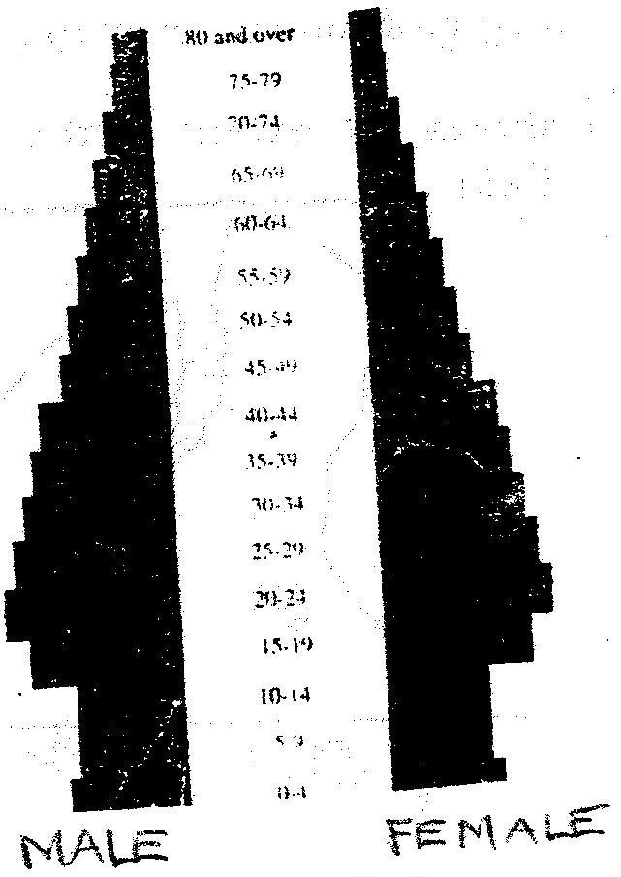

(a) Describe the characteristics of the population represented by the pyramid.
4 mks
(b) Explain three problems which may result from a high population growth rate. 6 mks
(c) Describe THREE measures that have been taken in Kenya to reduce infant mortality. 6 mks
(d) Explain four factors that have led to a high population density in Lake Victoria basin. 8 mks
7. a) Define the term population. 2 mks
(b) Explain factors influencing population distribution. 6 mks
8. (a) Explain factors influencing population growth. 8 mks
(b) Describe the main features of population structure of a developing country. 4 mks
9. Explain the factors leading to high fertility levels in a population. 6 mks
10. Compare and contrast population trends between Kenya and Sweden. 8 mks
11. The table below shows population distribution in Kenya by province in 1999. Use it to answer the questions below.
Province | Population | Area in Sq Kms
Nairobi | 2,143,254 | 696
Central | 3,724,159 | 13,220
Rift Valley | 6,987,036 | 182,539
Western | 3,358,776 | 8,264
Nyanza | 4,392,264 | 12,547
Coast | 2,487,264 | 82,816
Eastern | 4,634,779 | 153,473
N. Eastern | 962,143 | 128,124
Table 9.3 Population of Kenya by Provinces
(a) Calculate the population density of each province. 2 mks
(b) Give reasons why there is a high population density in Central Province of Kenya. 3 mks
CHAPTER 11
MANAGEMENT AND CONSERVATION OF THE ENVIRONMENT.
1. (a) Why is it necessary to conserve water? 3 mks
(b) How does terracing help in water conservation? 2 mks
2. (a) Apart from desertification, name two other environmental hazards
experienced in Kenya. 2 mks
3. (a) Name three physical regions through which river Tana passes. 3 mks
(b) Name two rivers in Kenya to the West of the Rift Valley which causes large scale flooding. 2 mks
(c) Explain four problems caused by floods. 8 mks
4. (a) Define the term pollution. 2 mks
(b) Explain three effects of land pollution on the environment. 6 mks
(c) State four ways through which Sand pollution can be controlled. 8 mks
5. (a) State ways in which drought affects the agricultural sector in Kenya. 4 mks
(b) What is soil conservation? 2 mks
(c) State three farming methods that assist in soil conservation. 3 mks
6. State three factors contributing to occurrence of floods 3 mks
7. State five negative effects of floods. 5 mks
8. State measures currently undertaken by Kenyan government to control natural disasters. 5 mks
9. Explain five economic importance of controlling floods. 10 mks
10. Name five natural hazards. 5 mks
11. Name three human induced hazards. 3 mks
12. Define desertification. 2 mks
13. Name causes of desertification. 4 mks
14. List effects of desertification. 4 mks
15. Explain five types of environment. 10 mks
16. (a) Define:
(i) Environment
(ii) Management of the environment
(iii) Conservation of the environment 6 mks
(b) Why is it necessary to manage and conserve the environment? 4 mks
17. (a) Mention six environmental hazards. 6 mks
(b) Explain:
(i) The causes of floods.
(ii) The effects of floods. 4 mks
18. (a) (i) What is lightning? 2 mks
(ii) What causes lightning? 2 mks
(b) (i) What are the effects of lightning? 2 mks
(ii) How can lightning be controlled? 4 mks
19. (a) (i) Define pollution. 2 mks
(ii) Name the four types of pollution.
(b) (i) What is air pollution? 2 mks
(ii) State five causes of air pollution. 5 mks
(iii) How can pollution be controlled? 5 mks
20. (a) (i) Name four non -governmental organizations involved in the
management and conservation of environment in Kenya. 4 mks
(b) Explain how legislation in Kenya is used to manage and conserve the
environment. 8 mks
MODEL PAPERS.
PAPER 1 (A)
2 HOURS 45 MINUTES
Answer all questions in this section.
1. (a) Define Geography. 2 mks
(b) Explain the relationship between Geography and Biology. 2 mks
2. (a) Differentiate between mass wasting and mass movement. 2 mks
(b) Outline four factors that cause soil creep to occur. 4 mks
3. (a) Name two fold mountains formed during Alpine Orogeny . 2 mks
(b) State three theories which explain the formation of fold mountains. 3 mks 4 Explain what you understand by each of the following;
(a) Vertical movement.
(b) Isostatic adjustment 4 mks
5. (a) Give three conditions necessary for the formation of Karst scenery. 3 mks
(b) List three zones of saturation below the earth surface. 3 mks

SECTION B
Answer question 6 and any other two questions
6. Study the map of Taita Hills (1: 50 000) sheet 189\4 provided and answer the following questions.
(a) What is the grid square of:
(i) Water reservoir at Mwasere
(ii) Water tank at Kirutai 4 mks
(b) What is the magnetic variation as of January 1991? 2 mks
(c) What is the direction of flow of River Goshi? 2 kms
(d) Explain four ways in which relief influences settlements in the area covered by the map. (8mks)
(e) Name three types of natural vegetation in the area covered by the map.
3 mks
(f) Students of the school at Zare carried out field study around the school,
(i) List four preparations they made. 4mks
(ii) State two methods they would use to collect data. 2 mks
7. (a) Define the term Lake, 2 mks.
(b) Explain three reasons why some Rift Valley lakes are saline. 6 mks
(c) (i) Describe how caldera lake is formed. 5 mks
(ii) Give three examples of caldera lakes in Africa. 3 mks
(d) Explain four ways in which lakes modify the climate of the surrounding areas. 8 mks
8. (a) (i) Define faulting. 2 mks
(ii) Distinguish between reverse and tear faults. 2 mks
(b) Explain formation of each of the following;
(i) Fault scarp
(ii) Tilt block 4 mks
(c) Explain four economic significances of faulting to human activities 8mks (d) (i) State three advantages of oral interviews. 3 mks.
9. (a) (i) Differentiate between zero lapse rate and environmental lapse rate.
4 mks
(ii) Name two types of fronts in air masses. 2 mks
(iii) State two effects on climate from urbanization. 2 mks
(b) (i) Name one type of hot climates. 1 mk
(ii) Account for the characteristics of rainfall experienced in Equatorial climate. 8 mks
(c) (i) State four causes of the recent global climatic change. 4 mks
(ii) State six major effects of climate change. 6 mks
10. (a) (i) State three characteristics of arid areas. 3 mks
(ii) Give two factors that promote wind deposition in arid areas 2 mks
(b) (i) Identify two processes of wind erosion. 2 mks
(ii) Describe how the barchan is formed. 4 mks
(c) Differentiate between a rock pedestal and a mushroom block. 4 mks
(d) Suppose you are asked to carry out a field study on the action of water in a desert.
(i) State two objectives for your study 2 mks
(ii) Name two water depositional features you are likely to observe.
2 mks
(iii) Explain three significance of arid landforms. 6 mks
PAPER 1 (B)
2 HOURS 45 MINUTES
SECTION A
Answer all questions in section A
1. a) Name the minerals found in the core of the earth. 2 mks
b) State ways we understand interior of the earth. 2,mks
2. a) What is the plate tectonic theory. 1 mk
b) Explain two evidences that support the continental drift theory. 4mks
3. a) State three characteristics of the troposphere. 3mks
b) State factors considered for positioning rain gauge. 3mks
4. a) List three natural causes of soil creep. 3mks
b) State two measures used to check mass wasting. 2 mks
5. (a) State two physical conditions for development of karst scenery. 2mks
b) Name two sources of under ground water. 2 mks

SECTION B
Answer question 6 and any other two questions.
6. Study the map of Nyahururu (10:50000) provided and answer the following questions.
a) (i) Measure the length of the dry weather road from Marmanet Saw
Mills, grid reference 054143 to the junction at Karima shopping centre grid reference 033099 in kilometers. 2 mks
ii) Calculate the gradient of the slope between point A grid reference 940021 and point B at grid reference 985021. 2 mks
(b) (i) Name drainage features found in the area covered by the map.
3 mks
(ii) List features found in the southern part of the map indicating the area receives low rainfall. 3 mks
(c) Describe the relief of the area covered by the map. 3 mks
(d) Three natural factors influencing settlements. 3 mks
(i) Name factors favouring location of Nyahururu town. 6 mks
ii) State two social functions of the town. 3 mks
7. a) What is a Lake? 2 mks
b) Discuss the formation following Lakes.
i) Lake Victoria
ii) Lake Tanganyika 8 mks
c) Explain how human activities have negative impact on lakes. 8 mks
d) i) List three positive effects of lakes to humans. 3 mks
ii) Name four follow up activities in fieldwork. 4 mks
8. a) i) Differentiate between mineral and rock. 4 mks
ii) State characteristics of sedimentary rocks. 3 mks
b) Classify rocks according to form and origin giving two examples in each type. 9 mks
c) Explain formation of following examples of rocks. 6 mks
i) Tuff
ii) Coral rock
d) State use of equipment listed below in fieldwork. 3 mks
(i) Geological hammer
(ii) Lenses
(iii) Hydrochloric acid
9. a) i) Name three hot deserts. 3mks
ii) State two characteristics of arid lands. 2 mks
b) Describe formation of following features.
i) Rock pedestals
ii) Yardang 8 mks
c) Name three resultant features of action of water in deserts. 3 mks.
d) i) Name three processes of wind transport. 3 mks.
ii) State advantages of using secondary sources of data. 2 mks
iii) List four evidences of desertification. 4 mks.
10. a) i) What is a fault 2 mks.
ii) Name the parts of a fault? 4 mks
b) i) Name two resultant features of faulting. 2 mks
ii) Explain formation of Rift valley by theory of anticlinal arching. 3 mks
c) i) Distinguish between basic lava and acidic lava. 6mks
ii) State four characteristics of composite volcano. 4 mks
iii) State four positive influences of volcanicity. 4 mks
KCSE MODEL PAPER 2 (A)
2 HOURS 45 MINUTES
SECTION A
Answer all questions in this section
1. (a) Name two exotic beef cattle reared in Kenya. 2 mks
(b) State three physical conditions favouring beef farming in Argentina 3 mks
2. (a) Name two products which can be transported using pipelines. 2 mks
(b) Give three advantages of using pipelines as a means of transport. 3mks
3. a) What is land reclamation? 2 mks
b) State three physical factors which influenced the establishment of the Perkerra irrigation scheme. 3 mks
4. a) Name three cities in Kenya. 3 mks.
b) State three problems facing the growth of Mombasa city. 3 mks
5. a) Name two environmental hazards other than floods 2mks
b) Give three problems resulting from flooding in Lake Victoria basin. 3mks

SECTION B
Answer question 6 and any other two questions
6. a) (i) What is statistics? 2 mks.
ii) Name three ways in which data analysis is done. 3 mks
iii) Name two advantages of a wind rose. 3 mks
b) State four physical conditions necessary for the growing of sugar cane.
c) Describe the commercial production of sugar cane from land preparation to harvesting. 8 mks
d) Explain three problems facing sugar cane farmers in Kenya. 6 mks
7. a) Name three national parks in Uganda 3 mks
b) (i) Explain two differences between a national park and a game
reserve. 4 mks
ii) Name three tourist attractions found in the Rift Valley Province of Kenya. 3 mks
c) i) State three physical conditions that influence distribution of
wildlife in East Africa. 3 mks
ii) List four problems experienced by the Kenya Government in its effort to conserve wildlife. 4 mks
d) Explain four factors which have made Switzerland a major tourist attraction in Europe. 8 mks
8. (a) i) What is agroforestry? 2 mks
ii) Give three reasons why agroforestry is being encouraged in Kenya.
3 mks
(b) i) Name three types of coniferous trees found in Kenya. 3 mks
ii) State five characteristics of coniferous forest. 5 mks
(c) Compare forestry in Kenya and Canada under the following sub-headings.
i) Tree harvesting.
ii) Transportation of logs
iii) Marketing
(d) Explain three problems that affect forestry in Canada. 6 mks
9. a) i) Name two non-renewable sources of energy other than coal. 2 mks
ii) Give three disadvantages of using coal as source of energy. 3 mks b) i) Name two Geothermal potential areas in Kenya. 2 mks
ii) Give three reasons why Kenya has not been able to fully exploit
her geothermal potential. 3 mks
c) Explain four conditions that favour the location of hydroelectric power station. 4 mks
d) i) What is energy crisis? 2 mks
ii) Explain three effects of energy crisis in Kenya. 3 mks
10. a) i) Differentiate between pelagic and demersal fishing. 2 mks
ii) Name any two examples of demersal fish. 2 mks
b) State four reasons why fresh water fishing is more important than marine water fishing in Kenya. 4 mks
c) i) What is fish farming? 2 mks
ii) State four ways through which fish farming contributes to the economy of t Kenya. 4 mks
d) State three problems facing fish farming in Kenya. 3 mks
e) Explain four conditions that favour fishing in Japan. 4 mks
KCSE MODEL PAPER 2 (B)
2 HOURS 45 MINUTES
SECTION A:
Answer all questions in this section
1. a) State three advantages of using solar energy. (3mks)
b) State two factors hindering the development of solar energy. (2mks)
2. a) State three ways through which Kenya has benefited from international
airports. (3mks)
b) Suggest two possible solutions to Africa's transport and communication problems. (2mks)
3. a) Distinguish between population distribution and population density. (2mks)
b) State three problems created by a decline of population in a developed country. (3mks)
4. a) State two physical factors which influence the location of settlements.
(2mks)
b) Which are the three functional zones of an ideal urban centre? (3mks)
5. a) List two types of fish reared in ponds. (2mks)
b) State measures that have been undertaken by the government of Kenya to encourage fish farming. (3mks)

SECTION B
Answer question 6 and any other two questions from this section.
6. Use the photograph below to answer questions (a) i and (ii)
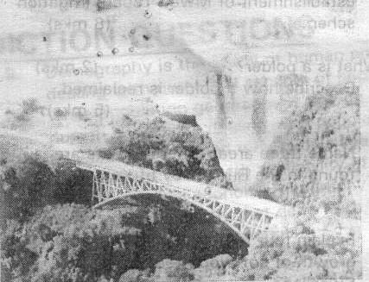

a) i) Identify the type of photograph given above. (1mk)
ii) Name two major features represented in the area shown on the photograph. (2mks)
b) Identify four road conditions that trigger mad accidents. (4mks)
c) Explain four limitations of road transport. (8mks)
d) Explain four problems faced by African states in efforts to improve roads.
(8mks)
7. (a) Give five reasons why wildlife conservation is encouraged in Kenya.
(5mks)
b) Explain what you understand by the following terms:
i) Domestic tourism.
ii) Eco-tourism (4mks)
(c) Explain three factors that have hindered the development of domestic tourism in Kenya.
(d) Explain four factors that have made Switzerland a major tourism destination in Europe.
8. (a) What do you understand by the following terms:
i) Land reclamation.
ii) Land rehabilitation. (4mks)
b) i) State any four methods used in land reclamation and rehabilitation
in Kenya. (4mks)
ii) Apart from Mwea Tebere, name two other large scale irrigation schemes in Kenya. (2mks)
iii) Explain four factors that led to the establishment of Mwea Tebere
irrigation scheme. (8mks)
(c) i) What is a polder? (2mks)
ii) Describe how a polder is reclaimed. (5mks)
9. a) i) Name three areas where forests are found in the Rift Valley of
Kenya. (3mks)
b) Explain four factors that favour the growth of softwood forests in Swaziland. (4mks)
c) i) Explain four problems experienced in commercial exploitation of
the equatorial forest in Africa. (4mks)
ii) Give three species of trees found in Gabon. (3mks)
d) State three measures being taken to conserve forests in Kenya. (3mks)
10. (a) i) Name two conditions that are necessary for the formation of
petroleum. (2mks)
ii) Give two reasons why Kenya imports her oil in crude form. (2mks)
(b) i) State two advantages of geothermal power. (2mks)
ii) State four factors that hinder the expansion of geothermal power production in Kenya. (4mks)
(c) Explain four ways by which the government of Kenya should apply to conserve her energy. (4mks)
(d) i) What is multi-purpose dam? (2mks)
ii) State three reasons why Akosombo dam was established. (3mks) iii) List three benefits of establishing the Akosombo dam. (3mks)
ANSWERS TO TOPICAL QUESTIONS
PAST KCSE AND PREDICTION QUESTIONS
FORM ONE
CHAPTER 1
INTRODUCTION TO GEOGRAPHY
1. Collective term for methodologies of fieldwork, maps and map work and photograph interpretation used in study of geography.
2. • Physical geography
• Human geography
3. • Climate
• Rocks and minerals
• Earth and the solar system
• Soil
4. • External conditions surrounding of an organism.
5. • Provides knowledge that promote conservation of resources
• Admission in careers that generate income e.g. Geologist.
• Learn skills in time management useful in personal activities
6. • Transport lines e.g. roads.
• Settlement structures e.g. houses
• Drainage features e.g. boreholes, water dams
• Industries e.g. coffee mills
• Farms e.g. tea estates
7. Part of physical conditions that provide home in which certain organisms live.
8. • History
• Biology meteorology
• Demography
• Sociology
• Agriculture
• Economics
• Physics
• Chemistry
• Geology
• Medicine
9. • Demography is the study of human population dealing with numerical
aspects of population while population geography is branch of human geography dealing with population explaining where and why people live.
• Economics deals with availability of resources while economic geography is branch of geography that deals with location and distribution of resources.
10. • Geo, graphein
CHAPTER 2
THE EARTH AND THE SOLAR SYSTEM
1. (a) • Causes day and night/apparent movement of sun from east to west.
• Causes differences in time at different longitudes.
• Causes deflection of winds\ ocean currents.
• Causes rising and falling of sea tides.
• Causes variation in atmosphere pressure on the earth surface.
(b) • Earth revolution
• Causes changes in position of midday sun at different times of the year.
• Causes varying length of the days and nights in northern and southern hemisphere.
• Causes changes in seasons; spring, summer, autumn and winter. • Causes lunar eclipse
2. (a) (i) P - Atmosphere
(ii) Q - Barysphere/centrosphere/core
(iii) R -Mohorovicic discontinuity/moho dicontinuity
(b) • Divided into two-upper and lower mantle
• Mantles' main constituent minerals are ferro-magnesium and silicate.
• Mantle is about 2, 900 km thick.
• Upper mantle has low temperature than lower mantle.
• Mantle has temperatures of about 1000°C.
• Mantle is made up heavier rocks than rocks of earth crust.
• Upper mantle is made up of an elastic solid/semi-molten
• Inner mantle is made up an elastic solid/semi molten basic rocks/ viscous liquid.
3. (a) The planets marked F and G is
• Mars
• Neptune
4. (a) Solar system refers to the composition of the sun, the planets and other
heavenly bodies related to the sun.
(b) i) Solar eclipse
(ii) L - Moon
M- Shadow
5. (a) i) 21st March and 23rd September
ii) Due to revolution of the earth.
(b) i) 274.5 days
ii) Summer season
6. (i) Solar system - Organization made up of the sun with the nine planets
orbiting around it and heavenly bodies,
(ii) Galaxy - Group/cluster of stars in the universe.
(iii) Star - Hot mass of glowing gases that transmit light to outer bodies.
(iv) Asteroid - Small planet-like objects orbiting around the sun between the planets of Mars and Jupiter.
7. • Latitude is the distance north or south of equator measured as an angle
from the earth's centre while longitude is the distance of the earth's surface measured east or west of prime meridian and expressed as an angle.
Latitude is imaginary line running from East to West showing how far North or South a place is from Equator.
• Dateline is line 180° at which a day is lost or gained while international dateline is zigzag line along longitude 180° deviating land surfaces and at which day is lost or gained.
• Glowing objects that quickly cross the sky before they burn up and disappear while meteorites are those meteors that pass through the atmosphere brightly but do not burn up.
8. • In solar eclipse moon lie between sun and earth while in lunar eclipse
earth lie between moon and sun.
• In solar eclipse shadow of moon is cast on earth while in lunar eclipse shadow of earth is cast on moon.
• Solar eclipse occurs during the day while lunar eclipse occurs during the night.
• Lunar eclipse is caused by earth's revolution while solar eclipse is caused by revolution of moon.
9. • Presence of water that support life.
• Presence of atmosphere with adequate O₂ and CO₂ levels that support life of animals and plants respectively.
• Enough heat and light due to earth's favourable distance from the sun.
• Proportional gravitational force that allow objects to be upright on the earth's surface.
10. (a) • Causes deflection of the winds
• Causes time difference between Meridians.
• Causes variation in speed of air masses.
• Causes rising and falling of ocean currents.
• Causes variation in atmospheric pressure.
G.M East
34°E 41°E
1 p.m. ?
1° = 4 minutes
4 x 4 = 16 minutes
Local time = 1.16 p.m.
11. (a) Periods 21st March and 23rd September when the sun is overhead at
midday along the equator.
(b) • Sun is overhead at mid-day along the tropic of cancer/Capricorn.
• The Arctic Circle experiences 24 hrs of daylight.
• Days are longer than nights.
• Temperatures are high in the region experiencing summer solstice.
• 24 hour sunshine within the circles.
12. 66 ½ ⁰, 23 ½ ⁰
13. (a) Silica, aluminium
(b) 2.7 gms/cc
(c) 6 -10 kms
(d) 3.0-3.3 gms/cc
(e) 3470 kms
(f) 5,500 cc
14. • Chances of another star approaching the sun are minimal.
• High temperature materials drawn from the sun would disperse rather than condense.
• It does not explain where the sun and the star came from.
15. Hydrosphere is part of the earth surface covered by water masses e.g. oceans, seas, rivers and swamps while atmosphere refers to thin layer of gases surrounding the earth and held by earth's gravitational pull.
16. (a) 1. Uranus
2. Venus
3. Earth
4. Venus
5. Jupiter
6. Venus
7. Mercury
17. • Earth rotates on its own axis to make a complete turn; and its poles rotate
of this axis and pulled towards each other (centripetal forces)
• Equator covers a long distance and therefore rotates faster, with more speed causing a flinging force (centrifugal force).
18. • Low temperatures
• Longer night times than day times at latitudes beyond equator
• The sun is overhead Tropic of Capricorn on 22nd December and its winter Solstice in the Northern Hemisphere.
• On 21st June the sun is directly overhead the Tropic of Cancer and its winter solstice is in the Southern hemisphere.
• Sun is not visible at cycles and there is darkness for 24 hrs.
19. • Winter solstice occurs on 22nd December and 21st June when the sun is
overhead at mid-day along tropic of Capricorn and Cancer respectively. At the Arctic Circle and Antarctic circles the sun is visible for only a few minutes when it appears above the southern/ Northern horizon.
• Summer solstice occurs on 21st June and 22nd December when the sun is overhead in the tropic of Cancer and Capricorn respectively. The sun rises higher in the sky and is visible for 24 hrs at the arctic and Antarctic cycles.
20. (a) It is a shadow that is formed when rays of the sun are blocked from
reaching the earth or the moon.
(b) • Comets
• Asteroids
• Meteorites
• Satellites
21. • It is an imaginary line running from North to South that shows how far
east and West a place is from the Greenwich prime meridian.
• It refers to angular distance east or west of the Greenwich prime meridian.
22. • It causes aphelion whereby the earth is sometimes in its farthest position
from the sun.
• It causes periphelion whereby the sun is sometime at its closest position to the sun.
• It influences the occurrence of spring and neap tides.
• It changes cycle of equinoxes and solstices
• It influences occurrence of seasons
23. 1° - 4 minutes
47° x 4 = 188 minutes
188 minutes = 3 hrs 8 minutes
Buchanan is 3 hrs 8 minutes behind Nairobi.
Time is 6.52 a.m.
24. (a) On crossing this longitude while going to the West, a day is gained and
white crossing to the East a day is lost.
(b) 66¹/₂°
(c) Photographs taken from the outer space or satellites show the curvature of the earth.
• During eclipse of the moon, the earth casts a spherical-shaped shadow on the moon.
• Circumnavigation of the earth along a straight path will bring one back.
• Earths horizon
• Other planets are curved and earth is one of planets.
• Different rising and setting times in different places.
• An approaching ship.
CHAPTER 3
WEATHER
1. (a) During the day the land heats faster than the sea.
• The air over the land rises
• Cooler air from the sea blows towards the land to replace the rising air
• The cool air from the sea is called sea breeze
(b) (i) H- Mozambique, J - Benguera
(ii) Raising temperature Causes rainfall
2 • Troposphere
• Stratosphere
• Mesosphere
• Ionosphere
3. (a) • Air must have abundant moisture.
• A cloudless night to facilitate terrestrial radiation.
• Air should be calm to remain in contact with the ground in order to be cooled.
• There should be gentle air currents to hold water droplets in suspension.
• The air must be cooled below dew point.
(b) (i) R - cumulus
4. (a) (i) X - 3°C
Y - 9°C
(b) (i) 583 mm
(ii) • Sea make water is heated intensely by solar radiation.
• Heating is intense in the afternoon
• Warm moisture laden air rises and condenses at higher altitude.
• Condensed water vapour forms cumulonimbus clouds.
• Clouds eventually give rain accompanied by thunderstorm.
5. (a) (i) 30.3 - 28.4 =1.9°C
(ii) 9.0 + 8.0 + 21.0 + 49.0 + 25.0 + 9.0 + 20.0+10.0 + 4.0+10.0+17.0+11.0 =1930 mm
(b) • Altitude - High altitude areas have low temperature and low
pressure. Temperature varies with height because air is heated from below.
• Winds transfer heat from one place to another causing changes in temperature.
• Latitude influences climate such that areas near equator are warmer.
• Aspect influences climate as south facing slopes in the northern hemisphere are warmer than north facing slopes in the same.
• ITCZ- zone of low pressure which migrates North and South equator affects rainfall.
6. (a) • Sunshine
• Rainfall
• Wind
• Cloud cover
• Air pressure
• Humidity
7. a) • Open area free of shade by trees and buildings.
• Gentle land free of flooding
• Area with wide view of surroundings.
• Away from concrete surfaces.
b) Reasons why Stevenson screen is;
• Painted white - can reflect direct heat from the sun.
• Louvred on sides - To allow free flow of air and regulate temperature.
8. Relative humidity refers to the ratio between water vapour actually present in the air and its capacity to hold water vapour at a given temperature.
9. (a) • It's heavy and torrential/falls in large drops.
• Usually accompanied by lighting and thunderstorms
• Falls mainly in the late afternoon
• It's highly localized and lasts for a short while (15-20 mins)
(b) Radiation fog forms when air in contact with the ground is cooled through terrestrial radiation while advection fog forms when warm moist air is cooled as it passes over cool surface e.g. land/sea.
10. (a) • When the temperature rises, the alcohol in the left hand column
expands and pushed the mercury column. The mercury in turn pushes the mercury in the right hand column and steel metal index up.
• The maximum temperature is shown by the end of the index pushed by the mercury.
• When the temperature falls, alcohol in the left hand column contracts and pulls the index along the tube. When the temperature rises, the alcohol expands leaving behind the index. Then the minimum temperature is read.
(b) • According to the altitude of their bases.
• Their appearance/structure
• Their formation
11. (a) - It should be in an open place with free flow of air.
- Away from barrier e.g. trees
- Should be on a fairly level ground.
- The site should be free from flooding
- The site should provide a wide view of the surrounding landscape and the sky.
(b) • Intensity of the sun's radiation in space the average distance from
the sun.
• The transparency of the atmosphere
• Position of the earth in its orbit
• The area and nature of the surface on which the rays fall.
12. Climate It's the average weather condition of a given place over a period or
time usually (30-35 years)
Relative humidity Refers to the ratio between water vapour actually present in the air and its maximum capacity to hold water vapour at a given temperature.
Weather forecasting it’s the prediction of the weather situation for a given place within a given period of time e.g. hour, a day, a week.
Absolute humidity It is the total amount of water vapour that a given volume of air can -hold.
Weather lore Refers to a body of traditional facts and beliefs relating to weather e.g. a halo around the moon, croaking of frogs, a rainbow, migration of birds
13. • The students are able to relate what they have learnt in class to the real
environment hence making geography real and interesting.
• It breaks the class monotony.
• It enables learners to develop skills or observation measurement, recording and analyzing data.
• It improves the visual memory through observation.
14. (a) • Rain gauge
• The rain gauge is kept in an open space in the weather station from above. Its raised to avoid splashes from entering into the gauge.
• The water collected is emptied into the measuring cylinder every 24hrs.
• Take readings on the measuring cylinder.
• This cylinder is graduated in mm and the level the water emptied reaches gives us the reading amount of rainfall for the day.
• Record the readings and interpret.
• A maximum and minimum thermometer
• When the temperature rises, alcohol in the left hand column expands and pushes the mercury column and maximum temperature is read.
• When the temperature rises, alcohol in the left hand column contracts and pulls the index along the tube and the minimum temperature is read from the upper end of the index.
• After recording the reading, the thermometer is reset using a magnet.
• Interpret the readings.
(b) (i) Convectional rainfall
Its formation
• The intense heating from the sun results into warm air rising in form of convectional currents.
• The rising air reaches the high atmosphere and moisture in it condenses. Forms clouds and falls rain.
• It falls in the late afternoon accompanied lighting and thunderstorms.
(c) Problems
• Lightening and thunderstorms which are destructive to life and property.
• The torrential/large drops which are harmful to the crops and other vegetation.
• The hailstones also are destructive to the crop leaves.
15. (a) • Weather forecasting
• Weather forecasting is the prediction of weather conditions
(b) (i) Problems of weather forecasting
• Inaccurate data
• Defective instruments
• Personnel with limited skills
• Vagaries of nature such as earthquakes
(ii) • Determines times for sea and air travel.
• Determine time when sporting activities take place.
• Determines the fishing activities and habits in the area.
• Help determine suitable clothing for the day.
• Help plan farmers calendar of activities.
• Help plan suitable housing.
16. (a) How clouds influence weather.
• Clouds determine the amount of solar radiation reaching the earth's surface and the amount leaving the earth's surface. This determines temperature conditions.
• Day temperatures are moderated by clouds.
• Areas of thick rain clouds have high rainfall.
(b) (i) Mean temperature ⁻²⁷⁶/₁₂ = 23°c
(ii) Annual rainfall 1073 mm
(iii) Annual range of temperature 5°C
(iv) Mean rainfall - 1073 mm
(v) Wettest month - April
NB. MUST SHOW WORKING!
17. (a) Large volume of air with uniform temperature and humidity and flow over
considerable distance
(b) • Equatorial air mass
• Tropical air masses
• Polar air masses
• Arctic and Antarctic air masses
(c) 15° - 20g/cm²
6g/cm³ =?
RH = A.H x 100% = 6 x 100= 30%
Max 20
18. (a) A thermometer/ maximum/ minimum/ six thermometer Hygrometer/wet
and dry bulb thermometer.
19. • At night, land looses heat faster than sea.
• Air upon land becomes cooler and heavier than that upon the sea.
• The relatively warmer air upon the sea is lighter and therefore it rises while the cooler heavier air at the land flows towards the sea to replace the warm rising air.
CHAPTER 4
STATISTICAL METHODS
1. (a) (i) 9600-800 = 8,800,000 Barrels
(ii) 21,150,000 Barrels.
(iii) 21,150,000\30 = 705,000 Barrels
2. Graph
(i) 29.3% (29 - 29.5%) 29%
(ii) 4.75%/4.8%/4.9%
(4.75% - 4.9%)
(iii) Describe the trend of the value of coffee exports from years 1999 to 2003.
• The value was generally declining over the five year period.
• The value was highest in 1999.
• The decline between 1999 and 2000 was minimal/gradual.
• The highest drop was between 2000 and 2001
• There was a minimal drop between 2002 and 2003.
• The decline between 2001 and 2002 was minimal/gradual.
• The value was lowest in 2003.
(iv) Explain three factors which may have led to the increased export earnings
from horticultural produce in Kenya between years 1999 and 2003.
• Improved technology which leads to advanced crop husbandry/increase the volume of fresh horticultural products.
• Aggressive promotion of trade abroad leading to a wide/ready market in foreign countries.
• Improved ways of packaging have made the produce more competitive/ attractive,
• Improved infrastructure/air/road transport have helped in the quick means of transportation of fresh produce to the market.
• The declining benefits from traditional agricultural exports leading to the expansion of the areas under horticultural crops.
• The government has encouraged the formation of organizations that are assisting horticultural farmers.
(v) Give three advantages of using simple line graphs to represent data.
• Give clear visual impression.
• Easy to construct.
• Easy to interpret.
• Can be used to represent a wide variety of variables.
• Appropriate for comparison.
(b) Reasons why Kenya's agricultural export earning generally are low
• Kenya sells most of her agricultural products in their raw form and they are priced lowly.
• International prices keep fluctuating from year to year.
• Prices of some commodities are externally determined.
• There is competition from other producing countries/from other similar products.
• Some products are inferior in quality.
• There are fixed quarters for some agricultural products.
• Decline in quantities of some agricultural exports.
3. (a) Statistics It refers to the art or science that is concerned with the
interpretation of numeric information.
Statistical data Refers to the information collected and arranged in a systematic manner.
Statistical methods Refers to the techniques used in collecting, recording, analyzing and presenting data.
(b) Primary data and Secondary data
(c) Closed-ended (rigid) - Open-ended
4. (a) • The method should be inexpensive.
• Should be time saving
• Should give accurate data
• Most applicable method
(b) • Discreet data refers to the non-continuous data over time given in
whole numbers only e.g.
• Total population in a nation.
• Monthly rainfall totals.
• No. Of livestock per district
• Continuous data can be given in any value including decimals e.g. 1.8km.
5. Sampling refers to the process by which a representative portion of the whole phenomena under study is analyzed and generalized/ generalization is made.
Types of sampling
Systematic sampling Stratified sampling Random sampling
6. (a) • Calculation of percentages
• Measuring of Central tendency (mean, median and mode)
• Frequency distribution
(b) • Predicting for future trends.
• Showing changes through time
• Establishing Geographical relationships
• For economic planning
• For explaining geographical phenomena.
• Useful for making comparisons.
7. (i) • Simple iine graph
• A combined line and bar graph
• Simple bar graph
(ii) • The simple bar graph
• Prominent values stick out well
• Bars are appealing to the eye
• Easy to draw, read and interpret the data represented
8. (i) A set of pre-questions which are related to the topic of study.
(ii) • Its a source of first hand information
• The researcher can ask for clarification from the respondent.
• Similar questions are used for all respondents and comparison can easily be made.
• When posted, rigid questionnaires reduce fieldwork expenses.
(iii) Interview involves collection of information by asking questions directly and recording the answers given. In this method the researcher established contact with the respondent and agree on time for face to face interview with the respondent. Interviews can also be carried out on telephone with the interviewee.
9. Methods of data recording
Tabulation This is recording of data by arranging facts of figures in
form of table or list.
Photographing This is done by use of a camera to record geographical
information.
Tape recording This can be done when one is collecting data through an oral interview where one uses tape recording device to record conversation.
Tallying Used when the data is collected through counting. One counts and puts a vertical strike for every item counted, on the fifth count one puts a diagonal crossing the four strokes.
10. Data refers to facts and figures collected from the field.
11. The mean is
72 + 60 + 65 + 70 + 65 + 80 + 65 + 70 + 80 + 84 + 63 + 75 + 63 + 71 + 74
= 1057 = 70.47
12
12. This is got by arranging the data in an ascending order as follows: 60, 63, 63, 65, 65, 65, 70, 70, 71, 72, 74, 75, 80, 80, 8.4. The middle number is the median: 70
CHAPTER 5
FIELD WORK
1. • The information on rainfall can be used by farmers to plan their calendar
of activities.
• The information on humidity can be used in improving storage of produce e.g. Cereals.
• The findings can be used to plan suitable time for drying farm produce.
2. Advantages of dividing class into groups.
• The class will be able to study the entire course of the river.
• Would enable them to obtain information on each stage of the river.
• Would save on time.
• Would enable studies to be carried out in an orderly way.
• Would encourage participation of all members of class/ entourage individual \ roles.
• Would facilitate more interaction among the group members.
3. Disadvantages of using secondary data.
• Recorded data could be out of date.
• Condition under which data was collected may have changed.
• Obtaining records on the particular river may be difficult.
4. (i)
• To design appropriate research method.
• To prepare the working schedule.
• To be able to identify relevant equipment for data collection.
• To identify suitable areas for study/ to familiarize with people who will provide information
• To seek permission from owners of the land.
(ii) • Interviewing
• Taking photographs/video recording
• Measuring the extent of polluted area
• Administering questionnaires
• Tape recording.
(iii) • Analyzing data
• Writing report
• Giving relevant advice to the stake holders
• Discussing the findings
• Displaying photography, sketches from the study area.
5. (a) • To get permission from the relevant authority.
• To be able to formulate objectives/hypothesis
• To be able to prepare a working schedule/decide on appropriate methods of data collection.
• To determine the respondents/resource persons.
• To determine methods of data collection required.
• To access the problem likely to be experienced in the area.
(b) • Use as fodder.
• Use for providing fruits/roots/vegetables as food.
• Providing wood fuel.
• Controlling soil erosion
• Use of ornaments/beauty, aesthetics.
(c) • In order to do a detailed study
• To reduce cost of study
• To save time
• The whole forest is too large to cover within a day.
• It would be less boring to study a small area.
• Some parts may inaccessible
• To reduce bias
6. • Types of field work
• Field excursions
• Field study
• Field research
7. • Importance of field work ~
• Breaks classrooms monotony.
• Make study of geography real.
• Helps learner to acquire skills.
• Encourages students to appreciate the environment.
• Enables learners to get first hand information from the field.
• Improves visual memory through observation.
• Enhances what has been learnt in class.
8. • Procedure of carrying out fieldwork
• Identify type of study
• Statement of objectives
• Formulate hypothesis
• Prepare necessary materials and tools.
• Conduct actual field study.
9. • Soils
• Rocks
• Vegetation
• Landforms
• Drainage
10. • Fieldwork preparation
• Seek permission from relevant authorities
• Conduct pre-visit
• Hold class discussions
• Determine methods of data collection and recording.
• Prepare objectives and hypothesis
• Dividing into groups.
• Read secondary materials
• Prepare work schedule.
11. • Importance of carrying samples
• For laboratory analysis
• There is no adequate time to analyze samples in the field
• Lack of adequate skill to analyze the samples hence need to expert opinion.
• For future reference.
• To expose more students to their findings.
12. Suitable objectives
• To know the type of forest.
• To determine the factors which have favoured growth of forest?
• To know the type of trees found in the forest.
• To find out the problems faced by the forest.
• To find out the economic significance of the forest.
13. Types of hypothesis
• Positive hypothesis This is stated in positive form.
• Null hypothesis Stated in negative form.
14. • Writing reports
• Drawing tables, graphs and charts.
• Drawing maps
• Displaying photographs.
• Displaying photographs.
• Displaying samples.
15. Problems during fieldwork
• Inaccessibility in some areas due to rugged topography.
• Attack by wild animals
• Harsh weather conditions
• Tiredness
• Accidents
• Language barrier
16. • To help in identifying methods of data collection
• To help in formulating hypotheses/objectives
• To help in assembling equipments
• To help in estimating the cost of the study
• To seek permission for the visit
• To determine appropriate routes
• To identify likely problems '-"^
• To identify location of data.
CHAPTER 6
MAPS AND MAP WORK
1. (a) (i) 14km (1 3.9-14.1 km)
(ii) 134° (133°-135°)
(b) • Availability of transport evidenced by railway\road to transport
sisal.
• Large tracts of land with scanty settlements allow expansion of far due to availability of land.
• The area receives low rainfall as evidenced by presence of scrub which discourages growing of other cash crops.
• Gentle sloping land evidenced by spaced contours ideal for mechanization.
• Supply of labour evidenced by nucleated settlement around Mwatunge.
(c) (i)
• Escarpments/steep slopes have few or no settlements.
• There are no settlements in the forested areas.
• Most settlements are found near\along roads\motorable tracks.
• South East area is sparsely settled.
• There are many settlements around shops.
• There are few settlements along rivers.
• Sisal estate has no settlements.
(ii) Citing evidence from the map, give two economic activities carried out in the area covered by the map other than sisal farming.
ACTIVITY EVIDENCE
Cattle keeping Cattle dips/scrub
Trading Shops
Transport Railway\road
Crop growing Sisal plantation
2. a) Ans; 114031
b) (i) Ans; 317° (316°- 318°)
(ii)
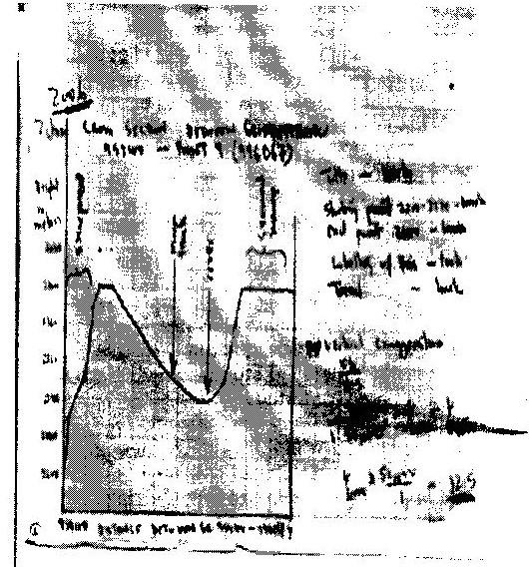

(iii)
c) • Rivers
• River valleys
• Scarp slope\escarpment\scarp face
• Gentle slope
• Seasonal swamp
• Woodland
d) i) Two types of physical factors that influenced the location of
Nyahururu town.
• Availability of water from the nearby rivers for domestic and industrial uses.
• The high altitude (over 2,300m) which makes the area experience cool climate ideal for settlement.
• Gentle sloping terrain ideal for settlement\road construction shown by contours wide apart.
• Presence of Thomson Falls which are a tourists' attraction and encourage settlement by construction of tourist houses.
• Availability of building stones from nearby quarry for construction of houses.
e) Describe drainage of the area covered by the map.
• The area has many rivers\ high density of rivers.
• The water courses are generally permanent.
• Some rivers end in swamps.
• There is a pond 020130.
• Main rivers includes Iguameti, Nyahururu.
• There are rapids at Thompsons falls.
• There is parallel drainage pattern along the escarpment.
• There are papyrus swamps and seasonal swamps.
• Rivers have denclintic drainage pattern.
3. a) 873m
b) Ans- 15 km ± 0.2 KM. (1 5km-1 5.2km)
c) Ans. -0 30"
d) Citing evidence from the map describe the relief of the area shown.
• Land rises from about 600m to about 2,200m above sea level.
• The highest point is Vuria peak at 2208 m \lowest point is about 600m.
• The landscape is generally hilly\numerous hills\mountains\ many ridges eg. Mugange hills ridges\Muraru ridge\ many spurs.
• There is a highland mass in the Mugange Wundanyi area which slopes downwards in all directions. ^{J}
• There is river valley of river Voi which has pronounced meanders.
• Some areas are plain e.g. Lower valley Kisushi.
• South-Eastern part is gently sloping.
• Central, Western and Northern side has steep slopes.
e) State differences between a map and a plan.
• The scale of a plan is large while the scale of map may be large or small.
• Plan is drawn to show specific information while map shows general information.
• Plan shows many details of specific feature while map shows few details of many features.
f) Explain two importance of scale in maps.
- Express relationships between objects on map and in real life enabling one to estimate or measure size.
- Control arrangement of symbols avoiding overcrowding.
- Controls space as large scale gives more details than the small scale maps.
4. (a) (i) 139° ± 1° (138 - 140°)
(ii) 7.2 km ± 0.1 (7.1 - 7.3 km)
(b) (i) Relief of the area covered by the map.
- The highest area is Nandi escarpment/187m above sea level.
- The lowest area is to the south West which is about 1140 m above sea level.
- The east is a plain\Kanu plain/plateau
- North western part is hilly with some steep slopes
- To the North Eastern is the Nandi escarpment
- The northern part is dissected by rivers
- The South-west is a basin occupied by a lake.
- There are numerous river valleys with steep sides in the highlands and are broad in the lowlands.
(ii) Influence of relief on settlements.
- The steep slopes/escarpment have been avoided because they are unsuitable for construction of houses/for farming.
- There are a few settlements on the hilly areas because the slopes are gentler.
- The plains are densely settled as the land is flat/gently sloping.
- The basin are avoided as the land is water logged/flooded/swampy.
(c) Economic activity Evidence
- Quarrying - Quarry
- Trading - Markets
- Transportation - Roads/railway/main tracks/foot paths
- Processing - Sisal factory
- Manufacturing - Ginnery/flour mills
(d) (i)
- The river has many meanders
- The river has tributaries/confluences
- The river disappears into a swamp
- The river has a wide flood plain
- The river is at its old age stage (ii) Advantages of studying rivers through field work.
- It enables students to relate what is learnt in classroom to what is in the field.
- Students are able to measure and calculate the velocity of a river and its size.
- Students are able to count the number of tributaries.
- Students are able to gauge the impact of the river on the area.
- They are to find out the uses of the river.
- It allows students to acquire appropriate attitude towards environment.
- It breaks classroom monotony for students and teachers.
- It allows students to use their observation skills to make conclusion.
CHAPTER 7
ROCKS AND MINERALS
1. (a) (i) Colour Distinct appearance by colour used to identify
specific minerals eg. Gold is yellow.
(ii) Cleavage Tendency of mineral to break in certain direction.
Some minerals break along planes on which atomic bonds are relatively weak.
(iii) Hardness Ability to resist scratching. Various minerals have
varying degree of hardness eg. Talc is softest while Diamond is hardest.
(b) (i) Hyperbbyssal rocks
- Volcanic rocks\extrusive igneous rock.
- Plutonic rocks/intrusive igneous rocks.
(ii)
• The water should be salty
• Water should be clear free from silt.
• Sea water should be warm with temperatures between 20°C to 29°C
• Shallow water with depth not exceeding 60m.
• Polyps must be in submerged condition.
• Water should be well oxygenated.
(c) • Some unique rocks e.g. crying stone of Kakamega present
spectacular scenery for tourist attraction which helps earn the country some foreign exchange.
• Rocks are parent material for soil formation exploited in agricultural activities.
• Valuable rocks and minerals such as gemstones and diamond are exploited to generate income.
• Rocks provide building and construction materials e.g. marble, ballast and sand used in construction of houses.
• Rocks are useful as raw materials in construction industry e.g. The coral rocks and coral limestone are used in manufacture of cement.
(d) • A folk jembe- excavating rocks for closer examination.
• A polythene bag -for carrying rocks samples for subsequent studies.
2. (a) • The rocks are formed from sediments of preexisting rocks.
• Rock sediments are arranged in layers.
• Processes involved act at ordinary temperatures
• Sediments are non-crystalline
• Some sediments contain fossils
• Sediments are compressed, hardened and consolidated by cementing material to form sedimentary rock.
(b) Give two examples of chemically formed sedimentary rocks.
Trona, gypsum, flint, rock salt
3. (a) In each case name the type of rock which results from the metamorphism
of:
(i) Granite
(ii) Clay
Granite → Gness
Clay → slate
4. (a) (i) Rocks are naturally occurring agglomerations of mineral particles
forming part of the earth crust.
(ii)
(a). Mechanically formed sedimentary rocks formed from deposition of sediments of other rocks in layers.
(b). Organically formed - formed from remains of dead plants and animals which are laid down to layers.
(c). Chemically formed - formed from mineral particles dissolved from tend and deposited in layers into water bodies.
(b) • Weight of averlying layers cause change in grain arrangement in
dynamic metamorphism.
• Heat of magma get into contact with sedimentary rocks causing
grains to crystallize or form new minerals.
• During mountain building rocks are compressed and heat generated in thermodynamic metamorphism causing changes in structure and recrystallization of minerals.
(c) i) Granite, diorite and peridotite
ii) Dolerite, porphyrite and diabase.
iii) Basalt, obsidian and pumice.
(d) i) Secondary sources
- Text books/pamphlets/journals/ periodicals/ magazines/ news papers/handouts.
- Photographs/pictures/video tapes/slides/films
- Maps/geological maps
- Tape recorded information
ii) Activities during the field study
- Drawing of sketches
- Observation
- Collecting rock samples
- Making notes
- Taking photographs
- Asking/answering question.
- Studying geological maps -
- Labelling samples
- Breaking rocks
- Digging to access rocks
- Filling in the table.
- Filling in questionnaires
- Tape recording
iii) Likely problems
- Inability to identify the rocks
- Inability to access the rocks
- Accidents/slipping
- Difficulties in climbing/descending steep rocks
- Hindrance by poor weather conditions/rainy/sunny
- Attack by wild animals.
5. (a) i) Plutonic rocks are igneous rocks which form beneath earth surface
when magma cool slowly forming large crystals\course grained/course textured.
ii) Volcanic rocks are igneous rocks formed on the earth surface when lava cool rapidly forming small crystals fine grained/textured.
6. (a) Conditions influencing characteristics of igneous rocks
• Mineral composition
• Mode of formation
(b) Characteristic of sedimentary rocks
• Arranged in layers/strata
• Non- crystalline
• Have bedding planes
• Contain fossils
(c) Limestone, chalk, coral reefs, ironstone, diatomite, coal.
(d) Original rock Metamorphic rocks
Limestone Marble
Sandstone Slate
Coal Graphite
Clay/shale Stale/schist
Mudstone Slate
Augite Hornblend
Granite Gneiss
(e)
• Some rocks forms uniqueness features which attracts tourists and helps to earn foreign exchange.
Rocks are parent material for soil exploited for agriculture.
• Valuable rocks and minerals are exploited to generate income.
• Provides building and construction materials e.g. sand.
• Source of raw materials for cement industry.
7. (a) Mechanically formed sedimentary rocks.
(i) Arenaceous - Sandstone and grit
(ii) Argillaceous - Shale, claystone, siltstone, loess, mudstone
(iii) Rudaceous - Congolomerate, breccia and boulder clay.
(b) Contact metamorphism is due to heat from magma which leads to changes in appearance and character while regional metamorphism is due to heat and pressure which creates changes in rock structure and minerals.
8. (a) Basalt obsidian, Pumice, tuff, ryorite, andesite.
(b) Intrusive igneous rocks are rocks formed when magma cools and solidifies below the earth's surface while extrusive are formed on the surface of the earth when lava has solidified.
Extrusive rocks - Basalt, obsidian
Intrusive - Granite, gubbro, diorite, perdotite, dolerite,
porphyrite, diabase.
9. A rock is an aggregate of mineral particles forming part of the earth's crust,
10. A mineral occurring inorganic substances with definite chemical composition and physical properties.
11. Heat and pressure - causes re crystallization of minerals. This creates new minerals. It also alters the structure of the minerals particles.
12. Calcareous rocks are formed from shells and skeletons of marine creatures. The shells skeletons accumulate in layers and are compressed to form hard correct mass.
13. Carbonaceous rocks are formed from remains of plants which are buried by overlying materials compacting them into hard mass.
14. Coral rocks results from accumulation of skeletons of coral polyps. The skeletons accumulates in layers to form hard compact mass (coral rocks).
15. • By being subjected to
• Pressure - dynamic metamorphism
• Heat - contact/thermal metamorphism
• Pressure and heat - thermal -dynamic metamorphism.
CHAPTER 8
MINING
1. Conditions that are necessary for the formation of petroleum.
• Presence/deposition of remains of flora and fauna fossils over a long
period of time.
• Presence of non porous rocks underneath the deposits of flora and fauna
• Deposition of other layers of rocks/ non -porous rocks over the remains of
flora and fauna.
• Compression of remain of flora and fauna due to folding of the layer of rocks.
2. (a) (i) Minerals mined in area marked
W - Fluorspar
X - Gold
Y - Diamonds
Z - Copper
(ii) • Alluvial mining
• Underground mining
• Open-cast mining
(iii) Sea ports through which some minerals mined in East Africa are expected through. -Mombasa, Dar-es-Saalam.
(b) Factors that influence exploitation of minerals.
• Modes of occurrence
• Economic value of the mineral/quality of the minerals/cost of mining.
• Size of the mineral
• Level of technology
• Availability of capital
• Labour supply
• Availability of transport facilities
• Government policy/political influence
• Availability of market
(c) Significance of soda-ash mining
• Creation of employment opportunities.
• Development of infrastructure.
• Development of related industries.
• Improvement of social facilities.
• Earns Kenya foreign exchange.
(d) • Planted trees
• Creating a park to attract tourists
• Introducing aqua culture
• Landscaping for settlement /farming
• Refilling
3. (a) • Gas
• Oil\petroleum
• Water
(b) • Wax
• Bitumen\pitch\asphalt
• Grease lubricants
• Resin\petrol-chemicals
4. Use the map of Africa below to answer the questions below.
(a) Name the minerals mined in the areas marked S, T and V.
S - Oil/Petroleum
T - Bauxite/Gold
V - Diamond
(b) State two formations in which mineral ores occur.
• Some minerals occur as evaporates.
• Others occur as veins/lodes.
• Some minerals occur as alluvial deposits.
• Some occur as weathered products.
• Some minerals are found in seam
(c) Explain four problems which Zambia experiences in the exportation of copper.
• Zambia is landlocked/ has no coastline hence copper has to pass through other countries to reach the seaport.
• The distance from Zambia to the coast is long which makes transportation of copper expensive.
• Political instability in the neighbouring countries makes it insecure to transport copper through them to the coast
• Congestion at the seaports causes delays in loading and off-loading of copper
• Loss of copper through theft while on transit deprives Zambia of the part of the expected revenue.
• Copper is bulky thus it can only be transported by rail which is slow.
(d) • Describe three negative effects of open cast mining on the
environment
• The land is left with gaping quarries which are ugly interfere with the natural beauty of the landscape.
• The heaps of rock waste hinder any other forms of land use/create a landscape that is expensive to rehabilitate/barren landscape.
• The dust produced during the mining pollutes the atmosphere/is a health hazard.
• Open cast mining causes shortage of land as it hinders settlement/leads to displacement/hinders agriculture.
• Large scale blasting of rocks leads to instability of the basement rocks.
• Water collects in the hollows left by open cast mines creating ponds which become habitats for disease causing organisms
• It interferes with the natural vegetation which is cleared before extraction of the mineral begins/takes time to regenerate.
5. (a) • A vertical shaft is dug to reach the mineral Tunnels are then dug
horizontally.
• The roof of the tunnel must be supported to prevent it from collapsing.
• The mineral is then removed by blasting using explosives.
• Its then brought to the surface using a lift.
• The mineral is then transported to the factory for processing.
(b) • It is an expensive method
• Accidents due to collapsing of mines.
6. (a) • Ugliness of the land.
• The open pits are health hazards once filled with water.
• The land losses productivity.
• Accidents are likely to occur especially children falling into pits.
7. • It involves digging out sand from river beats and swirling it around with
water in a shallow pan.
• This pan is tilted such that lighter sand is washed over leaving the mineral behind.
8. • Water shortage for power supply and processing
• Labour shortage
• Increased depth of mines
• Increased cost of mining
• Decreasing availability of ore
9. (a) • It earns the country foreign exchange
• It generate jobs to Kenyans
• Leads to uplifting of living standards
• Development of settlements e.g. Magadi town.
• Development of transport system
(b) • Causes scenery ugliness
• Pollution of dust, noise and overburden
• Dereliction of land
• Loss of land productivity which can lead to desertification.
10. (a) • It involves mixing the alluvial deposits with water in a container.
The mixture is rotated until light particles (sand, mud) are washed off
• Leaving minerals particles such as gold behind. This is called panning,
(b) Three mining methods
• Open-cast mining
• Underground mining
• Alluvial mining
11. • Occurrence It forms when rain water seeps down through volcanic
rocks which contain soda ash. The water is heated by underground hot rocks. This forces the water to move upwards into Lake Magadi.
Exploitation Its extracted using the dredger which floats on the lake. Pumps the mixture of trona and water to the factory on the shores through a pipeline. At the factory impurities are removed. This is heated and turned to soda ash ready for packaging and export.
12. • Earns foreign exchange
• Generates employment opportunities
• Development of settlements
• Lead to development of industry
• Earning higher income hence better living standards.
• Land dereliction
• Pollution
• Loss of biodiversity
• Soil degradation
• Enhancing mass wasting
13. Gold is found in quartz or redistributed sediments. Gold is extracted using the deep shaft method. Gold ore is crushed, dissolved and then precipitated to obtain the gold. Gold is used in making of jewellery and ornaments, in chemical industries, in density and for medals. Gold earns export revenue, has led to infrastructure development and provide employment. Rising costs of production, high labour costs and low quality gold are some of problems facing gold mining.

Diamonds are associated with volcanic activities. They occur in igneous rocks in pipes. The ore is blasted crushed and washed. It is then passed through filtering screen and then through a special solution. Diamonds are used in the jewellery industry, for polishing, for drilling, and for cutting instruments. Diamonds; earn foreign exchange, have led to development of towns, have created employment and contributed to development of infrastructure. The problems facing diamond mining to include exhaustion, unstable world market prices, high costs of processing and inadequate labour.
14. • Uses of soda ash
• Glass manufacture
• Paper making
• In oil refinery
• In textile industry
• In soap manufacture
FORM TWO
CHAPTER 1
EARTHS MOVEMENT
1. (a) - Vertical movement/ epierogenic
- Horizontal movement/ lateral/orogenic
(b) Describe the origin of continents according to the theory of continental drift.
• Theory first explained by F.B Tylor (91908), J.B Backer (1911) and adopted by German meteorologist Alfred Wegner in 1912.
• Says the present distribution of continents was due to disruption of super continent known as Pangea. Pangea was surrounded by a large super water body - Panthalasa.
• Pangea broke first into two continents i.e. Godwanaland and Laurasia.
• The two continents were separated by a long narrow ocean known as Tythys.
• Godwanaland broke further and drifted into southern contents of present Africa, South America e.t.c. while Laurasia drifted to present Eurasia, North America e.t.c.
2. • Earth movement are movements which occur within the crustal rocks due
to tectonic-forces.
• Internal land forming processed are those processes operating inside the earth. They are also known as endgenetic.
• External land forming processes operates on the surfaces of the earth. Also known as exogenetic.
3. Evidences of continental drift
• Geometrical fitting of Western coastline of Africa and Eastern Coastline of America.
• Similar plant and animal remains in different continents.
• Similarities in rock structures along coast of West Africa and Eastern South America.
• Evidence of glaciation in Southern continents which are formed from glaciated regions.
• Presence of coal in mild and high latitude regions coal is usually formed in tropical areas with dense vegetation.
• Similarities of fold mountains found in S. Africa and Argentina. Both in age and East -West trend.
4. • Plate tectonic theory suggests the earth is made of rigid blocks (plates)
floating of molten material.
• The plates are mobile.
• They move towards each other away from each other or parallel past each other.
CHAPTER 2
INTERNAL LAND FORMING PROCESSES - FOLDING
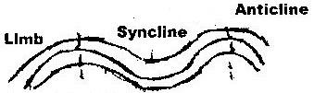
1 a)

b) Atlas, Dakenberg
2. a) Fold mountains in
    - Asia – the Himalayas
    - North America – Rocky Mountains and the Appalachians
    - South America – The Andes Mountains
b) i) Rolling plains, ridge and valley landscape, intermountain plateau,
inter-mountain basic, escarpments.
ii) Formation of over thrust fold.
      - Layers of rock of the earth’s crust are subjected to compression
forces.
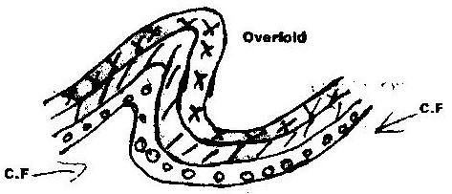
      - Intense compression results in formation of overfold

      - With increased pressure the overfold results in the formation of recumbent fold
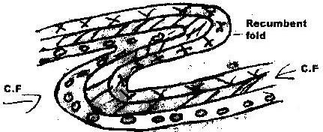

      - When pressure is very great a fracture occurs along the axis in the recumbent fold producing thrust plane.
      - The upper part of recumbent fold slides forward over the lower part along the plane resulting to the formation of an over thrust fold.
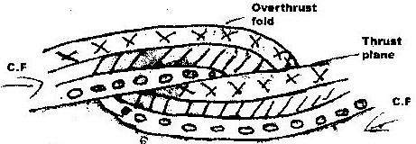

c) Effects of fold mountains to human activities.
    - windward side of fold mountains receive heavy precipitation which
    - Enhance agricultural activities / forestry.
    - Rivers which originate from fold mountains provide water which is used
    - For generation of HEP/irrigation/domestic and industrial purposes.
    - Some fold mountains have exposed minerals deposits which are exploited.
    - Fold mountains are important tourist attractions/snow capped mountains encourage sporting activities.
    - Fold mountains may act as barriers to transport and communication.
    - Topographic nature of the landscape may encourage/discourage agriculture/settlement.
d) i) formulate study objectives/hypothesis.
- Identifying methods of data collection/representation.
- Planning a schedule of activities
- Carrying out reconnaissance survey.
- Seeking permission from relevant authorities.
- Identifying/collecting/sorting out relevant equipments/tools for study.
- Drawing a route map
- Assembling relevant stationery
- Reading relevant information/literature review.
- Dividing themselves in groups
- Hold class discussions
ii) Gives first hand information on different types of land forms.
- Application of knowledge gained to real life situations.
- Development of various skills/ application of skills learnt.
- Help in familiarizing with the environment.
- Reduces monotony and boredom in the classroom.
- Provides in – depth/ broader learning
- Enables one to appreciate landforms
- Enhances visual memory of landforms better than the theory.
3. Orogenesis is the process through which Fold Mountains are build.
4. folding is the process of crustal distortion which causes the rocks to bend upwards
or downwards.
5. Compression boundaries – is one where plates move towards each other holding
or connecting line in a fold which rock layers dip or rise from opposite directions.
6. Limb – layers of rock on either side of the axis while axis is the central line in a
fold which rock layers dip or rise from opposite direction.
7. Foreland – is static block of land that is pushed in formation of geosyncline fold
while backland is block of land where forces originate that cause sediment in the geosyncline to wrinkle.
8. Fill in the table.
Orogeny | Years  (age) | Period | Mountains/features built.
Charnian | Oldest  600 million years ago | Pre- Cambrian period | -deccan plateau of India  -Laurentin shield of North Americ
Caledonian | Old 440 million years ago | Silurian period | -Akwapim Hills of Ghana  -Scottish highlands
Hercynian | Young 350 million years ago | Upper  Carbon  Ferrous  Period | -Cape ranges  -Appalachaian mountains  -Ural mountains
Alpine | Youngest 70 million years ago | Palaocene period | -Himalayas-Asia  -Rockies – USA  -Anses- S. America
9. Contraction theory.
According to the after earth had formed, the surface rocks of the crust cooled
faster than those in the interior. As the interior continues the cool, the surface
rocks wrinkled to fit on the contracting interior leading to formation of Fold mountains.
CHAPTER 3
INTERNAL LAND FORMING PROCESSES - FAULTING
1. a) Fault scarp
Tilt block
Block/horst mountain
b)
- Faulting disrupts lines of transport and communication
- Some features like Rift Valley form barriers which make establishment of transport and communication expensive.
- Faulting cause sinking of land which leads to destruction of property such as buildings and crops.
- Leads to formation of depressions which are filled with water to form lakes
- Unique features are formed which attracts tourists.
- Faulting exposes minerals making exploitation easier.
- Makes rivers to have waterfalls.
2 a) P- Horst
Q- Rift valley
R- Escarpment
b) Normal fault is fault resulting from tension in inclined place with
inclination of fault plane and direction of downthrow on same side while reversed fault is fault that results from compression forces where the one block is pushed upwards in relation to another forming up throw.
3. - Vertical faulting, across a river may cause waterfall/river rejuvenation.
- Rift faulting in an enclosed area may lead to formation of a depression which can be filled with water for form a lake.
- Some rivers flow along fault lines/fault guided drainage
- Uplifting of landscape which may cause reversal of direction of river flow
- Rivers may disappear to the ground through a fault line.
4. Pare, Usambara, Ruwenzori, Nyandarua and Mau Ranges.
5. - Block/ horst mountains are a source of rivers which provide water for
industrial/ agriculture/domestic use.
- Rift Valley formation has led to exposure of minerals such as diatomite, soda ash which are mined on rift valley.
- Mountains formed are barrier to moisture carrying wind leading to orographic rainfall which favours agriculture and settlement.
- Some Rift valley lakes are important fishing grounds/mining sites/provide water for irrigation
- Faulted features provide beautiful scenery which promotes tourism.
6. a) Layers of rocks are subjected to tensional forces.
Two normal fault develop
Middle block subsides between two side block
Middle part form depression called rift valley enclosed by escarpment

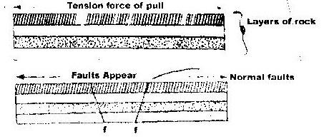

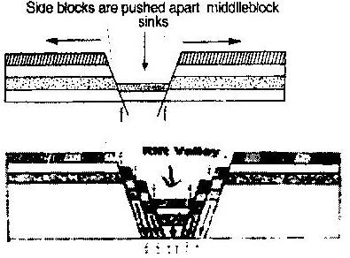

b) i) The importance of pre-visit
- To enable them to draw up study objectives hypothesis.
- To familiarize themselves with themselves with area of study/identify problems.
- To enable them prepare a work schedule plan of activities.
- To enable them identify/sort out relevant tools/ equipments for the study.
- To identify suitable methods of data collection.
- To seek permission from the occupants of the site of study.
- To enable them prepare financial requirements.
ii) Disadvantages of direct observation of the area.
- It is expensive
- It is time consuming
- It is tiresome
- It is limited to only direct sources/primary sources of data.
- It only suitable to sighted people
- Some features may be hidden out of view.

7.
- Normal fault
- Reverse fault
- Tear fault
- Anticlinal fault
- Thrust fault

8.
- Compression force tends to push rocks together.
- Lines of weakness develop and lead to formation of parallel reversed faults on the crustal rocks.
- Further compression thrust side blocks over middle block leaving it to form rift valley floor.
9.
- Nyandarua Range
- Lake Manyara escarpment.
- Nyando escarpment
10.
- Rift valley provides a spectacular scenery that attracts tourists earning foreign
- Mining of soda ash in rift valley generate export earnings
- Rift valley floor has fertile soils suitable for farming
- Rift valley lakes are suitable for fishing grounds.
CHAPTER 4
INTERNAL LAND FORMING PROCESSES- VULCANICITY
1. a) i) X-Laccolith
Y- Batholith
Z- Dyke
ii)
- Magma is forced along horizontal lines of weakness/ bedding
planes of rock strata.
- Instrusion of magma cool and solidify horizontally along bedding planes.
b)
- It has a vertical vent
- It is made up of alternating layers of ash and pyroclasts
- Conical in shape with steep sides
- May have crater on its peak or a plug
- It has sidevents
- Has parasitic cones/conelets
c)
- Volcanic ash and basalt on pouring provide fertile soils exploited for agriculture
- Occurrence of minerals such as fluorspar in Kerio Valley and Diatomite in Shinyanga are exploited to generate foreign exchange.
- Volcanic mountains act as water catchments areas from which major rivers and springs originate. The drainage features provide water for industrial and domestic use.
- Geoghermic areas which owe existence due to volcanic activities are tapped to generate electricity.
- Volcanic mountains form beautiful sceneries that attract tourists.
2 a)
- Formed when magma reaches the surface of the earth / or from lava through multiple vents/fissures.
- The lava is ultrabasic / extremely fluid of low viscosity.
- Lava flows over large area of distance and spread widely before cooling covering valleys and low lying hills
- Lava cools slowly forming an extensive plateau.
- Plateau may form through a series of eruptions which results in thick layers.
b)
- Some volcanic features create barriers making construction of transport and communication.
- The rugged nature of volcanic landscapes makes settlement and agriculture difficult
- Volcanic mountains create rain shadow effect which result too aridity.
- Recent volcanic lava flows have poorly developed soils which are unsuitable for agriculture.
- Volcanic eruption may produce poisonous gases which pollute the environment posing danger to life.
c) Ash and cinder cones
- Fumaroles/solfatara
- Hot spring/geysers/stream jets
- Crater caldera
- Volcanic cones
- Lava plateau
3.
- Hot springs/geysers/steam jets
- Craters/calderas/crater lakes
- Volcanic mountains
- Ash and cinder cones
- Fumaroles/sofatara/Muffette
4. Explain four negative effects of vulcanicity in Kenya
- Some volcanic features create barriers making construction of transport and communication lines difficult.
- Rugged nature of volcanic landscape make settlement and agriculture difficult
- Volcanic eruption may produce poisonous gases which pollute environment thus posing danger to life.
- Volcanic eruption may produce poisonous gases which pollute environment thus posing danger to life.
- Volcanic mountains create rain shadow effect which result in aridity on leeward side.
- Recent volcanic lava flows have poorly developed soils which are unsuitable for agriculture.
5.
- Forms from lava when magma reaches surface of each through fissures.
- Lava is ultra basic or extremely fluid or low viscosity.
- Lava cools slowly forming extensive plateau
- Plateau may further continue to form through series of eruption that follow
- Examples: Kaoutu, Yatta, Laikipia

6. A still is near horizontal /tabular sheet of igneous rock formed from solidified magma between bedding plane while a dyke is a sheet of intrusive rock which cut near vertical/discordantly across bedding plane.
7. Vulcanicity is the process of eruption/escaping of magma/through which gaseous,
liquid/molten and solid materials are intruded in to the earth’s crust or are extruded onto the surface.
8.
- Crater lake
- Outpouring of lava forms a volcanic cone.
- The vent may be sealed when lava solidifies in it.
- This leads to building of pressure below the plug.
- This leads to explosion of cone leaving depression on top.
- Water from rain or underground source accumulates in the depression.
- Examples: L. paradise on Mt. Marsabit, crater lake in Central Island of L. Turkana, L. Sonachi on South west of Lake Naivasha, Lake Simbi Nyamia in Nyanza.
9. Formation of Mt. Kenya
- Due to earth movements, the rocks of the crust were disturbed leading to formation of a vent.
- The underlying molten rock escaped through a central vent to the surface /volcanic eruption occurred
- There were violent eruptions which ejected acidic lava that cooled and solidified.
- These lava piled in layers around the vent.
- The resultant mountain was cone shaped
- Over the years, eruption ceased and the volcano became extinct.
- Erosion set in exposing the plug and produced the jugged peaks of the mountain.

CHAPTER 5
INTERNAL LAND FORMING PROCESSES - EARTHQUAKES
1. a)
- The Mercalli scale
- Rossi foren scale
b)
- Collision of tectonic plates
- Energy release in the mantle
- Violent volcanic eruptions
- Nuclear explosions
- Gravititive pressure
- Magma movement within the crust
2. c)
(i)
- Earthquake is sudden movements or tremors of the earth crust.
(ii)
- Primary waves
- Seconday waves
- Rayleigh waves
- Love waves
(iii)
- Rocks of the earth crust are displaced laterally.
- Earthquake causes uplift or subsidence of land.
- Earthquakes can rigger off landslides on the surface of the earth crust
- Earthquakes can lead to faulting of the crustal rocks.
- Earthquakes can lead to volcanic eruptions
3. a)
- Collision of tectonic plates
- Energy release in the mantle
- Violent volcanic eruptions
- Nuclear explosions
- Gravititive pressure
- Magma movement within the crust
b)
- Effects of earthquakes in built up areas
- Loss of life (human, animal and plant)
- Disruption of transport and communication lines.
- Outbreak of fires
- Avalances and landslides may occur covering build up areas
- Tsunamis may drown coastal settlements
4.
- Magma movement within earth crust
- Isostatic adjustment resulting in breakage of rocks
- Sudden explosions e.g Nuclear testing.
5.
- The strength of an earthquake is measured by its intensity and magnitude. Intensity measures how hard the earthquake hits the ground.
- Intensity is measured using Mercalli scale. Magnitude measures amount of energy given off. It is measured using Ritcher scale.
6.
- Damage to property
- Loss of human life
- Can cause landslide
- Disruption of infrastructure.
7.
- Seismograph is an instrument which detects and records seismic waves of earthquakes while seismogram is a graph-like record on which earthquake impulses are recorded.
8.
- Intensity measures how hard earthquake hates the ground. It looks at the effects while magnitude measure amount of energy released during an earthquake.
9. i)
- Written materials/books/magazines/newspapers.
- Maps
- Photographs/films/videos/slides (Visual aids)
- Resource persons
- Electronic media-radio, TV (Audio aids)
ii)
- Inaccessibility of the area due to massive destruction/restriction.
- Lack of informers because people may have been evacuated
- The rubble may obscure the evidence of the amount of damage.

CHAPTER 6
PHOTOGRAPHIC WORK
1. The photograph below provided shows a tea growing are in Kenya use it to
answer question (a) and b)
i) What is the evidence in the photograph that this is a ground general photograph.
- It focuses on all/ many objects.
- It does not focus on particular object.
- The objects become progressively smaller towards the background.
- Photograph captures the general appearance of the area.
ii) Draw a rectangle measuring 15cm by 10 cm to represent the area of the photograph on the sketch and label the main features shown on the photograph.
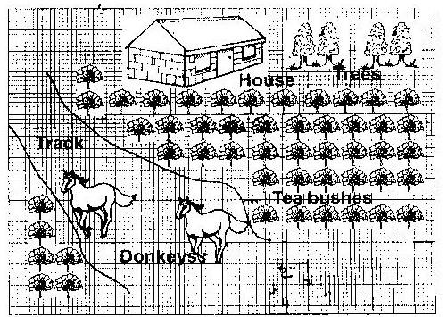

iii) The stages involved in cultivation of tea from land preparation to the stage shown in the photograph.
- The land is cleared of vegetation
- The land is ploughed /tilled.
- Seedlings are planted in nursery and allowed to grow to 20 cm.
- Seedlings are planted in rows which are about 1.5 metres apart.
- The plants are weeded and manure / mulching applied regularly.
- Once the bushes start growing. The tips of branches are oruried regularly to encourage plant to form more branches.
- The crop is harvested every two weeks once it attains maturity.
- After harvesting, the green tea leaves are transported to the factory within 24hrs.
iv) Identify two features from the photograph that shows that this is a small scale tea farm.
- The simple houses
- Mode of transport by use of donkeys
- Untrimmed edges of tea bushes
- Dry maize stalks near the houses.
2. Ground general photograph.
3.
- Flowers
- Horticulture/horticultural farming
- Fruits/vegetations
- Rift valley province
- Fruits/Vegetables

4.
- Inaccessible feeder roads
- Inadequate refrigeration facilities
- Improper marketing system
5.
- Netherlands/Switzerland
- Germany
- Britain
- France
6.
- Escarpment
- Hills/mountains
- Valleys
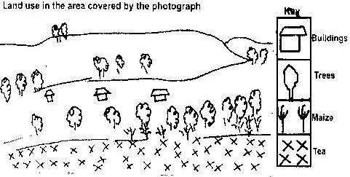
7.

CHAPTER 7
CLIMATE
1. a) Climate is the average weather conditions of atmosphere of a place for a
long time usually 30 to 35 years.
b)
- Disruption of natural ecosystems due to ecological changes that affect existence of some organisms and resources.
- Abnormal fast growth of plants due to increased carbon dioxide
- Flooding from rising sea due to melting or anteretic ice.
- Increased rainfall to between 7% and 11% annually due to increased rate of evaporation.
- Severe draughts due to reduced rainfall.
2. a) 28⁰C – 24⁰C = 4⁰
b) -1803 mm
c)
- The town experiences high temperatures throughout the year.
- The annual range of temperature is small about 4⁰C.
- The rainfall pattern has double maxima.
- The wettest month is June/the driest months are December and January.
- The total annual rainfall is high 1803mm.
3. a) (i) Polar climate
(ii) R - Canary current
S - Gulf stream current
b)
- High temperatures all year about 27⁰C
- Low diurnal range of temperature of approximately 6⁰C
- High rainfall of between 1500mm and 2000mm throughout the year.
- High humidity due to high rainfall and high evaporation
- Major winds are S. east and North East trade winds
- Thick cloud covers throughout the year.
- Rainfall is mainly convectional accompanied by thunderstorms
- Long hours of sunshine.
- Low atmospheric pressure.
c)
(i) How altitude influences climate.
- Temperature decreases with increase in height above sea level. This is because atmospheric air is denser at low altitude than high altitude.
- There is grater heat loss at high altitude due to few obstacles to interfere with outgoing terrestrial radiation hence low temperatures.
- Air pressure is higher in the lowlands due to greater weight of air above.
ii) Distance from the sea
- During summer cooler winds from the sea are onshore and modify temperature of
- The coastal land.
- During winter the sea water which is relatively warmer than land brings warming effect to the coastal land therefore modifying temperature.
- Onshore winds carry a lot of moisture from the sea bringing rainfall to coastal lands.
4.
- Characteristics of natural vegetation associated with equatorial climate.
- The natural vegetation is equatorial rain forest vegetation.
- Growth of this vegetation is due to high rainfall well distributed throughout the year.
- Forests consist of tall trees with straight and smooth stems. The trees reach great height of 40 metres because of competition for sunlight.
- The trees form canopy.
- Forest is characterized by close growth of trees of different species.
- Trees have broad leaves drip-tip in shape.
- Many trees have buttress root system mainly for support.
- Forest is evergreen
5.
- Five characteristics of hot desert climate
- Low annual rainfall less than 250mm/dry climate.
- Occasional flash floods/sporadic rains
- Clear sky/clear sunny days/high terrestrial radiations.
- High temperature during the day.
- Relatively low temperatures during the night/high diurnal range.
- Strong winds
- Low humidity
- High evaporation
- Unreliable rainfall
6. How following factors influence climate:
i) Wind/air masses
- Warm winds bring warming influence in the cool lands leading to warming effects
- Areas under influence of dry winds have little or no rainfall while areas under moist winds are usually wet.
ii) Latitude
- Areas near equator are hotter than areas far away from equator. This is due to concentration of sun rays per unit area at the equator.
- Amount of solar radiation and temperatures decreases polwards
7. Climatic conditions experienced in the Kenyan highlands.
- Region receives rainfall throughout the year
- Total rainfall ranges from 1000mm to 1500mm
- The region has double maxima in east and single maximum in west
- Rainfall is higher on the windward slopes than on leeward slopes
- Rainfall is higher on the windward slopes.
- Rainfall is caused mainly by S.E trade winds.
- Average temperature ranges between 17⁰C to 24⁰C.
- Area receives mainly relief rainfall.
8.
- Because of aspect slopes facing the sun are warm than slopes falling the opposite direction.
- The mountains cause anabatic winds which have a cooling effect on hill side during the day. Valley bottoms katabatic winds brings effect during the night
- Reduction of air pressure with increase in altitude
- Occurrence of relief rainfall on windward side as an influence of relief.
9. Green house effect is a condition where incoming solar radiation passes through
the atmosphere while outgoing terrestrial radiation is blocked by gases and clouds in the atmosphere. This makes earth to retain much of terrestrial radiation therefore becoming warmer.
10. Climate change due to human activities
- Burning of fossil fuels
- Forest and grassland fires
- Industrial and agricultural development.
11. Clearance of vegetation reduces disposal of carbon dioxide from the atmosphere
by photosynthesis. Due to inadequate vegetation that would otherwise utilize CO₂ in photosynthesis, there is build up of excess carbon dioxide gases in the atmosphere leading to global warming.
12. Climate- is the average weather conditions of a place or region which have been
observed for long period of time usually 30-35 years.
13. Isothermal layer – is a layer within atmosphere within which temperature remains
constant despite increasing height.

CHAPTER 8
VEGETATION
1. d) (i) Measure distances/estimation of heights of plants
- Collect sample of plants
- Draw sketches/transects
- Record/take notes
- Take photographs of plants/area
- Count plants
- Feeling the leaves
- Conduct interview
(ii) How to identify different types of plants
- By appearance
- Their colour
- By their leave size/patterns/type
- By their age
- By the nature of their bark
- By texture of their leaves
- By their system of the roots
- The type of fruits.
2. a) (i) W- Rainforest
X- Bamboo
Y-Health and moorland

(ii)
- Savanna vegetation consists of trees and grass
- Wetter areas/near forests the vegetation consists of tall trees similar to those found in forests and woodlands
- Wetter areas have tall thick grass.
- Gradually away from the forest, the trees become fewer and shorter
- Grass is shorter in drier areas
- In drier areas the trees are short and more scattered.
- Some trees are deciduous type
- Most trees are umbrella shaped
- Most common trees are acacia and other thorny trees.
- Where the rainfall is lowest grass is tufted and coarse/trees scrub
- There are scattered baobab trees and other drought resistant trees.
- Along river valleys there is riverine vegetation and thick bush.
(iii) Canada-Prairies
Russia- Steppe
Australia-Downs
b)
- Fire- Often large areas of forests are destroyed by fires and take long to recover.
- Diseases and pests attack mainly the planted forests causing many trees to die.
- Human activities/settlements/charcoal burning/logging have destroyed many forest areas.
- Over exploitation leads to depletion of certain tree species such as Meru oak, Campor and Elgon teak. These trees take long to manure.
- Government policy of degazetting of some forests made people free to clear many forested areas.
- Prolonged drought leads to degeneration of forest some of which take long to recover.
3. a) Natural vegetation is the plant cover which is growing wildly on its own.
b)
- The vegetation is adapted to long, hot dry summers.
- Some plants are evergreen
- Grasses dry up during summer and germinate during winter.
- Woody scrub is common in very dry areas.
- Some plants have small, spiny leaves while others have thick skinned or leathery leaves.
- Some plants have long roots.
- Some plants have thick barks
- Some plants have large and fleshy bulbous roots.
- Some trees are deciduous.
4.
- Campaigns against indiscriminate cutting down of trees/educating people/ reducing overgrazing.
- Establishment of vegetation/forest reserves
- Restriction on cutting down of trees
- Development of energy saving technology to reduce high consumption of wood fuel
- Use of alternative sources of energy
- Encouraging the planting of more trees to reduce reliance on existing ones
- Establish Nyayo tea zones to act as buffer zone.
5. (i) Variation in rainfall
(ii) Variation of temperature
(iii) Variation of altitude/relief.
(iv) Aspect
(v) Soil
(vi) Human activities
Variation of rainfall
Areas that receive high rainfall are forested while those receiving low rainfall have grassland vegetation.
Variation of altitude/relief
Vegetation varies with height above sea level (e.g. montane in high altitude) as altitude influence climate and soil.
Aspect
Areas on leeward slopes of Mountains have different vegetation from thick growth of vegetation in the windward side because they receive different amounts of sunshine and rainfall.
Soil
Sandy soil/swamp soil/saline soil influence growth of different types of vegetation. Vegetation on slopes is determined by soil catena.
Drainage
Vegetation is as luxuriant along water courses/along coastal flats because surface water supply is reliable/waterlogged areas support swamp vegetation.
Human activities
Settlement/mining/ farming interferes with the original vegetation leading to growth of secondary / derived vegetation/desertification.
Wild animals
Destroy vegetation leading to secondary type/desertification. They aid in seed dispersal.
6. State two reasons why mountain top have no vegetation.
- Temperatures are too low to support plant growth.
- There is no soil to support plant growth/bare rock.
- Water is in frozen state.
7. Vegetation refers to plant life on earth surface.
8. Areas where coniferous forests are found.
- Cool temperate continental climate/Siberian type.
- Cool temperate eastern margin- Laurentian type.
- West coast of Canada.
- Scandinavian region
9. Characteristics of temperate grasslands
- Trees are scarce except along water courses.
- In moist areas the grass is tall.
- Where it is drier there is short tough grass
- Grass withers in autumn and dries up in winter but sprouts during spring.
- Presence of scattered trees
- Common trees are acacia
10. Secondary vegetation comprises natural processes colony on a place which is in the process of receiving due to interference by man while planted vegetation comprises of plants grown in a place by people e.g. agro forestry.
11. Two significance of vegetation to physical and human environment.
- Vegetation is of aesthetic value as it adds beauty to landscape.
- Vegetations roots binds soil together protecting soil against erosion
- Plant decay to form humus adding fertility to soil.
a) - Ground close-up
- Acacia vegetation
b) - Thorny like leaves to reduce rate of water loss.
- Have long tap root to tap underground water
- Plant seeds remain dormant awaiting short rains.

CHAPTER 9
FORESTRY
1. a)i) Is science of planting caring and using trees/forests and their associated
resources or the practice of managing and using trees/ forests and their associated resources.
ii)
- The area receives high rainfall/1000 mm-2200mm throughout the year which
- encourages continuous growth of trees.
- The area has deep fertile volcanic soil that allow the roots for penetration deep
- into the ground support trees.
- The area is a gazetted reserve prohibiting cultivation and settlement hence
- allowing growth of trees
- The steep slopes discourage settlement thus forests thrive.
iii)
- The government policy of degazetement has allowed illegal cultivation and settlement in forest areas.
- Increased population of elephants that destroy trees
- Prolonged droughts have caused drying up of some trees.
- Plant diseases and pests destroy parts of forests.
- Over exploitation of certain species of trees
b)
- Legislations aimed of curbing encouraging public to participate in conservation of forests.
- Legislations aimed of curbing encroachment in forested areas.
- Encouragement in frosted areas
- Encouraging public to participate in conservation of forests.
- Setting up of buffer zones to hinder human encroachment into forested areas (Nyayo Tea Zones)
- Creation of forest reserves
- Encouraging agro-forestry
- Setting up presidential commission with the mandate of rehabilitation destroyed forested areas.
c) Give the difference in exploitation of softwoods forests in Kenya and Canada under following sub-headings.
i) Period of harvesting
ii) Transportation.
Period of harvesting
- In Kenya harvesting is done throughout the year while in Canada harvesting is in winter and early spring.
Transportation
- In Kenya transportation is mainly by road transport while in Canada transport is mainly by water transport.

- To ensure continuous supply of wood fuel, timber and raw materials for paper
industries.
- To protect soil from being carried away (erosion)
- To protect water catchment areas
- To create room for conservation of wildlife
- To create employment opportunities
- To reduce importation of forest products thus saving foreign exchange
- To promote scenic beauty.
2.
- The low temperatures limit other land use activities making forestry a good
alternative.
- The thin infertile soils due to keep glacial erosion limit agriculture and favours
- forests
- Adequate precipitation throughout the year
- Many rivers with waterfalls provide HEP used in the timber related industries
- River provides cheap transport and water needed in the processing purposes.
- An extensive ready market for forest products in Canada and U.S.A.
3.
- Meru Oak
- Elgon teak
- Cmphor
4.
- Furniture making
- Wood carving industry
- Construction
5.
- Mature trees felled are replaced immediately.
- Tree farming is practiced in many parts with the aim of raising trees for future use.
- Regions which previously were devoid of trees are being planted with trees
- People are now being encouraged to plant trees and food crops in the same farms.
- The reduction of wastage e.g. the use of waste paper to produce newsprint.
- The reduction of wastage e.g. the use of waste paper to produce newsprint
- People are required to seek permits if they have to cut trees. This reduces the rate of trees felling/unlicensed people do not cut down trees.
- The forest reserves are patrolled by guards to ensure that fires are reported promptly and also to ensure unlicensed people do not cut down trees.
- Forest reserves have been set aside to conserve indigenous species.
- Forestry department of the ministry of natural resources carry out research to produce and distribute seedlings to ensure the extension of forests.
- People are being educated through mass media on the importance of trees
- People are being encouraged to use alternative sources of energy/energy saving jikos.
6.
- There is a wide variety of trees species in a given area. This makes the exploitation difficult and expensive
- The buttress roots make the felling cumbersome
- The dense underground/thick forests and quick generation of plants hinder accessibility, exploitation difficult
- The heavy rainfall throughout the year results in muddy roads which makes transportation difficult.
- Inadequate capital limits the use of modern techniques in the exploitation of the forests.
- The demand within the region/markets are discouraging exploitation/expensive to transport/difficult to transport.
- River transport is hindered by waterfalls/rapids. This makes transport expensive.
7.
- Aridity that has reduced area under forests
- High population leading to clearing of forests for settlement
- Over exploiting of forests resources e.g timber fuel.
- Government policy of resettling people in forested areas.
- Forest fires which have contributed to destruction of forests.
- Pests and diseases which destroys trees.
8.
- Desertification
- Soil erosion/degradation
- Extinction of some tree species
- Decline in employment for those in forestry related areas
- Loss of plants with medicinal value
- Loss of aesthetic value
- Decrease in wild animals
9. Factors favoring forestry in Kenya
- Cool climate especially in the Kenya highlands.
- Fertile soils-Volcanic soils within the Kenya highlands and Rift valley.
- High precipitation ranging between 1000-2000 which favours growth of trees.
- Rugged landscape in some areas which discourages settlements and agriculture leaving growing of trees as the only alternative
- Varied altitude which favours growth of different types of trees due to varied temperatures and rainfall.
- High demand of forest products
- Creation of forests reserves which enables forests to develop without interference from humans
10. Secondary products of forests-Ply woods, Venner, fibre board, paper, wood, carvings wine, tannins
11. Mahogany, ebony, ironwood, rosewood, green heart, goarea, mahure, supele, duhuma, African walnut, camphor, palms.
12. a) Agro-forestry involves cultivation of both crops and trees.

b)
- Provides sources of firewood and charcoal
- Source of income to farmers after selling tree products like fruits
- Trees act as wind breakers
- Trees create micro climate within the farm
- Some trees are of medicinal value
- Trees leaves decomposes to form fertile soils

FORM THREE ANSWERS
CHAPTER 1
WEATHERING
1 a)(i) Weathering is disintegration/breaking down and decomposition of rocks in
situ due to exposure on the surface while mass wasting is down slope movement of weathered material under influence of gravity.
(ii)
- Climate changes
- Relief/topography
- Nature of rock
(iii)
- Pressure of expanding roots in cracks cause rocks to disintegrate.
- Plants like algae release organic acids on rock causing its decay.
- Linchens, mosses maintains rock moisture which facilitates chemical weathering.
2 a)
- Exfoliation
- Block disintegration
- Slaking
- Crystal growth
b)
- Hydrolysis
- Oxidation
- Solution
- Carbonation
3. a) Is the physical break up or disintegration of rock material without any
alteration in the chemical composition?
b)
- During the day suns’ heat in arid areas cause surface layers of rock to expand.
- At night the low temperatures result in cooling and contraction of outer layers
- This occur repeatedly
- Rocks with poor heat conductivity do not transmit heat to the inner rock.
- Expansion and contraction causes stresses within outer parts of the rock,
- Eventually shell of outer rock layer peal off from main rock mass.
- This leaves behind a rounded-off mass known as exfoliation dome.
4. Five processes;
Hydrolysis
This is the process where chemical reactions takes place between hydrogen ions in water and minerals in a rock.
Hydration
This is the process where some minerals in a rock take up water and expand causing stress in the rock. This causes the rock to fracture.
Solution
This is the process where some rock materials dissolves in water and are washed away in solution. This leaves behind a weak rock.
Carbonation
This is the process by which rainwater with carbonic acid dissolves calcium carbonate in rocks. This leaves behind a weak rock.
Oxidation
This is the process in which oxygen in the air reacts with iron compounds in the rocks. The ferrous state of iron minerals changes to ferric state which weakens the rock.
5. Pressure release/unloading
Exfoliation
Block disintegration
Crystal growth
Slaking
6. Climate changes
Relief/topography
Nature of rock
Vegetation cover plants
Action of humans and animals
7. Denudation is the wearing away/sculpturing of land surface by processes of weathering/mass wasting/transport and erosion.
8. a) Block disintegration
b)
- A well jointed rock is subjected to intense heating during the day and cooling during the night.
- The rock minerals expand due to heating and contract as a result cooling during the night.
- The rock minerals expand due to heating and contract as a result of cooling
- The joints enlarge due to alternating expansion and construction of the rock mass.
- When this occurs repeatedly the rock mass eventually break into blocks along joints hence the name block disintegration.

CHAPTER 2
MASS WASTING
1. a)
- Amount of precipitation and extent of saturation.
- The gradient of the slope
- Human activities such as mining.
- Occurrence of earthquakes and faulting
b) i) Rock fall
ii) P-cliff face/steep slope/scarp slope
q-Talus/rock debris/boulders
2.
- Due to temperature changes soil particles expand and contract hence shift position down slope.
- Moisture/rain water cause soil to become wet and compact. On drying the particles loosen and shift position down slope.
- Moisture acts as lubricant to soil particles causing their movement down slope.
- Removal of soil on the downhill side makes the rest of soil to shift down slope.
- Human activities/action of borrowing animals may cause the removal of soil on lower part of slope. This triggers soil particles on the upper part of the slope to shift down slope.
- Freezing of soil water expands the space between soil particles. Once water thaws particles fall by gravity shifting position down slope.
- External forces e.g moving a trigger effect which causes downwards movement of soil particles.
3.
- Soil creep pushes posts and fences from their original positions
- Displacement of soil particles down slope leaving steep upper slopes bare
- Burry roads and railways making repair expensive
- Causes slope retreat
- Leads to formation of terrace
- Leads to formation of terrace
- Leads to formation of deep fertile soils down slope which favours agriculture
4. Mass wasting:
This is the down slope movement of weathered materials under the influence of gravity.
Mass movement:
This is the down slope movement of weathered materials after lubrication by water.
5. Soil creep:
Movement of fine soil down a gentle slope. It is the slowest movement and quite hard to notice.
Talus creep:
Slow movement of angular waste of rock of various sizes down a cliff, hill, scarp and mountain side.
Solifluction: gravitational flow of surface materials saturated with water.
6.
- Very steep slope these accelerate the rate of movement.
- Very high rainfall which makes the materials to be extremely fluid and the ground to be generally unstable.
- Tectonic movement such as earthquakes and faulting.
- Human activities e.g mining or removal of soils at the base of slopes making the upper layers unstable.
7. Evidence of soil creep includes:
- Joint blocks of distinctive rocks types are dislodged from the outcrop
- Edges of strata seem to bend in the down hill direction.
- Fences posts and telephone poles lean downwards and even shift measurably out of line.
- Retaining walls of road cuts lead and break outward under pressure of soil creep from above.
- Accumulation of deep soil at the base of slopes while the upper slopes are left bare.
- Bare and exposed steep upper slopes due to soil displacement
- Slope retreat
- Bent tree trucks.

CHAPTER 3
THE HYDROLOGICAL CYCLE
1. a) E - Surface run-off
F - Evaporation
G - Condensation
b) A watershed is a ridge line boundary line separating drainage basins or
river systems while a catchment area wetland which a river draws its water.
2.
- Heavy rainfall /high intensity of rainfall/
- Low rate of evaporation
- Sloping ground/steep slopes
- Presence of vegetation/bare surfaces
- Saturated soil surfaces.
3. Is the endless circulation of water from earth’s surface to the atmosphere as moisture or water vapour and back to the surface of the earth as rain or snow with source of energy being the sun.
4. Type, amount and duration of rainfall e.g light showers in long duration reaching the ground facilitate infiltration as apposed to heavy rain in showt duration
Nature of slope- Level land hold water on ground long enough to infiltrate than on steep slope where run-off is accelerated.
Level of soil saturation-Infiltration is greater in areas with lower water table and lower soil water than in higher water table with high amount of soil water
Soil type- Coarse grained soil allow greater infiltration than fine grained compact soil
5 a) Refer to all water held in form of ice in storage on the earth surface.
b)
- Provide underground water
- Ecological balance
- Formation of clouds
- Oxygen and carbon dioxide cycles
- Occurrence of leaching which is soil forming process.
6. Dew, mist, fog snow, snow, frost
7. Type, amount and duration of rainfall e.g. light shower reaching the ground gently will facilitate infiltration as opposed to heavy storm which encourage run off.

The duration the rainfall takes also determine the rate at which it infiltrates i.e. longer shower enhance infiltrates while short heavy storm encourages run off.

Nature of the slope: flat land holds water onto the earth surface longer hence encourages infiltration but when the land is sloppy surface, run off is accelerated.

Amount of water already in the soil e.g the lower the water table, the lower the chances of run off; but the higher the water table, and amount of water in the soil, the higher the surface run off.

Vegetation cover: Where vegetation is thick, the rate of run off would be reduced because the rain drop impact will be reduced. A lot water will be retained through interception hence lower rates of surface run off.

Soil type: Course-grained open textured sandy soil have higher infiltration rate than fine grained compact soil. This reduces run off. Likewise, deep uniformly permeable soil have extensive infiltration hence lessens the chances of overland flow.

Environmental factors e.g where the rate of evaporation exceeds the rate of infiltration, surface runoff is minimized (if other factors are treated constant) but where the rate of evaporation is lower overland flow will be higher.

Human activities: This can control runoff deliberately by construction of reservoirs acting like natural water bodies.

In urban areas, surface sealing by concrete and bitumen accelerates surface runoff.

Agricultural practices can also modify runoff through contour farming and levee construction which will store water and increase both infiltration and evaporation at the expenses of runoff.
8.
- Reducing the rate of deforestation and increasing afforestation and reaforestation programmes so as to facilitate transpiration process
- Activities which can cause global warming such as releasing chlorofluorocarbons in the atmosphere should be reduced so that water held in the cyrosphere can still be maintained and used as storage in future
- Avoiding excessive harvesting of sand on river beds.

CHAPTER 4
ACTION OF RIVERS
1. a)
- Birds foot delta.
- Estualine delta
- Aruate delta
- Cuspate delta
b)
- River must have a large load of sediments
- absence of filters like lakes or swamps in the river’s course
- Rate of river deposition should be faster than rate of erosion by tides and waves.
2. a) (i) P- Deposition
Q- Erosion
(ii) R- Bluff/cliffs
(iii)
- In a stream, water flows in meandering motion.
- The motion sweeps the current to outer bank where lateral erosion/undercutting occurs and deposition occurs in the inner bank.
- This leads to formation and enlargement of a meander
- Subsequent cutting through the neck of the meander by the stream establishes a new channel
- The abandoned cut-off meander channel forms a crescent shaped lake-ox-bow lake
b)
- Gentle sloping/flat surface
- Has levees
- Has deltas/distributaries
- Has meanders
- Land is fertile-alluvial deposits
- Has mashes/swamps
- Has braided channels
- Presence of ox-bow lakes
3. a)
- Increased discharge because of increased rainfall increases erosive activity of the river
- A fall of sea level leads to river renewing its head ward erosion. Starting from the new base level.
- Uplift of land causes a stream to increase its erosive power
- Changing rock resistance from hard to soft along the river course reactivates rivers erosive power.
b) X- Resistant rock
Y- Plunge pool
Z- Rock boulders/rock pebbles.
4.
- Some particles are carried in suspension because they are light and can be maintained within turbulence of water.
- Some load is dissolved in water and carried in solution.
- Some particles are heavy and are momentarily lifted by turbulence of the water and then dropped onto the river bed by saltation process.
- The heavy particles are rolled along the river bed through process known as traction.
5. i) Dedritic pattern resembles a tree trunk and its branches. The tributaries
join the main river at acute angles.
Trellis pattern comprises a main river with tributaries joining at right angles. The minor tributaries also join the main tributaries at right angles.
ii) Trellis pattern comprises a main river with tributaries joining at right angles. The minor tributaries joining at right angles, the minor tributaries also join the main tributaries at right angles.
iii) Central petal pattern comprises rivers which flow into a common inland basin or depression such as a lake or swamp.
6. a)
- Gradient of the river channel which determine river energy.
- The nature of bed rock whereby soft rocks would be more eroded.
- Volume of the water which affects river ability to erode.
b)
(i) Define river rejuvenation
Refers to the revival of rivers’ erosive energy.
(ii)
- Incised meanders
- River terraces
- Knick points
- Rejuvenation gorges
7. a) River basin: The entire system of the river including tributaries and
Distributaries
b) Water shed: A boundary line separating neighbouring river basins. It’s also called river divide.

c) Catchment area: the entire area from which the river draws its water.
d) river regime: this is the seasonal variation of the amount of water in the
river channel or the variation of the quantity of water (discharge) passing down a stream.
8. a) Inland delta is formed at any part of the river course before it reaches its
mouth e.g Niger delta in Mali and Okavango delta in Botswana, while an alluvial fan is deposit composed of silt, sand, gravel and boulders found at a point where a river enters a plain from high land e.g. Ewaso Narok fan on river Ewaso Narok in Kenya, kilombero alluvial fan in Tanzania and lumu alluvial fan in Uganda.
b) Estuarine delta: develops at the mouth of a drowned river e.g Zambezi and
volta river deltas
An estuary is a mouth of the river which drains its water in the ocean in one complete channel e.g. river Zaire in democratic republic of Congo

c) A bluff is a blunt, low embankment on the bank of the river as a result of
recession of interlocking spurs due to lateral erosion.
A river cliff is an overhanging undercut river bluff (river bank) due to lateral erosion.
d) Levees and river banks
Levees are temporal raised river banks made of sand deposits on the flood plains between which a river flows. A river bank is an elevated land alongside a river which may either be vertical or sloping towards the river.
e) River valley and river channel
A river valley includes both the cross and long profile of a river including
all the associated features from its source to its mouth, while a river channel is the narrow groove or furrow through which a river flows.
f) Paired terraces and unpaired terraces. Both are associated with river
rejuvenation (renewed erosion of river to cut new channels). Paired terraces have valley levels on the opposite side with equal elevation while in the case of unpaired terraces benches on the opposite sides do not match.
g) Drainage pattern and drainage system. A drainage pattern is the layout or pattern made by the river and its tributaries on the landscape whilst a drainage system develops where rivers either flow in accordance or discordance to the existing rock structure and slope.
h) A misfit river and deferred river
A misfit river is one whose water has been pirated by another powerful river flowing adjacent and on a lower ground.
A misfit river is also referred to as an under fit or beheaded stream. A deferred river is a tributary that flow for long distances parallel to the main stream before joining it due to the presence of the levees.
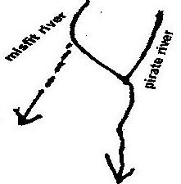

A misfit river and deferred river are shown in the diagram below.
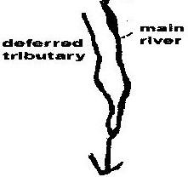

i) Antecedent drainage and superimposed drainage.
Antecedent drainage is a drainage system where a river maintains its course while the surrounding land is uplifted.
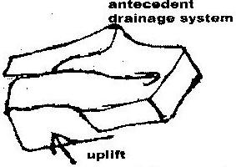

In superimposed drainage a river valley is developed on the former cover of rock which have been exposed and have a completely different structures
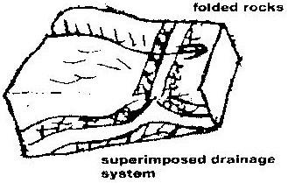

9.
- Abrasion
This is the wearing down of river bed and sides by use of the load carried by the river. The load is hurled by water against the banks and dragged along the bed acting as a scouring tool.

- Hydraulic action
High force moving water removes loose materials e.g. gravel. The water scoops out rock particles.
10. a)
- The river is in youth stage
- The main function of the river at this stage is erosion
- The main features of the river includes:
- Water fall
- Rapids
- Gorges
- Potholes
- Interlocking spurs
b) i) The river is in mature stage
ii)
- Main function of the river are erosion and deposition though lateral erosion is more dominant than vertical erosion.
- Main features of the river includes.
- Wider valleys with an open v-cross section
- Gentler river gradient, wider valley floor
- River bend begins to appear
- Concave banks standout as river cliff while
- Convex banks becomes slip off slopes
- Interlocking spurs changes to bluff due to gradual removal by lateral erosion
c) i) The river is in the old stage
ii)
- The main function of the river is deposition
- The main features of a river at this stage include;
- Meanders and ox-bow lakes , natural levees and deferred tributaries, Incises meanders and terraces, Braided channels, Flood plains, Deltas and tributaries, Very gentle gradient, Shallow broad and flat valley.
11.
- River provides water for irrigation this has enhanced food production of the local people in the areas where the river passes.
- River provides route ways e.g. the navigable rivers. This has facilitated easy transport and communication between any area served by the river
- River provides sand which is a building material. People can put up permanent structures and this has changed their lifestyles
- Rivers are sources of alluvial soil. These deposits of river soils form rich agricultural land e.g. along the Tana river valley. This has increased food production hence better living standards.
- Rivers form natural boundaries between communities, districts provinces or countries. Such boundaries have helped in settling disputes related to land at the borders
- During floods, rivers destroy properties and human life. This has led to migration of people to higher ground and inadequate development of physical infrastructures such as permanent housing, roads e.t.c.
- Rivers are tourist attraction features. The revenue earned through tourism where there are rivers is a source of income to the local inhabitants, and hence the revenue raises therir standard of living
- Rivers provide fishing ground. Fish which is a rich source of protein is used to supplement other food resources such as meat. This ensures a healthy population devoid of diseases such as kwashiorkor.
- Communication barrier some river form barrier between communities making communication difficult e.g communities making communication difficult e.g. communication between Lamu and Tana river district. The local therefore have to use alternative longer routes which is expensive and time consuming.
- Water borne diseases: In rivers where water is almost stationary many water borne diseases are a problem. These diseases may include river blindness, malaria and bilharzias. The treatment of this diseases is difficult and very expensive
- Rivers provide site for hydro-electric power generation. The lifestyle of locals in other benefits which comes along with power generation. This may include trade, urbanization; better road and communication network this has led to improved living standard.
- Rivers provides port facilities. The presence of ports also offers employment opportunities to peoples within the region.
- This has enhanced the living standard in the region e.g port of Mombasa.
- Rivers supply water for both domestic and industrial use. The construction of industries in the area is also a major source of employment to locals hence improvement of standards of living.
12. a) Vertical aerial photograph
b) I. Arcuate delta
II. Birds foot delta
c) - Presence of large load/ample supply of load.
- Absence of strong waves/Currents in the sea/lake.
- Decrease in the velocity/speed of river
- Presence of gentle gradient
- A shallow shore at the river mouth.

CHAPTER 5
LAKES
1.
- Erosion
- Volcanic
- Tectonic movement
- Deposition
2.
- Earth movements caused crustal warping
- A basin was formed
- Uplift of land masses/back-tilting of plateau around the depression diverted the flow of rivers into the depression by reversed drainage.
- Deposition into the depression resulted into further down warping
- Water from the rivers accumulated in the depression forming a lake.
- Water from the rivers accumulated in the depression forming a lake.
3.
- The lake breezes have a cooling effect on the surrounding areas
- The high rate of evaporation from the lake leads to formation of convectional rainfall in the area.
- Moistures from the lake leads to an increase in the amount of rainfall received in the area
- Evaporation from the lake leads to increase in the relative humidity of the lake region.
4.
- Lakes formed due to earth movements such as faulting and down warping.
- Lakes formed due to vulcanicity such as when water occupies crater
- Lakes formed due to glaciations e.g tarns.
5. a) Formation of lake Victoria:
Lake Victoria was formed as a result of warping and tilting of the earth
crust. During the drainage evolution process, the western part of the depression was uplifted to form a Ruwenzori and middle part down warped Rivers like Yala, Nzoia, Mara, and Kuja were cutoff and started pouring their water into this depression to form lake Victoria.
b) Formation of lake Tanganyika: lake Tanganyika was formed as a result of
faulting. During the formation of the rift valley some parts of the valley were deeply faulted to form long narrow hollows. When water accumulated in this hollow, Lake Tanganyika, which is faulted or Rift Valley Lake was formed.
c) formation of lake Chala: Lake Chala was formed when water
accumulated in the crater of a volcano.
d) Formation of lake sare is a lagoon that formed at the shore of Ugowe Bay
in Siaya District. Action of long shore drift deposited materials across the by which cutoff part of Lake Victioria to isolate the water mass to form a lagoon new lake Sare.
e) Formation of Lake Kivu; Lake Kivu is a lava dammed lake. It was formed
during the eruption of virunga volcanoes which blocked the west rift. One of the tributaries of river Zaire was dammed to form Lake Kivu.
6.
Eastern | Generally fresh
- Generally alkaline  - Have no out lets except Naivasha and Baringo  - Short narrow and deep | - Generally fresh  - Have outlets  - Long and deep

7. Significances of lakes in East Africa
- Sources of fishes e.g lake Victoria turkana
- Hydro electric power production e.g. owenfalls on Lake Victoria
- Irrigation purposes e.g Lake Naivasha
- Transport e.g. Lake Victoria source of water for both domestric and industrial use e.g. Lake Victoria
- Sources of rivers e.g. Lake. Victoria is source of river Nile.
- Tourist attraction e.g Lake Nakuru and Elementaita
- Source of minerals e.g. soda ash at Lake Magadi
- Building materials e.g sand from Lake Victoria
- Modifying climatic condition of the environment e.g Lake Victoria
- Reaction purposes e.g. Lake Turkana
- Habitat for destructive animals e.g. crocodiles and snakes in lake Shakababo
- Destruction of properties and displacement of people e.g Masinga dam due to flooding.
CHAPTER 6
OCEANS, SEAS AND THEIR COASTS
1. a) H-Lagoon
J-Island
K-Tombole
L-Spit
b)(i)
- A gently sloping shore.
- The shore should be shallow
- The breaking waves should have a strong swash and a weak backwash.
- Waves should carry a large load of materials to be deposited.
(ii) Processes involved in marine erosion.
Hydraulic action
- Breaking saves/swash hits against cliff shattering the rock
- The force of breaking waves compress air into the cracks/joints in the cliff face. This enlarges the cracks and part of the rock break off.
Corrosion/Abrasion
- The rock fragments carried by the waves are used as a tool to erode the cliff as the wave break at the cliff face.
- The material/ load carried by the backwash erodes the sea floor.
Attrition
- The searing down of particles/loads as they continuously hit against each other and against the cliff
Solution/corrosion
- The solvent and chemical action weakens and removes the minerals found in the cliff and sea-floor where there are limestone rocks.
c) (i) Objectives to formulate for the study.
- To assess/find out the importance of depositional features.
- To identify different types of depositional features.
- To find out how the features were formed
- To establish how features are distributed along the coast
- To establish how features are distributed along the coast
- To find out the materials that make up each of the depositional features
- To find out how constructive wave break at the shore.
ii) Methods to use to record the information collected
- Photographing/video taking/filming
- Tape recording
- Taking notes
- Sketching/drawing
- Filling tables Tallying
2. a) Submerged highland coasts
Submerged lowland coast
b) i) Hard rocks carried by waves increase the erosive power of the
waves as they hit against the Coast.
ii) A coast made of soft rocks wears away easily when subjected to sea waves.
3. Rise in sea level/eustatic change in base level/positive eustatic change.
Depression of coastlands/submergence of coastlands.
4. Fjords/fyord
Rias/creeks
Islands
Estauaries
5. Coastline is the line reached by the highest storm water and demarcated by a cliff.
6. Destructive waves are waves which have strong backwash and weak swash
leading to enhanced erosion and less deposition.
7. Erosion features include:
- Cliffs -Blowholes
- Caves -Arch
- Geos -Stacks
- Stump
8.
- Cliffs are formed by action of destructive waves
- These waves start by cutting a small notch or hollow on the rock face called a notch.
- As soil erosion continues a notch is enlarged.
- The upper section collapses due to its own weight forming a cliff.
9.
- A steeply sloping coast is subjected to sea waves
- Due to wave attacks a notch is formed.
- When the upper side of the notch collapses a cliff develops
- Continued undercutting of the cliff makes the cliff to collapse and to retreat inland
- As cliff retreats it leaves behind a rocky floor which slopes gently towards the see (wave-cut platform)
10.
- Emerged coast
- Submerged coast
- Coral coast
11. a)
- Formed from tiny marine organisms called coral polyps
- Coral polyps live in colonies
- They extract from sea water, calcium and use it to build protective shells
- When they die their skeletons pile together and are commented together by calcareous algae to form a ridge like rock parallel to the shore called coral reef.
- Coral reefs include fringing reefs barrier reefs and a toll.
b)
- Rias have been used to develop habours
- Most resultant land forms are tourists attractions sites
- Some Rias are habitat for marine life which promotes fishing industry
- Coral rock is a raw material for cement industry
- Most of landforms have promoted education and research.
12.
- Shingle beaches are beaches made up of unsorted particles of shells, mud, stones and sand particles of various sizes. Such kind of beaches allow backwash to infiltrate into the beach.
- Sand beaches-these are beaches made up purely of sand. But since sand is compact they don’t allow easy infiltration of water into the ground.
13.
- Ria coast
- Fiord coasts
- Dalmatian coast
14.
- Horizontal movement
- Vertical movement
15 a) A- Stack
B- Arch
C- Cave
b) Abrasion and wave action attacks the pre-existing lines of weakness at the
base of headland leading to formation of a hollow.
The hollow is enlarged to form a tunnel like chamber known as cave.

CHAPTER 7
ACTION OF WIND AND WATER IN ARID AREAS
1. a) (i) X- horns
(ii) Y- Eddie currents
(iii) Z- Steep leeward slope
b) Traction
Suspension
Surface Creep
2. a) (i) Processes through which wind erodes the surface.
-Deflation
-Abrasion
-Attrition
ii) Ways through which wind transports its load
Suspension
- The fine dust particles are lifted and suspended in the air
- Eventually they are blown away by wind currents
Saltation
- Larger fragments/sand particles are lifted from the ground by eddy
actions
- They are moved in a series of hops/jumps by wind currents
Surface creep/attraction
- The heavy materials /small stones/pebbles are dragged along the
ground by wind currents
b) (i) How oasis is formed
- A pre-existing depression formed through faulting or otherwise is
exposed to wind erosion
- Wind eddies remove unconsolidated materials through deflation
- As deflation continues, the depression is deepened and enlarged.
- The process of deflation is aided by weathering
- With continued deflation, the level of the water table is reached.
- Water oozes out of the ground collects into the depression to form a lake known as oasis.
ii) Zeugens
- Zeugens are formed in desert areas where alternating horizontal layers of hard and soft rocks occur
- The top layer of hard rock is jointed/has cracks.
- Weathering opens up the joints
- Wind abrasion erodes the joints deepening them to reach the soft layer of rocks
- Abrasion continues, farrows are formed and gradually widened
- The hard/resistant rock forms ridges separating the fallows
- This process creates a ridge-furrow landscape
c) (i) Ways through which students would prepare for field study
- Reading from the relevant written materials.
- Assembling relevant tools/equipments/materials for the study.
- Formulating hypothesis/objectives
- Grouping /appointing group leaders
- Planning a schedule of activities
- Carrying out reconnaissance
- Studying /drawing a route map
- Identifying methods of data collected
ii) Information that would be collected through observation of the arid
area.
- Sparse vegetation/large patches of bare soil
- Sparse settlements
- Presence of drought resistant crops
- Stunted trees/tufts of grass
- Dust storms/land storms
- Evidence of wind erosion/deposition
iii) Measure s to be recommended for controlling desertification.
- Planting of trees
- Controlling overgrazing
- Avoiding bush fires
- Controlling tree cutting
- Practicing appropriate methods of cultivation/planting cover crops
- Irrigation/mulching/terracing/strip cropping/contour farming
- Gabion construction
3. Abrasion- Wind picks loose weathered, material and transports them. During
the course of transportation the material scrubs other tock surfaces it comes into contact with.
4.
- Zeugen
- Rock pedestal
- Yardangs
- Deflation hollows
- Mushroom blocks
5. - Occurs in alternating soft and hard layers
- The hard layer is underlain by soft layers
- Weathering breaks the hard cap in the well joined rock.
- Wind abrasion deepens and widens the joints to produce a landscape of
furrows and ridges
- The ridges are called zeugens
6.
- Barchans
- Seif dunes
- Transverse and wake dunes
- Loess
- Drass
7. - Sheet floods develop on gently sloping surfaces surrounding upland areas
- On steep sided and undulating landscape flash floods cut out rills which
are then enlarged to form gullies.
- Continues erosion of gullies enlarges them to form a steep sided rocky valley
or ravine known as wadi.
8. Differentiate between suspension and saltation
Suspension
Fine particles are carried within the turbulence of wind while in
Saltation
Saltation- Medium size particles are tolled along the group and when they
collide they bounce off into the air and cause other particles to be lifted in the air.
9. Name four types of desert surface
- Erg desert
- Reg desert
- Hamada
- Badlands
10. i) Abrasion- materials carried by wind scours/grinds against the desert
surfaces leading to removal rock particles.
ii) Deflation- strong winds blows away dry unconsolidated materials.
iii) Attrition- Heavy materials carried by wind hits against each other leading to reduction of size facilitating their transportation.
11. a) Suspension – fine and light materials are picked by the wind and carried within the air turbulence.
Saltation – medium sized materials are transported through a series of hops and jumps along the surface.
b) - Wind speed and force
- Nature of the load
- Presence/absence of obstacles
- Weather changes
12. Bajadas- Bajada starts with formation of alluvial fans when alluvial cones
coalesce along the edge of a depression
The margin leads to formation of gently surface.
Due to erosion, land mass waste a high area recedes
The retreating mountain leave a gentle sloping rock known as pediment.

13. i)
- Sparse vegetation/large patches of bare soil
- Sparse settlements
- Presence of drought resistant crops
- Stunted trees/tuff grass
- Dust storms/sand storms
- Evidence of wind erosion and deposition features.
ii)
- Planting trees
- Controlling tree cutting
- Practicing appropriate farming methods-strip, cropping, mulching, gabion construction.

CHAPTER 8
UNDERGROUND WATER
1. a) P – Clint
Q - Grike
R - Jointed limestone
b) Rain water dissolves carbon dioxide in the atmosphere to form weak
carbonic acid.
Acid rainwater falls on jointed limestone rocks.
The reaction forms calcium bicarbonate which is soluble and easily
disintegrated.
2. - The surface rock and the rock beneath should be thick limestone or dolomite
- The rock should be hard and well jointed
- The climate should be warm or hot
- Rainfall should e moderate to high
- The water table in the rocks should be deep below surface.
3.
- The rock has thin soils which discourage agriculture
- Inadequate surface water for domestic use
- Surface is rugged hindering construction of houses and infrastructure
- Presence of underground caves which may collapse.
4.
- Influence formation of spring.
- Occurrence of permeable rock on top of an aquifer: A spring will
develop at the point where the two meet.
- Existence of a well joined rock; water is absolved through the joints and
eventually spring out where the water table meets the surface.
- Dyke cutting across a layer of permeable rock:
The water on the upper slope of the dyke is impounded which causes the water table to rise and causes springs where the water table meets the surface.
5 a) Effluent streams are underground streams in limestone areas which are fed
by a water table above their level while influent streams are underground streams which are fed by the water table lying beneath their bottom.
b) Artesian basin is the statum in the earths crust in which one or more
acquifers are sandwiched between impermeable rock strata from a permanent water holding facility while an artesian well is a wll dug in the basins to tap water.
6. -Grikes
-Clints
-Sink holes
-Dolins
-Uvalas
7. Stalactites are finger like underground masses of calcite hanging vertically
from the roof of a limestone cave.
8. - Limestone regions are very good for grazing purpose especially for
sheep because soil is thin and the surface is dry.
- The Karst landscape is characterized with intermitted streams or
absence of streams leading to scarcity of water supply in these regions.
- Limestone is extracted for use in industries e.g Building industry,
iron and steel industry.
- The features such as gorges, caves and burns form good tourists
attraction.
CHAPTER 9
GLACIATION
1. a) Is large continuous mass of ice which covers vast areas of lowland
b)
- Initially ice collects in shallow hollows on the mountain sudes
- The hollows are enlarged by the plucking action of the ice to form cirques
- More ice accumulate in the hollows leading to further erosion
- The cirques recede until a knife edged rock called arête separates them.
c) (i) S- Medial moraine
T-Lateral moraine
V-terminal moraine
(ii) - Alluvial fans and outwash plain have fertile soils exploited
for agriculture.
- Fiords coastline provide good fishing grounds because they
are deep and shelted.
- Lakes and rivers from channels for development of route ways
- Rivers provide water for domestic and industrial uses.
- Some features attract tourists earning foreign exchange
2. a)(i) Is a mass of ice of limited width which moves outwards from a central
area of ice accumulation.
(ii) Valley glaciated mountain while ice sheets are large expanses of ice
covering large areas of permafrost land.
3. a) P- Pyramidal peak/horn
Q- Arete
R- Hanging valley

b) -A pre-existing U-Shaped valley is filled with ice/glacier.
-The glacier erodes the valley by abrasion or plucking
-The end of spurs are truncated/cut
-Ice melts away leaving behind a U-shaped valley
4. a) Formation of pyramidal peak
- Ice exerts pressure on the hollows
- Plucking actions of ice enlarges the hollow allowing more ice to collect
in them.
- Freeze-thaw action leads to expansion of cracks/hollows making them
large basins.
- Moving ice plucks off loose rock materials from the basin enlarging them
further.
- Nivation eats into the back wall of basins making them recede into the
mountains side
- Steep-sided knife edged ridges are formed separating the basins.
- Three or more these ridges/arêtes converge at the mountain top forming a
jugged peak known as pyramidal peak/horn.
b) Significance of upland glaciated features to human activities.
- The upland glaciated valleys are suitable for livestock farming
- Glacial upland areas forms magnificent features that encourage recreation
and tourism.
- Glaciated mountains encourage the growth of forests hence lumbering is
practiced.
- Waterfalls formed in glaciated uplands provide suitable sites for hydro-
electric power production.
- U-shaped valleys form a natural route way
- Flooded coastline form deep well sheltered natural harbours/good fishing
grounds.
c) i) Why it is difficult to carry out field study of glaciated feature.
- Climbing the mountain is difficult due to rugged terrain.
- Features are found far from the schools/settlements
- Time may be inadequate
- Poor weather conditions i.e. rainfall and low temperatures
- Thick forest and dangerous animals which makes it difficult to
access such areas.
- It is difficult to conduct a previsit
- Avalanches
ii) How students would use the photograph of Mt. Kenya to identify
the glaciated features.
- By dividing it into parts
- By observing and identifying the features in each part of the photograph
- By recording the features observed
- By drawing sketches of the features observed
- By labeling the features observed.
5. A snout is the lower part of glacier where it begins to melt while a snow niche is a smaller niche mass laying on a steeply sloping hollow, gulley or bench in the high mountains.
6. - Lewis glacier (between Lenana and Nelion)
- Tyndall Glacier (North of Lenana peak)
7. It is caused by Glacier as it erodes vertically and laterally. The sub-glacial moraines scrub the floor while the lateral moraine scrubs the walls. The trough is thus broad, flat bottomed, and steep sided with a U-shaped cross-section.
8. It is a permanent cover of ice on the land surface extending to a small area of
land
9. Pyramidical peaks e.g Lenana, Batian, Nelion Cirques e.g Teleki tarn, Hobley
Gorges, Aretes
10. It is a shallow pre-glacial depression that has progressively enlarged. A patch
of snow produces alternate freezing and thawing on rocks around the margins
which then cause them to rot and disintegrate. Melt water helps to remove the
resulting debris thus forming nivation hollow.

CHAPTER 10
SOIL
1. a)(i) This is the arrangement of soil layers along a mountain slope from top to
bottom.
(iii) - Soils are thin/shallow
- Have low organic content
- Soils have low moisture content
- Soils are rich in calcium/alkaline
c)
- In savanna areas there is alternating wet and dry season
- During wet season, mineral salts in the horizon A dissolve in the percolating
- rainwater.
- The dissolved minerals are precipitated/deposited in the lower layer. This process is called eluviation.
- Insoluble minerals such as iron and aluminium accumulate in A horizon/top layer to form a crust known as laetrile
- During dry season illuviation occurs. Soluble minerals are dissolved in the capillary water and moves upwards to horizon A.
- Evaporation occurs on the horizon A.
- Minerals are precipitated near/on the surface to form crust.
2. a) Loamy
Clay
Silty
Sandy
Gravel
b) -Humus help to improve soil porosity
-Humus improves the moisture retention capacity in the soil
-Humus improves soil texture
-Humus provides essential minerals in the soil
3. - Soil accumulation of rock particles, minerals, organic matter, water and air
found on the surface of the earth.
- Is the superfacial layer of loose/unconsolidated rock material overlying on crustal rocks and on which plants grow.
4.
- Zonal
- Intrazonal
- Azonal
5.
Take place through to stages namely mineralization and humification mineralization is the biological and chemical breakdown of dead plant tissue by soil micro-organisms to produce simple soluble organic substances. This is the initial stage of decomposition.
Humification is the second stage of decomposition where the dead plant material which had been mineralized are regrouped into large molecules to form humus.

6.
- Leaching process common in arid areas.
- Soils are leached upward through capillarity
- In some areas this leads to formation of thin salty crust or the surface
7. Zonal order soil is a type of soil classification which group together soils which
have undergone long time of soil formation process under good drainage conditions.
8.
- Planting cover crops
- Ploughing along contours
- Practicing crop rotation
- Controlled grazing
- Agro forestry
- Mulching
- Adding fertilizer
9.
- Is a severe leaching process
- Is limited to middle and high latitude areas
- The climatic conditions are too cold that bacteria action is inhabited while moisture is sufficient enough to allow large green plant to grow.
- Humic acid produced from a abundant leaf mould and humus, leach the upper soil strongly of bases, colloids and oxides of iron and aluminum leaving composed largely ash gray as soil horizon of silica.
CHAPTER 11
AGRICULTURE –CROP FARMING
1. a)
- High temperatures throughout the year temperature range of 20⁰C to 30⁰C.
- High rainfall that is evenly distributed throughout the year 1500mm to 2100mm,
- High relative humidity of 80% to 90%
- Plenty of sunshine during the ripening season.
b)
- Competition from other oil vegetables
- Poor road network
- Production of low quality oil
- Reduction of low quality oil
- Reduced production that has lowered the amount of oil exported.
2. b) Describe the stages involved in cultivation of tea from land preparation to
the stage shown in the photograph.
- The land is cleared of vegetation
- The land is ploughed/tilled
- Seedlings are planted in nursery and allowed to grow to 20cm
- Seedlings are planted in rows which are about 1.5 metres apart.
- The plant are weeded and manured/ mulching applied regularly.
- Once the bushes start growing. The tips of branches are pruned regularly to
encourage plant to form more branches.
- The crop is harvested every two weeks once it attains maturity
- After harvesting. The green tea leaves are transported to the factory within
24hrs.
c) (i) Name two districts in Eastern province where tea is grown
-Embu
-Meru North
-Meru South
-Meru Cental
(ii)
- Organizes farmer education days/ provides extension services for the farmers at
a low prices
- Buying farm input in bulk and sells to farmers at low prices.
- Providing credit facilities to the farmers to enable them purchase farm inputs
- Collecting the green leaves and delivers the factory on behalf of farers
- Establishing factories where the green tea leaves are processed
- Undertaking the marketing of tea on behalf of the farmer.
- Improves feeder roads to ease transportation of green leaves
- Conducts researches on tea crop varieties/diseases/pests in order to produce
high yield tea/ better quality tea.
3. a) -High temperatures/24.30⁰C.
-High rainfall/1,200-1,500mm.
-Well distributed rainfall throughout the year.
-Deep, well drained, fertile soil/volcanic/light clays
-High relative humidity
-Shade from strong sun rays for seedlings/young plants
-Shelter from strong hamattan wind.
-Undulating lowlands/below 750m above sea level.
b) -Fluctuation of prices in the world market
-Competition from other land uses.
-Inadequate labour during harvesting
-High production costs
-Competition from other beverages like coffee, flowers, fruits, vegetables
4. a) -Temperature ranging from 14⁰C – 26⁰C
-High rainfall 1100mm - 2030mm per year.
-Well distributed rainfall throughout the year
-Gently sloping landscape.
-Deep, fertile, well drained soils
b) -The crop is attacked by pests and diseases
-Fluctuation f coffee prices in the world market
-Poor infrastructure
-Mismanagement of coffee co-operatives
-Inadequate rainfall
-Inaccessibility of credit/inadequate capital
-Poor marketing strategies
-Low payments
5. a) (i) -Central
-Rift Valley
-Eastern
(ii)
- Moderate rainfall/500mm to 1270mm to enhance the growth of
wheat.
- Temperatures ranging from 15⁰C to 20⁰ C/warm conditions to
facilitate growth/maturity of wheat.
- A warm /dry /sunny spell for ripening and harvesting.
- Fertile volcanic soils to sustain high production
- Gentle sloping/undulating landscape to allow proper drainage/mechanized cultivation.
b) i) Storage
- In both Canada and Kenya wheat is stored in grain silos.
- In Canada wheat on transit is stored in huge grain elevators/special
car boxes while in Kenya it is stored in sacks.
ii) Transport
- In Canada wheat is transported by railways (CPR and CNR), roads and waterways while in Kenya it is transported by roads and railways.
iii) Market
- In Canada whet is for both local and export markets while in Kenya wheat is for local market
- Canada has a larger and reliable local market than Kenya.
- Kenya wheat sold through NCPD or directly to the millers, Canada sold by government/individuals.
c) i) Climate problems that affect wheat farming in Canada.
- Low rainfall/Unreliable rainfall which leads to carop failure
- Low temperature/long and cold winters which limit outdoor
activities/delays cultivation of wheat.
- Frost which destroys wheat leading to low yield.
- Hailstones which destroys wheat leading to low yield
- Strong winds causes soil erosion especially affects ploughing
resulting to loss of fertile soils
ii)
- Uses of wheat
- Used as animal feed
- Used as human food
- Used for brewing/distilling alcohol
- Used for making adhesives/glues
- Used for paper and straw boards.
d)
-Nakuru -Samburu
-Uasin Gishu -Trans Mara
-Narok -Nyandarua
-Trans nzoia -Keiyo
-Laikipia -Mt.Elgon
e) -Alberta
-Saskatchewan
-Manitoba
f)
- Wheat growing in Canada is more mechanized leading to higher production than in Kenya
- More capital is available in Canada enabling farmers to sustain production
- Farmers in Canada are more experienced due to long history of wheat production than in Kenya
- Advanced scientific research in Canada enables the production of higer yielding seeds/better farm inputs/control of pests and diseases/overcome limitations of weather
- Wheat farmers in Canada specialize in wheat production while in Kenya, farmers practice mixed farming
- In Canada, there are more extensive tracts of land suitable for wheat growing than in Kenya.
6 a)
- Cool/warm climate/10⁰C to 18⁰C throughout the year.
- High rainfall/100-2000 mm per year
- Well distributed rainfall throughout the year
- Areas that are frost-free
- Deep, light and well-drained soils
- Gently sloping/undulating land
- Acidic/volcanic soils
- High altitude/1200 mm -2300 mm
b)
- Delayed payments/low payments that lower the morale of the farmers.
- Mismanagement /embezzlement of funds thus farmers are discouraged
- Poor feeder roads in the tea growing areas lead to delays in collection/delivery of the green leaf hence wastage.
- Adverse weather conditions such as long droughts/hail storms lead to destruction of the crop.
- Fluctuation of prices in the world market makes it difficult for the farmers to plan ahead.
- High production costs due to high prices of farm inputs leads to lower yields since most farmers cannot afford to buy them
- Pests/ Fungal diseases destroy/reduce yields
- Inadequate /unreliable transport facilities delay the collection/delivery of green leaf reducing the quality.
7. a) W- Kapenguris
X- Kericho /Kisii
Y- Meru/Embu/Nyeri/Kirinyaga/Mt Kenya region
b)
- Expansion of tea growing areas and the establishment of the Nyayo tea zones.
- Increase in the number of small-scale tea farms in the country
- Improved marketing strategies through KTDA
- Expansion/increase in the number of tea factories.
c)
- When the bushes are ready only the two top leaves and a bud/flush are picked
- The green leaves are transported in airy baskets to a collecting centre for weighing.
- The weighed leaves are transported by lorries fitted with bags to the processing factories. The leaves are weighed again at the factory.
- The tea leaves are spread out on long wire trays.
- The leaves are then dried by blasts of warm air from beneath the trays.
- The dry leaves are passed through a set of rollers to chop them/the leaves are crushed.
- The leaves are placed in containers for fermenting reducing tanning acid and changing the above to grey-brown.
- The leaves are passed through a conveyor belt which takes them to a tunnel which is a temperature of 100⁰ C for roasting after which they turn black.
- The leaves are sifted for grading /lasted for classification.
- The graded tea is packed in tea sets for export and small packages for local market.
8. Cocoa growing areas
-Kumasi
-Tokoradi
-Accra
9.
- High rainfall 1200-1500 mm per year
- High temperature throughout the year 24-27⁰C
- Deep soils which are well drained
- Shelter from strong sunrays
- Plenty of labour force during harvesting
- High relative humidity 70-90%
10. Types of commercially cultivated coffee.
  - Arabica
  - Robusta
  - Liberia
11. Ways through which Brazilian government responds to problems facing coffee
industry.
    - The government has established an institute for the permanent defence of coffee. The institute manipulates the amount of coffee released to the international market thus creating artificial shortages consequently maintaining high prices.
    - The government lobbies for higher quota in the international market
    - The government has been encouraging crop diversification/mixed farming by introducing annual cops such as sugar cane and soya beans in the coffee growing areas to reduce over dependence on coffee.
    - When the prices are low the government buys coffee from farmers and stores it thus stabilizing the prices for the farmers.
    - To solve the problem of overproduction the government prohibits planting of more coffee.
12 Use of maize
    - Animal feed
    - Industrial use in manufacturing of alcohol
    - Vegetable oil, rayon, olastics, paper and wall boards.
    - Fuel (stalks, cobs, especially in rural areas)
    - Manure.
13. Problems facing maize farmers
- Pests and diseases (stalk borer, rodents
- Unreliable rainfall
- Poor storage facilities leading to loss of harvest (rodents/Weevils)
- Exploitation by middlemen
- Rising production costs e.g expensive fertilizer, chemicals, certified seeds
- Fluctuating market seeds
14. Processing of cocoa
- Cocoa pods are split open with a machete
- Beans embedded in the pulp are removed by hand
- Beans are fermented for a week by heaping them into a single heap and covering them with banana leaves
- Beans are washed after fermenting cleaned and sun dried.
- They are cleaned roasted and husks removed to produce cocoa nuts
- Cocoa nibs are ground into powder as cocoa butter is separated
- The powder is mixed with milk.

CHAPTER 12
AGRICULTURE –LIVESTOCK
1. b)
- The landscape/gentle sloping land which is suitable for grazing.
- The climate has warm and sunny summers that allow outdoor grazing
- The climate has warm and sunny summer that allow outdoor grazing
- There is cool climate suitable for pasture growing
- There moderate rainfall/ rainfall suitable for grass/fodder crops
- Soils are fertile to support high quality pasture.
2 a)
- The government has set up demonstration ranches to educate the pastoralists on better ways of keeping livestock.
- Cattle dips have been constructed to control pests
- Extension services are provided to give advice to the pastoralists
- Boreholes and dams have been constructed to provide water for the livestock.
- Road s have been constructed to enable the pastoralists to transport their produce to markets
- Through formal education the pastoralists have leaned the advantages of keeping manageable sizes of herds
- The government encourages group ranching to enable the pastoralists to view livestock keeping as a commercial undertaking.
b)
- Replacement of coarse grass with alfalfa/corn has improved the quality of pastures for the beef cattle
- Cross breeding of the traditional cattle with higher quality breeds/Hereford, Aberdeen Angus, Short horn has improved the quality of the yields.
- The maritime climate of the area makes grazing of cattle possible throughout the year.
- Availability of water supplied using wind pups ensures constant supply of water cattle.
- Availability of vast lands/pampas suitable for cattle grazing encourages beef ranching.
- Availability of market both local and external encourages the farmers to expand the beef industry sustains the industry .
- Availability of refrigeration facilities enables beef to reach far off markets in good condition.
c)
- Presence of undulating landscape
- Adequate water supply
- Large tracks of land/expensive tracks of land
- Adequate pasture for the animals
- Moderate fainfall which supports growth of natural pasture
d)
- Abedeen Angus
- Hereford
- Charolais
- Red Angus
- Short horn
- Santa Getaways
3.
Pests and diseases e.g foot and mouth, nagana.
Poor pastures due to soil infertility
Low and unreliable rainfall thus inadequate pasture drought.
Low quality animals due to high temperatures and pastoral preference for large quantity of animals rather than quality
Inaccessibility which limits transportation of beef products to market.
4.
- Availability of refrigeration facilities
- Well –organized and fairly mechanized beef ranches
- Availability of well developed transport networks
- Supplementing natural grass with artificial pasture e.g. alfalfa
- Availability of local and eternal market.

5.
Denmark | Kenya
i)Breeds are exotic  ii) Machinery is supplied to the farmers  iii) Cool climate provides fodder throughout the year  iv) Most of the products are for export | i) Most breeds are indigenous  ii) Little or no use of machinery by  farmers  iii) Shortage of fodder during the dry spell  iv) Most of the products are local  consumption
6.
- Introduction of high quality breeds through cross breeding.
- Introduction of various animals feeds to promote more milk production
- Better prices offered to farmers create an incentive to farmers to produce more milk
- Control and elimination of disease through veterinary services
- Development of dairy co-operatives
- Better management techniques like zero grazing
7.
- It‘s the extensive grazing on natural pasture involving constant or seasonal migration of nomads and their flock.
- Cattle are kept as a sign of wealth.
- Uncontrolled breeding
- Lack of organized land tenure (community owned)
- Diseases incidences are common
- Animals are of low value
- Marketing systems are inefficient
- Involves seasonal movements
- Many kinds of animals are grazed/kept
8.
- Introduction of pedigree British cattle/cross breeds them with indigenous breeds
- Educating and encouraging farmers to adopt modern methods of rearing breeds
- Providing water by building dams and reservoirs ploughing and resourcing pasture land with special strain of drought resistant (more nourishing grasses)
- Funding research in animal disease control and management, educational programmes and drug supply
- Providing extension officers to give the farmers necessary advice
- Decontrolling the price of meat products
9.
- Low temperature of about 18⁰C for survival of exotic breeds
- Cool conditions hence few diseases hence greater survivor for the animal feed
- Plenty of nutritious grass
- Fertile soils which ensure high quality of grass throughout the year
- Constant water supply throughout the year.

FORM FOUR WORK
CHAPTER 1
LAND RECLAMATION AND REHABILITATION.
1. a)
- Irrigating dry land.
- Draining of swamps
- Adding manure to infertile soils
- Introducing drought resistant crops
- Planting of trees/Afforestaion
- Tse-tse fly control
- Part of the low lying land covered by sea water is enclosed using strong walls/ ring dykes
- Ring canals are constructed to lead water to pumping station.
- The water is pumped out using windmills/diesel pumps/electricity pumps.
- Ditches are then dug to drain the excess water from the enclosed land
- Chemicals are added to the soil to reduce salinity /fresh water is pumped into the enclosed land to reduce sality.
- Oats, rye and sugar beets are planted to improve the PH of the soil and reduce the land salinity further.
- The land is dry and (ready for use)
2 a)
- Land reclamation is a process by which unproductive land such as deserts, mash or swamp is converted into a land fit for cultivation.
- Land rehabilitation is the restoration of land that has been ruined through man’s negligence to its former reputation or good condition.
b)
- Control of soil erosion
- Afforestaion/ reforestation/agro-forestry
- Irrigation
- Draining of swamps and flood prone areas
- Introduction of drought resistant crops
- Control of pests e.g. tsetse flies
- Use of manure to improve soils
c)
- Construction of the ring dykes and ring canals
- Construction of the ring dykes and ring canals
- Construction of ditches within each polder leading water to a pumping station
- Water is pumped out into the canal
- Land is allowed to dry
- Desalination to improve the soil through flushing with fresh water and planting hardy plants
- Dividing the polder land into economic units
- Infrastructure is laid out
- People are settled in villages.
- People are settled in villages
- Farming activities began with spreading of soil to improve fertility
- Addition of fertilizers to the soil
d)
- Floods were controlled
- Pests/water borne diseases were controlled
- There was an increase in the land for agriculture
- Better farming methods were introduced
- There was an increased agricultural output/new crop introduced
- There was an increase in the employment opportunities.
3. b)
- The areas was sparsely populated hence less displacement of people
- Low rainfall received in the area made it suitable for irrigation
- The area had fertile soil suitable for rice farming
- The black cotton soils in the area has a high water retention, a condition required for rice cultivation
- Presence of rivers Nyamindi and thiba which provides irrigation water.
c)
- Stagnant pools of water have led to water borne diseases e.g bilharzias and malaria which weakens farmers hence lowering their productivity.
- Siltation of canals which calls for regular dredging which is expensive.
- High rates of evaporation has led to salinisation of soils.
- Pest like quelea destroy crop and reduce yield thereby reducing farmers income
- Mismanagement of funds has led to delayed payments to farmers.
d)
- It has helped resettle landless people
- The scheme has opened productivity in former wasteland
- Tenants generate income from horticultural farming which has helped raise their living standards
- Creation of employment for the local people.
- 2001
- There is insufficienat amount of water in River Perkerra and this limits expansion of the scheme.
- The harsh climate and high temperatures in the area hinders production of some variety of crops.
- The scheme is located in remote areas with sparse population limiting market for the produce
- Financial constraints which affects farmer activities.
4. Horticulture is the intensive cultivation of vegetables, fruits and flowers while
market gardening is the intensive cultivation of vegetables and fruit for the nearest urban centre.
5.
- Price fluctuation due to over production
- High degree of perishability of the products
- Pests and diseases destroy crops and reduced yield.
- Lack of adequate capital to run the farms
6.
- Mwea Tebere irrigation scheme mitunguu/Ishaaira scheme
- Kibwezi scheme
- Kibirigwi scheme
- Taveta scheme
- Daula scheme
- Bura/Hola Gabole scheme
- Perkerra scheme
- Perkerra scheme
- Bunyala scheme
- A hero scheme
7. Hot and dump climate providing conducive physical conditions for the tsetsefly
Bush vegetation in the area provides environment preferred by the tsetse fly.
8.
- Clearing of the bush
- Spraying of the bush area from flying aircraft.
- Sterilizing the male fly by curing it to some chemicals substances placed at strategic place
- Killing the host animal
- Creation of consolidated zones
- By using traps
9.
- Sparse population making it easy and cheap to resettle people
- Land availability due to low population tributaries of R. Tana (Thiba, Nyamidi)
- Black cotton soils which retain water longer
- Gently sloping topography enabling gravity flow of water
- Low, unreliable rainfall received in the area make irrigation necessary.
10.
- It causes sleeping sickness in humas
- It causes tryponosomiasis in cattle
11 a) Land reclamation is the process by which unproductive land e.g a desert or
a swamp is converted into a useful agricultural land, while land rehabilitation is the restoration or bringing back to its former good condition a land that has been wasted through human negligence.
b)
    - To settle thousands of hitherto landless people in central Kenya
    - To provide some form of work or political detainees during the state of emergency
    - To increase agricultural production aimed at attaining self-sufficiency in food production.
    - To harness the rainy season
c)
- Stagnant pools of water have led to waterborne diseases e.g bilhazia and malaria weakens the farmers hence lowering their productivity.
- Siltation of canals which calls for regular dredging which is expensive
- High rates of evaporation which have led to salination of the soils.
- Pests e.g. quela birds attacks the crop thus lowering the yields and farmers income
- Mismanagement of funds has led to delayed payment to the farmers thus lowering their morale.
12.
- There is insufficient amount of water in River Perkerra and this limits the expansion of the scheme.
- The harsh climate and high temperatures in the area hinders the production of some crops.
- The scheme is located in a remote area with sparse population and poor transport and communication network. This limits the market for products.
13. a)
- The schemes have helped in boosting food production thus enhancing self sufficiency.
- Through irrigation farming, many people are employed
- It has helped to resettle landless prople
- Through irrigation, farmers have earned income. Through the direct sales of their produce thus raising their stands of living
- It has opened up remote areas for development by promoting the development of infrastructure and social amenities.
b)
- Siltation of canals
- High rates of evaporation
- Fluctuating regimes of rivers
- Inadequate capital
- Closing up of canals by water weeds
- Presence of waterborne diseases
- Presence of pests and diseases
- Delayed payments
- Low pricing of the crops
14. a)
- Draining in wet and low lying areas
- Planting of vegetation
- Tsetse fly control
- Planting of drought resistant crops in marginal lands
b)
- Draining wet and low lying areas
- Used to reclaim swampy and marshy lands
- Ditches and canals are dug to drain away excess water
- Trees with high water absorption capacity are planted
- River channels are straightened to improve the flow of water.
Planting of vegetation
  - Reaforestation and Afforestation programmes are undertaken.
  - Reforestation is the planting of trees where they have been cut while Afforestaion is the planting of trees where non existed.
Tsetse fly control
This is done by:
  - Bush clearing
  - Sterilizing the male fly
  - Creation of consolidated zones
  - Spraying of tsetse fly infested areas
  - Killing of the hot animals
Planting of drought resistant crops in marginal areas
- Marginal areas are transition zones between high rainfall and very low rainfall areas. They receive low rainfall areas. They receive low rainfall.
- In these areas , research has been done in the drought resistant crop varieties e.g sorghum, millet and cassava
- These tend to withstand long spells of no rainfall and mature within the short cycle of rain.
- The marginal areas include Kitui, Turkana, Busia, Baringo etc
15
- It has led to the introduction of farming through irrigation
- It has helped in the control of floods in the area
- It has increased the amount of agricultural land
- Contributed to the improvement of transport systems
- It has increased the amount of agricultural land
- Contributed to the improvement of transport systems
- It has created employment opportunities
- Over 800 hectares of land have been rehabilited and are now being utilized for agriculture
- It has assisted in the control of floods
- The project has enhanced agricultural production
16. a) A low lying land reclaimed from the sea and enclosed by dykes in the
Netherlands.
b) Construction of ring dykes and canals
- Construction of ring dykes and canals
- Construction of ditches within each polder which leads water into a pumping station
- Water is pumped out into the canals
- The land is allowed to dry
- The land is allowed to dry
- The soil is improved through desalinization by flushing in with fresh water, planting of hardy plants and additions of soil.
- The polder land is then divided into economic units
- Infrastructure is laid out and people are settled in villages
- Farming activities then commence.
c) Creation of fertile agricultural land
- Control of floods
- Contributed to urbanization
- Production of horticultural products for export has earned foreign exchange
- Provision of fresh water through Lake Yssel.
- Improvement of road transport between
- North Holland and Friesland.
17.
  - Methods employed in Kenya are less capital intensive as compared to those Netherlands which is capital intensive.
  - More varied methods of reclamation are employed in Kenya while in Netherlands mainly one method is used
  - Reclamation is mainly due to insufficient moisture in Kenya while in Netherlands it is due to excess water.

CHAPTER 2
FISHING
1. a)
- The over fished areas are being restocked
- There are laws enacted against indiscriminate fishing types of nets/seasons for fishing/areas free for fishing.
- Special hatcheries have been set up for artificial fertilization of eggs (pisciculture)
- Disposal of effluent into fisheries is prohibited
- Research is carried out to expand and improve fisheries
- Institutions have been set up to train personnel to manage fisheries
b)
- It has an extensive continental shelf
- Its waters are rich in plankton
- It has a long forded coastline which provides sheltered waters ideal for fishing/breeding ground for fish.
- Cold climate/rugged terrain drove people to fishing.
- Norway has a long tradition in sailing and fishing
- It has a well developed ship building industry which provides fishing vessels.
- Its cool climate makes preservation of fish easy/it has advanced technology in fish preservation.
c)
- Harrowing
- spearing
- Poisoning
- Using of rafts
- Single lining
d)
- Setting up fish ponds and hatcheries demonstration farms
- Provision of extension officers to advice farmers
- Encouraging farmers to set up fish ponds
- Provision of extension officers to advice farmers
- Encouraging farmers to set up fish ponds
- Provision of technical and financial assistance to fish farmers by fisheries department
- Government’s food policy encourages eating of fish by communities that never ate fish.
2 a)
- Trawling
- Purse seining/serning
- Drifting
- Lining
b)
- Salmon
- Mackerel
- Herring
- Haddock
- Flounder
- Sardine
c) Indented coastline
- These provide secure breeding grounds for fish because the bays are sheltered from sea waves
- The sheltered bays provide suitable sites for building fishing ports/fishing landing site.
Ocean currents
- The meeting of cool and warm currents causes upwelling of ocean water which brings plankton/fish food to the surface and for oxygenated waters.
- Cool waters provide ideal water temperatures for survival of numerous species of fish.
d)
- Freezing
- Sun drying
- Salting
- Smocking
- Canning
e)
- The occurrence of strong winds leads to high waves causing accidental drowning/destruction of fishing vessels and nets.
- Most fishermen have poor fishing equipment/motor boats engines which are ineffective. This leads to low catch delayed landing
- Fishermen lack appropriate storage/preservation facilities which cause heavy losses of the catch/low catch.
- Presence of floating vegetation/water hyacinth which entangle and tear the fishing nets which is a loss to the fishermen
- Parts of the lake shores are swampy/marshy which makes the landing of the catch difficult.
- Insecurity/theft of fish and fishing equipment discourages the fishermen.
3. a) P-Norway
Q- Japan
b)
- The areas have cool waters which have abundant supply of planktons which is the main food of fish.
- The areas have shallow continental shelves which allow light to penetrate to the sea bed encouraging the growth of micro-organisms used as food by fish.
- The areas experience convergence of warm and cool currents which result in upwelling of ocean water thus bringing minerals for fish and planktons from the sea bed to the surface.
- Cool waters experienced in most of these coastal areas encourage thriving of numerous fish species
- Most of the coasts are indented/have numerous sheltered bays which provide secure breeding grounds for fish.
- The sheltered bays provide suitable sites for building fishing ports/fish landing sites
- The large population in these areas provide a ready market which promotes the fish industry.
- The rugged landscape in some of the areas limits agricultural activities thus people turn to fishing as an alternative economic activity.
- Cool to cold climate provides natural preservation of fish.
- Advanced technology enhances fishing
- Cold climate limits agriculture
4 a)
i) R- Trawling
S - Basket fishing
ii) Basket fishing
- The basket is funnel shaped to slow easy entry for fish.
- At the mouth there is no –return valve which restricts the outward/escape movement of fish once inside the basket
- The basket is lowered in water with the mouth facing the direction from which the water is flowing.
- A bait is put in the basket.
- The basket is held in position with ropes/stones/sticks to prevent it from being swept downstream
- The basket is left in that position for sometime/overnight for landing.
Trawling
- A gag-shaped net is attached to a ship/trawler
- The nets mouth is kept open by other boards/head beams
- The upper part of the net is net kept afloat by corks/floats.
- Weighs are used to keep the lower parts of the net at the seabed.
- The trawler drags along the net
- After sufficient fish is caught, the net is hauled to the trawler.
5. a)
- Fishing are all activities involved in harvesting of aquatic life in the seas and inland waters world over
- Fisheries refer to all the water resources which form the habitat from which fish is harvested. They are numerous such as seas, oceans, rivers, ponds, lakes among others.
b)
- Presence if planktons which fish feeds on.
- Cool climate favouring the growth of fish food and for preservation of the catch.
- Idented coastlines for breeding of fish as well as development of fishing ports and villages
- Environmental influences such as numerous islands
- Large population to offer ready market and labour.
- Advanced fishing technology for high volume of catch as well as processing of catch.
6. a) World’s major fishing grounds
- High latitudes offers cool climate ideal for flourishing of planktons and preservation of fish.
- They are washed by warm and cool ocean currents and indented coasts offering ideal breeding ground for fish.
- Environmental factors limiting meaningful agricultural activities hence fishing is the alternative occupation
- A wide continental shelf for a rich fishery.
7. a)
- Pelagic fishing; fishing used to catch fish which swims near the water surface
- Dimersal fishing: Fishing done close to the shores in shallow and sheltered waters along the coast and stretches of rivers
- Inshore fishing: Fishing done close to the shores in shallow and sheltered waters along the coast and stretches of rivers
- Fresh water fishing: Fishing done in streams, rivers, lakes and ponds having fresh waters.
b)
- Traditional methods of fishing include;
- Harpooning
- Wooven baskets
- Traps
- Handlines
- Herbs
c)
Drifting method
- Tennis like nets are hanged vertically in water
- The nets are kept open by floats on upper side and weights on the lower side and weights on the lower side.
- On both sides , the edge of the net is anchored on the seabed.
- It is left in the position overnight
- When fish swims on it. They are entangled by their gills.
d)
Trawling method
- A cone shaped bag is attached to a slow moving ship
- The bag is dragged over the seabed
- Its upper part is kept open by floats (otter boards) and lower part kept open by weights.
- When sufficient catch is realized, the net is hauled back to the trawler.
8. a) Uganda
i) Lakes kyoga, Albert, george and Katwe. Rivers Nile, kafu, Smiliki,
Katonga and Kagera.

Tanzania
Lakes Rukwa and Malawi
Malagasi swamp
Rivers Ruvuma, Rufiji, Rungwa and Great Ruaha.
ii)
- The lake has many landing grounds
- Dense population around the lake offer cheap labour and ready market
- Lake has many fish species of commercial and domestic value
- High demand for fish around the lake region.
b)
- Inadequate market for marine fish.
- Inadequate capital to purchase the required fishing gear.
- Narrow continental shelf hence poor fishery.
- Competition from other foreign countries
- Rough sea wave limiting deep sea fishing
9. a) Source of employment
- Tourist attraction- sport fishing
- Source of food rich in protein
- Facilitate development of industries
- Medical value
- Income generation
- Source of foreign exchange
- Development of settlement
- Improvement of infrastructure
b)i)
- Inadequate capital to purchase modern equipment
- Low level of technology to undertake commercial fishing
- Inadequate transport network leading to high perish ability of fish.
- Limited internal market
- Presence of aquatic weeds hindering fishing activities
- Pollution of fisheries
ii)
- Formation of co-operative societies to advance loans and market fish.
- Ban on indiscriminate fishing in order to harvest only fish required sizes
- Restocking of overfished waters with fast maturing fish
- Legislation to control any form of pollution on the fisheries
- Improvement of infrastructure to the fish landing grounds
- Construction of cold storage facilities to preserve fish
- Establishment of research centers to research on fast maturing fish species
- Increased surveillance of fisheries to curb illegal gear and overfishing.
10. Similarities
- In both countries, fishing co-operative societies have been formed
- Fisheries in both centres face the problem of overfishing and pollution of fisheries.
- In both countries, fish farming is done
- Similar methods of preservation and processing is employed in both cases
11. a)
i) Management of fisheries refers to all measures undertaken for bibber and
useful exploitation and rehabilitation of fisheries
ii) Conservation involves the proper utilization of fisheries to ensure little or no wastage.
b)
- International agreement on fisheries
- Forbidding indiscriminate fishing
- Carrying out research
- Restocking overfished waters
- Control of pollution
- Artificial fertilization

CHAPTER 3
WILDLIFE
1. i)
- Name the national parks marked P, Q and R.
- P - Ruwenzori/Queen Elizabeth
- Q - Serengeti
- R - Tsavo (East/West)
ii)
Differences
Kenya | Japan
1. Traditional methods of fishing are used | 1. Advanced fishing technology is applied
2. Expansion of fishing industry is limited by insufficient capital | 2. Expansion of fishing is favoured by easy access to capital
3. Limited fishing grounds with regular coastlines | Many fishing garounds with indented coastlines.
4. Fishing is done on a small scale | Fishing is done on large scale
5. Few species of fish of commercial value | 5. Many fish species of commercial value
6. Both marine and fresh water fishing is practiced | 6. Only marine fishing is practiced
7. fish research is not quite extensive | 7. Advanced research in fishing is carried out
2.
- To protect the endangered animal and plant species
- To promote tourism
- To promote foreign exchange
- To keep them for prosterity
- To sustain the raw materials for supply of herbal drugs
- For education and research purposes
- For aesthetic value.
3.
- To preserve the natural beauty
- To conserve wildlife/plants and animals
- To promote tourism/provide for recreation
- To create an environment for education and research.
4. a)
Game reserves are areas where wildlife is protected but some limited human activity is protected but some limited human activity may be allowed while game parks are gazetted regions where settlement hunting and cutting of plants is not allowed whatsoever.
b) State four steps taken by Kenyan government to promote wildlife
resources
- The establishment of anti-poaching unit has helped curb poaching.
- Encouragement of ecotourism has helped reduce wildlife human conflict and negative impact on wildlife habitat
- Isolation and treatment of sick animals/extending veterinary services to wild animals
- Ban on hunting and trading in game trophy
- Construction of electric fencing around game parks and reserves in order to reduce wildlife human conflict.
5.
- Poaching wildlife by illegal hunters has reduced the population of the animals
- Pollution caused by industrial and domestic refuse has greatly affected marine life
- Soil erosion due to improper farming methods has led degradation of wildlife habitat.
- Cutting down trees in forest to pave way for settlements and agriculture.
6. Refers to animals and plants in their natural habitat
7.
- Reasons for the need to conserve wildlife
- Wildlife earns foreign exchange through the tourist industry.
- While conserving wildlife in its natural habitat, forest has been preserved and this has helped protect water catchment areas and soil.
- Commercial exploiting of wildlife population through consumptive methods for meat or other products earns income
- Tourism which is associated with wildlife generates employment
- Scientific benefits include biological studies which have led to some conservation and management of wildlife and environment problems being solved
- Marginal land in tropical lands where most of the parks and game reserves are located cannot adequately support domestic animals, crops and forestry due to unreliable rainfall has been utilized.
8.
- Birds e.g flamingo
- Trees e.g Acacia
- Animals such as zebra, buffalo, rhino.
9. Poaching-it threatens the survival of some animal species
- Destruction of habitats due to population pressure
- Over exploitation of eater resources e.g sea weeds thus posing the danger of extinction.
- Interference with animals’ way of life due to frequent visits hence trampling on vegetation by vehicles. Animals are also harassed by the noise from the vehicles.
- Destruction of crops and property by wildlife.
- Destruction of crops and property by wildlife.
- Inadequate capital to assist in conservation measures
- Drought since most national parks and reserve are in arid and semi arid areas
- Overstocking of some wild animals leads to destruction of environment through overgrazing
- Fire outbreaks destroy wildlife
- Pollution of the environment leads to death of wild animals
- Illegal hunting of wild game threatens the conservation efforts
- Rapid human population growth leads to encroachment of game parks and reserves.
- Inadequate capital limits government conservation efforts.
- Frequent droughts experienced in some of the national parks and reserves leads to loss of animals through starvation and death.
10.
- Pollution of their habitats through dumping of untreated wastes leading to their
- deaths.
- Over exploitation of water resources through over fishing leading to extinction of some species.
- Poaching : man kills for their trophies or food thus makes them timid since they have been taken from their natural habitats
- Man clears their habitats like forests and therefore threatens their existence.
11.
- Should buy them fire arms and ammunitions in order to protect themselves and the animals from poachers
- Should equip them with two-way radios so that they are able to communicate effectively with their colleagues in cases of any impending danger
- Should be provided with vehicles so that they can travel easily throughout the national parks and also carry any injured animals to safety.
- Should be provided with camping equipments so that they can take care of any part of the park away from their houses/homes
12. a) i)
Wildlife refers to all untamed plants (flora) and animals (fauna) found in their natural habitat.
ii)
Tourism is the act of traveling and visiting places within ones country for pleasure and recreation
b)
- Game reserves are areas where wildlife is protected but some limited human activity may be allowed while national parks are gazetted regions where settlement, hunting and cutting of plants is not allowed whatsoever.
- Sanctuaries are special set aside to give protection to specific plants or species of animals which are threatened with extinction.
c)
- Forms the basis of the tourist industry
- It has offered employment to many people
- It has also encouraged education and research in the animal species
- Conservation and management of wildlife and environment
- Wildlife has provided game meat for local consumption and export
- Forested areas are sources of rivers which in turn has been harnessed for hydro-electric power projects, irrigation and fishing.
- Some of the trees have medical value and their products have been used for the manufacture of drugs
- Wildlife further has aesthetic value which enhances scenic beauty of the environment.
13. a)
- The encroachment of wildlife habitat as the population increases. There is need for more land for settlement and faming
- Poaching wildlife by illegal game hunter has reduced the population of the animals.
- Pollution caused by both industrial and domestic refuse has greatly affected marine life
- There has been inadequate funding to the organizations managing the wildlife department
- The changing climate trends have led to droughts leading to death of wild game in some areas.
- The soil erosion has combined with the changing
- Conditions to the natural habitat of wildlife.
b)
- The establishment of anti-poaching unit has also been established to curb poaching.
- Encouragement of eco-tourism where the communities living within the parks and reserves are involved in the management of the parks and in return a percentage of the proceeds is used in community projects.
- Intensifying of the training offered to the personnel handling wildlife
- The construction of electric fence around game parks and reserves.
- The isolation and treatment of sick animals
- The ban on hunting and trading in game products especially ivory has helped in reducing cases of poaching

CHAPTER 4
TOURISM
1 a) (i) Climate
While the climate of East Africa is warm and sunny most of the year, encouraging sun bathing, in Switzerland there are cold winters which enable winters which enable winter sports and hot summers that expose beautiful sceneries.
ii) Culture
In east Africa there are varied/diversity of African cultures while Switzerland tourists are attracted to the Swiss hospitality than European languages.
b)
- Development of tourist facilities provide employment opportunities thus reducing unemployment and raising the standards living
- Exchange revenue which is used to develop other sectors
- Tourists provide a ready market for trade items such as handcrafts and other curios tourists in hotels and lodges has stimulated the growth of agriculture and other related industries
- The need for improved transport and communication has led the promotion of infrastructure to tourist sites which also benefits the local people
- Establishment of national parks and museums as tourist attractions enabled Kenya to protect/preserve its rich cultural heritage.
- Tourism encourages cultural exchange which promote international understanding.
c)
- Development of infrastructures/roads/airports/communications to all tourist-sites which make them easily accessible
- Improved securities to ensure the safety of the tourists is guaranteed.
- Advertising the country more aggressively in order to make it more attractive/improve the image or the country a broad.
- Establishing a diversity of tourist attractions/emphasis to avoid depend the traditional attractions and reduce competition with others
- Establishing/modernizing tourist facilities in areas such as western Kenya where such facilities are inadequate.
- Intensify domestic marketing to reduce reliance on foreign to improve/train more tourist personnel to sensitize citizen on the need hospitable.
2 a)
- Sandy beaches
- Marine life /wildlife
- People’s culture
- Coastal land forms e.g caves/cliffs
b)
- They are a tourist attraction
- for education purposes/research purposes
- For aesthetic/beauty of land
- For posterity/for future generation
- For preservation of culture
3. a)
  - South Kitui
  - Shimba Hills
  - Buffalo Springs
  - Maasai Mara
b) A type of tourism where people visit certain attraction sites within their
country for pleasure and recreation.
c)
- Low capacity at hotels
- Reduction on employment when hotels close down
- Affected transport industry
- Less market for agricultural goods e.g pork and eggs
- Loss of foreign exchange
- Scaring away potential investors in the sector
4. a)
- Improving transportation to tourists’ sites to make them accessible
- Building hotels to increase bed capacity
- Improving air links with other countries so as to facilitate direct movement of tourists to Kenya
- Preserving wildlife/eradicating poaching/maintenance of tourist sites
- Improving security in the parks
- Promoting cultural heritage so as to attract more tourists
- Advertising abroad-opening tourist offices abroad
- Providing package tours
- Charging low rates during low tourists
- Advertising abroad-opening tourists offices abroad
- Providing package tours
- Charging low rates during low tourist seasons
b)
- Switzerland has a well developed transport network e.g electrified railways/cable cars
- The country enjoys political stability and neutrality which enables people from different parts of the world to visit Switzerland anytime
- The Swiss are known for their hospitality/tourists feel at home.
- The Swiss speak more than three international languages i.e Italian, German, French and English which enables them to communicate with visitors from all over world
- Switzerland has well developed financial institutions and international bank
- The well developed hotels offer excellent services/all inclusive hotels/package tours attract many tourists because it is cheaper.
5. a) (i)
Ecotourism
Ecotourism is practice of involving tourists and community living around the tourists attractions in order to minimize negative environmental influences and to maximize economic gain.

ii)
Domestic tourism
Domestic tourism is whereby local people visit places of interest within their country for pleasure or recreation
iii)
International tourism
International tourism involves tours by people to foreign countries
b)
- Both countries are endowed with beautiful sceneries consisting of snow capped mountains.
- In both countries tourists are the main foreign exchange earner.
- Both countries enjoy sight of wildlife of tourist attraction.
- Climate plays a vital tourist attraction in both countries.
6. It is produced and consumed within the country though it is an export item
which brings foreign exchange.
7 Employment –Directly and indirectly e.g tour guides, drivers, hotel employees, game rangers etc.
Development of infrastructure- Tourism has encouraged the development of roads and air transport
Direct income – This comes from payment made when entering national parks and game reserves
Training facilities have expanded in Kenya to cater for tourism industry.
8. i)
Kenya has no winter season while Switzerland has double season i.e winters
and summers which enable tourists to visit the country.
ii)
Kenya has few glaciated mountain while Switzerland has more glaciated
mountain scenery and glaciers of alphas
iii)
Kenya has game parks whereas Switzerland has zoos
iv)
Kenyan cultures are more varied than those of Switzerland
v)
Kenya’s beaches are used throughout the year where in Switzerland they are seasonal.
9.
- Remoteness due to poor means of transport
- Hostile climate e.g drought which leads to death of wildlife
- Settlement of people in places meant for game parks and reserves
- Human wildlife conflict where man kills wildlife.
- Insecurity in some areas
10.
- International terrorism that has scared tourists
- Inadequate capital to provide the necessary facilities for tourists
- Decreased tourist attractions especially the flora and fauna due to encroachment into conserved land by human beings
- Hostility from local residents
- Poaching which reduces some animals species
- Poor means of transport and communication
11.
- Kenya has established parks and gage reserves to conserve wildlife
- High class hotels have been built along the coast, the major towns and in parks
- Infrastructure facilities such as roads have been improved in most of the parts
- More qualified personnel are being trained for the tourist industry in Utalii
- Tourist promotion offices have been opened in major cities of Western Europe, North America, Japan and many African countries
- Domestic tourism have been encouraged
- Efforts have been made to keep a stable political climate. This has led to an increase in the number of tourists.
- Improvement of cultural activities
- Creation of the ministry of tourism
- Preservation of historical sites
- Overseas advertisements.
12. It’s where people visit places of attraction in their own country for leisure and recreation.
13.
- Hot springs/geysers/geothermal
- Birds/flamingoes
- Varied relief features
- Mining sites
- Sports fishing
- Wild animals
- Vegetation
14.
- Negative attitude towards local tourism limits the number of people who engage in tourism
- Inadequate local campaigns and advertisement of tourist attractions/ special packages lead to low public awareness
- Familiarity with the tourist attractions among the local people makes them fail to appreciate their beauty and value.
- Insecurity from poachers in national parks and game reserves scare prople away from visiting them
- The high cost of accommodation in the game lodges discourages local tourism
- The roads leading to tourist sites are poorly maintained. This discourages people from visiting such sites.
15. Gede ruins, Forth Jesus, Lamu museum
16 a)
- Eco-tourism is the practice of involving the community living around the tourist attractions in the management and conservation of the tourist attractions in the management and conservation of the tourist attraction sites and the surrounding environment for economic gain
- Domestic tourism is whereby the local people visit places of interest within their country for pleasure and recreation
- International tourism involves organized tours by people from other countries of world.
b) i) Wildlife
  - Beautiful scenery e.g. snow capped mountain
  - Excellent beaches
  - Warm sunny climate
  - Culture and tradition
ii)
The relative peace and political stability enjoyed in the country since independence
International terrorism where Kenya has been a victim which has led to decline in the number of visitors
Insecurity in the countries parks and major urban areas
Improved airlines between Kenya and other countries which have contributed to growth of international tourism
The establishment of hotels of international standards has led to increase in beds in hotel rooms.
The economic recession in the world often reduces the number of tourists to Kenya because the spending power of tourists is reduced.
17. a)
- Climatic conditions
- Beautiful mountains
- Improved infrastructure
- Peace and stability
- A highly skilled manpower
b)
Climatic change which have affected the wildlife habitat
Decline in wildlife because of illegal hunting of wild game and harvesting of trees
Erosion of moral values due to the youth copying some of the tourists antisocial behaviour
Incidences of banditry activities which have scared tourist away from the tourist attraction spots
18.
- Both countries are endowed with beautiful scenery consisting of snow capped mountains
- Both countries have magnificent features e.g. the Rift Valley Kenya and glaciated valleys in Switzerland.
- Both countries have their tourism industries backed by the government
- In Kenya the tourists enjoy the sight of animals in national parks while in Switzerland the animals are put in zoos. Kenya enjoying sunny periods throughout the year but Switzerland has sunny periods only in summer and very cold periods in winter.
- Kenya have a varied culture while Switzerland have limited culture.
19. a)1999
Total number of tourists – 8.13 million
1999
1.53 x 360⁰ = 67.7⁰
8.13

1999
1.77 x 360⁰ = 67.6⁰
8.13

2001
1.65 x 360⁰ = 73.1
8.13

2002
1.77 x 360⁰ = 78.4⁰
8.13

2003
1.54 x 360⁰ =68.2⁰
8.13
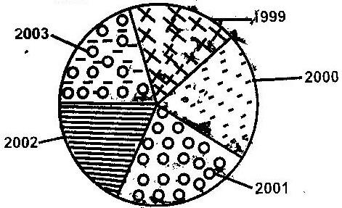

b) Advantages of statistical pi-charts
- Gives good/clear visual impression
- They are easy to construct
- Easier to compare information represented

CHAPTER 5
ENERGY
1. a)
- Provision of water for domestic use
- Provision of water for irrigation
- The dams serve as bridges across the river
- The dams and the reservoirs are fresh water fisheries
- The reservoirs have modified the local climate.
b)
- Changes in the river regime
- Silting or reservoirs
- Poor maintenance of machinery at the power houses
- Inadequate capital to purchase spare parts.
c)
- Limited number of suitable sites
- Inadequate capital for investment
- Scarcity of skilled labour.
- Uranium
- Cool/peat
2. b)
- Presence of large volume of water from a river/lake /large catchment area to provide water to drive turbines
- Regular/constant supply of water to ensure continuous generation of power
- Hard basement rock to provide a firm foundation for the construction of a dam
- Presence of rapids/water falls/nick points to provide a massive hydraulic force/head for power generation
- Presence of a deep valley/a river gorge to reduce the cost of the construction of the dam
- Non-porous rock to prevent seepage.
3. a)
- It would encourage setting up of industries in the rural areas thus stimulating
- decentralization of industries.
- It would attract /improve social amenities in rural areas reducing the need for
- people to move to urban centres
- More people would invest in the rural areas which would lead to higher standards of living
- It would encourage development of horticultural farming/to have ideal storage of perishable products.
b)
- It leads to closure of some industries
- It led to unemployment/redundancy/early retirement of workers
- It led to an increase in the cost of production of goods
- It led to an increase in the cost of electricity
- It led to power rationing
4. a)
- High volume of water e.g. River Tana, Nile, Niger, etc.
- Regular flow of water throughout the year
- Several falls and rapids provide good sites
- Presence of hard basement rocks
b)
- Inadequate technological resources
- Lack of adequate capital
- Lack of sufficient skilled manpower

5. a) i)
S – Masinga
T- Kindarum
ii) U- Mutonga
b)
- Wind
- Wood fuel
- Solar
- Geothermal/underground stream
6. a) L- Gas
M-Oil/petroleum
N- Water
b)
- Wax
- Bitumen/tar
- Sulphur
- Lubricants
- Resin/petro-chemicals
c)
- Proper maintenance and manufacture of fuel efficient vehicles.
- Improvement of public transport system encouraging people to walk, use public
- means of transport/use bicycles
- Making domestic appliances like refrigeration and cookers more energy efficient
- Switching off electrical gadgets when not in use
- Development of energy saving jikon and other techniques and technologies
- Developing alternative sources of energy other than petroleum.
7.
- It’s highly pollutant
- Non-renewable
- Dirty
- Bulky to transport
- Limited in usage
8. Expansion and establishing more power plants
- Increasing importation of bulky HEP from Uganda and SA to add to the national grid
- Encouraging and streamlining public transport so as to attract more commuters other than use of private vehicles reduce number of vehicles on the roads.
- Improvement expansion of road network to ensure easy flow of traffic to reduce fuel consumption
- Contacting foreign investors to explore oil in Kenya
- Encouraging use of bicycle by lowering or eliminating tariffs
9. What are the causes of energy crisis?
- Increase in oil prices
- Depletion of wood fuel in developing countries
- Exhausting of coal mines
- Economical and political embargoes
- Over development of oil and its products
- Artificial shortages may be created
- Waste and misuse of energy
10.
- Uses of nuclear energy
- Generation of electricity
- Production of heat
- Making atomic weapons
11.
- Uses of wind energy
- Used to turn propellers and rotors that run machines e.g windmills
- Pumbing water
- Grinding grains
- Generation of electricity
12.
- Coal
- Nuclear
- Peat
- Petroleum and natural gas
13.
- Why has coal as a source of fuel/energy declined? Explanation:-
- Has low calorific value. It’s dirty compared to other sources of energy/pollution
- It is bulky and cumbersome to transport
- Development of other sources of energy e.g. like oil, solar, nuclear and HEP
- Coal seams are exhaustible
- Inadequate capital
- Inadequate technological know how
- Over-dependency on other sources of energy e.g. HEP and petroleum
- Low demand for power
- Inadequate skilled personnel
14.
- Switching off power source when not in use
- Use of energy saving means e.g. use of public as opposed to private vehicles
- Exploiting the renewable sources of energy e.g. solar, HEP
- Aforestation, reforestation, agro forestry
- Buy product which consume less energy e.g. do away with fuel guzzling vehicles
15. i) Source of energy derived from organic matter
16. a) Energy is a resource of fuel used to operate machinery
b)
- Hydro-electric power
- Geothermal power
- Wind energy
- Solar energy
- Sea energy/wave energy/Tidal
- Biomass energy
c)
- Coal is bulky making it difficult and costly to transport
- It contribute a lot to air pollution through soot and smoke
- It has low caloric value
- It causes a lot of environmental degradation during mining by leaving
- Ugly cars on the land scape
17 a) Seven Folks Scheme
b)
- They have provide water for domestic use and irrigation
- They have served as a bridge across the river.
- They are tourist attractions
- They have acted as fresh water fisheries
- They have led to micro-climate along the area
c)
- changes in river regimes
- Inadequate funds for maintenance
- Silting of the reservoirs
- Inadequate skills and technology
- Mismanagement of funds
18 a)
- Turkwell Gorge Dam on River Turkwell.
- Gogo Falls on River Kuja
- Sondu-miriu project on river Miriu
b)
- It has promoted the growth of industries within the region
- It has earned the country revenue through the exportation of electricity
- It has earned the country revenue through the exportation of electricity
- It has acted as a bridge across the lake
- It has acted as a bridge across the lake
- It is a tourist attraction

c)
- Limited number of suitable sites
- Inadequate capital for investment
- Inadequate technology
- Scarcity of skilled labour
19.
- They have enhanced fishing
- Provision of water transport
- Promoted agriculture through irrigation
- Some have enhanced flood control
- Creation of micro-climate
20. It is used in the domestic sector for various purpose e.g. cooking, lighting, heating etc. It is the engine that runs the industrial sector.
21 a)
- Energy crisis is the price and supply uncertainties they are is usually accompanies by the rapid depletion of fossil fuels
- b)
- Overdependence on oil and its products
- Depletion of wool fuel in the developing countries
- Economic and political embargoes against the leading producers
- Exhaustion and deeping of coal mines
- Artificial shortages caused when some countries decide to conserve their resources e.g. U.S.A
- Wastage and misuse of energy
22.
- The country does not produce crude oil hence relies on importation thus ignoring other sectors of the economy
- Oil imports affects the countries’ balance of payments
- When oil prices are high, the cost of manufactured goods and services increases causing inflation in the country
- The Oil producing and Exporting Countries dictate the prices without consulting the consumer countries such as Kenya. This necessitates higher taxation to increase revenue for importing oil
- Frequent shortage of petroleum products to leads to destruction of forests.
23. a) Management of energy implies the need and careful use of energy
resources while conservation of energy means the efficient use of energy to avoid wastage.
b)
Proper maintenance and manufacture of fuel efficient vehicles.
Improvement of the public transport system encouraging people to walk/use bicycles
Making domestic appliances like refrigerators, televisions and cookers more energy efficient and switching off.
Electrical gadgets when not in use
Development of energy saving techniques and technology
Development and use of alternative sources of energy other than petroleum.
CHAPTER 6
INDUSTRY
1. a)
The raw materials may be too bulky and thus expensive to transport
Some raw materials are perishable so they have to be processed before transportation
Processing reduces transport costs
b)
- Give three characteristics of the cottage industry in India
- They rely on simple equipment/machines
- They are labour intensive
- They are owned by families/individuals
- They produce mainly for local markets
- They are widespread in the country/located in homes
- Labour is provided by individuals/members
- They need little capital to start or operate
2 a)
- Are operated by individuals/small groups
- Are pursued as part time or full time occupation. The industry:
- Require low capital investment
- Use simple equipment
- Use local or recycles raw materials
- Use basic/simple skills in craft
- Are operated in the open
- Are widespread
b)
- Difficulty in getting raw materials
- Inadequate capital
- Competition from locally well established industries/competition from imported products
- Adequate marketing skills
- Inadequate security
c)
Manufacturing is a process of changing raw materials into a finished product/commodity ready for use while tertiary industries provide services and facilities for use by other industries.
d)
- Availability of coal and iron ore as raw materials.
- Cheap water transport on River Rhine.
- Availability of capital.
- Abundant sources of power such as coal and HEP
- Ready market from Central and Western Europe
- Availability of skilled labour
- Industrial interdependence
- Availability of water.
3 a)
- Tobacco processing
- Soap manufacturing
- Footwear making
- Vegetable chemical products making/pyrethrum processing
- Leather tanning
- Rope making
- Textile manufacturing
- Saw milling/pulp and paper making
b)
- large scale importation of second hand clothes has reduced demand for locally produced textile products/second hand clothes are cheaper than the locally produced raw clothes
- There has been a decline in the production cotton which has led to limited supply of raw materials for the textile industry.
- Mismanagement of textile factories has led to closures of such operations.
- Liberalization of the economy has encouraged business people to import textile from other countries instead of selling locally produced ones.
- Belief that imported garments are superior to locally produced ones has reduced demand for local garments.
- Decline in the economy has discouraged investors who would set up textile investors who would set up textile industries in Kenya.
c) i)
- Water pollution
- Treating the industrial waste to reduce the negative impact particularly industrial effluents/enforcing environmental laws on the use of improved technology for industry efficiency.
- Recycling wastes in order to reduce the industrial waste turn over
ii)
- Rural –urban migration
- Improve agriculture to create employment in rural areas
- Encourage growth of jua kali industries in rural areas to promote self employment
- Decentralize industries so as to control the number of people moving to industrial centers in search of employment.
d)
- Availability of adequate financial resources which have helped in the setting up and expansion of the industry.
- Presence of large population which provides a large domestic market for electronic goods/availability of large external markets
- Government policy on industrialization has led to rapid development of electronic industries.
- The highly developed sources of power encourage growth of electronic industries
- Advanced technology/research has promoted efficienty methods of production/high quality goods which are competitive in the world market.
- The numerous sea ports ease the importation raw materials and exportation of finished electronic products Japan had skilled/industrious work force which enhances efficiency in production.
4. a)
It is the process of change from primary to secondary and tertiary production.
b)
- Oil refining-Mombasa
- Paper manufacturing –Webuye
- Motor vehicle assembly –Nairobi, Mombasa
c)
- It requires less capital to establish since it is made up of small-scale units
- It creates employment for the growing labour force
- It produces mainly for the local market thus the country saves foreign exchange
- It requires less expensive machinery since production is manual
- It facilitates decentralization of industries since it spreads easily/thus checking rural urban migration.
- It produces relatively cheap products that are affordable by many/improving the quality of living
- It uses locally available/recycled raw materials thus reducing the cost of imports/conserves the environment
- It uses locally available /recycled raw materials thus reducing the cost of imports/conserves the environment
- It imitates the products that are already in the market thus spreading technological skills
- It operates at grass roots level thus uses locally available skills
- It empowers the people to initiate projects thus reducing reliance/dependence on the government, donors etc
d)
- Leather tannin
- Tobacco treatment
- Textiles
5.
- Development of industry e.g. Magadi Soda company
- Source of foreign exchange from export of soda as
- Creation of employment opportunities e.g in mining, industry
- Opening up of previously remote parts of Kajiado through construction of tarmac roads and railway line
- Cheap source of mineral e.g common salt
6.
- Encouraging foreign investors through organizing international investment conference
- Improvement in transport system e.g tarmac king roads easing congestion at the port of Mombasa
- Making electricity supply reliable and affordable.
- Establishment of export processing zones
- Exploiting market for Kenya’s industrial goods e.g. under AGOA
- Fighting corruption
- Easing licence issuing procedures.
- Joining economic organizations e.g EAC and COMESA
7. It is the process of change from primary to secondary and tertiary production or
the setting up of more industries and expansion of already existing industries.
8
- It creates employment for the growing labour force
- Requires less capital to establish since it’s made up of small units
- Produces mainly for the local market thus country
- Local production saves foreign exchange or foreign exchange where exported
- Does not require expensive machinery since production is labour intensive
- Facilitates decentralization of industries hence reducing rural-urban migration
- Produces relatively cheap products that are affordable by many
- Uses locally available raw materials e.g. scrap metal, plastics hence conserve the environment
- Uses locally available skills thus encourages people to initiate projects and reduces reliance on the government and foreign procedures
- Raises the peoples living standards
9 a)
An industry is an establishment set up to process and transform simple and ordinary raw materials to a more complex materials of great value. Industrialization is the process and the speed at which a country plans and establish a country plans and establishes industries.
b) i)
-Its availability
-Its in exhaustibility
-Its bulkiness
ii)
-Industries dealing with perishable goods are close to the market
-Industries whose products are bulky hence increasing transport costs, are
located near the market.
c) Modern fuel and power can be transported for long distance for example, electricity can be transferred by high tension wires, petroleum by oil tankers and through pipelines. Natural gas is also transportable by road, air and water.
10 a) i)
Primary industries; these are the simplest forms of industries which first extract
raw materials from their sources. They are also referred to as extractive industries
ii)
Secondary industries: These are industries which depend on the primary industries for raw material
iii)
- It makes use of locally available materials
- It produces cheap consumer goods which substitutes the expensive imported goods
- They are found in nearly every corner of the country thus improving the economy of the rural areas
- They also assist in solving unemployment problems
- It has stimulated development where they have been established
- It has encouraged the utilization of local resources
- It has enhanced the production of agricultural products
- It has led to the growth and development of urban centers

11. a) Significance of industrialization to Kenya.
i) Provision of employment. People are employed in different categories of industry e.g transport
ii) Reduces reliance an imported goods thereby saving foreign exchange
iii) Development of settlements e.g. Magadi town
iv) Improvement of infrastructure e.g road and railway network connecting Magadi and the Mombasa port
v) Earning of foreign exchange which is used to develop other sectors of economy.
vi) Promotion of relationship between Kenya and other countries though trade
relations involving industrial goods.
vii) Helps in promoting rural areas where industries are established.
12. a) i) Thick -Fruit canning
-Motor vehicle
ii) Athi river -Cement making
-Meat canning
iii) Kisumu -Fish processing
-Textile manufacture
iv) nanyuki -Textile manufacture
-Garment making
v) Nakuru -Soft drink making
-Floor milling
b)
- It has resulted in pollution leading to environmental deterioration
- It has led to rural-urban migration depriving the areas of able bodied people
- It has led to uneven economic development creating two district regions; the developed rural areas
- Other economic activities
- In some instances it has led to loss of life
- Due to technological advancement, some people have been rendered jobless.
13. - Availability of raw materials i.e iron ore and limestone.
- Availability of coal which provides power to iron and steel industries (used for smelting iron ore)
- Accessibility-The area has direct links with the rest of Europe thorugh air, road and water. This allows transportation of raw materials and finished goods
- Availability of capital which is used to invest in industries
- Availability of ready market within the region and other parts of the world.
14. a)
i) Tokyo - Yokohama industries zone
- Osaka Kobe- Industries zone
- Okazaki- Yokaichi industries zone
- Yawata- Kokura-Moji industries zone
ii)
- Availability of capital
- Availability of market
- Production of simple and unsophisticated cars and electronic gadgets
- Development of hydroelectric power
- Availability of abundant water
- Presence of skilled manpower
- Advancement in technology
- Japan’s geographical location.
- Inadequate agricultural land.
b)
- Availability of labour which is skilled
- High demand for products from cottage industries due to high population
- Need to earn living to uplift their living standards which motivated Indians to establish cottage industries.
- Availability of localized raw materials
- Availability of simple machines which are affordable

CHAPTER 7
SETTLEMENT
1. a)(i) X- Industrial zone/lower class housing
Y- Suburb area/high class residential area
ii) -Trading
-Administration
-Commerce/banking/insurance
-Location or light industries
2. a) -Rural
-Urban
b) Q- Nucleated
R- Linear
3. a) -Nucleated
-Scattered/ dispersed
-Linear
b) -Urban-urban
-Rural-rural
-Rural-urban
c) -Retirement/from formal employment in urban areas
-Lack of jobs in urban centres
-Insecurity in urban centres
-The strategy of District focus for rural development
-Provision of infrastructure facilities in the rural areas.
4. -It has a deep-sheltered harbour/natural/harbour
-It is located at a strategic point on the East African Coast/enter port/gateway.
-It it well linked to the interior by railway, road and air
-Early settlement/Early trade
5. a) It is the process whereby an increasing proportion of the total population
in a country settles/concentrates in town/the process which towns or cities grow.
b)
New York | Nairobi
-It is seaport  -It is a state capital  -It is an international commercial/financial centre. | -It is an inland port  -It is a national capital  -It is a national commercial centre
6.
- Insecurity due to high rate of criminal activities
- Unemployment resulting from too many job seekers competing for limited job opportunities.
- Inadequate housing facilities caused by inadequate resources for putting up housing estates.
- Limited land for expansion caused by rapid population growth in urban centers
- Traffic congestion due to increase and concentration of activities in the C.D.
- Inadequate social amenities e.g schools, hospitals to cater for the rapid population growth in urban centers

7.
- Nairobi is situated on low lying plane interior of continent while New York is sited on island along the downwards mouth of River Hudson
- Expansion of Nairobi is horizontal extending into adjacent rural areas. New York is extending vertically due to limited horizontal space.
- New York is characterized by many high building called skyscrapers while in Nairobi skyscrapers are few.
8. Two main functions of rural settlements
a) Production of agricultural goods
b) Mining activities
c) Forestry/lumbering
d) Fishing
9. a) Large unemployed population which is idle and encourages
Criminal/immoral practice e.g. parking boys and girls, baggers
b) Rapid growth of population which has led to an acute shortage of
housing/slums
c) Traffic congestion during rush hours leading to loss of time
d) Heaps of uncollected garbage which are health hazard as they can lead to
Epidemic/land pollution
e) Perennial water shortages due to increased number of consumers
f) poor sewage system in some parts which is a health hazard for poor
Drainage system
g) Rapid growth of population has led to inadequate provision of health and
Education services and facilities/social facilities.
h) Pollution of air/water/sound from industries and vehicles causing a health
Hazard.
10. a) sheltered harbor making it an international sea port
b) Central location making it local point of routes/strategic sites
c) Large hinterland rich in agriculture and minerals.
d) Development of many industries e.g tourism, oil, refinery, etc has attracted
many people due to employment
e) Development of commercial activities attracting many people.
f) Administrative centre attracting many people
g) Construction of the railway and other lines of transport to interior
Contributing to rapid growth of the town.
11. a) It has deployed traffic police to control traffic/installation of traffic
lights/construction of fly over construction of tunnels to control traffic congestion.
b) Its encouraging self –employment like jua kali sectors to solve
Unemployment problems in Nairobi.
c) encouraging use of easily available raw materials for building low cost
house/funding high rise on multi-stored flats/expanding urban area
boundaries.
d) Location of industries away from residential areas establishing proper
waste/garbage collection system to reduce pollution in the city.
e) Increased police surveillance to reduce high crime rate in the
city/strengthening the security intelligence to reduce high crime rate in the city/strengthening the security intelligence unit.
f) The government has encouraged independent bodies to come up with different ways to sensitize the public on ways to take care of cleanliness, drug abuse, vandalizing equipment and public policing.
12. a) Settlements is a place on the earth surface occupied by people.
Urbanization is the process in which an individual or proportion of a country’s population is transformed from rural based agricultural life to urban based non-agricultural life style.
b) Availability of water
- Natural calamities
- Presence of building materials
- Relief
- Defence
- Transport
- Shelter
13. a) Kenya
  - Major urban centres are found in the Rift Valley and associated highland
  - Others are in the lake basin and the coastal region
  - They include: Kampala, Mbarara etc.
Uganda
- Major urban centres are found in the southern part of the country around Lake Victoria
- They include: Kampala, Mbarara etc
Tanzania
- Urban centres are found along the coastal belt e.g Tanga and Mtwara.
- Around Lake Victoria e.g Mwanza and Musoma
- Others are found in mineral rich areas of Mwandui and Shinyanga.
b)
- Population increase put stress on existing infrastructural facilities forcing
- urban centres to expand their territories
- Industrial development attracts large population who seek for employment hence leading to emergence of industrial towns.
- Administration functions leads people to settle close to admininistrative services. Such places grow into urban centres.
- Mining activities attracts subsidiary economic activities in an area. These attract large settlement leading to growth of urban centres.
- Tourism attracts infrastructure, other investments and large population. This leads to the expansion of urban boundaries hence urban growth.
14. a)
  - Railway terminus reaching the shores of lake Victoria made it handle a lot of exports and imports from Uganda leading to its growth
  - The early Asian settlers who came during the construction of railway line to Uganda established commercial activities in Kisumu which further contributed to its growth.
  - Administration function i.e for long time, Kisumu served as provincial headquarters of Nyanza, Western and Kericho districts. It was also used by early railway engineer.
  - High population from the densely populated districts of Vihiga, Kakamega, Kisii and Siaya ensures steady supply of labour for industries and the provision of market to the manufactured goods.
  - Road linkages i.e it is served with road linkages to the surrounding districts of Kakamega, Kericho, Busia and Kisii which has led to increased trade hence leading to its growth
  - Development of pier which is strategically located at the shores of Lake Victoria has led to trade between Tanzania and Uganda. This has provided a trading advantage.
  - Rich hinterland i.e the town is surrounded by agricultural hinterland of Vihiga, Kakamega, Kisii and Kericho which provide food for residents and raw materials to industries.
b)
- Industrial centre
- Administrative centre
- Tourist centre
- Education centre
- Communication centre
- Commercial centre
15.
- Housing problems due to ever-increasing population in the city that has led to development of slums like Harlen,
- Brooklyn and Bronx
- Limited space for expansion because of its site has led to emergence of skyscrapers
- Traffic congestion during rush hours leads to waste of time and fuel
- Social evils such as crime rates lawlessness and prostitution due to lack of employment
- Pollution due to heavy concentration of industries, motor vehicles and domestic refuse leading to air, water and noise pollution
- Loneliness due strenuous life and joblessness leading to homicidal tendencies
- Climatic problems in which heat concentration makes the city residents feel uncomfortable. At times during winter, blizzards are common.
16. a)
- Nairobi is sited on a low lying plain while New York is sited on an island of a
- long the drowned mouth of River Hudson
- Nairobi expansion is horizontal emerging into adjacent rural areas. New York on the other hand is expanding vertically into the air due to limited space.
- Mode of transport within Nairobi city is motor vehicles and is some cases railways while in New York a part from motor vehicles and in some cases railways while in New York a part from motor vehicles and railways, rivers and canals are being used.
- New York is characterized by very high buildings known as skyscrapers while in Nairobi skyscrapers are very few.
- The climate in Nairobi is warm and sunny throughout the year, New York city experiences summers and winters
b)
  - Port of Mombasa serves as a developing and agricultural hinterland whereas Rotterdam serves developing and highly industrialized hinterland
  - Exports through the port of Mombasa are mainly agricultural products and minerals, while exports through the port of Rotterdam are manufactured goods and chemicals
  - Mombasa’s imports are mainly manufactured goods while Rotterdam’s imports are agricultural commodities
  - Both ports are ice free throughout the year
17. Positive effects
- Urban centres lead to the development of infrastructure to facilitate movement of
- People and goods.
- Creation as it leads to development of industries
- Provision of market as population in urban areas leads to high demand of goods
- Leads to national integration as it encourages interaction of people.
Negative effects
- Inadequate housing due to uncontrolled population influx
- Inadequate public amenities as the existing ones are overstrained
- Unemployment as the number of job seekers exceeds employment opportunities.
CHAPTER 8
TRANSPORT AND COMMUNICATION
1.
- The high cost of postage
- Competition from cheaper and faster means of communication
- The delay in the delivery of letters
- Loss of letters
- Tampering with letters
2. a) Give three advantages of railway over road transport
- Railways can carry more bulky goods over long distances at once.
- Railways are cheaper than road
- Railways are less susceptible to traffic jams.
- Once built, railways do not require frequent relaying unlike roads, which are frequent relaying unlike roads, which are frequently resurfaced.
- Vehicles get stuck on dry weather roads during wet seasons while trains cannot get stuck.
- Railways are more efficient because they operate on a rigid timetable
b) X- Nakuru
Y- Eldoret
c)
      - They are expensive to maintain
      - They are not flexible
      - They do not serve intermediate locations
      - They can cause excessive loss of in case leakages.
d) i) A- Chacago B- Detroit
ii) X- L. Ontanrio
Y- Ere
Z- Superior
iii) Welland canal
3. a)
P – Jinja
Q – Bukoba
R – Mwanza
b)
- Containers guard against destruction of goods
- They make loading and off-loading easy
- They guard against theft of goods
- It saves time when loading and off-loading
4. a)
- Motor vehicles are cheaper to buy and maintain than aircrafts
- Road transport is more flexible than air transport
- Construction of roads is cheaper than that of airports
- Fares/freight charges on roads are lower than that of air transport
- Skills required to operate air crafts are higher and rare than those required to
- Operate motor vehicles.
b)
- It encourages the growth of tourist industry
- It promotes horticultural exchange between Kenya and other countries.
- It encourages international cooperation/facilitates international emergency services
- Earns foreign exchange from landing fees
5. a)
P- Kasese
Q- Butere
R- Kigoma
b) S- Maize /Wheat/ cattle
T-Soda ash
c) U- Tanga
V-Malawi/Nyasa
d)
- It is cheaper to construct and maintain
- Roads are flexible and provide door to door services
- Roads can be used by a wide range of transport
- The roads are faster to use
- There is greater demand for road transport than railway transport
- The roads are faster to use
- There is greater demand for road transport than railway transport
- Roads can be constructed at varied terrain
e)
- Narrow roads where heavy traffic limit use of movement and overtaking
- The pot-holed sections of the roads may cause tyre busts/vehicle break downs/may make drivers who are avoiding potholes crash the vehicles.
- The narrow bridges may cause vehicles to rear off the roads.
- The narrow bridges may cause vehicles to crash
- Sub-standard surfaces may cause vehicles to skid and overturn
- Blurred/missing road sighs may make drivers lose control of vehicles to skid and overturn.
- Blurred/missing road signs may make drivers lose control of vehicles
- Unavailability of pedestrian paths/sidewalks may cause pedestrians to walk on the roads.
6.
  - Reduction in road accidents through use of speed governors
  - Source of government revenue through payment of income tax
  - Improves confront in public transport
  - Increased profitability due to reduced insurance premiums
7.
- Dense forest covering large areas
- Political instability and political differences between some African Countries
- Presence of large and many rivers that make road construction difficult and expensive to bridge.
- Insufficient capital by individual governments to construct and maintain parts of the highway in their countries.
- some flow in the areas lack substantial resources
- Most rivers are narrow and shallow
- Some rivers fluctuate in the volume of water
- Some have waterfalls, rapids and cataracts
- Presence of floating vegetation along some rivers
8.
  - Ease congestion within Nairobi
  - Promote both local and international trade
  - Ease transportation of bulky goods
  - Opening of rural urban areas around Nairobi
9. a) Define containerization
Means packing of a commodity in large box like structures which are once filled in a factory can be transported by railway or lorry to the dock and into and off the ship by cranes.
b)
- Speeds up the process of handling goods
- Saves spaces in a ship as their dimensions are uniform
- Minimizes loss of goods through theft
- Relatively cheap as it requires little labour-checking the content on entity is quite easy.
10. a) State three problems facing rail transport in Kenya
- Poor maintenance of rail transport in Kenya
- Poor maintenance of rails and wagons leading to accidents
- -Inadequate capital to purchase new Wagons.
- -does not offer door to door services –not flexible
- Faces stiff competition from other forms of transport
- Its initial objective was to serve foreign markets and not local markets hence most sections passes through low density areas
b) Identify the advantages of rail transport in a country
- Enables transport of goods over long distances at cheap rates
- There ‘s economy of spaces as many trains can be scheduled to use the same rail
- -they have minimal pollution
- Its effective in moving a large number of people and goods within a short time
- Has fewer accidents
- Requires less lab our because many wagons are pulled by one driver
- -Convenient to clients because they follow a time schedule-can plan his movement.
11 Differentiate between transport and communication.
Transport is the act of moving, carrying and conveying items and people from one place to another while communication is the transmission of words and messages from one part to another
12. Apart from cell phone state two other modern means of communication
-Telephone
-Telex
-Telegram
-Email/Internet
13. State the advantages of using cell phone in communication.
-Are portable
-Are quick/fast
-There is immediate feedback
-Messages can be sent over long distances within a short time.
-Message can be stored
14.
- To remove rock shoals, rapids and several small islands in river channel which hampered navigation
- To deepen the river channel which hampered navigation
- To deepen the river and regulate flow of the river
- To construct locks along the route to regulate flow of water as well as movement of vessels
- To construct locks along the route to regulate flow of water as well as movement of vessels
- To generate H.E.P.
15. a)
i) Transport is the carriage of goods and people from one place to another
ii) Communication is the transmission of information from one point to
another

b)
- Air transport
- Road transport
- Railway transport
- Pipeline transport
c)
- Inland waterways
- Oceanic waterways

16. a)
  - Presence of floating vegetation makes it difficult for vessels to sail on rivers
  - Silting at river mouths hinder the development of ports and makes the river
  - Channel shallow.
  - Some of the rivers are too swift in their courses.
b)
- The north Atlantic sea route
- The Mediterranean Asiatic sea route
- The European-Eastern South America sea route
- The panama Canal sea route
- The Cape of Good Hope, sea route
- The North pacific sea route

c)
- It offers the cheapest form of transport for large bulky goods
- It is route free/uses the natural routes e.g rivers, seas ect
- Accidents are minimal
- Water transport experiences no traffic congestion
- It is able to accommodate vessels ot any dimension
17. a)
- The African countries were administered by different colonial governments who constructed rail lines only with in the areas of their jurisdiction
- Many African countries have political differences which leads mistrusts and hostility thus working against any effort to undertake railway construction jointly.
- African countries have railways of different gauges which makes it difficult for them to be connected.
- The little interstate trade among African countries doesn’t warrant construction of railways to transport bulky goods
- African countries lack sufficient capital to establish railways
b)
- Trans Cameroon railway
- Tanzania – Zambia railway
- Trans DRC railway
- Kenya Uganda railway
c) Advantages
  - It is cheap when transporting bulky goods
  - It is will weather e.g it is not affected by weather changes
  - The train follow a regular timetable hence help people to plan their movement
d) Disadvantages
- It is a slow mode of transport
- It is not flexible
- It is not economical on short distance
18. a)
- Motor vehicles are cheaper to buy and maintain
- Fares and freight charges on roads are lower
- Skills required to operate motor vehicles are readily available
- Construction of roads is cheaper
- Road transport is more flexible
- It is relatively cheaper over short distance
19.
This is the packing of goods in large standard sized box like structures which are sealed at the factory or by the exporter and transport by road , railway/water to the importer while sealed.
(a) Advantage
    - It reduces the loss of goods trough theft
    - It lowers the insurance premiums due to reduced risks
    - It speeds the process of handling goods
    - Breakages of goods is minimized

(b) Disadvantages
      - It is expensive to adopt as it requires special docks, ships etc
      - It may lead to redundancy of labour at the port as machines require human labour.
(c) Advantages
    - Provide the fastest means of transport
    - Relatively independent of physical barriers
    - Accidents are limited
(d) Disadvantages
      - Highly vulnerable to poor weather.
      - Accidents though rare are fatal.
      - Airports are expensive to construct.
20. -Telegraph -Fax
-Telephone -Internet
-Television -E-mail
-Radio
21. a) -The Great North road from Cape town (South Africa) to Cairo (Egypt).
-The Trans-African highway from Mombasa (Kenya) to Lagos (Nigeria)
b)
- They have provided employment in the transport sector
- They have provided employment in the transport sector
- They have enhanced international trade
- They are source of government revenue through toll station revenue
- The highways have contributed to urbanization
- They have opened up remote areas for development
c)
- Low level of inter-state trade among the African countries.
- Hostile environment in some sections through which the highways pass e.g deserts, thick/dense vegetation
- Rugged landscape caused by mountainous and hilly terrain.
- Political differences amongst some of the countries through which the highways pass.
22.
- It promotes industrial development by facilitating the movement of raw materials to the manufacturing centres and finished goods to the markets.
- It has promoted both local and international trade
- Promotion of tourism by opening up potential sites
- It has promoted both local and international trade
- Promotion of tourism by opening up potential sites
- It has opened up remote areas for exploitation e.g. through mining agriculture etc
- It has enhanced interaction among people leading to exchange of technology.
23. a)
- Inadequate manpower of the development of new networks.
- Insufficient funds for the development of new infrastructure
- Civil wars leading to destruction of existing network
- Mot of the continents rivers are not navigable
- Colonial heritage which led to the development of externally oriented transport and communication facilities
b)
- Construction of trans-African highways
- Construction of international railways
- Establishment of regional economic blocs to improve transport and communication lines
- Seeking donors to help finance the construction of infrastructure
24. a)
- Frequent fog and mist at the mouth of the St. Lawrence
- Different water levels
- Rocky islands within the river channel
- Shallow and narrow sections of the water ways
- Freezing during the winter season
- Presence of rapids and winter season.
- Presence of rapids and waterfalls
b)
- Construction of canals
- Dredging of river channels
- Blasting to remove the rocky islands
- Use of fog lights and radars to avoid accidents due to gog.
c)
- Development of urban centres and ports e.g. Tororo, Port Arthur, Buffalo and Detroit
- It has led to the production of hydroelectric power for both domestic and industrial development by offering cheap transport for raw materials and finished goods
- It has led to an increase in the volume of trade within the region especially due to proximity to Europe.

CHAPTER 9
TRADE
1. a)
- To encourage member countries to reduce duties charged on goods among the countries from COMESA member states.
- To promote trade among member states.
- To acquire greater economic strength/higher bargaining power with
trading blocs of the world.
- To establish a larger market for the goods produced in the region.
- To remove trade barriers among member states.
- To create regional specialization in order to improve the quality of goods.
- To create political cooperation among s member states.
- To create monetary and financial cooperation among member states
2. a) International trade is the exchange of goods and services between different
countries.
b) -Machinery
-Capital equipment
-Textiles
-Pharmaceutical products
-Fertilizers
-Automobiles
c) -Governments policy/government legislation
-demand for goods both locally and outside Kenya
-Variation of natural resources/goods/quality of goods
-Availability of transport and communication
-the purchasing power
-the level of industrialization
-Tariffs imposed on Kenya exports
d)
- There will be improved access to raw materials for industrial development
- The expanded market will attract new investments from local and foreign
sources which will lead to expansion of industries/more earnings.
- There will be improved negotiating powers in the international arena
- There will be improved transport links between Kenya, Uganda and Tanzania which will facilitate faster movement of goods and people.
- There will be mutual political understanding between Kenya and its neighbors.
e)
- Overspecialization/overdependence on a particular items is risky in case of
a fall in the prices in the world market.
- Imported items may become a threat to the local industries leading to closure of some of items
- Some imported goods e.g expired goods e.g. expired goods sub-standard goods may have adverse effects on the citizens/economy
- If a country depends on another, it may sometimes have to tolerate some undesirable gestures from such countries.
- There may be over exploitation of natural resources leading to their depletion e.g. minerals
- Over-emphasis or export oriented product at the expense of other sectors of the economy.
3. a)
- Encouraging the development of jua kali industries which do not require importation of heavy machinery.
- Restricting the importation of luxury items through taxation.
- Establishing/importation of luxury items through taxation.
- Establishing/import substitution industries to cut down on importation of some commodities.
- Developing alternative sources of energy in order to reduce importation of some commodities
- Encouraging the production of high quality manufactured goods for exports in order to earn higher income
- Diversifying the agricultural export base to enable the country to have a variety of exports
- Opening new markets to avoid dependence on the trading partners.
b)
- The imported industrial inputs led to growth of manufacturing industries
in the country.
- Demand for Kenya’s exports has led to the expansion of the industries that produce those goods
- Kenya earns foreign exchange which enables it to import goods from other countries
- Transport and communication network in Kenya has been improved to facilitate the movement of trade goods/modernization of the facilities for handling goods at the port of Mombasa.
- Taxation of commodities and services rendered has generated revenue for the country.
- Employment opportunities have been created in the manufacturing and service industries that handle imports and exports
- Trade has enhanced exchange of technology between Kenya and the trading partners.
- Trade encourages specialization which leads to production of high quality goods in some industries in Kenya, thus enabling the country to earn higher income.
4. a) Trade is the exchange of goods and services for mutual benefit
b) - Wholesale trade
- Retail trade
5. - The availability of capital for investment
- Presence of well developed transport and communication system
- Demand for the trade items and the presence of an adequate source of
supply
- The absence or presence of trade barriers
- The creation of common markets
6. a) Visible exports are tangible goods sent out of the country for sale while
invisible exports are the payments received for services rendered outside the country.
Visible exports | Visible imports
Coffee | Cereals
Tea | Crude oil
Soda | Pharmaceuticals
Fluorspar | Industrial machinery
Horticulture products | Iron and Steel
Petroleum products | Motor vehicles
7.
- Through trade, the country is able to obtain goods which it cannot produce
- Trade enables Kenya to dispose surplus production
- International trade enabled Kenya to earn foreign exchange
- Through trade, the country has been able to generate many job opportunities
- Trade offers market for industrial goods and also enables industrial goods and also enables industries to obtain raw materials and other inputs. This has promoted industrial development in Kenya
- Trading centres have attracted dense settlements. This has turn promoted urbanization.
8.
- With increased cordial relationship with her neighbors, trade will continue to prosper.
- Through COMESA, trade with the rest of the region will further improve
- The country’s balance of trade will continue being unfavorable unless the quality of the exports is improved on and import substitution industries set up
- With the signing of multi-lateral and bi-lateral agreements, and through the Lome convention, the country will gain access to the lucrative markets in Western Europe.
9. a) A group of countries usually sharing a common history and within the
same geographical region who come together for economic benefits
b)
- Common market for Eastern and Southern Africa (COMESA).
- The southern Africa Development Community (SADC)
- The Economic Community through the removal of customs among member state.
- It has promoted the free movement of persons, services and currencies hence increasing the volume of trade.
- Has established financial institutions e.g. the European Investment Bank
- This has financed economic projects.
10.
- The neighboring countries produce similar agricultural goods to Kenya thus reducing trade.
- Trade tariffs have discouraged free trade with her neighbors
- In the past there has been restriction of movement which has limited the degree of movement of people and goods within the region.
- The development countries offer manufactured goods and industrial machinery hence they are better trading partners.

CHAPTER 10
POPULATION
1. a)
- The area receives low unreliable rainfall.
- Most parts have thin undeveloped soils/sandy soils unsuitable for agriculture
- -the area has scanty vegetation that cannot support livestock
- There is inadequate supply of surface water
- Some areas have rugged terrain unsuitable for settlement
- -some areas have ragged terrain unsuitable for settlement
- -Some areas are insecure and therefore avoided
- The area experiences high temperatures unsuitable for settlement
b)
- National census/head count
- Sample survey/sample count
- Vital statistics/registration of birth/death/Marriages
c)
- The size of the population
- The different age cohorts (groups)
- The proportion of males to females
- The composition by sex
- The proportion of the youthful/working/ageing/dependency ratio
- The population of Kenya has large number of young people below 20 years of age while Sweden has an ageing population
- Kenya’s population has a lower life expectancy while Sweden has a high life expectancy
- The population birth rate in Kenya and low in Sweden it is low
- The death rate is high in Kenyan and low in Sweden
- The population growth rate is high in Kenya and low/negative in Sweden.
- A high percentage of the population in Kenya lives in the rural areas while in Sweden most people live in urban centres.
e)
- Pressure on land makes people to buy/look for land elsewhere and move to settle there.
- People move from one rural area to another/to plantations in search of employment
- Insecurity in some rural areas make people move to safer places
- Settling up of government development projects cause displacement of people who are settled elsewhere such projects attract settled elsewhere such projects attract settlements in those areas (settlement schemes).
- Natural hazards force people to migrate to other areas for safety
- Pastoral communities migrate from one rural area to another in search of pasture/water for their livestock.
- Changes in land tenure system/land dispute cause people to move and settle elsewhere.

2.
- The rate of population growth is higher than the rate at which job opportunities are generates leading to high unemployment
- The high demand for social amenities caused by the high population growth rate leads to congestion in schools/hospitals/housing/transport facilities
- The large number of youthful population creates a high depending ratio which causes slow economic growth.
- The high demand for agricultural land cause land fragmentation/landlessness
- The large number of poor people/leads to temptation to commit crime/high crime rate.
3.
- Improve diet
- Improved medical facilities
- Improved education for mothers/patients
4.
- Nearness to Nairobi – many people lives in Thika town and work in Nairobi because house rents are lower. This increases the population of the District.
- Thika town is an industrial centre and attracts large population of workers unlike Murang’a where there are few industries that are rural based.-Thika town is a large commercial centre compares to Murang’a town.
- Thika attracts many people who operate different businesses. This increases the population of the district.
5 a)
- For planning purposes
- To help in the distribution of resources
- To make estimates of population growth
- To identify the rates of deaths and births
b)
i) Early marriage
People who marry early are likely to get more children because they have a long period during which they can get children

ii)
- Improved medical facilities
- Both the child, mothers and the general population have better chances of survival because of the available medical facilities/
- The country is able to control the spread of diseases and has ability to cure diseases. This leads to higher survival rates.

iii) Culture beliefs
- Some cultures encourage large families. In almost all cultures, there is a tendency of people preferring male children. This may lead those who are not getting male children to have a large family as they hope to get a boy.
6. a)
- The number of male and female population is almost equal at all levels
- From 0-14 years, the population is low
- From 15-44, the population is high
- The ageing population is low
- The population has a low birth rate
- The population has a low birth rate
- The population has low death rate
b)
- There is likely to be a high unemployment rate because job opportunities do not increase at a rate that can cope with the increasing number of job seekers.
- The standard of living is likely to be low because the government is not able to promote adequate social amenities.
- It may lead to a high dependency ratio which will slow down the economic growth
- Strain on natural resources/scarcity of land which would lead to landlessness and fragmentation.
- There would be low food production hence food shortages.
c)
- Improving medical facilities such as immunization of children to control diseases. This has created a healthy environment for child survival.
- Providing more education opportunities for parents ensures better care for their children e.g. in providing balanced diet
- Introduction of family planning programmes has led to emergence of manageable sizes of families which promote higher chances of child survival
- Carrying out research on infant related diseases to come up with ways of controlling them ensures higher chances of survival.
d)
- Presence of large towns with industries has attracted large of numbers of job seekers
- High rainfall which influences production of a wide variety of crops hence sufficient food.
- Fertile land which attracts settlements
- High fertility rate leads to a high natural increase
- The fairly level land encourages agriculture and settlement
- Increased commercial activities/trade attract a large number of populations
- Early settlement in the reason encouraged growth of towns which formed a focus migration
- Developed communication has enhanced movement in the area.
7. a) Population is the sum total number of people living in a given area either a
home, village, town, rural area or even the whole world.

b) i) Physical factors:
- Relief: Areas with rugged relief, valleys and steep slopes are avoided while gentler slopes are densely populated.
- Climate: High rainfall and cool temperatures encourages high population while, low and unreliable rainfall with high temperatures leads to low population.
- Soils: Fertile soils, which are well drained encourages population concentration, while poorly drained soils which are less fertile are sparsely populated.
- Drainage: Poorly drained areas discourages population while well drained areas encourages high population
- Vegetation: Densely vegetated areas, woodlands and savannas are sparsely populated.
ii) Human factors
- Economic activities: areas of industrial concentration, mining centres, fishing ports are all responsible for high population concentration
- Security: Areas where security is poor discourages population while areas with good security attracts population.
- Government policy: Creation of land for settlement encourages population while settlement of forests and game reserves discourages population
8. a)
- High fertility encourages high births. This encourages high population growth where fertility is low; there are low hence low population growth.
- Increase in mortality rates leads to low population growth rate while mortality decrease leads to high population growth.
- Immigration results into population increase in the receiving area while emigration results into population decrease in the area of origin
b)
- High birth rates
- Low life expectancy
- High dependency ratio
- High death rates
9.
- Cultural factors e.g. polygamy and early age. Improved diet resulting to better nutrition leads to healthy people who become parents at an early age
- Religious influences whereby certain churches advocate for natural family control method which are less effective.
- Disapproval of artificial family planning practices leads to high fertility levels.
10.
Kenya | Sweden
a) Higher population | Lower population
b) Population is predominantly youthful | Population is predominantly ageing
c) Lower life expectancy | Higher life expectancy
d) Population growth is higher | Population growth rate is lower
e) majority of population is rural based | Majority of population is urban based
f) High birth rate | Low birth rate
g) Dependency ratio is high | Dependency ratio is low

11. Population density in Kenya
Region | Density
Nairobi | 3079 p/km²
Central | 281.7 p/km²
Rift Valley | 38.3 p/km²
Western | 406.4 p/km²
Nyanza | 350 p/km²
Eastern | 30 p/km²
North Eastern | 7.5 p/km²
12.
- Suitable climate: Central Province experiences high rainfall totals per annum. This encourages various agricultural activities hence attracts high population densities.
- Fertile soil: The red volcanic soils which favours variety of agricultural activities have attracted a high population.
- Industries: the establishment of manufacturing industries in the towns of Central Province like Thika have attracted many people who seek for employment.

CHAPTER 11
MANAGEMENT AND CONSERVATION OF THE ENVIRONMENT
1 a)
- To ensure that there is supply for present and future generations
- To maintain the hydrological balance
- To maintain the eco-system
b) By reducing surface run-off which ensures that rain water seeps slowly into
the ground.
2. a)
- Lighting
- Strong winds
- Dust storms
- Pest/diseases
- Floods
- Pollution
- Soil erosion
- Fires
- Land slides
b)
- Population pressure/clearing of forests for farming/settlement
- Climatic changes
- Accidental fires
- Poor methods of farming/overgrazing/Overstocking/poor irrigation methods
3. a)
- Central highlands
- The Nyika plateau
- Coastal lowlands
- Nyando
- Nzoia
- Kuja/Gucha
c)
- The stagnant water becomes breeding ground for vectors that cause water related diseases.
- Floods cause loss of property/lives
- Floods cause soil water logging which lowers crop production
- Floods wash away crops leading to food shortages/famine
- Floods wash away bridges/roads/telephone lines/air fields disrupting transport and communication
- People are displaced by floods/are made homeless
4. a) The presence in the environment of contaminants which are injurious to
human, land, plant animals life.
b)
- The garbage may result to foul smell/air pollution
- When it rains, the dumped waste/garbage is washed to rivers causing water pollution.
- Garbage can be a breeding ground for rodents/flies/cockroaches which can cause disease outbreak e.g plague.
- Accumulation of garbage leads to blockage of roads/drainage systems
- Garbage heaps are an eye sore as they make the environment ugly.
c)
- Burning waste materials
- Digging pits for throwing rubbish
- Minimizing use of harmful chemicals/Use of organic manure
- Creating public awareness on the dangers of land pollution and how to control it.
- Recycling of waste materials
- Government legislation against dumping
- Settling up proper garbage collection programmes
5 a)
- Leads to shortage of pasture
- Leads to crop failure
- Leads to shortage of water for livestock and irrigation
- Leads to shortage of agricultural raw materials for agro-based industries
- Leads to reduction in export of agricultural commodities/reduction in the farmers’ income.
b) What is soil conservation?
It is careful management/protection of soil against erosion/exhaustion
c) State three farming methods that assist in soil conservation
- Ploughing along the contour
- Controlled grazing
- Strip cropping
- Making terraces
- Digging cut off drains/trenches
- Planting cover crops
- Mixed cropping
- Agro-forestry
6.
- Occurrence of heavy rainfall leading to high volume of water than river banks can hold e.g. Nzoia and Nyando
- Siltation of lakes, river channels and canals on the lands due to soil erosion upstream thus reducing carrying capacity triggering floods.
- Nature of land- plain areas are prone to floods as drainage tends to be poor
- Deforestation-Clearing of vegetation on catchment areas along the river (river line vegetables) entrance run off and reduce percolation.
7.
- Stagnant grounds are breeding grounds for carrier diseases e.g. malaria, typhoid, bilharzias
- Loss of life
- Loss of property which take time to regain
- Causes soil water-logging thus lowers crop production
- Food shortages or famine where farmers calendar is disrupted or crops washed away
- Traumatized people or make people panic
- Loss of confidence and interest in undertaking development and economic activities.
- Disrupts clean water supply to major towns where floods wash away water pipes.
8.
- Construction of dams to reduce volume and velocity of river discharge downstream
- Construction of dykes or artificial levees which help to restrict outflow of rivers or canals e.g. along river Nyando and Nzoia.
- Conservation of vegetables on catchment areas and along the course of the river meander thus smooth flow of rivers
- Engaging government and non-governmental organizations ICRAF in creating awareness on importance of activities e.g. agro-forestry, water management and conservation which enhance infiltration
- Clearing deepening and widening of rivers and canals to facilitate easy flow of water into lakes and dams.
9.
- Excess water stored in dams can gainfully be used to generate HEP
- Excess water can also be used for commercial farming through irrigation
- Creation of environment e.g. irrigation schemes
- Promotion of fishing activities in dams and lakes due to reduced sedimentation and pollution
- Poverty would also go down due to reduced incidence of loss live, crops, homes and livestock
- Flood plains are highly rated for agricultural due to fertile soil deposits.
10.
- Floods
- Droughts
- Earthquakes
- Diseases Pests
- Lighting
11.
- Fires
- Soil erosion
- Pollution
- Desertification
12.
It’s spread of arid conditions/deserts into formerly productive areas

13.
- Climatic changes
- Wanton destruction of vegetation
- Overstocking resulting on overgrazing
- Cultivation of marginal lands
- Poor cultivation methods
- Population pressure leading to opening up of virgin land and clearing forest
14.
- Food shortage
- Reduction of livestock due to lack of water and pasture-dwindling of agricultural and potential land
- Low standards of living of farmers
- Stagnation of Agro-based economy
15. i) Natural environment
Includes things that are availed by nature e.g. landscape and air
ii) Geographical environment
Refers to environment factors whose relationships are considered in terms of spatial location
iii) Physical environment
Includes all phenomena apart from man and the things he creates.
iv) Non human environment
Includes all those things that are not in a social system, whether man made or not
v) Cultural environment
Includes all aspects of human culture found within a given environment for his survival e.g. taboos, totems, traditional beliefs, etc.
16. a) i) Environmental refers to all those external conditions that surrounds
a living organism. It comprises of the atmosphere, water, land, vegetation and animals.
ii) Management of the environment involves all the measures aimed
at better and useful exploitation and rehabilitation of natural resources.
iii) Conservation of environment involves the proper utilization of
resources that ensures little or no wastage.
b)
- In order to sustain life
- For recreation purpose
- For protect wildlife
- For aesthetic value.
- Lightning
- Windstorms
- Pests and diseases
- Pollution
- Droughts
- Earthquakes
- Windstorms
c) i)
- Heavy downpour which increases the river volume leading to the river bursting its banks
- Impermeability of the soils which reduces the rate at which rain water percolates into the ground
- The rise of lake levels that causes the lake water to rise hence flooding the adjacent land
- The occurrence of tsunamis which produces strong sea waves leading to sea water spilling onto the land
- Deforestation that results into land being exposed to run-off causing flash floods.
- Poor urban drainage that clogs the drainage system.
ii)
- It leads to loss of life
- It results in the destruction of property
- People have been displaced
- Flooded areas are associated with waterborne diseases
- It also disrupts the infrastructure.
17. a) i)
It is a bright sudden flash of natural electricity produced during a thunderstorm
ii)
It is caused by a formation of the clouds whose ions are positively and negatively charged thus releasing an electrical charge.
b) i)
- Claims many lives
- destroys property
ii)
- By installing lightning arresters
- By public awareness campaigns
- By conducting research
18. a) i) Pollution is the addition of harmful substances into the environment
ii)
- Air pollution
- water pollution
- Land pollution
- Noise pollution
- Radiation pollution
b) i) Air pollution is the additional of harmful substances into the atmosphere
making it to be contaminated.
- Discharge of smoke and gases by industries
- Emission of fumes from motor vehicles
- Engagement in agricultural activities that leads to such pollution.
- Discharge of smoke from domestic heating using charcoal, firewood and coal.
- Smoke emitted from air crafts
- Mining and quarrying
- Poor disposal of domestic waste
iii)
- Ensuring that industrial effluents and fumes are properly treated
- Encouraging the use of biodegradable materials
- Legislation to regulate the amount of noise in social places
- Increase in the farm manure as an alternative to organic fertilizer
- Regulating by law the setting up of industries which are likely to pollute the environment
19. a)i)
- The international Centre for Research in Agro forestry (ICRAF)
- The Swedish International Development Agency (SIDA).
- The United Nations Environmental Programme (UNEP)
b)
- Several laws have been enacted to combat environmental degradation like the Water Act which gives guidelines on the safety and welfare of employees and the working conditions in factories.
- The Wildlife Conservation and Management Act whose aim is to protect the wild game and their natural habitats.

ANSWERS TO MODEL PAPERS
MODEL PAPER 1 A
312/1 PAPER 1
SECTION A
1. a) The study of distribution and interrelationship of natural and human
phenomena on the earths surface.
b)
- Biology is the scientific study of organisms focusing on their anatomy and physiology and behaviour while Geography is interested in the distribution of organisms and the factors influencing this distribution, i.e. Biogeography.
- Biology applies geographical information to explain factors which determines the distribution of species on the earth surface
2. a) Mass wasting is the down slope movement of rock materials under force
of gravity. Mass movement is the down slope movement/of rock materials due to lubrication of water.
b)
- Alternating heating and cooling
- Freezing of soil particles
- Removal of soil down slope
- Rainwater
- Ploughing down slope
3. a)
- Himalayas
- Atlas in Africa
- Alps in Europe
b) State three theories which explain the formation of fold mountains.
- The contraction theory
- The convectional theory
- Continental drift
- Plate tectonic theory
4 a) Vertical movements along a radius from the earths center to surface or
from the surface towards the earths center.
b)
    - Isostatic adjustment occurs when sialic (continental crust) layer which is
    - less dense floats on the dense simatic (oceanic crust) layer
    - Erosion on the continents reduces pressure on continental crust (sial)
    - leading to isostatic uplift, while deposition of sediments on sea crust(sima) adds pressure which results to isostatic sinking.
    - The continental crust (sial) and oceanic crust (sima) constantly adjust to one another in process known as isostatic adjustment.
5. a)
    - The rock below should be limestone/chalk/Dolomite/Soluble
    - The rock should be well jointed to allow water percolation
    - The area must have high rainfall/moderate rainfall to facilitate solution
    - The water table must be deep to allow water percolation.
SECTION B
6. a) The grid squares are;
i) 3926
ii) 4225
b) 0⁰ 30’
c) North West to South east
d)
- The steep slopes/escarpments have been avoided because they are unsuitable for construction of houses /for farming
- The plains/gentle sloping areas are densely settled as the land is flat/gentle sloping suitable for construction of houses/farming
- The basins are avoided as land is waterlogged/flooded/swampy therefore not suitable for settlements
- Some river valleys are avoided because of flooding .
- Very high areas have few settlements because the areas experience low temperatures
e)
- Woodland
- Forests
- Scrub
- Scattered trees
- Papyrus
- Thicket
f) i)
- Carry out reconnaissance
- Read from reference books
- Prepare questionnaire
- Assemble necessary tools and equipment
- Prepare sketch map of study area
ii)
- Oral interview method
- Questionnaire method
- Observation method
7. a) This is a body of water which collects or accumulates in
hollow/basin/depression on the earths surface
b)
- High evaporation due to high temperatures in the rift valley. This results to concentration and accumulation of dissolved salt in the lakes
- Washing of mineral rich soils by surface run-off and rivers into the lakes.
- The lakes have no streams flowing out which causes the accumulation of minerals in the lakes.
- Lake bed is made of salty bedrock.
c) i)
- It occurs after an eruption
- Outpouring of lava forms a volcanic cone vent, which is sealed
- Lava cools and solidifies in it
- This leads to pilling of pressure below the plug
- The pressure lead to a violent eruption that blows off the top of the cone
- This leaves a wide depression at the top of the cone called a caldera
- This depression is later filled either melt water, ground water or rainwater to form a caldera lake.
ii)
- L. Shala in Ethiopia. Largest in Africa.
- L. Ngozi in Tanzania
- L. Nyois in Cameroon.
d)
- Evaporation from lakes leads to formation of convectional rainfall.
- The lakes breezes have a cooling effect hence lower the temperature of surrounding areas
- Regular land and sea breezes help to moderate the temperature
- Evaporation from lakes leads to increase in the relative humidity of the surrounding areas.
8. a) i) Faulting is the formation of cracks or lines of weakness in the
earths crust due to tensional and compress ional forces acting on
crustal rocks.
ii) Reverse faults are formed when compress ional forces push a block
of a land on one side of a fault upwards in relation to another
while a tear fault is formed where two each other which causes a
faults to form two adjacent lands sliding past each other
b) i) Fault Scarp
A fault scarp is formed when there is an upward and downward
displacement on either side of a single fault line- the exposed part is the fault plane
ii) Tilt Blocks
During faulting vertical tectonic forces may push the blocks of
land upwards, the process some parts may be raised more than others due to uneven forces forming an uplifted tilted block.
c)
- Faulting may result to formation of rift valley lakes which are used for fishing/irrigation/transportation/mining.
- Faulting results to attractive sceneries such as rift valley, geysers which attract tourist which earns foreign exchange.
- Hot springs and geysers resulting from faulting can be utilized for geothermal electricity.
- The windward side of block mountains receive high rainfall useful for Agriculture/settlement/forestry
- Faulting exposes minerals such as diatomite which a source of income.
d) i)
- Gives first hand information
- One can seek clarification
- Its useful method in collecting information from people who cannot read or write
- Further discussions can be initiated
- One can gauge accuracy of the responses
9. a) i)
- Zero lapse rate is where temperatures remain constant with increase in height
- Environmental Lapse rate is the decrease in temperature with altitude.
ii)
- Polar front/cold front
- Intertropical front/ITCZ/Warm front
iii)
- Smoke from factories form fog/increase the temperatures
- Presence of tall buildings/planned roads change the direction of winds
- Smoke dust particles act as nuclei increasing precipitation.
b) i)
- Tropical Desert climate
- Savanna climate
- Tropical maritime climate
- Tropical monsoon climate
ii)
- The areas experience high rainfall/1500-2000mm all year round due to ITCZ where moistened wind converge leading to high rainfall
- Double maxima rainfall/two rainfall seasons due to sun’s being overhead twice a year.
- The rainfall is mainly convectional due to high temperatures accompanies by continuous evaporation/Eva transpiration
- High grounds receive relief/orographic rainfall due to high altitude effect
- The rainfall is accompanies is accompanied by thunderstorms due to cumulo nimbus clouds/rapid convectional currents
- Rainfall mainly occurs in the afternoon due to intense heat/evaporation
(4x2= 6mks)
c) i)
- Appearance of sunspot/dark area of the surface of the sun causing higher/lower temperatures on the surface f the earth
- Higher solar radiation received during perihelion period leading to higher surface temperatures
ii)
- Global warming encouraging farming in cold areas/poles
- Ecosystem is affected where grassland/desert areas/deforestation will increase
- Expansion of ocean water will lead to sea level rising leading to floods.
- Rise in temperatures/evaporation will increase rainfall in some areas
- Temperature land winters will be wetter/summers drier.
- Increase in pests/diseases due to wetter and warmer climatic conditions
- Extinction of some plant/animal species.
10. a) i)
- The areas receive very low rainfall less than 250mm per annum
- Rainfall is irregular/sporadic
- The areas have high rate of evaporation
- The areas have high diuanal/daily temperature range
- The areas have little or no vegetation cover.
- The areas are sandy
- The areas are rocky
ii)
- Reduced wind spread/velocity
- Presence of obstacles/vegetation
b) i)
- Abrasion
- Deflation
ii)
- Bachan form when sand deposition occurs around an Obstacle/Rock /bush
- Continued deposition leads to enlargement of the mound of sand
- Wind pushes sand forward along the edges to form horns
- Further push by the wind causes the horns to grow longer thus giving the barchan a crescent shape
- The windward side is gentle due to gradual deposition.
- The leeward side is steepened by the eddies.
- They lie at right angles to the prevailing wind.
- They form either singly or in groups.
(Any 4 well explained x 1 = 4 marks)
(c)
ROCK PEDESTAL | MUSHROOM BLOCK
It is formed where the rock is heterogenous | It is found where the rock is homogenous.
It is irregular in shape and thin at base | It is broad at the top and narrow at the bottom.
(Any 2 well explained x 2 = 4 marks)

(d) (i) - To find out how water erodes the desert surface.
- To find out how water transports its load.
- To find out factors influencing water erosion and deposition.
- To find out the features resulting from the action of water.
- To find out the significance of' resultant features.
(ii) - Alluvial fans
- Bajadas
(iii) - Some of them e.g. rock pedestals, Zeugens etc are unique
hence a tourist attraction. This may earn a country foreign exchange.
- Some of them offer suitable sites for film making.
- Some areas have cases which provide water for domestic use/livestock/irrigation/attract human settlement.
- Some areas have loess which is fertile/suitable for crop growing.
- They offer suitable sites for testing military weapons/for military training.
- Hot sun in arid areas provides a large potential for solar energy which can be used for domestic purposes.
- Arid areas may have dug - in caves which may provide human shelter.
- Sand - dunes may cover transport routes thus hindering transport/wadis may be too wide thus making construction of bridges expensive.
K.C.S.E MODEL PAPER 1B
SECTION A
1. a) - Iron
- Nickel
b)
- Analysis of volcanic materials that have erupted
- Examine mines and bore holes matter and profiles
- Study earthquake/seismic waves.
- Analyse rocks of meteorites and moon

2 a) A theory that state that the earth crust is divided into block of land (plates)
that float and move towards, away, or parallel past each other. Eg. African block etc.
b)
- Geological evidence -Rocks similar in Eastern coast of South America and Western Coast of Africa.
- Jig-Saw-fit-some coasts can fit each other e.g. Western Coast of Africa and Eastern South America.
- Similarity in climate e.g. Southern, continents share tropical climate and lack winter.
- Fossil remains are similar at Coasts that fit each other.
- Paleo magnetism. .

3. a)
- Temperature decreases with increase in height above sea level
- Is most dense layer
- Contain weather forming elements
- Life supporting zone
b)
- Far from obstacles e g houses, trees which may provide shade.
- Placed upright on the ground.
- On flat ground / free from flooding
- Cylinder kept at height of 30cm above the ground

4. a)
- Alternating cooling and heating shift soil particles
- Moisture in soil and its loss compact and loose soil particles
- Earth quake triggers off soil creep
- Freezing and thawing
b)
- Afforestation and reforestation
- Proper agricultural practices e.g. terracing, planting cover crops
- Regulating livestock and controlled grazing
- Building gabions, dams and cutoffs.

5. (a)
- Rock must be chalk, limestone, and dolomite
- Climate be high temperatures and high rainfall
- Deep water table
- Thick vegetation to release and increase amount of carbon dioxide

b) Name two sources of under ground water. (2mks)
- Water trapped in rocks (Manmatic water)
- Lake and sea water percolating into the ground
- Melt water sinking to the ground
- Rain water percolating into the ground

SECTION B
6. a) (i) Ans. 5.4 +-0.1 km
(ii)
Gradient = Vertical rise = VI
Horizontal equivalence (HE)
- =
4600 1/13 1 in 13

b) (i)
- Rivers
- Seasonal swamps
- Water reservoirs
- Dams
- Waterfalls
(ii)
- Scrub vegetation
- Seasonal swamps
- Water reservoir
- Seasonal streams.
(c)
- Western part of the area has a continous steep side of a scarp. This is evidenced by close contours.
- Southern part is plain land evidenced by wide apart contours.
- Northern part of the map has numerous hills evidenced by concentric contours.
- There is presence of numerous river valleys.
- Rugged relief (steep slope / Escarpment) on the western part discourages settlement
- Gentle relief on the central and Eastern region encourage settlement -Forests have little or no settlements
- Swamps not settled
(d)(i)
- Good transport/ railway /roads
- Gentle relief/wide contours
- Availability of water for domestic use from rivers
- Expansion room/sparse neighborhood
- Railway roads
- Contours apart
- Rivers
- Sparse neighbor hood
(ii)
- Education center - school
- Health center – hospital
- Recreation center -club, hotel

7. a) Accumulation of water on a large inland basin (depression)
b) Formation of lakes formation of the following lakes.
(i) Lake Victoria
(ii) Lake Tanganyika
(i) Formed by down warping and reverse of rivers waters. Forces within the crust during rift valley formation. (Western rift valley and Eastern rift valley) made land between them to sink. Rivers from 'Kenyan side' moving westwards were cut. Rivers from 'Ugandan side' like Kagera and Kitonga reversed their westwards movement, and flowed backwards. Their waters filled created depression
(ii)
- Lake Tanganyika
- Is a rift valley lake
- Formed through faulting
- During rift valley formation areas between minor faults in rift valley sunk deeper than rift valley level
- Water collected in the depression between minor faults. The lakes are usually long and narrow
- Lake Tanganyika was formed in this way
- Both surface runoff and ground water filled the depression

(c)(i) Explain how human activities have negative impact on lakes.
- Industrial disposal of waste pollute lakes
- Oil spillage / leakage affect aquatic life in water
- Insecticides and pesticides from agricultural farms find way to lakes polluting it.
- Over exploitation of water has shrunk lakes.

d) i) List three positive effects of lakes to humans.
- Fish source
- Transport by water
- Domestic and industrial use
- Hydro- electric power production (e.g. Lake Masinga)

ii) Name four follow up activities in fieldwork.
- Group discussion
- Report writing
- Group leaders read reports to class
- Displaying samples/pictures.

8. a)(i) Differentiate between mineral and rock.
- Mineral- Inorganic substance occurring naturally beneath the earth's surface
- Rock- Naturally occurring materials made of one or more aggregate of mineral particles forming part of the earth's crust.

ii) State characteristics of sedimentary rocks.
- Form from sediments of already existing rocks.
- Laid down in layers / strata.
- Rick are non- crystal line.
- Some contain fossils.
- Are stratified
b) Classify rocks according to form and origin giving two examples in each type.
Igneous e.g. Granite, Gabbros
Sedimentary e.g. Iron stone, Clay
Metamorphic e.g. Gneiss, Graphite
c) Explain formation of following examples of rocks.
(i) Tuff (ii) Coral rock
(i) Tuff
- During violent volcanic eruption
- Magma burned to ash /dust like substance
- Thrown to space in volcanic explosion
- Finally dust falls to surface
- Particles pile on each other/get segmented
- On consolidation of particles, rock called tuff is formed.
(ii) Coral rock
- Skeleton of dead microscopic / sea organisms / sea polyps are buried under - sea waters.
- The skeletons pile to each other
- Get compacted in mass.
- A organically formed sedimentary rock called coral forms.

d) (i) State use of equipment listed below in fieldwork.
(a) Geographical hammer - Check rock hardness
(b) Split the rock to get samples Lenses -magnify and identify rock particles / crystals
(c) Dilute hydrochloric acids – test chemical composition of rocks e.g. carbonate compounds.

9. a)(i) Name three hot desert
- Arabian desert
- Sahara desert
- Great Australian
- Namib

(ii) State two characteristic of arid lands.
- Lack of sufficient.
- High evaporation
- Little or no vegetation.

b) Describe formation of following features.
i) Rock pedestals ii) Yardang
(i) Rock pedestals
- An outcrop rock is eroded by wind from all sides
- The rock has horizontal alternating hard and soft layers.
- Hard rock is eroded a; a slower rate, while soft rock layer is eroded faster. - Continued erosion through abrasion, make the softer layer to be highly
eroded and hard layer is left outstanding
- Near the ground more erosion narrow it because it has more load.
- A feature with thick head and narrow base formed is called rock pedestal.
ii) Yardang
- Occur where alternating parallel vertical bands and soft rocks lie parallel to the prevailing wind.
- Wind abrasion erodes the weaker rock more than hard rock.
- Weaker rock forms furrows / trough and the hard rock form ridges called
yardands.
c) Name three resultant features of action of water in deserts,
- Inselbergs
- Masa + bullets
- Wadis
- Alluvial fans
- Bajada

d)(i) Name three processes of wind transport.
- Traction.
- Surface creep
- Saltation

ii) State advantages of using secondary sources of data.
- Not expensive since publication may already be available
- Skilled people have written information / books
- Such information may not be found in primary sources.

iii) List four evidences of desertification.
- Increasing temperatures.
- High evaporation.
- Low and unreliable rainfall.
- Reduction in vegetation densities.
- Drying of surface water lowering of water table.
- Poor and reducing crop yield.

10. a) i) What is a fault
Fracture / crack on the earth's crust
ii) Name the parts of a fault?
- Upthrow
- Fault scarp / escarpment
- Throw
- Heave

b) Name two resultant features of faulting.
- Fault blocks.
- Tilt blocks.
- Fault steps.
ii) Explain formation of Rift valley by anticlinal arching.
- Sedimentary young rocks experience upthrust force at the anticline
- Minor and major faults form at the fold crest
- Bigger arch is formed
- More upthrust cause gaping at crest
- Either side of the faults raise more than central block
- Central block is left at a lower level forming the rift valley.

c)i) Basic lava
- Fluid or less viscous
- Travel long before solidifying / cooling.
- Silica Content between 45% - 55%.

Acidic lava
- Does not cover long distance from vent
- Silica content 65%.
- Lava is viscous.
ii)
- Has a crater / caldera.
- Pipe.
- Parasitic cones.
- Alternating layers ash, lava pyroclasts.
iii) State four positive influences of volcanicity.
- Features attract tourists thus earning foreign exchange.
- Lava forms fertile volcanic soil good for agriculture.
- Geothermal energy can be tapped from geysers.
- Volcanic rocks are good building materials.
MODEL PAPER 312/2 PAPER 2a
SECTION A
1. a) - Aberdeen Angus
- Hereford
- Charolois
- Red Angus
- Shorthorn
- Galloway
- Santa Gertrudis
b) Adequate water for the animals
- Extensive rolling grassland which allows the cattle to graze freely.
- Fertile soils of the Andes mountains which give rise to healthy natural grass for feeding the animals
- Moderate temperatures of about 24°C during summer and 10°C and during winter which ensures continuous growth of grass throughout the year
- Moderate rainfall 1000mm which ensures growth of nutritious natural pastures/pampas.

2. a) Gas - Oil/petroleum
- Water
b) It allows continuous flow and supply of the commodities.
• It is not affected by bad weather conditions
- It is reliable and convenient especially on highly inflammable products
• Low operating costs/cheap to maintain
• It is free from pollution
• It helps to reduce the number of tankers/reduces congestion in
roads/reduces accident on the roads.

3. a) It is the process by which unproductive land is converted into useful land
fit for cultivation.
• The pressure of river Perkerra which ensures a constant supply of water
• Gently sloping land which allows the natural flow of water by gravity
• Availability of fertile/loamy/alluvial soils rich in minerals which ensures
growth of variety of crops
• Availability of extensive land for expansion
• The area receives unreliable rainfall/low rainfall/ semi arid conditions
which necessitated irrigation

4. a) - Nairobi
- Mombasa
- Kisumu

b) State three problems facing the growth of Mombasa city.
- Acute shortage of water
- Pressure on available social amenities
- Inadequate housing facilities
- Narrows streets/congestion/traffic jams
- Limited space for expansion
- High rate of unemployment
5. a)
- Pests and diseases
- Drought
- Lighting
- Volcanic eruptions
- Pollution
- Earthquake
- Windstorm
b)
- Loss of life and property
- Displacement of people
- Floods wash away crops
- Floods cause soil water logging lowering crop production
- Flooding results to waterborne diseases which can cause death

SECTION B
6. a)(i) Organized facts and numerical figure collected for a purpose.
(ii)
- Measures of central tendancy
- Percentages
- Measures of dispersion.
iii)
- Easy to construct
- Easy to interpret
- Clear visual impression - easy to compare frequency.
b)
- Deep soils.
- Well drained soils.
- Alluvial/drained 'black cotton soils.
- High temperatures (20°-27°G -throughout the year.
- High rainfall/(1, 200-1, 500mm)
- Undulating land
(c)
- Land is cleared.
- Land is ploughed using machines.
- Furrows are made in the field.
- Cutting of cane from the old plants is done.
- The cane cutting/setts are dipped into insecticides before planting.
- The setts are buried/planned in furrows and covered with soil.
- Fertilizer is applied regularly
- Weeding/spraying with herbicides is done severally.
- The crop matures after 18 months/ 18-24 months.
- The cane is harvested using pangas/matchete.
- The cane is piled in heaps in the field.
- The cane is loaded into tractors/lorries and transported to the factories.
d)
- Pests e.g. White scale, white grab and termites and diseases e.g. Rattoon stunting, smut, yellow wilt, leaf spot etc. destroy the cane stagnating the growth thus lowering the yields. Burning the cane by arsonists/fire outbreaks destroys the cane lowering the yields.
- Delay in harvesting of sugarcane reducing the quality and tonnage of the harvest making the farmers to earn less. Flooding of the local market with cheap imported sugar leads to insufficient market for local producers lowering their income.
- Delayed payments/low payments discourage the farmer.
- Mismanagement of sugar factories demoralizes the farmers.
- High costs of farm inputs greatly reduce the farmers profit margin.

7. a)
- Bwidi
- Semliki
- Kidepo Valley
- Murchuson falls
- Queen Elizabeth
- Mt Elgon
b)i)
- A national park is established exclusively for wildlife while a game reserve can accommodate both wild and domestic animals.
- A national park is set up and controlled* by the central government whereas a game reserve is set up and managed by a local authority where it is located.
(ii)
- Wild animals.
- Lakes.
- Birds/flamingoes.
- Vegetation.
- Hot springs/geysers/fumaroles.
- Varied relief (any feature).
- People's culture.
- Mining sites.
- Pre-historic sites.
- Sport tourism
c)i)
- Climatic
- Vegetation.
- Soil type.
- Relief/terrain
- Drainage
(ii)
- Illegal hunting/poaching.
- Overstocking of some wild animals.
- Frequent drought.
- Human-animal conflict.
- Inadequate capital.
- Pollution of environment.
- Fire outbreaks
d)
- Favourable climate with warm sunny summers, which allows sunbathing and cold winters which encourage winter sports e.g. Skiing.
- Varied sceneries i.e. Snow capped mountains, cascading waterfalls provide varied tourist attractions.
- Central position of Switzerland within Europe makes the country easily accessible from other European countries.
- Diversity of languages spoken in Switzerland makes it possible for tourist to communicate.
- Well developed transport network to tourist sites provide easy accessibility.
- Availability of health resorts/spas.
- Inherent hospitality encourages more tourists to visit the country.
- Well developed financial institutions banks promote easy transactions hence encouraging tourism.
- Switzerland is the headquarters of several international agencies leading to influx of delegates.

8. a)i) It is growing of trees and crops in same area and at the same time.
(ii)
- To ensure continuous supply of woodfuel/timber/herbal medicine/raw material for paper making.
- To protect soil from erosion.
- To protect water catchment areas/create microclimate/ maintain hydrological cycle.
- To create scenic beauty.
- To expand the habitat for wildlife/conservation of wildlife.
- To create employment opportunities.
- To reduce importation of forests products/save foreign exchange.
b)(i)
- Pine
- Cedar
- Cypress
- Fir
(ii)
- The trees are conical in shape.
- Trees occur in pure stands.
- Trees grow tall and straight (30-40m)
- Trees have needle like leaves.
- Trees bear cones.
- The forests are evergreen.
- The forests have no undergrowth.
- The trees have thick barks.
- Trees have shallow roots.

c)(i) Tree harvesting.
- In Canada harvesting is done through clear cutting while in Kenya it is selective logging.
- In Canada logging is done in winter while in Kenya cutting takes place throughout the year.
- In both countries commercial logging is mechanized.

ii) Transportation of logs
In Canada logs are transported using melt, water/rivers while in Kenya transportation is by roads.

iii) Marketing
- In Canada the forest products are mostly for export to USA and European markets while in Kenya they are consumed locally.
- In both countries the forest products have a ready market locally.

d)
- Accidental fires which consume large tracts of forests reduce the area under forest.
- Cold climate lead to trees to take too long to mature which delays harvesting time.
- Rugged landscape especially in mountainous area hinder smooth
exploitation of forests/Northern parts are inaccessible in winter because of cold climate.
- Over-exploration of some areas has created a shortage in some of the tree species which take a long time to mature when re-planted.

9. a)(i)
- Petroleum/oil
- Natural gas.
- Uranium
- It is a major pollutant.
- It is bulky/heavy/costly to transport.
- It has low calorific value.
- It is dirty/sooty.
- 1t is exhaustible.
b)i)
- Ol Karia.
- Lake Bogoria.
- Eburru.
- Lake Magadi
- South of Lake Turkana.
- Menengai crater.
- Around L. Baringo.
- Area between Mt. Longonot and Suswa.
(ii)
- Limited number of suitable sites
- Inadequate capital for investment.
- Scarcity of skilled labour/inadequate technology.
- Pressure from steam in some sites is not powerful enough to turn the turbines.
c)
- Pressure of large volume of water from a river/lake to provide water to drive the turbines.
- Regular/constant supply of water to ensure continuous generation of water.
- Hard basement rock to provide a firm foundation for construction of a dam/power house.
- Presence of rapids/ waterfalls/ knick points to provide a massive hydraulic
- Presence of a deep valley/a river gorge to save on the cost of constructing a dam/to provide a space for a reservoir.
d)(i) It is a situation where demand for a given fuel exceeds supply/acute shortage of energy in the world caused by increase in oil prices.
(ii)
- Petroleum becomes too expensive for the importers, affecting their balance of trade.
- The government passes extra cost to the consumers, this may result to inflation. The country undergoes through a period of economic recession leading to diminished job opportunities and closure of factories.
- Prices of other forms of energy rise due to higher transport and production costs.
- Agricultural production drops and the economy in general declines.
- Increased deforestation creates environmental problems as demand for fuel wood and charcoal increases.

10. a)(i) Differentiate between pelagic and demersal fish.
- Pelagic fish are those fish that live near the surface or at shallow depths of seas while demersal fish live at or close to the bottom of the sea.
- Pelagic live and move in shoals while demersal live and move singly.
(ii)
- Cod
- Halibut
- Plaice
- Skate
- Dogfish
- Haddock
- Hake
- Flounder
- Catfish
b)
- There are numerous inland fishing ground e.g. Rivers/lakes.
- Fresh water fish is more popular/high demand.
- Kenya has a regular coastline with narrow continental shelf which is unsuitable for fish breeding.
- Marine water is too warm for fish breeding.
- Fresh water fishing requires simple fishing equipment/technology.
- Fresh water fishing requires little capital.
c)(i) It is the rearing of fish confines in ponds.
(ii)
- Provides another alternative source of protein.
- Saves foreign exchange.
- Creates job opportunities.
- Is a sources of income/earns foreign exchange.
- Encourage development of infrastructure
- Provides industrial development.
- It leads to better use of derelict land by creating fish ponds e.g. around Bamburi
d)
- Limited/shortage of market.
- Inadequate capital
- Presence predators
- Inadequate skills/technology.
- Poor transport network.
e)
- Japan has cool waters which have abundant supply of planktons the main food for fish.
- Japan has shallow continental shelf which allow light to penetrate to the sea bed encouraging growth of microorganisms used as food by fish.
- The country experiences convergence of warm and cool currents which results in upwelling of ocean waters thus bring minerals for fish.
- It has cool waters which encourage thriving of numerous fish species.
- It has idented coast/numerous sheltered bays which provide secure breeding grounds for fish.
- Japan has a large population which provides a ready market.
- It has advanced technology which enhances fishing.
- Cool to cold climates provides natural preservation for fish.
MODEL PAPER 2B
SECTION A
1. a) State three advantages of using solar energy in Kenya.
- It is a cheap source of energy as it is absolutely free.
- Solar energy is available in all parts of the world, however the duration and intensity differs.
- It is easy to tap and requires minimized maintenance costs e.g. Solar panels lasts 20-30 years before they can be replaced.
- Solar energy is a clean and environmentally friendly form of energy.
- Solar energy can be stored in batteries and used later in the night where there is no sunlight.
- The development of solar power lessens the dependence on oil or coal especially for those countries which do not have fossil fuels.
- It is versatile in its use to power diverse items ranging from simple light bulbs to solar cars and satellite.
- It is an inexhaustible source of energy; solar energy is available as long as the sun continues to rise

b) State two factors hindering the development of solar energy
- It is difficult to store solar energy and can only be stored in small portable batteries. The cost of producing the equipment required for large scale solar energy production is high.
- The sophisticated technology required to produce the equipment for solar energy is lacking.

2. a) State three ways through which Kenya has benefited from international
airports.
- Boosting industries like tourism and in food processing.
- Encourages precision and advancement in technology.
- Can now easily export its perishables.
- Has offered employment opportunities to Kenyans at different levels.
- It has promoted international understanding and harmony.

b) Suggest two possible solutions to Africa's transport and communication problems.
- Construction of Trans-African highways to improve the quality and volume of international road traffic in Africa.
- Construction of international railways.
- Encouraging regional economic cooperation.
- Establishment of national airways.
- Establishment of ground satellites.

3. a) Distinguish between population distribution and population density. –
- Population distribution refers to the way people are spread out on the land while population density describes the concentration of people in a specific area.
b) State three problems created by a decline of population in a developed country.
- Inadequate manpower/labour is expensive.
- Underutilization of social facilities such as schools/ under utilization of resources.
- High old age dependency ratio.
- Underutilization of public utilities such as schools, health facilities, roads etc.

4. a) State three physical factors which influence the location of settlements.
- Availability of water supply/good drainage.
- Availability of land/space.
- Nature of relief.
- Suitability of climate or good rainfall.
- Absence of pest and diseases or health environment or fertile soils.

b) Which are the three functional zones of an ideal urban centres.
- Central/commercial business district.
- Residential zone.
- Manufacturing/industrial zone.

5. a) Types of fish reared in ponds
- Tilapia
- Trout
- Mud fish
- Carp

b) State three measures that have been undertaken by the government of
Kenya to encourage fish farming.
- Establishment of research institutions.
- Setting up of ponds and hatcheries as demonstration farms.
- Advising farmers on fish farming techniques.
- Establishment of cooperatives which give credit facilities to fish farmers. -- Diversification of food and source of protein leading to setting up of fish
farms.

SECTION B
6. Use the photograph provided to answer question b
a) i) Identify the type of photograph given. Ground photograph 1mark
ii) - Gorge
- Bridge
- River
- Road
b) - Narrow roads.
- Potholes
- Sharp bends
- Unmarked roads
- Slippery road surfaces.
c)
- Roads cannot carry heavy and bulky goods
- Roads are vulnerable to adverse weather conditions eg. Heavy rain.
- Road transport is more prone to accidents.
- Traffic congestion make the transport slow especially during rush hours. (d)
- Inadequate skilled manpower required for construction of road network.
- Inadequate capital for development of transport system.
- Political differences among African states have hindered development of inter-state linkages.
- Rugged terrain \ thick vegetation makes it difficult to construct roads.

7. a) Give five reasons why wildlife -conservation is encouraged in Kenya.
- To protect the endangered animals/plant species/regeneration.
- To promote tourism.
- To generate foreign exchange/revenue.
- To keep them for posterity/ future generation
- To sustain the raw materials for supply of drugs.
- For education and/research purposes
- For aesthetic value/beauty/recreation.

b) Explain what you understand by the following terms.
i) Domestic tourism.
Is the visit of citizens of a country to places of interest within the country
ii) Eco-tourism
It is a word derived from ecology and tourism. It is a tourism approach which involves the community around the tourist attraction in conservation and management of tourist site and the surrounding environment.

c) Explain four factors that have hindered the development of domestic tourism in Kenya.
- The roads leading to the tourist sites are poorly maintained. This discourages people from visiting such sites.
- Inadequate local campaign/advertisement of tourist attractions/special packages lead to low public awareness.
- Familiarity with the tourist attractions among the local people makes them fail to appreciate their beauty and value.
- Negative attitude towards local tourism limits the number of people whip engage in tourism.
- Insecurity from gangsters/poachers in the national parks and game reserves scare people away from visiting them.
- The high cost of accommodation in the game lodges discourages local tourism/the high cost of hiring tourist vehicles discourages people from touring/low income
d) Explain four factors that have made Switzerland a major tourist
destination in Europe.
- Favourable climate, with warm sunny summer which allow for swimming and sunbathing/the cold winters which encourage winter sports such as skiing.
- The varied scenery consisting of snow capped mountains, cascading waterfalls and glaciated landscape provides varied tourist attractions which are lacking in other parts of Europe.
- The central position of Switzerland within Europe makes the country easily accessible from the other European countries.
- Political neutrality of Switzerland removes any travel restrictions to the country as a tourist destination. Diversity of languages spoken in Switzerland makes it possible for tourist to communicate and move around with ease.
- Well developed transport network to tourist sites provides easy accessibility.
- Advanced training in the tourist management enables Switzerland to provide the necessary service to tourists thus attracting more tourists to the country.

8. a) What do you understand by the terms
i) Land reclamation.
This is the practice by which less useful land is converted into more useful lands
ii) Land rehabilitation.
This is the process of recovery of land which has been misused and destroyed through human activities such as quarrying, overgrazing, deforestation, charcoal burning or over cultivation.
b) i) State any four methods used in land reclamation and rehabilitation in
Kenya.
- Drainage of swamps.
- Irrigation dry land.
- Application of manure.
- Rehabilitation of eroded landscape.
- Filling up of quarries.
- Control of pests.
- Afforestation and reafforestation.
- Agro-forestry.
- Planting of drought resistant crops.
- Control of floods.
ii) Name two large scale irrigation schemes in Kenya.
- Perkerra.
- Bura.
iii) Explain four factors that led to the establishment of Mwea Tebere
irrigation scheme.
- Presence of perennial rivers of Thiba, Murubara and Nyamindi from Mt. Kenya provide adequate water throughout the year.
- The Mwea plains have black cotton soils which are suitable for rice farming as they are capable of retaining water.
- The climate of Mwea is not suitable for agriculture. The rainfall is low, poorly distributed and unreliable. The rainfall varies from 635 mm to 1270 mm p. a. falling in April to May and October to November.
- During the years of emergency in 1950's many people were detained and the government need projects to keep the detainee busy hence it provided work to the detainees.
- The land is gently sloping making it possible for irrigation farming.
- The Mwea plains were sparsely populated having been previously used as a communal grazing land.
- The presence of loamy soils made it possible to cultivate other crops to support the families settled.
- Number of landless people from Central province who lost their land to white settlers so the government needed to settle them hence they used Mwea Tebere project as most appropriate site to settle the landless.

c) i) What is a polder.
This is land reclaimed from the sea and enclosed by dykes
ii) Describe how a polder is reclaimed
- Each polder is surrounded by a ring canal and a high dyke to protect it
against the higher water level.
- The ring canal carries excess water to the sea or to a water reservoir.
- Barges are used to bring boulder clay to constructing two outer walls of the dykes.
- Sand is pumped from lake or sea bed to fill the space between two outer walls of the dyke.
- The boulder clay walls are reinforced from their outer surface by use of blocks of basalt.
- Water from the polder is then pumped out or drained through ditches and canals into the ring canal until the former lake or sea bed is exposed.
- The exposed land is studied in detail to understand the nature of soil e.g. Acidity, fertility, depth and composition.
- Reeds are then grown to drain the excess water and use up the polder. -Drainage pipes are then laid and ditches are dug to dry up the polder.
- Experimental crops are planted and buildings put up for five years before the land is open for general use.

9. a) Areas in Kenya where forests are found in Rift Valley
- Uasin Gishu.
- Timboroa.
- Burnt Forest.
- Mau Summit.
- Tinderet.
- Turbo

b) Four factors that favour growth of softwood forest in Swaziland.
- Swaziland receives high rainfall/adequate /reliable/sufficient which favours the growth of softwoods.
- Swaziland experiences cool temperatures due to high altitude hence favouring the growth of softwood.
- The reggedness of the landscape in Swaziland hinders the development of agriculture making the forestry the major land use.
- It is the government policy to increase the areas under soft wood forest/afforestation.
- This is major programme of reafforestation which encourages planting of softwood.
- There is high demand for wood products in South Africa.

c)i) Explain four problems experienced in commercial exploitation of the equatorial forest in Africa.
- Poor roads hinders tranportation of logs especially due to bad weather.
- Logs are heavy and bulky hence making it difficult to transport.
- Some trees species have big buttresses which makes tree felling difficult.
- Inadequate capital limits the use of modern facilities like powered saws.
- Thick undergrowth which makes development of roads impossible.
- Tree species grow in a mixture (no pure stands) in case of natural forests which makes tree extraction very difficult.
- Inadequate skilled or expertise personnel as managers and lumberers.
ii) Three species of trees found in Gabon.
- Mahogany.
- Okuome.
- Iron wood.
- Rose wood.
- Iroko.
- Ebony.
- Sapele.
- Green heart.
- Obeche.
- Teak.
- Camphor

d) Measures taken to conserve forest in Kenya.
- Reafforestation.
- Afforestation.
- Agroforestry.
- Soil conservation
- Use of energy saving jikos.
- Creation of awareness on forest
- Management through chief barazas.
- Setting tree planting day.
- Employing forest guards.
- Creation of forest reserves.

10. a) i) Conditions necessary for formation of petroleum.
- Presence of sedimentary rocks.
- Presence of organic remains/fossils.
- Presences of non-porous rocks/cap rock.
- Presence of pressure to compress organic remains.
- Presence of porous rocks.
- Time taken for sedimentation and pressure to compress.
(ii) Reasons why Kenya import her oil in crude form
- To create more employment opportunities.
- To get by-products used in making other materials e.g. Polythene bags, plastic.
- Tar a by-product is used for making roads.
- To earn foreign exchange through export (earning the country foreign exchange).
- It is cheaper.
- To diversify her source of energy?
- To reduce the cost of transport.

b) i) Two advantages of geothermal power.
- It is provided naturally.
- It is not exhaustible.
ii) Four factors that hinder expansion of geothermal production in Kenya.
- Inadequate capital.
- Low level of technology.
- Inaccessibility of areas where the geysers and hot springs are found.
- They are limited to few areas.

c) Four ways by which the government of Kenya should apply to conserve her energy.
- Limiting the use of fuel guzzler vehicles.
- Encourage people to walk on short distances.
- Using power rationing criteria where applicable.
- Educating the mass on the need of conserving energy for future use.
- Encouraging afforestation and reafforestation.
- Encouraging use of alternative sources of energy e.g. Solar.
- Use of energy saving jikos.
d) i) A multi purpose dam
- A reservoir that serves more than one purpose i.e. Providing electricity, irrigation, macro-climate, tourism etc
(ii) Reasons for establishment of Akosombo Dam.
- To provide water for irrigation.
- To provide electricity.
- To control floods.
- To create employment opportunities.
- To improve transport of the surrounding area.

iii) Benefits of establishing Akosombo Dam.
- Lighting the area.
- Provided water for irrigation.
- Attracted tourists.
- Created employment opportunities.
- It has helped to regulate the flow of river Volta. - It has modified the climate of the surrounding region
- It has improved transport in the surrounding region.
KCSE 2007
PAPER 2
Agriculture livestock
1. Name two exotic breeds of dairy cattle reared in Kenya
2. State three physical conditions that favour daily faming in Denmark.
Agriculture crop farming
3. State two climatic conditions that favour the growth of palm oil in Nigeria.
4. State two problems experienced in the marketing of palm oil in Nigeria
5. Explain for ways in which the Kenyan governments assists tea farmers.
6. Name two districts in Eastern province where tea is grown
Mining
7. State three conditions that are necessary for the formation of petroleum.
Industry
8. Name three agricultural food processing industries in Kenya
9. Explain how the following factors have favoured the development of industries in
Thika own.
i) Proximity to Nairobi
ii) Availability of water
iii) The hinterland
Field work
13. You intend to carry out field study on population in the local open air market.
i) State three reasons why it would be necessary for you to visit the market
before actual field study.
ii) Give two methods you would use to collect information
ii) Give two follow-up
Activities you would carry out after the field study.
Photographs
14. The photograph below provided shows a tea growing are in Kenya use it to
answer question (a) and (b)

a) i) What is the evidence in the photograph that this is a ground general
photograph.
ii) Draw a rectangle measuring 15cm by 10cm to represent the area of
the photograph on the sketch and label the main features shown on the photograph
b) Identify two features from the photograph that shows that this is a small
scale tea farm
15. Describe the stages involved in cultivation of tea from land preparation to the
stage shown in the photograph.
Forestry
16. What is forestry?
17. Explain the factors that favour the growth of natural forests on the mount Kenya.
18. State five factors that have led to reduction of area ujnder forests on mount Kenya
19. Give the difference in exploitation of softwoods forests in Kenya and Canada
under following sub-headings.
i) Period of harvesting
ii) Transportation.
Transport
20. Name three international airports in Kenya.
21. Give four advantages of air transport over road transport
22. Explain measures improve road transport
23. Explain why there are few rail links among African Countries
24. Give four reasons why there is limited use of the river transport in Africa
Environmental conservation
25. State two causes of water pollution
26. Give two effects of water pollution on environment
27. Explain four methods used to control floods in Kenya
28. Explain how the following soil conservation methods are used to improve the quality of soil
i) Contour ploughing
ii) Mulching
iii) Crop rotation
KCSE 2007
PAPER 2
QUESTIONS AND ANSWERS
Agriculture livestock
1. Name two exotic breeds of dairy cattle reared in Kenya
- Fresian/Holstein
- Arshine
- Guesey
- Alderney
- Brown swiss/swiss brown
2. State three physical conditions that favour daily farming in Denmark
- The land scape/gentle sloping lan
- The climate has warm and sunny summers that allow oudoor grazing.
- There is cool climate suitable for pasture growing
- There is moderate rainfall/rainfall raining of grass/fodder crops
- Soils are fertile enough to support high quality pasture.
Agriculture crop farming
3. State two climate conditions that favour the growth of palm oil in Nigeria
- High temperature range of 20⁰C to 30⁰C
- High rainfall that is evenly distributed throughout the year/ 1500mm to
2100mm.
- High relative humidity of 80% to 90%
- Plenty of sunshine during the ripening season
4. State two problems experienced in the marketing of palm oil in Nigeria
- Competition from other oil vegetables
- Poor road network
- Production of low quality oil
- Reduced production that has lowered the amount of oil exported.
5. Explain for ways in which the Kenyan governments assist tea farmers
- It organizes farmer education days/provides extension services for the farmers at low prices.
- It buys farm input in bulk and sells to farmers at low process
- It provide credit facilities to the farmers to enable them purchase farm
inputs
- It collects the green leaves and delivers to the factory on behalf of farmers
- It establish factories where the green tea leaves are processed
- It undertakes the marketing of tea on behalf of the farmer
- Improves feeder roads to ease transportation of green leaves
- Conducts researches on tea crop varieties/diseases/pests in order to
produce high yield tea/better quality tea.
6. Name two districts in Eastern province where tea is grown
- Embu
- Meru North
- Meru south
- Meru Central

Mining
7. State three conditions that are necessary for the formation of petroleum.
- Presence/deposition of remains of flora and fauna fossils over along period
of time.
- Presence of non porous rocks underneath the deposits of flora and fauna
- Deposition of other layers of rocks underneath the deposits of flora and
fauna
- Compression of remain of flora and fauna due to folding of the layers of
rocks
Industry
8. Name three agricultural food processing industries in Kenya.
- Tea Processing
- Milk processing
- Sugar refining
- Fruit canning/processing
- Grain milling
- Vegetable canning /processing
- Oil processing
9. Explain how the following factors have favoured the development of industries in
Thika town
i) Proximity to Nairobi
ii) Availability
iii) The hinterland
i)
- Nairobi provides some inputs required by the industries in Thika there is
industries interdependence among the industries in Nairobi and Thika.
- The rail and road connection between Nairobi and Thika provide cheaper
movement of goods and services for the industries in Thika
- Nairobi provide ready market for manufactured goods from Thika.
ii) Availability of water.
- River chania which passes through Thika town provide fresh water for
industrial use especially coffee processing and fruit canning industries
- Water for use in the industries in available through the year since river
chania is permanent.
iii) Hinterland
Thika town has rich agricultural hinterland is densely populated hence provides cheaper labour for the industries/ready market for industries.
10.
- It has created employment opportunities hence raising the standards of living of
- people/reducing problem of unemployment
- It has led to development of transport and communication network thus
- facilitating development of other sectors of the economy.
- It has facilities development of social amenities in the area where industries are located .s
- It has led to increased agricultural production since some industries use agricultural raw materials.
- It has led to acquisition of management and technical skills which are also used in other sectors of economy reducing/enhance the expansion of industries.
- It has led to improved balance of trade since there is added value to the export products
- It has led to improved balance of trade since there is added value to the export products
- It has led to growth and expansion of settlements and urban centres as labour migrates to the industrial centres.
11.
- Nairobi
- Mombasa
- Thika
12.
- The country has adequate capital to invest in industry
- Advanced technology has led to efficient methods of production of high quality
- cars which are competitive in the world market.
- Japan provides duel saving vehicles leading to high demand for them in the world.
- Japan has highly skilled industrious workforce which enhances efficient
production
- Japan has many sea ports which makes the importation of raw materials and
exporting cars possible.
- The government policy/peace and stability encourage industrialization led to rapid development of industries.
- Japan has highly development hydro-electric power projects which provide power projects which provide power needed for industries.
- The presence of high population provide large local market.
- Japan’s terrain is rugged unsuitable for development of agricultural and thus
industries provide an alternative source of income to be used for buying food and
other commodities
- Strategic position of Japan in relation to other countries encourages trade thus promoting production of vehicles/Japan as accessible from all directions.
Field work
13. You intend to carry out field study on population in the local open air market
i) State three reasons why it would be necessary for you to visit the market before actual field study.
  - To get permission from the relevant authority
  - To be able to formulate objectives/hypothesis
  - To be able to prepare a working schedule /decide on appropriate methods of data collection
  - To determine the respondents/resource persons
  - To access the problem likely to be experienced in the area
ii) Give two methods you would use to collect information on pollution
  - Interviewing
  - Taking photographs
  - Measuring the extent of polluted area
  - Administering questionnires
  - Tape photographs
  - Measuring the extent of polluted area
  - Administering questionnaire
  - Tape recording / video recording.
iii) Give the following up activities you would carry out after the field study
  - Analyzing data
  - Writing report
  - Giving relevant advice to the stake holders
  - Discussing the findings
  - Displaying photography/sketches from the study area.
Photographs
14. The photograph below provided shows a tea growing are in Kenya use it to
answer question (a) and (b).
a) (i) What is the evidence in the photograph that this a ground general
photograph that this is a ground general photograph.
- It focuses of all /Many objects
- The objects become progressively smaller towards the background
- Photograph captures the general appearance of the area
ii) Draw a rectangle measuring 15cm by 10cm to represent the area of the photograph on the sketch and label the main features shown on the photograph.

b) Identify two features from the photograph that shows that this is a small
scale tea farm
  - The simple houses
  - Mode of transport by use of donkeys
  - Untrimmed edges of tea bushes
  - Dry maize stalks hear the houses.

15. Describe the stages involved in cultivation of tea from land preraration to the stage shown in the photograph
  - The land is cleared of vegetation
  - The land is ploughed/tilled
  - Seedlings are planted in nursery and allowed to grow to 20cm
  - Seedlings are planted in rows which are about 1.5 metres apart.
  - The plants are weeded and manure/mulching applied regularly.
  - Once the bushes start growing. The tips of branches are oruried regularly to encourage plant to form more branches
  - The crop is harvested every two weeks once it attains maturity.
  - After harvesting. The green tea leaves are transported to the factory within 24hrs.
Forestry
16. What is forestry?
- Is science of planting caring and using trees/forests and their associated resources.
- The practice of managing and using trees/forests and their associated resources.
17 Explain the factors that favour the growth of natural forests on the slopes of Mt. Kenya.
  - The area receives high rainfall /1000mm -2200mm throughout the year which encourages continuous growth of trees.
  - The area has deep fertile volcanic soil that allow the roots for penetration deep into the ground support trees.
  - The area is a gazetted reserve prohibiting cultivation and settlement hence allowing growth of trees.
  - The steap slopes discourage settlement thus forests thrive.
18. State five factors that have led to reduction of area under forests on mount Kenya.
- The government policy of degazetement has allowed illegal cultivation and settlement in forest areas
- Increased population of elephants that destroy trees
- Prolonged drought has caused drying up some trees.
- Plant diseases and pests destroy some trees forests
- Over exploitation of certain species of trees.
19. Give the difference in exploitation of softwoods forests in Kenya and Canada under following sub-headings.
i) Period of harvesting
ii) Transportation
Period of harvesting
  - In Kenya harvesting is throughout the year while in Canada harvesting is in
  - Winter and early spring.
  - In Kenya transportation is mainly road transport while in Canada transport is mainly water transport.
Transport
20. Name three international airports in Kenya.
- Nairobi- Jomo Kenyatta international airport
- Mombasa – Moi international airport
- Eldoret international airport.
21. Give four advantages of air transport over road transport
- Air transport is faster
- Air transport is efficient method of transporting perishable goods/ valuable
items.
- Air transport is not affected by traffic jams
- Helicopters are flexible and can land in remote areas.
- There are few accidents.
- It is more comfortable
22. Explain measures that should be taken to improve road transport.
- Construction of by –passes /tunnels/flyovers to reduce congestion in large
Towns
- Construction of highways/dual carriages way to accommodate more traffic
- To educate road users on road safety precautions/discipline on roads to
ease traffic on roads.
- To enforce traffic rules to regulate traffic flow
23. Explain why there are few rail links among African Countries
- Most of the existing rail lines were constructed by colonialists who had no interest in linking the colonies
  - The rail lines were constructed in different gauges making it difficult for the counties to link them up.
  - Political differences discourage attempts to links the lines
  - Inadequate capital limits the construction of new lines are and for maintainace of railways.
  - Large areas of the continents are economical unproductive thus it would be uneconomical to links them by railway
  - Difficult terrain/thick forests make it expensive to construct railway lines.
  - Limited trade links due to production of similar commodities fail to justify construction of railway links
  - Competition from preference of other means transport lead to neglect of railways.
24. Give four reasons why there is limited use of the river transport in Africa
- Some rivers have seasonal regime/varying volume
- Some rivers have seasonal regime/varying volume
- Some rivers have shallow water/silted rivers mouths
- Some rivers have floating vegetation that choke the course
- Some rivers have narrow channels unsuitable for sailing vessels.
Environmental conservation
25. State two causes of water pollution
- Oil leaks from ships/trucks
- Industrial effluents when discharged into rivers/lakes\
- Washing away (into rivers and lakes) of chemicals, fertilizers,
pesticides/insecticides
- Dumping of soil waste into water courses
- Disposing of raw sewerage into rivers / lakes
26. Give two effects of water pollution on environment
- It may cause death of aquatic life
- It may destroy beaches
- It leads to spread of water borne diseases
27. Explain four methods used to control floods in Kenya
- Dykes are constructed on raised banks / levels to increase their heights and
prevent water from over flowing.
  - Dredging of river channels to deepen/widen them to, take it possible for them to accommodate excess water
  - Dams are built across the rivers to control the amount of water discharged by the river
  - Draining/redirecting a river/straightening of a river to control its wild flow
  - Planting of trees in catchments are to reduce surface run- off and increase infiltration.
28. Explain how the following soil conservation methods are used to improve the quality of soil.
i) Contour ploughing
ii) Mulching
iii) Crop rotation
Ans
i) Contour ploughing
- It helps trap water to reduce the speed of water thus
preventing the formation of gullies and removal of topsoil from slope
- It helps reduce the speed of water thus preventing removal of top soil.
ii) Mulching
- It enhances the retention of water in the soil by preventing it from direct sunlight wind
- It increases the rate of infiltration by holding the rainwater and releasing it gradually
iii) Crop rotation
- Since different crops utilize different minerals rotation helps in balancing / replacing the material content in the soil.

2008 KCSE GEOGRAPHY QUESTIONS
PAPER 1 312/1
SECTION A
Answer all the questions in this section
1 a) Give three reasons why it is necessary to study the plate tectonics theory.
(3mks)
b) Name two types of tectonic plate boundaries (2mks)
2. a) The diagram below shows a Six’s Thermometer. Name the parts marked
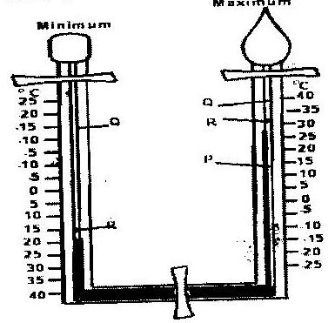
P, Q and R. (3mks)

b) The table below shows temperature readings at a weather station for one
week
Temp/Day | Mon | Tue | Wed | Thur | Fri | Sat | Sun
Max. ⁰C | 28 | 27 | 28 | 29 | 29 | 29 | 26
Min. ⁰C | 18 | 18 | 20 | 16 | 22 | 21 | 19
Calculate the following:
i) The diurnal range of temperature for Tuesday: (1mk)
ii) The mean temperature for Saturday. (1mk)
3. a) Give two examples of non-metallic minerals. (2mks)
b) Why is industrial diamond used in shaping hard stones and metals? (1mk)
4. a) Apart from water vapour, name two other substances that are suspended in
the atmosphere.
b) i) Give two factors that are considered when classifying clouds. (2mks)
ii) Name two types of clouds that give rise to rainfall in the tropical
regions. (2mks)
5. a) The diagram below shows an eclipse. Name the features marked V and
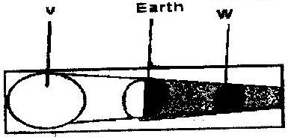
W. (2mks)

b) State four proofs that the shape of the earth is spherical. (4mks)

SECTION B
Answer question 6 and any other Two questions from this section
6. a) Study the map of Kericho 1:50,000 provided and answer the following
questions.
i) Give the longitudinal extent of the area covered by the map.
(1mk)
ii) Convert the scale of the map into a statement scale. (2mks)
iii) What is the approximate height of the hill in the grid squire 6770?
(2mks)
iv) Calculate the area of Kericho Municipality. Give your answer in
square kilometers. (2mks)
b) i) Give three types of natural vegetation found to the west of Easting
53 (3mks)
ii) What is the bearing of the trigonometrical station at grid reference
554668 from the factory at grid reference 610626? (2mks)
iii) Identify three forms of land transport found to the north of
Northing 68 and west of Easting 53? (3mks)
c) Describe the distribution of settlements in the are covered by the map.
(4mks)
d) Citing evidence from the map, explain three factors that favour the
establishment of tea estates in the area covered by the map. (6mks)
7. a) Differentiate between magna and lava. (2mks)
b) The diagram below shows some intrusive volcanic features.
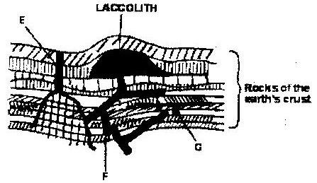

Name the features marked E, f and G. (3mks)
c) Describe how the following features are formed and for each give and example from Kenya:
i) A crater (3mks)
ii) A geyser (5mks)
iii) A lava plateau (4mks)
d) Explain four ways in which volcanic features influence human activities.
(8mks)
8. a) i) Name two sources of rivers. (2mks)

ii) The diagram below shows the three stages of the long profile of a
river.
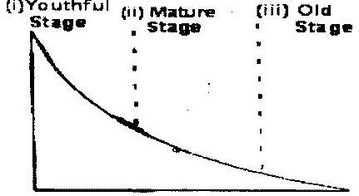

Give two features formed by the rivers in each of the three stages.
(6mks)
b) Describe the processes by which a river transports its load. (6mks)
c) Describe each of the following drainage patterns;
i) State two methods you would use to collect data. (3mks)
ii) State three advantages of studying the work of rivers through
fieldwork. (3mks)
9. a) i) Describe how ice is formed on a high mountain. (3mks)
ii) Apart from a valley glacier, name two types of ice masses found
on Mountains in East Africa.
b) Explain how the movement of a valley glacier is influenced by the
following factors:
i) Temperature (2mks)
ii) Width of a glacier channel. (2mks)
c) Describe the distinctive characteristics of the following features resulting
from glacial erosion:
i) A corrie (3mks)
ii) A pyramidal peak (3mks)
iii) a fiord (fjord) (3mks)
d) i) The diagram below shows a glaciated upland area
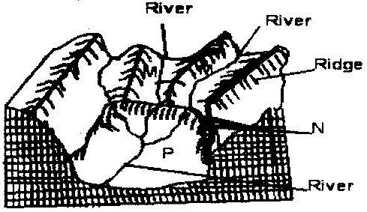

Name the features marked M, N, and P.
ii) Describe the process through which a crag and tail is formed
(4mks)
10. a) The diagram below shows a breaking sea wave.
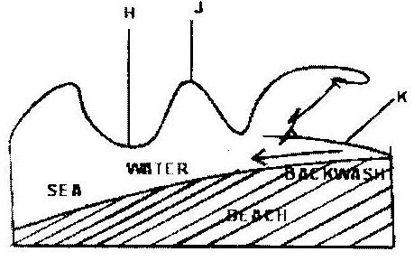

i) Name the features marked M, N, and P.
ii) Describe the process through which a crag and tail is formed.
(4mks)
b) Describe three processes of wave erosion along the coast. (2mks)
c) Explain how the following factors influence wave deposition:
i) Gradient of the shore (4mks)
ii) Depth of the sea (4mks)
e) Using well labeled diagrams, describe how a bay bar is formed. (6mks)

GEOGRAPHY PAPER 2
SECTION A
Answer all the question in this section.
1. State four characteristics of shifting cultivation. (4mks)
2. Give the difference between softwood forests in Kenya and Canada under the
following sub-headings.
a) Distribution of softwood forests (2mks)
b) Transportation of the logs. (2mks)
3 a) Differentiate between land reclamation and land rehabilitation. (2mks)
b) State two ways in which each of the following problems experienced at
the Mwea irrigation Scheme can be solved;
i) Low prices of rice (2mks)
ii) Fluctuating water levels in the irrigation canals. (2mks)
4. Give five reasons why it is necessary to conserve wildlife in Kenya (5mks)
5. a) State two economic benefits of the common Market for Eastern and
Southern Africa (COMESA) to the member countries. (2mks)
b) Give four factors that limit trade among countries of Eastern Africa.

SECTION B
Answer question 6 and any other two questions from this section.
6. The photograph below show cattle rearing in an area in Kenya. Use it to answer
question (a)

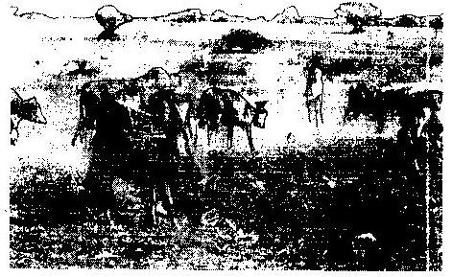

a) i) Identify the type of photograph. (1mk)
ii) Describe the features shown on the photograph. (3mks)
iii) What three indicators show that the area was experiencing drought
When the photograph was taken. (3mks)
b) Discuss nomadic pastoralist in Kenya under the following sub-headings;
i) The cattle breeds kept (2mks)
ii) The pattern of movement (2mks)
iii) Marketing of the animals. (3mks)
c) i) give three reasons why nomadic pastoralists keep large herds of
animals. (3mks)
ii) Explain four measures taken by the government of Kenya to
improve beef cattle farming (8mks)

7. a) i) Give two documents from where information on population data is
obtained (2mks)
- The pyramid below represents population structure Kenya.

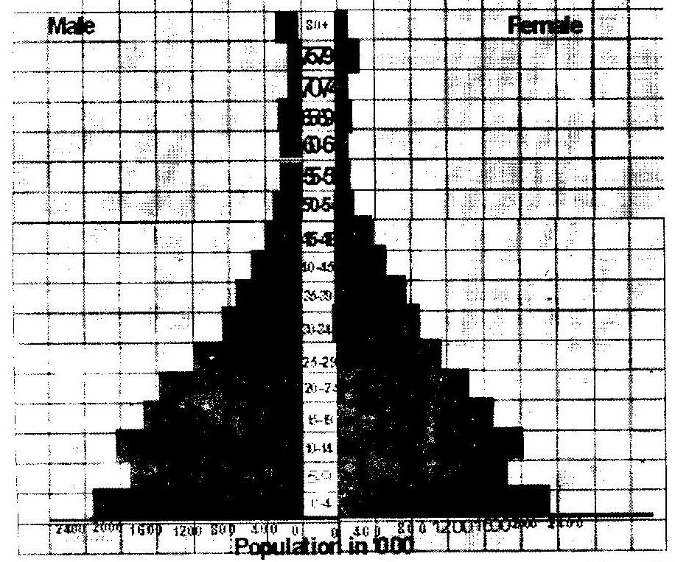

Describe the characteristics of the population as represented by the
pyramid. (3mks)
b) i) In 1989 Kenya population was 21.4 million while in 1999 it was
28.7 million. Calculate the population was 21.4 million. Calculate the population growth rate over the 10 year period. (Show your calculations) (2mks)
ii) Explain two factors which may have led to the large population
increase between 1989 and 1999. (4mks)
c) Explain three consequences of high population growth rate. (6mks)
d) Explain four physical factors that influence population distribution in East
Africa. (8mks)
8. a) The table below shows the quantity of minerals produced in Kenya in
tones between years 2001 and 2005. Use it to answer questions (a) (i)
and (ii).
Mineral/Year | 2001 | 2002 | 2003 | 2004 | 2005
Soda ash | 297,789 | 304, 110 | 352, 560 | 353, 835 | 360, 161
Fluorspar | 11,885 | 85,015 | 80, 201 | 117, 986 | 26, 595
Salt | 5,664 | 18,848 | 21,199 | 31,139 | 26,595
Others | 6,093 | 7,000 | 4,971 | 6,315 | 8,972
Source: Economic Survey 2006
i) Calculate the average annual production of soda ash over the 5
year 5 years period. (2mks)
ii) Calculate the total mineral production for the year 2003. (1mk)
b) The diagram below shows shaft mining.
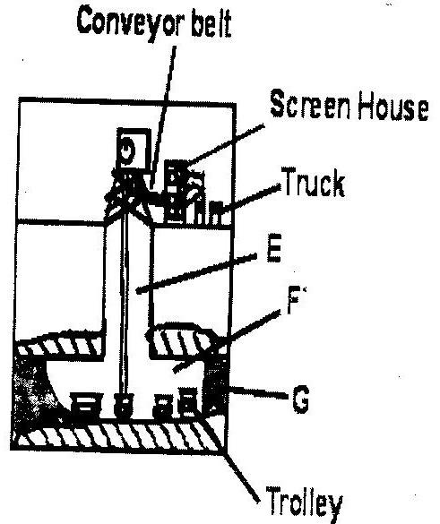

i) Name the parts marked E, F and G. (3mks)
ii) State two problems associated with shaft mining. (2mks)
c) Explain four ways in which gold mining has contributed to the economy
of South Africa. (8mks)
d) Explain three negative effective effects of mining on the environment
(6mks)
9. a) State three physical conditions that favour large scale sugarcane faming
in Kenya. (10mks)
b) Describe the cultivation of sugarcane farming in Kenya. (10mks)
c) Explain five problems facing sugarcane farming in Kenya. (10 mks)
d) Your class visited a sugar factory for a field study on sugar processing.
i) Outline four stages if sugar processing that the class may have
observed. (4mks)
ii) Name two by-products of sugar that the class may have identified
during the study. (2mks)
10. Use the map of North-West Atlantic below to answer questions (a) and (b).
NORTH –WEST ATLANTIC FISHING GROUNDS

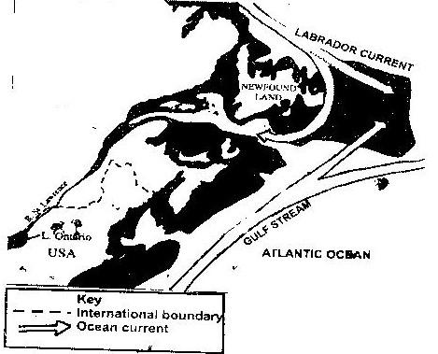

a) i) Name the country
ii) Explain how the two ocean currents shown on the map influence
fishing in the area shaded on the map other than ocean currents.
(6mks)
b) Explain three factors that favour fishing in the area shaded on the map
other than ocean currents (6mks)
c) Explain why in East Africa, fresh water fishing water in the area shaded on the map other than ocean currents. (6mks)
d) The diagram below shows a fishing method

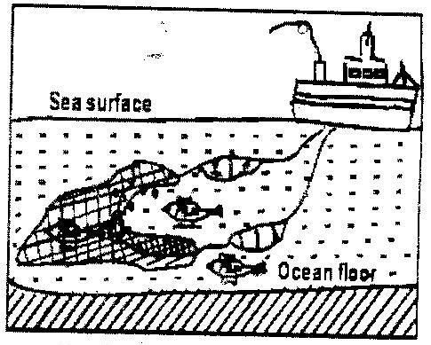

i) Describe how the method is used in catching fish. (5mks)
ii) List three methods used to preserve fish. (3mks)
ANSWERS TO GEOGRAPHY KCSE 2008 QUESTIONS
PAPER 1
SECTION A
1. a) Give three reasons why it is necessary to study the plate tectonics theory.
- It explains the current position of the continents
- It enables one to understand the creation of the structural land forms
- It helps one to understand how the earth maintains balance/isostasy
- It explains the cause of earth quakes/volcanicy
b)
- Divergence/extension/constructive
- Convergence/compress ional/destructive
- Transform /conservative.
2. a) P- Mercury
Q- alcohol/oil of Cleo salt
R- Metal index.
b) i) The diurnal range of temperature for Tuesday; 27-18 =90⁰C
ii) The mean temperature for Saturday
29 + 21 = 250C
2
3. a) -Coal
-Petroleum
-Diamond
-carbon
b) Because it is the hardest mineral/ it does not break easily
4. a) -Dust particles
-Pollen grains
-Gases
-Salt particles/sodium chloride
-Smoke Any 2x1 mks
b) i) -Their height
-Their shape/form
-Appearance
ii) -Cumulonimbus
-Cumulus
-Nimbostratus
5. a) V - The sun
W - The moon
b)
    - The gradual emergence of a ship approaching the shore.
    - Circumnavigation of the earth along a straight path leads one to the
starting point from the opposite direction.
    - The different times during which the sun rises and sets in different parts of the world.
    - The appearance of the middle pole to be relatively higher than other poles placed along a straight line on a level ground at equal distances. (curved)
    - The circular shape of the earth seen on photographs taken from satellites
    - The circular shadow cast by the earth during a lunar eclipse
    - The earth is a planet and all planets are sphere. Any 4x1 mks

SECTION B
6. a) i) -35⁰ 15’ to 35⁰ 25’/ 10’
ii) Map scale 1: 50,000 km
100,000
= 0.5 km
Statement scale is 1cm represents o.5 km / ½ km
iii) Just over 2120 m and below 2140m
iv) 10.5 - 11.0 km²
b) i)
- Scrub
- Woodland
- Scattered trees
- Thicket
- Papyrus/papyrus swamp vegetation Any 3x1 = 3mks
ii) 305⁰C (304⁰ – 306⁰) / N 55⁰ (55⁰- 56⁰)
iii) All weather loose surface
iv) Dry weather road
v) Motorable tracks/main track
vi) Foot paths /other tracks.
c)
- There are few settlements/labour lines within the tea estates and forested
areas
- To the north and west of Kericho-Lumbwa road, the settlements form a dispersed pattern
- To the north of Tugenon river, there are few or no settlements
- There are nucleated settlements in the market/shopping centres/labour lines/villages
- Some areas with the steep slopes and river valleys have a few or no settlements
- Kericho town is the main settlement are/forms a large cluster of settlement
- Few settlement in the tea estate.
d)
- The high relief modifies temperatures making the area suitable for the
growing of the area suitable for the growing of tea bushes.
- The relatively undulating slopes allow proper drainage of soils making it
ideal for tea farming/allows mechanization
- Presence of forests/many permanent rivers show that the area receives high rainfall which is suitable for tea growing.
- The area has fairly dense settlements which indicates availability of labour needed in tea farming.
- The area is well served by all weather roads which are needed for the transportation of tea from the farms to the factory /transportation of labour
Any 3x2=6mks
7. a) Magma is the molten rock material which originates from the interior of
earth, cools while below the earths surface (and has large crystals) while lava is the molten rock materials that has reached the surface. (Has solidified and has small crystals. (2mks)
b) E- Dyke
F- Lapolith
G- Sill
c) i) A crater
- Eruption of lava through a central vent causes building up of a
cone.
- The lava in the vent cools and contracts.
- The cool lava withdraws into the vent leaving a shallow depression of the cone
- Gas explosions may blow away surface rocks causing a crater
Examples
Mt Longonot
Menengai
Mt/suswa
Mt Marsabit
ii) A geyser
- Rainwater percolates down through cracks in the rocks.
- The water gets into contacts with hot igneous rocks
- The water gets into contacts with hot igneous rocks
- The water is super heated and gases/steam form
- Pressure builds up in the cracks.
- The pressure causes steam and water to be ejected explosively as
jet to the surface intermittently.
- The water and steam are emitted intermittently as pressure level
changes.
Example – Lake Bogoria
iii) A lava plateau
- It is formed when magma reaches the surface of the earth through a series of vents/fissures
- The lava is extremely fluid/ultra-basic
- The lava spreads evenly over a large area
- The lava cools slowly and solidifies
Example
Yatta plateau
Uasin Gishu plateau
Laikipia plateau
d)
- Volcanic highlands/mountains are sources of rivers which provide water
for domestic/agriculture/industrial use.
- Volcanic rocks weather down to form fertile volcanic soils which support
agriculture
- Volcanic rocks are important building materials in the construction industry
- Volcanic features are tourist attractions which promote tourism.
- Volcanic mountains/highlands influence formation of relief rainfall which encourages agricultural activities.
- Volcanic highlands influence formation of relief rainfall which encourages agricultural activities
- Volcanic highlands/mountains modify temperatures making them making them attractive to human settlements
- Volcanic features such as steam jets and geysers provide suitable sites for geothermal power generation.
8. a) i) -Lake /swamp
-Melting ice/snow
-Springs
-Surface run off.
ii)
Youthful stages
- Rapids/water fall/cascades
- V-shaped valleys/canyons
- Potholes
- Plunge pools
- Interlocking spurs
Mature stage
- Meanders
- River cliff/bluff
- Wide v shaped valley
- Slip –off- siopes
- Alluvial fans
- Braids
Old stage
- Meanders
- Ox-bow lakes
- Braided channel/isels
- Flood plain
- Levees
- Devees
- Deferred tributaries
- River terraces
- Distributaries/deltas
- Bluffs
- Meanders scar
b) Traction process
The large and heavy loads of the river are rolled /dragged along the riaver by the force of the moving water and gravity.

Saltation
Some large fragments that cannot remain suspended in the water are momentarily lifted and dropped by water turbulence. The series of hops move the load down the river.
Suspension
Light insoluble materials such as sand and silt grains are carried and maintained within the water by river turbulence and transported downstream.
Solution process
The soluble minerals /materials are dissolved in river water and carried away
c) i) Dendritic patterns
- It develops in areas where rocks have uniform structures.
- The direction of flow is influenced by the slope of the land
- The tributaries converge on the main river forming a shape like that of a tree and its branches.
ii) Trellis pattern
- The pattern develops where soft and hard rocks alternate vertically
- The tributaries join the main river at acute angles.
- The consequent streams flow to the opposite direction of the main river
- The main river and its tributaries form a rectilinear pattern.
d) i)
- Observation/digging up the deposits to expose the inner layers
- Collecting samples
- Taking photographs
- Interviewing the people around the river.
ii)
- It enables one to collect first hand information
- It promotes development of practical skills
- It promotes application of acquired knowledge
- One is able to develop skills of data analysis.
9. a) i)
- Due to low temperatures, water vapour freezes and forms snow
- Snow falls and accumulates on the mountain top/higher slopes
- Snow continues pilling and new layers exert pressure on the lower
layer
- Lower layers become compressed/compacted as air is expelled
from the spaces by show particles
- The compacted layers are ice.
ii)
- Ice caps
- Cirque glaciers
b) i) Temperature
- Glaciers move faster in summer/when the temperatures are higher
because the ice melts due to the warm conditions whereas in winter/ when temperatures are low, ice movement is slow due to cold conditions.
- The temperature of the bottom of the valley glacier rises with
Pressure. Thereby thawing and enabling its movement down slope.
ii) Width of a glacier channel
- When the channel is wide ice movement is slow that is because ice
spreads out forming a thin layers there is less pressure to cause thawing that would facilitate ice movement/vice versa.
c) i) A corrie
    - Is a deep rock basin
    - Has steep sides
    - Is arm-chair in shape/semi circular
    - Has a high back wall
    - Has a reverse slope on the lower side
ii) Fiords
- Has steep walls
- Is a narrow sea inlet
- Is a U-shaped
- Has hanging valleys
- Has deep water shallower seawards/deeper landward
d) i) M- Hanging valley
N-Water valley
P-U-shaped valley / glacial trough
ii)
- A large block of rock stands on the path of oncoming glacier
- The moving ice plucks off/erodes weak rock fragments from the
upper side of the rock
- As the ice moves round and over the resistant rock it carries the eroded materials to the lee side
- The lee side does not experience erosion.
- Eroded materials are deposited materials increase on the lee side.
- With time the moving ice smoothens the side of the on coming ice deposited materials increase on the lee side
- The resistant rock is the crag while the materials deposited on the
leeward to form the tail.
10. a) i) H-Trough
J-Crest
K-Swash
ii) A backwash is the return flow of water down the beach to the sea
after a wave is broken.
b) Abrasion/corrosion
- Rock fragments carried by waves are used as a tool to grind against
the cliff . As waves break rock fragments carried by the back wash erodes the sea.

Solution/corrosion
- The solvent and chemical action of the sea water dissolves and
removes the minerals that are found in the cliff/sea floor especially where there are limestone rocks.
Hydraulic action
- The swash/breaking waves hit against the cliffs shattering the rocks. The breaking waves compress air into the cracks/joints in the cliff face. This widens the cracks and parts of the rocks may break off.
Attrition
- Particles that are carried by waves are constantly colliding against each other and wears them into smaller sizes
c) i) Gradient of the shore
A show with a gentle gradient reduces the velocity/speed of the flow of the backwash causing the waves to deposit the load on the shore. Where the shore is steep, the velocity/speed of flow of the backwash will cause the materials to be moved from the shore back into the sea. (There will be little or no deposition)
Gentle gradient 2 marks
Steep gradient 2 marks
ii) Depth of the sea
Shallow water causes waves to break thus encouraging deposition.
Where the sea is deep, there is less deposition because the sea bed is not in contact with the waves carrying deposits.
Shallow water 2 marks
Deep water 2 marks
d) Using well labeled diagrams, describe how a bay bar is formed
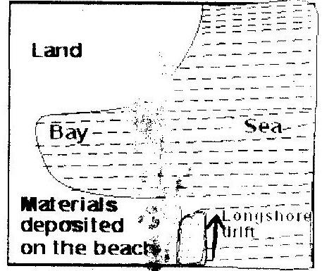

Stage 1
Longshore drift deposits materials at the entrance
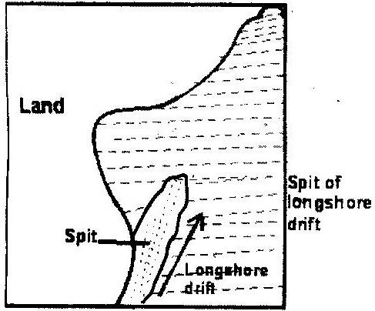
Stage 2
A spit forms at the entrance of the bay
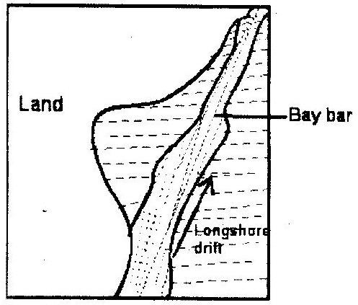

Stage 3
The alongshore drift continues to deposit materials and the spit extends towards the other end of the lagoon. Eventually the spit reached the other end thus forming a bay bar. Diagrams 3 marks
Text 3 marks
PAPER 2 ANSWERS
SECTION A
1. - Vegetation is cleared by slashing and burning
- There is the use of little or no manure/use of ash
- The land is communally owned
- The yields decline after a certain period of continuous use. The land is abandoned when the yields decline
- Both the settlements and plots are temporary
- Farming depends mainly on family labour
- The farmers use simple implements
- It is mainly for subsistence
- Plots are small and scattered
2. a)
- In Kenya, softwood forests are found mainly in the highlands while in
Canada they are found both in highland and lowland areas.
- In Kenya, softwood forests cover a small percentage of the total land area while in Canada they cover large tracts of land.
b)
- In Kenya, logs are transported by road/trucks while in Canada transport is
mainly by water by rivers.
- In Kenya, transportation is expensive while in Canada it is cheap.
3. a) Land reclamation is the process of converting less productive land into a
more productive state for agricultural or settlement purposes while land rehabilitation is the process of restoring degraded/impoverished/damaged land back to a useful state.
b) i)
- Diversifying the crops produced in the scheme.
- Improving the quality of the rice produced through research
- The government should restrict the importation of rice to reduce
competition.
- Improve the marketing strategies to enable farmers to source for
market outside Kenya
ii)
- Continuous dredging of canals/deepening of canals
- Construction of dams to store water for use during dry season.
- Government to enforce laws on proper land use in the catchment
areas of the rivers that supply water to the scheme.
4. - To maintain the genetic diversity/genetic pool
- To preserve wildlife for future generation/posterity.
- To protect the endangered species of plants and animals
- To ensure sustainable utilization of species
- To attract tourists/to earn foreign exchange.
- To use wildlife for research/for education.
- To maintain aesthetics for recreation
- To provide materials for medicinal extracts.
5. a)
- It has created a large market for goods produced in members countries
- It has resulted in the availability of a variety of goods
- It has led to the establishment of common tariff
- The removal of visa requirements has mad it easier for traders to move
across borders within the region.
b)
- Membership to different trading blocks by different countries.
- Lack of a common currency.
- Underdeveloped infrastructure/poor transport network
- Restriction of movement of people and goods/high taxes rates
- Political instability
- Political differences
6. a) i) Ground /ground general view
ii)
- On the foreground there is bare ground/some short vegetation
cattle browsing /grazing.
- In the middle ground there is a herdsman and some cattle on the
move/raising dust.
- There is a road in the middle ground
- At the background there are some patches of grass/some trees/shrubs/thickets
- Some parts of the background are bare surface
- There are in the middle
- Clear skies in the background
- There is a fence in the middle ground
iii)
- The cloudless sky
- The malnourished/thin animals
- Dust raised by moving animals
- Bare ground/sparse vegetation /patches of vegetation/little
vegetation
- Patches of dry /brown grass
b) i) The pastoralists keep mainly indigenous breeds such as Zebu and
Boran.
ii)
- Their movement is seasonal.
- During the dry season the pastoralists migrate with their livestock
to the highlands where there is pasture and water
- During the wet season they move to the plains since pasture is
available.
iii)
- Some cattle are sold to slaughter houses/to individuals.
- Some pastoralists sell their livestock through community
groups/ranches.
- Some livestock are sold to the livestock are sold to the livestock

marketing Department
- Some pastoralists sell their animals to Kenya Meat Commission.
c) i)
- It is a form of insurance against natural calamities /diseases /
drought.
- Animals are kept as a sign of wealth/prestige/social status.
- Animals are kept for use to pay dowry.
- Animals are used as a source of food/milk/meat/blood
- Animals are a source of income
ii)
- It encourages research /the cross-breeding of traditional cattle
breeds with exotic ones. This improves the quality of the animals/cross breeds are more resistant to diseases than pure exotic breeds
- It strengthens community education to teach beef cattle farmers better livestock managements
- It has constructed roads to make services accessible to farmers/make transportation of animals to markets easier
- It encourages the replacement of the coarse grass with nutritious pasture to improve the quality of animals.
- It has sunk bore holes/dug wells/constructed dams to provide water for the animals.
- It has revived Kenya Meat Commission (KMC), a government parastatal that buys animals from farmers for slaughter.
7. a) i)
- National census report
- Text books
- Magazines
- Periodicals/Journals
- Statistical abstracts
ii)
- The number of male and female is almost equal to all ages.
- The dependency ratio is high
- The number of infants from age 0-4 is high/the population has a
high birth rate.
- The middle age/working population is low
- The number of youth aged 5-19 is high
b) i) -28.7 – 21.4 = 7.3
7.3 x 100 = 3.4%
21.410
ii) Early marriages.
Many people in Kenya get married early and this allows them a longer period of fertility resulting in many children being born.

Improved medical care:
This leads to higher chances of survival for both the mothers and infants as well as the general population, thus increasing the survival rates.
Improved Diet:
This results into better health for the entire population hence reducing the mortality rate.
Cultural beliefs:
Some cultures encourage large families due to the preference of one gender to other/some /some cultures/religions discourage the use of contraceptive/family planning leading to couples getting many children.
Migration:
Due to political instability in neighboring countries e.g Sudan, Ethiopia there was an increase of refugees hence high population increase.
c) - It leads to high dependency ration resulting into little savings by
the working group /low investments/low living standards
- There is likely to be a high unemployment rate since job opportunities may not increase at a rate that can cope with the increasing number of job seekers /may increase the rate of crime
- It increases demand for food which may lead to food shortage
- It increases demand for agricultural land causing land fragmentation/landlessness/destruction of forests.
- Expenditure while meeting demands for the large population reduces revenue that would be used for development of income generating projects hence slow economic growth.
d) Climate:
The cool and wet/hot & wet/high & reliable rainfall areas are densely populated because they are suitable for farming/hot dry areas have sparse population because they are unsuitable for farming
Relief:
Mountains and hilly areas have low temperatures/are rugged and this discourages settlement/development of infrastructure/agricultural activities.
Plains and gently sloping areas are usually densely populated because they are suitable for settlement and other economic activities. Flat areas depression are sparsely populated because of poor drainage, which causes swampy conditions/flooding.
Soil:
Fertile soils are suitable for agriculture thus attracting large population/areas that have poor soils have sparse population.
Pests and diseases:
Areas that are infested with pests and disease-carrying vectors discourage settlement since the conditions are unhealthy

Drainage:
Low-lying areas that are prone to periodic flooding and water logging have sparse population because they are unsuitable for agriculture and other economic activities/well drained areas attract settlement
Vegetation:
Forested areas/savannah woodland have wild animals, disease vectors and discourage human settlement and other economic activities
8. i) Soda ash average production for 5 years
=1668446 ÷ 5
=333689 .2 Tonnes
ii) Mineral production for the year 2003
=45369.2 Tonnes
iii)
- It is a raw material for making glass
- It is used in king detergents
- It is used in some chemical industries /petroleum refining
- It is used as a water softener/water treatment
- It is in desulphurising steel
- It is used in paper industries.
b) i) E- main shaft/vertical shaft
F- Tunnel/horizontal shaft/Gallery
G- Mineral ore
ii)
- Sometimes, mines get flooded with sub/terrain water.
- There are occasional emission of poisonous gases in the mines.
- The dust produced causes respiratory diseases
- Sometimes tunnels collapse causing deaths of miners.
c)
- Gold is highly prices, thus it earns foreign exchanger which used to
improve other sectors of the economy.
- Gold provides raw materials for industries that make jewellery and other
highly valued items thus promoting industrial expansion.
- Gold as a medium of exchange in the world is used in South Africa as a
means of paying international debts.
- Gold mining industry has generated employment opportunities, which
raises the standard of living of the people /earn more income
- Gold mining has led to development of towns in the Rand and the Orange Free State creating a large demand for agricultural products.
- Mining of gold has led to the expansion of infrastructure such as transport and communication/provision of social amenities.
- Gold mining has led to the development of industrial mining skills that are useful in other sectors of the economy.
d)
- The dumping of rock waste had led to the loss of biodiversity/destruction
of natural vegetation
- Dereliction of land due to dumping of waste materials is an eye
sore/destroys the natural beauty of the land
- Dereliction of land due to dumping of waste materials is an eye
sore/destroys the natural beauty of the land
- Pollution of the areas by noise/blasts smoke and water pools are all
health hazards.
- Mining disrupts the water table which may lead to shortage of water.
- Mining takes up land that would have been used for agriculture thus
interfering with food production.
- Mining displaces human settlements thus disrupting people and
necessitating expensive resettlement processes.
9 a)
- Well drained fertile soils /Black cotton soils
- Gently sloping/undulating landscape
- High rainfall 1200 to 1500 mm well distributed throughout the year.
- Moderate high temperature/20⁰C- 28⁰C
- Long periods of sunlight.
b)
- The land is cleared of its natural vegetation
- It is ploughed using either tractors or ox-drawn ploughs
- Harrowing is done to loosen the large lumps of soil.
- Shallow furrows are dug at intervals of 1.2 and 1.8 metres apart.
- Cutting/seed cane are planted in the furrows
- Top dressing/nitrogen fertilizers are applied
- Weeding is done regularly/herbicides are applied
- After 18 months the cane is ready for harvesting
- The cane is cut/harvested using pangas
- The harvested cane is loaded into Lorries for transportation to the factory.
c)
- Pests such as termites and white grub/diseases such as ratoon stunting and
smut attack the plants and lowers the yields leading to low income for the farmers
- Accidental fires/fires set by arsonists destroy the cane resulting in heavy losses to the farmers.
- Flooding of market by cheap imported/sugar results in unfair competition
causing delay in payments to the farmers.
- Delays in harvesting reduce the quality tonnage of the cane reducing the
farmer’s earnings.
- Closure of some factories such as (Ramisi and Miwani ) has deprived farmers of the source of income/annual closures of factories for servicing of machines disrupts the farmers’ calendar of activities.
- Poor feeder roads in some areas leads to delayed delivery of the cane to the factory lowering the quality and subsequently the profit to the farmers.
- Prolonged droughts in some areas destroys the crop leading to heavy
losses.
- High cost of farm input reduces the farmer’ profit margins
- Mismanagement of factories and cooperatives leads to delayed payments thus discouraging the farmers
d) i)
- Weighing of the cane
- Chopping of the cane
- Crushing of the cane
- Boiling
- Filtering
- Grading
- Packing/bagging of sugar
ii)
- Molasses
- Bagasse
- Wax
- Aconitic acid
- Filter cake/mud
10. a) i)
- Canada
ii)
- The convergence of the warm and cold currents causes upwelling
of ocean water which bring minerals for planktons to the surface attracting large number of fish to the area
- The convergence of warm and cold currents modifies the
temperature of the ocean water making the area ideal for fishing throughout the year
- The cool waters favour survival of a wide variety of fish species which makes the area an important fishing ground
b)
- The area has a broad shallow continental shelf which provides suitable
conditions for the growth of plankton used by fish as food
- The region experiences low temperatures that are favourable for the
survival of fish/for preservation/storage of fish.
- Due to the ruggedness of the land bordering the shaded area/the short
growing season. Many people therefore concentrate on fishing as an alternative economic activity.
- The hinterland is densely populated thus providing ready market for the fish.
- Advanced technology has resulted in highly developed ship building/fishing vessels are equipped with modern preservation facilities, thus making it possible for fishermen to carryout large scale fishing.
- The indented coastline provides ideal fish breeding sites/sheltered bays are ideal for setting up fishing villages and ports.
c)
- There numerous inland fishing grounds such as lakes and rivers which are
accessible to many people.
- There is low demand for sea fish compared to fresh water fish making
fresh water fishing more preferable.
- The narrow continental shelf along the coast of East Africa limits the growth of plankton thus limiting the breeding of fish/limiting the variety of edible fish.
- The stiff competition if the open sea from the industrialized countries whose fishermen use modern fishing equipment discourages local fisherman
- The limited technology and inadequate capital make it difficult to develop marine fishing.
d) i)
- A bag-shaped net is attached to a trawler/ship
- The net is cast into the water by the trawler
- The nets’ mouth is kept open by other boards/head beam
- The upper part of the net is kept afloat by corks/floats.
- Weights are used to keep the lower part of the net at the sea bed
- The trawler drags the net along the sea bed.
- After sufficient fish has been caught, the net hauled to the trawler to
empty the fish,
ii)
- Canning
- Freezing
- Smoking
- Salting
- Sun-drying
- Frying

