NUTRITION IN PLANTS
- Nutrition- it’s the process by which organisms in food materials.
  - Importance of nutrition
- It provides a living organism with raw material for:
- Respiration to produce energy in the cells
- Growth of cells and tissues
- Repair of worn out or damaged tissues such as healing of wounds
  - Types of nutrition
- There are two types of nutrition
- Autotrophic nutrition – This is where the plants contain chlorophyll make their own food. Such organisms are called autotrophs.
- Heterotrophic nutrition- This is where the organism takes in or ingests food from plants or animals. The organisms are called heterotrophs.
- Nutrition in plants
- Plants and certain types of bacteria are autotrophs. There are type of autotrophic nutrition i.e.
- Phototropism
- The organisms use carbon dioxide water and energy from soil to make their own food in a process called photosynthesis.
- Phototrophic nutrition is also called holophytic nutrition.
- Chemotropism
- The organisms called chemotrophs make their own food using energy from special types of chemical reactions.
- They do not use sunlight, chemotrops include certain bacteria.
  - PHOTOSYNTHESIS
- This is the manufacture of food materials using light energy from the sun. It takes place in green plants.
- Importance of green plants
- As source of food and energy
- Plants make their own food and animals depend directly or indirectly on plants for their food. Food contains energy from the sun stored as chemical energy.
- Provides oxygen
- It replaces oxygen in air which is continuously used up by all living things for respiration.
- Makes carbon IV oxide available to plants and animals
- Photosynthesis uses carbon IV oxide from the air and incorporates it into carbon found in food substances.
- It is responsible for the energy stored in coal and petroleum
- Plants and animals that existed on earth millions of years ago were converted into fossils. The energy they contained is stored as fossil fuels such as petroleum and coal.
- External structure of a leaf
- It consist of ;
- Leaf blade/lamina-it’s the flattened surface.
- Its green in colour and contains the photosynthetic tissue
- In dicotyledonous plants, simple leaves have a thick mid-rib which runs in the middle.
- From the mid-rib arises small veins that run into the lamina forming an extensive network of veins
- In monocotyledonous plants, the mid-rib is absent small veins run parallel to each other
- In some plants the leaf is attached to to the stem or a branch by a petiole while in others the leaf is attached directly
- In monocotyledonous plants, some leaves are attached to the stem by the leaf sheath
- Internal structure of a leaf
- X
- Cuticle
- It covers the upper surface of most leaves and makes them appear shiny.
- It’s very thin waxy transparent coating found on the upper and lower leaf surfaces of some plants.
- Its waxy nature makes it waterproof.
- Functions of cuticle
- To reduce the amount of water lost from the plant by transpiration.
- To protect the inner tissues from:
- Infection by micro- organisms that may cause disease
- Mechanical damage by animals or falling objects.
- Epidermis
- This is the layer of cells below the cuticle. It’s usually one cell thick to allow light to pass though the cells easily.
- The epidermis forms a protective layer over the cells that carry out photosynthesis
- Palisade mesophyll
- Maximum photosynthesis takes place in the palisade mesophyll. This is a layer of cells located below the upper epidermis.
- Palisade cells are closely packed with a few air spaces between them
- The cells are elongated and lie at right angle to the leaf epidermis. They contain many chloroplasts. Their shapes allow them to absorb most of the light falling on the leaf.
- They are close to the upper epidermis so as to absorb maximum light. The chloroplast can move within the palisade cells to the side receiving the optimum amount of light.
- Spongy mesophyll
- It’s composed of cells located between the palisade mesophyll and the lower epidermis.
- The cells are irregular in shape and are loosely arranged. They have large air spaces between them which allows for air circulation and gaseous exchange between the cells and the air surrounding them.
- Spongy mesophyll cells are also lined with moisture to facilitate uptake of oxygen and release of Carbon iv Oxide. They have fewer chloroplasts than the palisade mesophyll cells.
- Vascular tissues
- The network of veins in the leaves is made up of vascular tissues. This tissue has xylem vessels which supply water and mineral salts to the leaf. It also has phloem which takes away manufactured food substances from the leaf to other parts of the plant.
- Vascular tissues also provide support for the cells in the leaf
- Stomata
- They are found on the upper or lower epidermis or both.
- They allow entry of Carbon iv Oxide into the leaf for photosynthesis
- Adaptations of a leaf for photosynthesis
- The leaf blade (lamina) is broad and flat to provide a large surface area for absorption of sunlight and Carbon iv Oxide
- Most leaves are thin to reduce the distance across which Carbon iv Oxide has to diffuse from the stomata to reach the photosynthesizing cells.
- The leaves are arranged on the stems of some plants in such a way that each leaf is able to absorb the maximum light. This regular arrangement of leaves on the stem minimizes overlapping and overshadowing. This is called leaf mosaic
- The presence of air spaces in the spongy mesophyll allows for faster movement of gases.
- The leaf veins conduct water and mineral salts to the photosynthetic cells. They also transport manufactured food to other parts of the plant enabling more to be made.
- The cuticle and epidermis are transparent, ensuring penetration of light to the palisade cells.
- Each palisade cell contains a large number of chloroplasts and their arrangement and location next to the epidermis enables them to receive maximum sunlight
- Presence of stomata for efficient diffusion of oxygen, water vapour and Carbon iv Oxide
- Palisade cells are closely packed and vertically elongated to allow many to be packed beneath the epidermis where they can receive maximum light
- Structure and function of the chloroplast
- The chloroplast is the organelle in a plant cell where photosynthesis takes place.
- Chloroplasts are found in the cytoplasm of palisade mesophyll, spongy mesophyll and guard cells.
- Cells that have chloroplasts are called photosynthetic cells
- 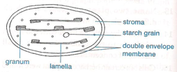
- Each chloroplast is surrounded by two membranes ie the outer and inner membranes.
- Inside each chloroplast, are small units called grana (singular granum)
- A granum consists of a number of disks placed on each other like a pile of coins. One granum is connected to another by inter-granular/lamellae
- Granum contains chlorophyll molecules, and other photosynthetic pigments for the light reactions of photosynthesis
- Granum provides a large surface area to accommodate a large number of chlorophyll molecules
- Stroma contains enzymes that speed up the rate of photosynthesis.
  - Activity 1: testing for starch in a leaf
- Materials
- Water bath
- Bunsen burner
- Forceps
- Droppers
- Iodine
- Water
- Ethanol(methylated spirit)
- 2 test tubes
- White tile
- stop watch
- Procedure
- Take a leaf from a green plant that has been in the sun for several hours and dip it in a boiling water bath for 2-3minutes. This treatment:
- Kills all the living tissues in the leaf thus preventing further chemical reactions.
- Ruptures any starch granules present
- Put a boiling tube half filled with methylated spirit into the boiling water (water bath). Do not expose the methylated spirit to a naked flame because;
- Alcohol boils at a lower temperature than water (78ºC) so it will boil in hot water.
- Take the leaf and dip it into the boiling methylated spirit. Leave the leaf in the hot methylated spirit until all the chlorophyll is removed – the hot methylated spirit is a good solvent which dissolves and extracts (removes) chlorophyll from the leaf leaving it white.
- NB: Alcohol also makes the leaf stiff and brittle.
- Remove the leaf from the test tube and dip it in a beaker of cold water. This softens the leaf by returning water that was removed by ethanol.
- Take the leaf using a pair of forceps and spread it out carefully onto a white tile.
- Using a dropper, place a few drops of iodine solution onto the leaf and note the colour.
- Results
- The parts of the leaf containing starch are stained blue- black while those without starch are stained brown.
- Methylated spirit turns from purple colour to green colour indicating presence of chlorophyll from the leaf.
- Destarching a plant
- When a plant is left in a dark cupboard for 2days (48 hours) and is tested for the starch, it is found out that there will be no starch; it is found out that there will be no starch.
- Explanation
- The plant cannot photosynthesize in the dark. Therefore no starch is formed in the leaves when the plant is in the cupboard.
- During this period the starch already in the plant is used up. The plant is then described as being destarched.
- Factors influencing photosynthesis
- Light intensity
- The intensity of light varies with time of day, season and position of the plants on the earth’s surface.
- Photosynthesis takes place more rapidly on bright days than on dull days. Very bright light destroy chlorophyll and slows down photosynthesis.
- Plants in environment that receive a lot of sunlight have thick cuticles or hairy leaves for protection.
- Expt: To investigate the effect of light intensity on the rate of photosynthesis
- Set up the experiment as shown below:
  - X
- Place the set up first inside the laboratory, count the number of bubbles released in a minute by the plant.
- Repeat the counting but with the plant in the bright sunlight. Fill in the table below:
Light intensity | Number of bubbles produced in I minute
Inside laboratory
 | Average =
Bright sunshine | Average =
    - Discussion
- When the amount of light increases e.g. from inside laboratory to the outside in the bright sunshine, the rate of photosynthesis increases. This is seen by an increase in bubbles of oxygen gas and oxygen leaving the plant)
- Therefore increasing the light intensity increases the rate of photosynthesis to a certain level e.g.
          - X
- Temperature
- Photosynthesis is an enzyme controlled process. Any changes in the external temperature of a plant affect the activity of the enzymes in the plant cells.
- If the temperature is very low (0ºc) the enzymes become inactive and little photosynthesis occurs.
- If the temperature is higher than 40ºC, enzymes are denatured (destroyed) hence no photosynthesis i.e.
  - X
  - NB: Compensation point- this is the point at which the rate of respiration is equal to that of photosynthesis. In most plants compensation point is reached at around dawn e.g.
          - X
- Respiration rate is high and carbon iv oxide release is high
  - A-B- Increasing light intensity therefore increases rate of photosynthesis. Carbon iv oxide uptake increases.
- Compensation point. Rate of photosynthesis is equal to the rate of respiration
- B-C- Rate of photosynthesis is much higher than the rate of respiration therefore rate of uptake of carbon iv oxide is more than the rate of release of carbon iv oxide Concentration of carbon iv oxide
- Activity: effect of carbon iv oxide on rate of photosynthesis
- Set up the apparatus as shown below:
    - X

- Using the elodea plant place boiled but cooled water in the beaker. Place the set up in bright sunshine and count the average number of bubbles that will be produced per minute.
- Repeat the experiment using water with some Sodium Hydrogen Carbonate (NaHCO₃) in it count the average number of bubbles of oxygen released per minute.
- Discussion
- Boiled water is free of gases including carbon iv oxide. The rate of photosynthesis will be very low. This is by the fact that very few bubbles are counted.
- Water that has sodium hydrogen carbonate has more CO₂ dissolved in it. The rate of bubbles formed is high as O₂ is produced.
  - ACTIVITY 2
  - Set up two destarched potted plants as follows
  - Plant A: put some sodium hydrogen or potassium hydrogen carefully on the soil holding the plant. Take the transparent polythene bag and cover the whole plant with it. Secure the bottom by tying it with elastic band
        - X
  - Plant B: Repeat the procedure but place sodium hydrogen carbonate (NaHCO₃) the plastic container.
- Leave the set up in a well lit part for several hours. Detach leaves from each set up and test presence of starch
        - X
- Discussion
- Sodium hydroxide /potassium hydroxide) absorb CO₂ from the air. The air in the bag in set-up A becomes free of CO₂ after sometimes photosynthesis will not take place without carbon iv oxide. As a result no starch .test is negative.
- In set B, NaHCO₃slowly breaks up to release carbon iv oxide into the air in the polythene bag. Photosynthesis takes place and produces starch.
- This experiment shows that carbon iv oxide is needed for photosynthesis to take place. Set up B acts as the control experiment.
- Water
- Only about 1% of the water taken in by plants is used for photosynthesis. Therefore water shortage only indirectly affects the rate of photosynthesis.
  - Chlorophyll
- A high chlorophyll content in a plant implies a fast rate of photosynthesis cannot take place in a plant that does not have chlorophyll e.g. the parasitic plant (dodder) has no chlorophyll hence cannot photosynthesis.
- Activity: To determine whether chlorophyll is necessary for photosynthesis
- Expose the destarched variegated plant to bright sunlight for 3-4hours. Detach a variegated leaf from the plant and draw it.
- Label the green part and the white part. Test the leaf for starch. Draw the leaf after the teat and label the yellow/brown parts and blue black part.
- Discussion
- A variegated leaf is one whose surface shows two colours e.g. green on some parts and white on the others.
- The green plant has cells with chlorophyll so they can photosynthesize and form starch. This show a positive test for starch. This parts show positive test for starch by turning from brown to blue black.
- The white part has cells that do not have chlorophyll. These cells will not carry out photosynthesis so no starch will be formed.
- The green part of the leaf acts as a control experiment because it has all the conditions necessary for photosynthesis.
- The process of photosynthesis
- Photosynthesis occurs through a series of chemical reactions. These reactions can be divided into main stages.
- The first stage requires light energy and therefore it’s called light stage or the light dependent stage.
- The second stage does not require light energy and therefore it’s called the dark stage or the light independent stage.
- The light stage
- It takes place in the grana. During this stage chlorophyll absorbs light energy. This energy is used in various ways.
- Some is used to split up water molecules into hydrogen and oxygen atoms This is known as photolysis. i.e. photo means light
Lysis means splitting ie
- 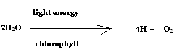Hydrogen produced is used in the dark stage.
- Some of the oxygen formed is released from the leaf through the stomata. The rest is used up in the plant cells.
- Some of the absorbed sunlight energy is stored and is used in dark stage.
- Some of the solar energy absorbed by chlorophyll molecules is used in the formation of energy- rich Adenosine Triphosphate (ATP). This reaction involves conversion of light energy to chemical energy.
- The dark stage
- It takes place in the stroma. It proceeds whether light is present or not. This process involves combination of carbon IV oxide with hydrogen atoms to form simple sugar such as glucose. This process is known as Carbon iv Oxide fixation eg
- The energy required for this reaction is provided by ATP from light stage reaction.
- The process of photosynthesis is summarized by the following equation.
6H₂O +6CO₂ light energy C₆H₁₂O₆ + 6O₂
_{(Water)} (_{Carbon IV oxide)} (Chlorophyll) (Glucose) (Oxygen)
End products of photosynthesis
- some glucose is used in respiration
- Some glucose is converted into starch for storage
- Some glucose is converted into sucrose which is translocated to other parts of the plant
- Some other glucose is used in making cellulose for the cell wall
- Fatty acids and glycerol are combined to form oils and fats
- Amino acids are converted to proteins
- Oxygen is used by plants in respiration
- Excess oxygen is released into the atmosphere
- Chemical compounds which constitute living organisms
- Cells, tissues and organs are composed of chemicals which are refered to as chemicals of life
- Carbohydrates
- They are compounds of Carbon, Hydrogen and Oxygen (CHO). The elements are in the ratio of 1Carbon, 2Hydrogen and 1Oxygen. This gives Carbohydrates a general formula (CH₂O)n where ‘n’ represents the number of carbon atoms a molecule of Carbohydrate has.
- They are divided into;
- Monosaccharide
- They are the simplest Carbohydrates and have a general formula of (CH₂O)n where n =6 hence their chemical formula is C₆H₁₂O_{6.}
- Examples; Glucose, Fructose, Galactose, Ribose and Deoxyribose.
Monosaccharide | Where found
Glucose | Cell cytoplasm, blood of vertebrates
Fructose | Ripe fruits
Ribose | Nucleus
Deoxyribose | Nucleus
- Properties of Monosaccharide
- They are soluble in water to form sweet tasting solutions.
- When they are mixed with Benedict’s solution and heated, the copper Sulphate is reduced to red Copper i Oxide hence described as reducing sugars.
- They crystallize- molecules of Monosaccharide link together to form complex carbohydrate molecules. This process is called condensation. In this reaction water molecules are formed.
- Functions
- Some of them e.g. glucose are used to provide energy during respiration.
- They are building units for larger molecules eg starch and cellulose in plants and glycogen in animals
- (ii) Disaccharides
- It’s a double sugar formed when two monosaccharide molecules combine. The chemical process that forms a Disaccharide from two monosaccharide is called a condensation reaction. In this process, a water molecule is formed and released e.g.
- Monosaccharide+ monosaccharide→ Disaccharide+water
- Glucose+ Fructose→Sucrose+Water
Condensation
- Glucose+ Glucose→Maltose+Water
    - Condensation
- Glucose+ Galactose→Lactose+Water
Condensation

Disaccharide | Where found
Sucrose (Cane sugar) | -Green plants  -Commercially extracted from sugar-cane and sugar beet
Maltose (Malt sugar) | In germinating barley
Lactose (Milk sugar) | In milk of all mammals

- Properties of Disaccharide
- Soluble in water to produce sweet tasting solutions e.g. sugar-cane juice is rich in sucrose.
- Some Disaccharide such as sucrose cannot reduce copper Sulphate in the Benedict’s solution unless they are first broken down to their constituent monosaccharide. Therefore known as non-reducing sugars.
- Some Disaccharide such as maltose reduces Copper Sulphate in Benedict’s solution when heated together hence known as complex reducing sugars.
- Disaccharide can readily be broken to their constituent monosaccharide molecules in a process known as hydrolysis e.g.
- Disaccharide+water→2 monosaccharide
- Sucrose+Water→ Glucose+ Fructose
    - Hydrolysis
- Lactose+Water→ Glucose+ Galactose
    - Hydrolysis
- Maltose+Water→ Glucose+ Glucose
    - Hydrolysis
Functions
- Disaccharides are hydrolyzed by enzymes into monosaccharide which are then oxidized to release energy.
- Sucrose is the main form in which carbohydrates are translocated in plants
- Some plants store their carbohydrates as sucrose eg sugar-cane and sugar beet
- NB Reducing sugars include;
- -All monosaccharide
- -Maltose (Disaccharide).
- (iii) Polysaccharides
- They have a general formula of (C₆H₁₀O₅)n where the value of n is very large
- They are made up of many monosaccharide molecules.
- Examples
- Starch
- It’s present as stored food in plant tissues. It’s formed by condensation of a large number of monosaccharide (300-1000 Glucose units).
- Cellulose
- It exists as a component of the cell wall in plants.
- It’s formed by condensation of a large number of monosaccharide (14000 Glucose units).
- It’s tough, fibrous and insoluble in water. Because of its fibrous nature, it’s used by man to make cotton goods and also used to make paper.
- Glycogen
- It’s present as stored carbohydrates in animal tissues. It’s synthesized from excess glucose.
- It has about 30000 glucose units.
- Properties of Polysaccharides
- All are insoluble in water and do not have a sweet taste hence referred to as non-sugars.
- Functions of Carbohydrates
- As a source of energy
- Some Carbohydrates such as glucose are broken down to provide energy in the cell.
- As part of the structure in plant cell
  - E.g. cellulose forms part of the cell wall in plants.
- As roughage in humans
- Foods of plant origin such as vegetables and fruits are rich in cellulose and fibre. They provide bulk and resistance to the muscles in the alimentary canal. This allows easy movement of food in the gut and prevents constipation.
- Food tests for Carbohydrates
  - Test for Starch
- Requirements
- Starch powder
- Test tube
- 10cm³ measuring cylinder
- Iodine solution
- Dropper
- Procedure
- Put a spatula endful of starch in a Test tube, add some water and shake.
- Add 3-4 drops of Iodine solution using a Dropper and shake.
- Observe the colour change and record your observations.
- Observations
  - Colour changes to blue black.
  - Test for reducing sugar
- Requirements
  - Test tube
  - Glucose solution
  - Benedict’s solution
  - 10cm³ measuring cylinder
  - Source of heat/hot water bath
  - White tile
- Procedure
- Put 2cm³ of Glucose solution in a Test tube. Add an equal amount of Benedict’s solution into the Test tube.
- Note the colour of the mixture.
- Place the test tube in a hot water bath and note the colour changes.
- Observations
- If colour changes to;
- Green- very little/ traces of reducing sugar is present in the solution.
- yellow-average amount of reducing sugar is present in the solution.
- Red/orange/brown- a lot of reducing sugar is present in the solution.
  - Test for non-reducing sugar
- Non-reducing sugars do not react directly with Benedict’s reagent. They are first hydrolyzed into monosaccharide.
- Requirements
- Test tube
- Benedicts solution
- 10cm³ measuring cylinder
- Source of heat/hot water bath
- White tile
- Dilute Hcl acid
- Sodium Hydrogen Carbonate
- Sucrose solution
- Procedure
- Put 2cm³ of Sucrose solution in a Test tube.
- Add a few drops of dilute Hydrochloric acid.
- Place the test tube in a hot water bath for 3 minutes.
- Remove the test tube and cool it in cold water.
- Add Sodium Hydrogen Carbonate solution drop by drop until fizzing stops.
- Add 2 drops of Benedict’s solution to the mixture. Place the test tube in a hot water bath and observe the colour change.
  - NB (i) Dilute Hcl acid hydrolyses and breaks down non-reducing sugar to reducing sugar
- (ii) Sodium Hydrogen Carbonate is used to neutralize the acid.
- The final colour can be green, yellow or red/orange/brown which indicates presence of reducing sugars after hydrolysis.
- (b) Lipids
- These are fats and oils.
- Fats | - Oils
- Found in animals | - Found in plants
- Solid at room temperature | - Liquid at room temperature
- Lipids are compounds of Carbon, Hydrogen and Oxygen however, the number of oxygen atoms is fewer in lipids than in carbohydrates.
- The building units of lipids are fatty acids and glycerol.
- The synthesis of lipid molecules requires 3 fatty acid molecules condensing with one molecule of
- glycerol e.g.

- 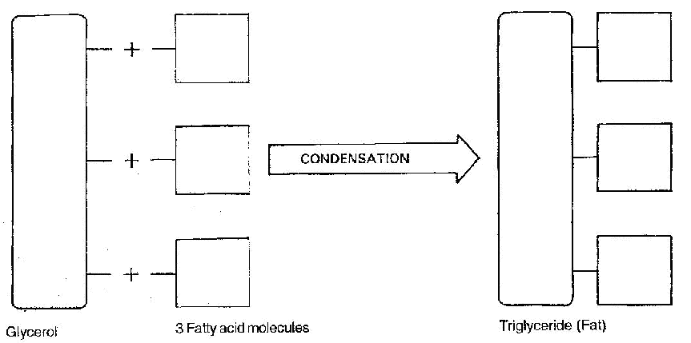
- The nature of lipids depends on the fatty acid it contains even though the glycerol is the same in all lipids.
- Complex lipids are formed by a condensation process e.g. phospholipids, waxes, steroids and cholesterol.
- Properties of lipids
- When fats are heated they readily change into liquid while the oils solidify if subjected to low temperatures.
- Both fat and oil are insoluble in water however; they readily dissolve in organic solvents such as alcohol, ether and chloroform forming emulsions and suspensions.
- Lipids are quite inert hence can be stored in the tissues of organisms.
- Functions of lipids
- Lipids as a source of energy
- A given weight of a lipid will liberate almost twice as much energy as an equivalent weight of a monosaccharide.
- As a source of metabolic water
- When oxidized, lipids release energy and water known as metabolic water, which supplements the requirements in the body. This is why animals like camels accumulate large quantities of fat reserves in their bodies.
- They metabolize these fats to obtain the metabolic water in addition to the energy released.
- As structural compounds
- They are constituents of plasma membrane and protoplasm.
- Oils are storage materials in some seeds e.g. groundnuts, castor seed, maize grain etc.
- Heat insulation
- In animals, fat is deposited under the skin where it forms the adipose tissue which acts as a heat insulator. In this way, fats assist to reduce heat loss from the bodies of mammals.
- Mammals living in temperate regions have thick adipose tissue which greatly reduces the heat loss. Also the thick adipose tissue in some aquatic mammals helps them to be buoyant in water.
- Protection
- Fat is deposited around the major organs such as kidney, heart, at the back of the eyeball where it acts as a shock absorber.
- Also wax in plant cuticles reduces excessive water loss.
- Testing for the presence of lipids
  - Sudan iii Test
- Requirements
- Vegetable oil/ olive oil/ melted fat
- Test tube
- Sudan iii dye
- Procedure
- Put 2cm3 of oil/melted fat in a Test tube and add a few drops of Sudan iii dye into the oil.
- Observations
- A red colour indicates the presence of lipids.
  - Grease spot test /translucent spot test
- Requirements
- Vegetable oil/ olive oil/ melted fat
- Filter paper
- Water
- Procedure
- Rub a little oil/ fat on a filter paper. Let it dry.
- Hold the paper against the light and observe what happens to the spot on which the oil was applied.
- Repeat the procedure with a drop of water and allow it to dry.
- Note the difference the lipid and the water spots.
- Observations
- If a permanent translucent spot is formed, it indicates the presence of lipids.
  - Emulsion test
- Requirements
- Vegetable oil/ olive oil/ melted fat
- Test tube
- 10cm³ measuring cylinder
- Alcohol
- Water
- Procedure
- Put 2cm³ of oil/melted fat in a Test tube
- Add 4cm³ of alcohol into the oil and shake thoroughly.
- Transfer the contents of the Test tube into another Test tube about half full of water.
- Observations
- Formation of white emulsion confirms the presence of lipids.
  - Proteins
- They compounds of Carbon, Hydrogen and Oxygen. They contain Nitrogen and sometimes Sulphur or phosphorus.
- Some proteins such as haemoglobin also contain elements like iron.
- Proteins are made up small units called amino acids. There are about 20 different types of amino acids occurring naturally.
- All amino acids contain amino group (NH₂) which consists of Nitrogen and Hydrogen, but the number of carbon atoms differ from one amino acid to another.
- Proteins are referred to as Nitrogenous compounds because of the presence of Nitrogen in their structure.
- Proteins are formed by the condensation. The process involves combinations of two amino acids to form a dipeptide molecule. During this process, water molecule is formed. The two amino acids are joined by a force called a peptide bond e.g.
- 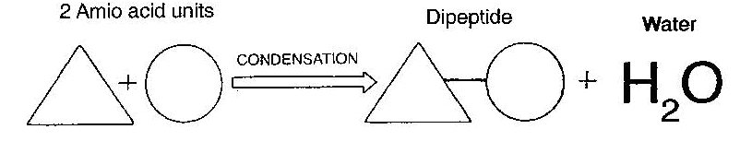
- Continued condensation leads to the addition of more amino acids to a protein chain, resulting in a long protein chain known as polypeptide chain e.g.

- 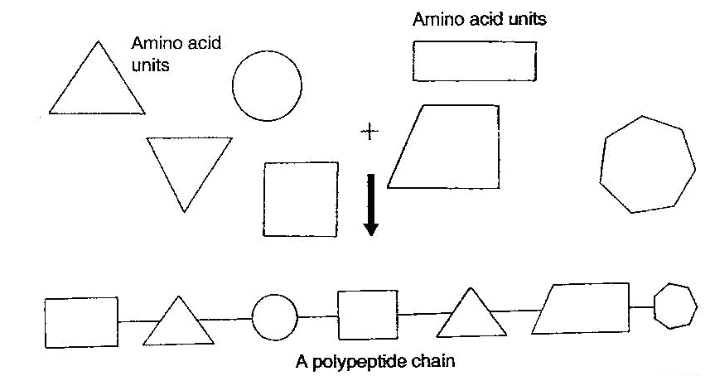
- The uniqueness of a particular protein is determined by the type and sequence of amino acids that it contains.
- Properties of proteins
- Most proteins dissolve in water but do not form true solutions. They form colloidal suspension where particles remain suspended in water
- Most proteins are denatured at temperature above 40ºC. The heat alters the structure of the protein molecule. Denaturing can also be caused by chemicals such as acids, bases, detergents and organic solvents.
- Proteins have both acidic and basic properties hence are described as amphoteric. This enables them to react with acids and bases. This property enables proteins to combine with non-protein compounds to form conjugated proteins e.g. in mucus the non-protein compound is a carbohydrate while in haemoglobin the non-protein compound is iron.
- Functions of proteins
  - Structural functions
- Proteins form of the structure of animal tissue. They are found in the form of;
  - -Keratin in hairs, horns and feathers
- -Collagen in tendons and ligaments
- -Myosin in muscles
  - Proteins are functional units in plants and animals
- Some functional proteins are;
- Enzymes
- These are proteins that speed up the reactions in plants and animals cells. Reactions like photosynthesis and respiration proceed with the help of enzymes
- Haemoglobin
- This protein is found in red blood cells of vertebrates. Its function is to transport oxygen from the lungs to the other parts of the body.
- Hormones
- These proteins regulate life processes in animals e.g. insulin which regulates the sugar level in the body.
- Antibodies
- These are proteins that provide the body with the immunity against diseases.
- Fibrinogen
- This protein is important in the clotting of blood.
  - Proteins are storage products
- Plants store excess proteins in the seed which are used by the seed during germination.
- Mammals store some of their protein in the form of casein in milk.
  - Source of proteins
- About 10 of the known amino acids cannot not be synthesized by the human body and must be obtained from the diet. They are known as essential amino acids.
- The body is able to synthesize non-essential amino acids using compounds from the various food substances. These amino acids are therefore not required in the diet.
- Some proteins that we eat contain all the essential amino acids hence called 1st class proteins e.g. nearly all animal proteins and Soya beans.
- Other proteins lack one or more of the essential amino acids. They are called 2nd class proteins e.g. most plant proteins and a few animal proteins.
  - As source of energy
- Proteins are normally used as a source of energy in conditions of starvation.
- Test for proteins
- Requirements
- Milk /albumen
- Test tube
- 10% NaOH
- 1% CUSO₄
- Droppers
- Procedure
- Put 2cm³ of albumen / milk solution in a test tube.
- Into the test tube add an equal amount of 10% NaOH solution and shake.
- Into the mixture above, add a few drops of 1% CUSO₄ solution drop by drop shaking well after each drop.
- Observation
- Purple colour indicates the presence of proteins.
- ENZYMES
- These are organic catalysts which are protein in nature. They are produced in living cells.
- As catalysts they speed up or slow down the rate of chemical reaction in the body without themselves being used up.
- There are two types of enzymes;
- Intracellular enzymes-they are secreted and used within the cells which produce them e.g. respiratory enzymes.
- Extracellular enzymes- Are produced within the cells but used outside the cells which produced them e.g. digestive enzymes.
- Naming of enzymes
- Trivial naming- This method involves names given to the enzymes by the people who discovered them. The names end in-in e.g. pepsin, trypsin.
- Use of suffix-ase
- This is the modern method of naming enzymes. The suffix-ase is added to the substrate (type of food) or the reaction which the enzyme catalyses e.g.
Substrate | Enzyme
Carbohydrate | Carbohydrase
Starch e.g. amylase | Amylase
Sucrose | Sucrase
Maltose | Maltase
Protein | Protease
Lipids | Lipase
- The following are some of the examples of enzymes which catalyze certain reactions.
Reaction | Enzyme
Hydrolysis | Hydrolase
Oxidation | Oxidase
Reduction | Reductase
- Properties of enzymes
- Enzymes are protein in nature. They are therefore affected by temperature and PH.
- Enzymes are substrate-specific.
- Enzymes are efficient in small amounts since they are not affected by the reactions they catalyze. They can be used again and again.
- They are catalysts that speed up the rate of cellular reactions. They are not used up in the reactions they catalyze.
- Many of these enzyme-catalyzed reactions are reversible.
- Factors which affect enzyme- catalyzed reactions
- Temperature
- Enzymes are protein in nature hence they are sensitive to changes in temperature.
- The best temperature (optimum temperature) of an enzyme is 35-40ºC e.g.
- 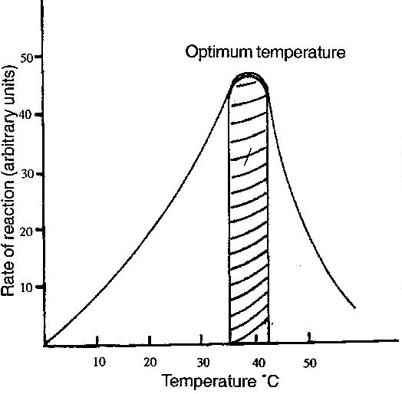
- From the graph above, the rate of enzyme reaction increases with increase in temperature up to optimum temperature (35-40ºC). Any further increase in temperature above the optimum leads to a decrease in enzyme reaction because enzymes are denatured (destroyed).
- NB Low temperature does not denature enzyme but it inactivates the enzymes.
- Activity1; To investigate the effect of temperature on enzyme activities
- Requirements
- Saliva obtained after rinsing the mouth with water (ptyalin/salivary amylase).
- Starch solution (2cm³)
- Test tubes
- Beaker
- Water bath
- Burner
- Iodine solution
- Benedict’s solution
- Labels
- Measuring cylinder
- Thermometer
- Procedure
- Place 2cm³ each of starch solution into 3 different test tubes 1-3.
- To each test tube add 1cm³ of saliva/ptyalin enzyme.
- Immerse the 1st test tube into a beaker of cold water (preferably with ice cubes)
- Put the 2nd test tube in a water bath maintained at 37ºC.
- Boil the contents of the 3rd test tube.
- Test the contents of each test tube with iodine and Benedict’s; solutions. Record your observations in the table below

Test tube | Test with iodine after adding enzyme |  | Test with Benedict’s solution after 20 mins
 | Observation | Conclusion | Observation | Conclusion
Cold water(0°C) | Blue black | Starch present-enzyme inactivated | No colour change- Colour remains blue | Reducing sugar absent
Water bath at 37°C | Brown | Starch absent-ideal temperature for enzyme | Orange | Reducing sugar present
Boiled contents | Blue black | Starch present-enzyme denatured | No colour change -Colour remains blue | Reducing sugar absent

- Explanation
- Test tube A- Starch was present because it had not been broken down to maltose. The enzyme had been inactivated by the low temperature (0ºC).
- Test tube B- Reducing sugar present. Starch (polypeptide) was broken down by enzyme to reducing sugar (maltose). The temperature was ideal for the working of the enzyme.
- Test tube C- Starch present because it had not been broken down by enzyme. The temperature was too high hence denatured the enzyme.
- PH
- It refers to the acidity or alkalinity of a substance. Most enzymes have optimum PH close to 7.
- However, some enzymes work best in alkaline conditions. Extreme acidity or alkalinity denatures the enzymes.
- Activity11; To investigate the effect of PH on enzyme activities
- Requirements
- Saliva obtained after rinsing the mouth with water
- Starch solution (2cm³
- Test tubes
- Dilute Hcl (1cm3)
- Dilute NaOH (1cm3)
- Water
- Water bath
- Burner
- Iodine solution
- Benedicts solution
- Labels
- Procedure
- Place 5cm³ each of starch solution into 3 test tubs.
- To test tube 1 add 1cm3 of dil. Hcl and shake. Add 1cm3 of the enzyme ptyalin and shake.
- To test tube 2 add 1cm³ of dil. NaOH and shake. Add 1cm³ of the enzyme ptyalin and shake
- To test tube 3 add 1cm³ of water and shake. Add 1cm³ of the enzyme ptyalin and shake
- Place the labeled test tubes into a water bath maintained at 37C for 20 mins.
- Test the contents of the test tubes for the presence of starch and reducing sugar. Record your observations and conclusions in the table below.

Test tube | Test with iodine after adding enzyme |  | Test with Benedict’s solution after 20 mins
 | Observation | Conclusion | Observation | Conclusion
Dil Hcl+starch+ptyalin | Blue black | Starch present-unsuitable pH | No colour change- Colour remains blue | Reducing sugar absent
Dil NaOH+starch+ptyalin | Brown | Starch absent-ideal pH for enzyme | yellow | Reducing sugar present
Water +starch+ptyalin | Blue black | Starch present- unsuitable pH | No colour change -Colour remains blue | Reducing sugar absent

Observation
- Ptyalin is an enzyme found in saliva. It converts starch to maltose. The PH of saliva is 7. The enzyme works best in a slightly alkaline medium.
- Specificity
- Enzymes are specific in nature. A particular enzyme will only act on a particular substrate eg salivary amylase (ptyalin) will only speed up the breakdown of starch to maltose.
- Substrate concentration and enzyme concentration
- When the substrate concentration is increased, the rate of enzyme reaction also increases up to a certain level. However, further increase in Substrate concentration does not increase the rate of enzyme reaction. This is because all the active sites of the enzyme are occupied. When the enzyme molecules are increased, there is a proportional increase in maximum rate of enzyme action.
- 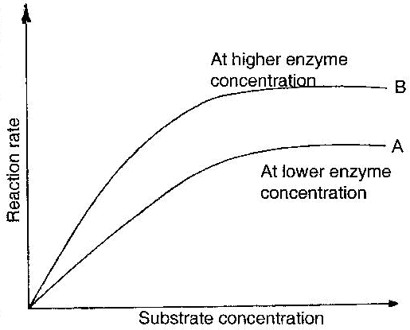
  - Graph A- Shows the effect of increasing substrate concentration on the rate of an enzyme –controlled reaction.
  - Graph B- Shows the effect of increased enzyme concentration on the rate of an enzyme –controlled reaction
  - Enzyme co-factors and co-enzymes
- Co-factors are non-proteinous substances which activate the enzymes. Some of the co-factors are metallic ions such as those of iron, magnesium, zinc, copper while others are vitamins.
- Co-enzymes are organic non-protein molecules that work in association with particular enzymes. Many co-enzymes are derived from vitamins.
- Enzyme inhibitors
- Inhibition occurs when action of an enzyme is slowed down by another substance called inhibitors. The inhibitor competes with the normal substrate for the active sites. In other cases, the inhibitor takes up the active site of the enzyme permanently.
- Competitive inhibitors
- This is where both substrate and inhibitor molecules are competing for the active sites so that the action of the enzyme is slowed down.
- The inhibitor is not normally affected by the enzyme so it stays in the active site longer than the substrate. This type of inhibition has no permanent effect on the enzyme action. The inhibition they cause can be overcome either by increasing the substrate concentration or reducing the concentration of the inhibitor.
- Non-competitive inhibitors
- They are called non-competitive inhibitors because they do not compete with the substrate. They combine permanently with the enzyme molecules thus blocking the active sites and this prevents the enzyme from interacting with the substrate.
- Such inhibitors include poisons such as cyanides, mercury and silver-arsenic compounds.
- Importance of enzymes
- They speed up cellular reactions so that they proceed at a pace that is appropriate for sustaining life.
- Enzymes control cellular reactions and this prevents violent incidents in the cell.
- Activity1; To investigate the presence of enzymes in living tissues
- Requirements
- Test tubes
- Labels
- Measuring cylinder
- Hydrogen peroxide
- Liver
- Muscle tissue
- Potato
- Water bath
- Source of heat
- Procedure
- Label 4 test tubes A, B, C and D.
- Measure 2cm³ of Hydrogen peroxide and put in test tube A. Repeat the same procedure for test tube B and C.
- Cut a small piece of liver and place in test tube A. Immediately introduce a glowing splint into the mouth of the test tube.
- Repeat step III using muscle tissue (in test tube B) and a potato (in test tube C).
- Repeat step III using boiled liver (in test tube D) and make sure that the liver is thoroughly boiled for about 5 mins. Tabulate your results e.g.

Test tube | Observation | Conclusion
A-Hydrogen peroxide+ raw liver | - glowing splint bursts into flame  -Vigorous production of bubbles/froth/foam | A lot of catalase enzyme present
B-Hydrogen peroxide+ muscle tissue | -Relights glowing splint  -A lot of bubbles produced/froth/foam | Medium amount of catalase enzyme present
C-Hydrogen peroxide+ potato | -Relights glowing splint  - low production of bubbles/froth/foam | Little amount of catalase enzyme present
D- Hydrogen peroxide+ boiled liver | -No production of bubbles | Enzymes denatured by boiling

- Discussion
- Living things contain an enzyme called catalase which breaks down hydrogen peroxide to water and oxygen. The oxygen produced relights a glowing splint i.e.
- 2H₂O₂ → 2H₂O + O₂
- Hydrogen peroxide catalase water oxygen

